Table S1 Ingredients and RxNorm codes of medications included in the study
RxNorm code | Ingredient name
821601 | Acetaminophen/Aspirin/Caffeine/Codeine
689552 | Acetaminophen/Aspirin/Caffeine/Codeine/salicylamide
689555 | Acetaminophen/Aspirin/Codeine
689561 | Acetaminophen/butalbital/Caffeine/Codeine
689563 | Acetaminophen/butalbital/Codeine
814657 | Acetaminophen/Caffeine/Codeine
817430 | Acetaminophen/Caffeine/Codeine/Meprobamate
689568 | Acetaminophen/Caffeine/Codeine/salicylamide
817579 | Acetaminophen/Codeine
817356 | Acetaminophen/Codeine/Ibuprofen
1007238 | Aconite/Codeine/Erysimum preparation
690996 | Aluminum Hydroxide/Aspirin/Codeine/Magnesium Hydroxide
214237 | anhydrous calcium iodide/Codeine
214160 | Aspirin/butalbital/Caffeine/Codeine
689511 | Aspirin/Caffeine/Codeine
689522 | Aspirin/Carisoprodol/Codeine
135095 | Aspirin/Codeine
1008493 | Benzoate/Codeine
1008060 | Butalbital/Caffeine/Codeine
691032 | Calcium iodide/Codeine
2670 | Codeine
1008110 | Codeine/Diclofenac
1008954 | Codeine/Erysimum preparation
1007477 | Codeine/Ethylmorphine
710303 | Codeine/Ibuprofen
214443 | Codeine/iodinated glycerol
729517 | Codeine/Kaolin
690089 | Codeine/Papaverine
1007293 | Codeine/Potassium
690096 | Codeine/potassium citrate
1007204 | Codeine/propyphenazone
690101 | Codeine/Pyrilamine
689569 | Acetaminophen/Caffeine/dihydrocodeine
151196 | Acetaminophen/dihydrocodeine
689783 | Acetaminophen/dihydrocodeine/salicylamide
689512 | Aspirin/Caffeine/dihydrocodeine
23088 | Dihydrocodeine
352362 | Acetaminophen/Tramadol
10689 | Tramadol
Table S2 Ingredient names and RxNorm codes of strong or moderately strong CYP2D6 inhibitors included in the study
RxNorm code | Ingredient name | Strength of inhibitor (21)
42347 | Bupropion | Strong
1551467 | Bupropion / Naltrexone | Strong
4493 | Fluoxetine | Strong
611247 | Fluoxetine / Olanzapine | Strong
32937 | Paroxetine | Strong
1040053 | Dextromethorphan / Quinidine | Strong
9068 | Quinidine | Strong
1007942 | Quinidine / Verapamil | Strong
1721552 | Florfenicol / Mometasone / Terbinafine | Strong
37801 | Terbinafine | Strong
818150 | Alginic acid / Cimetidine | Moderate
2541 | Cimetidine | Moderate
407990 | Cinacalcet | Moderate
72625 | Duloxetine | Moderate
42355 | Fluvoxamine | Moderate
1300786 | Mirabegron | Moderate

Table S3 Risk of poor pain control or adverse reactions by sex, race, and ethnicity
Characteristic |  | Poor pain control |  | Adverse reactions
Characteristic | Total | N | p-value | N | p-value
Total | 2,877 | 117 (4.1) |  | 198 (6.9)
Sex, n (%)
Male | 1,186 | 51 (4.3) | 0.596 | 61 (5.1) | 0.002
Female | 1,691 | 66 (3.9) |  | 137 (8.1)
Race, n (%)
White | 2,706 | 112 (4.1) | 0.038 | 185 (6.8) | 0.158
Black | 11 | 2 (18.2) |  | 2 (18.2)
Asian/Pac. islander | 23 | 0 (0) |  | 2 (8.7)
Unknown | 137 | 3 |  | 9
Ethnicity, n (%)
Non-Hispanic | 2,839 | 116 (4.1) | --- | 196 (6.9) | 0.815
Hispanic | 34 | 0 (0) |  | 2 (5.9)
Unknown | 4 | 1 |  | 0

Figure S1 Adverse reactions and poor pain control related to opioid use extracted from electronic health records

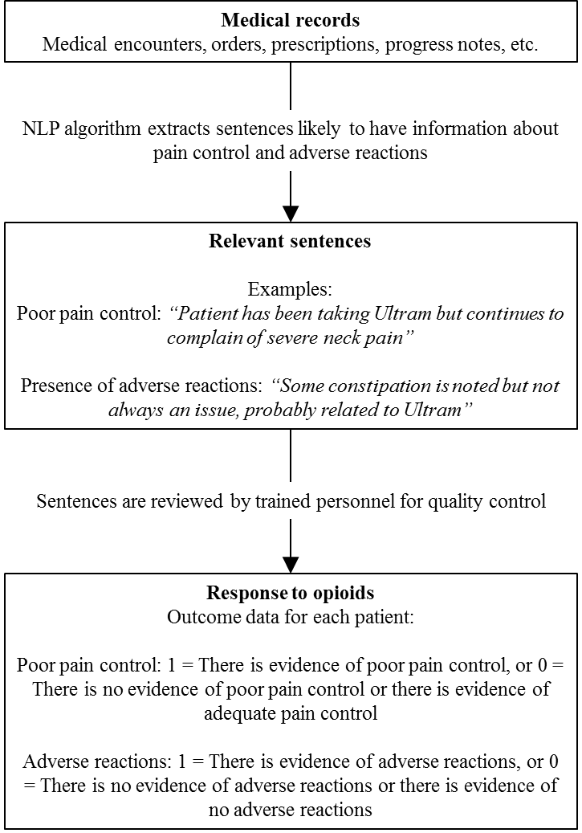

Figure S2 CYP2D6 activity scores of participants who experienced vs did not experience adverse reactions or poor pain control (n = 2,788).

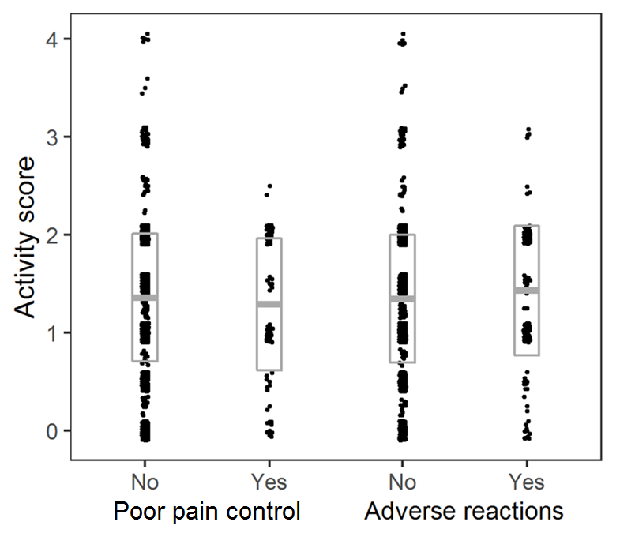

Note: Bars represent means and standard deviations.

Figure S3 Risk of adverse reactions or poor pain control between each CYP2D6 metabolizer status relative to a normal and intermediate to normal metabolizer status by sex
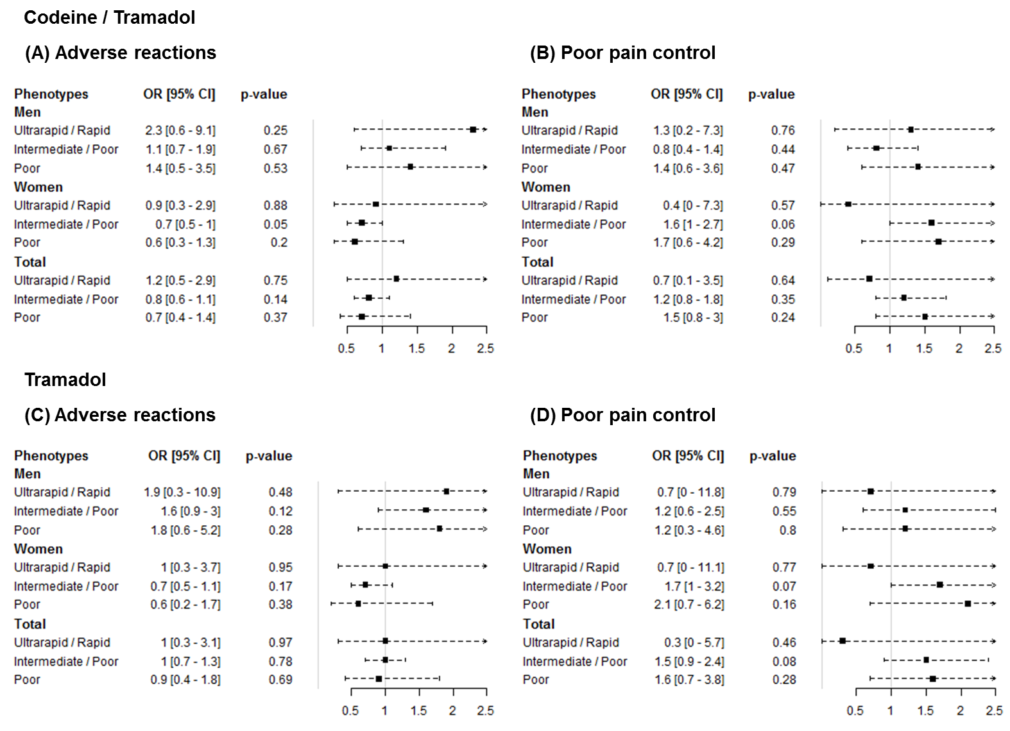
Note: Estimates and p-values adjusted for age, race, and ethnicity.

