SUPPLEMENTARY FIGURES

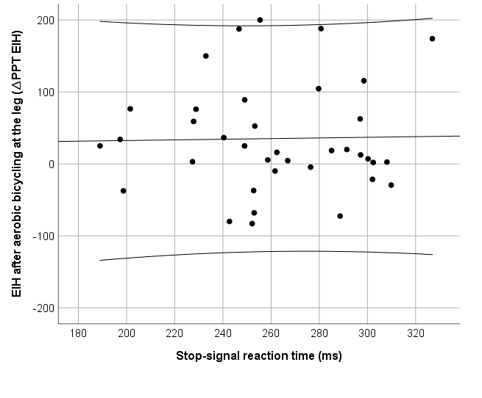
S1: Scatterplot of ∆PPT_{EIH} after aerobic bicycling exercise at the leg and stop-signal reaction times (r = -.10, 95% CI: -.36; .18, p = .553).
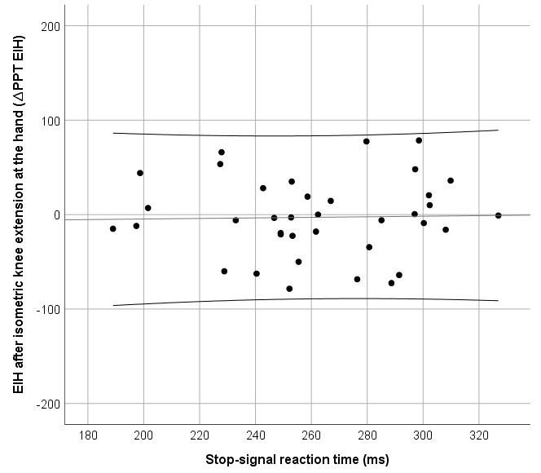
S2: Scatterplot of ∆PPT_{EIH} after isometric knee extension exercise at the hand and stop-signal reaction times (rho = -.03, 95% CI: -.30; .25, p = .884).
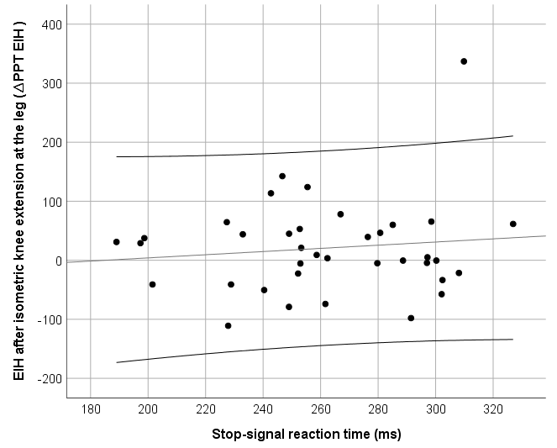
S3: Scatterplot of ∆PPT_{EIH} after isometric knee extension exercise at the leg and stop-signal reaction times (rho = .03, 95% CI: -.25; .30, p = .857).
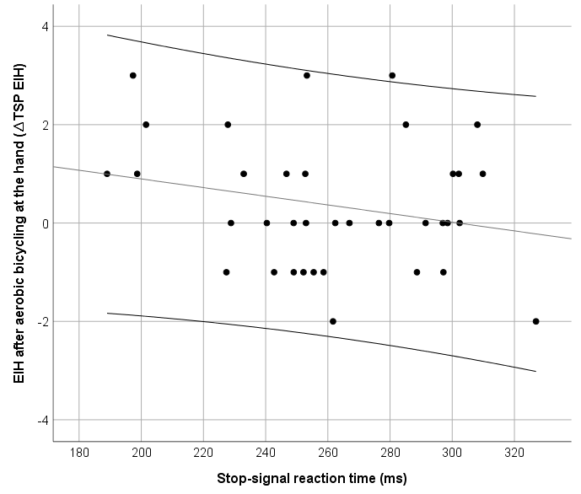
S4: Scatterplot of ∆TSP_{EIH} after aerobic bicycling exercise at the hand and stop-signal reaction times (rho = -.14, 95% CI: -.40; .14, p = .397).
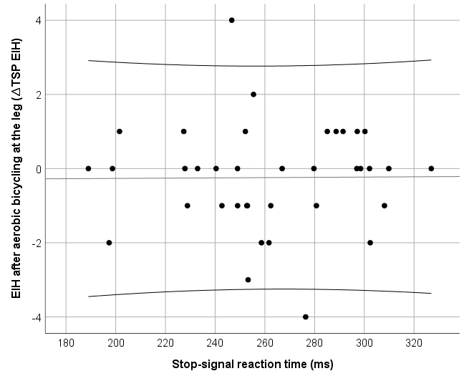
S5: Scatterplot of ∆TSP_{EIH} after aerobic bicycling exercise at the leg and stop-signal reaction times (rho = .02, 95% CI: -.26; .29, p = .904).
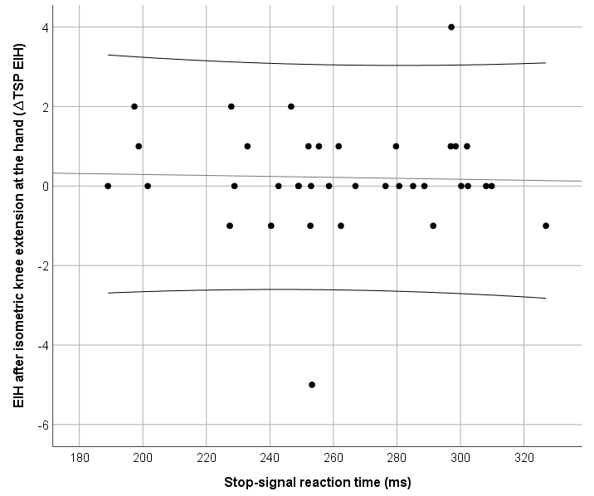
S6: Scatterplot of ∆TSP_{EIH} after isometric knee extension at the hand and stop-signal reaction times (rho = -.09, 95% CI: -.36; .20, p = .598).
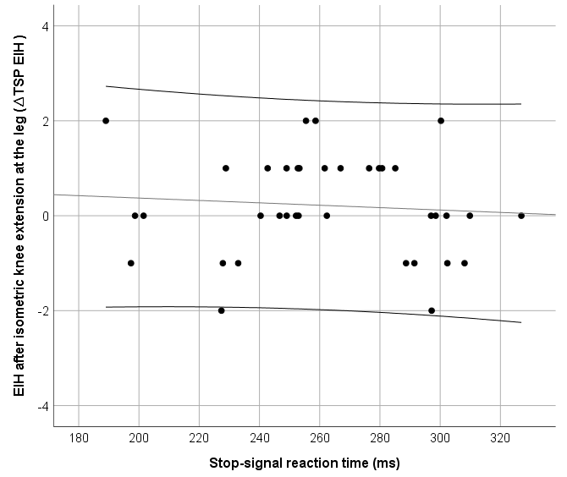
S7: Scatterplot of ∆TSP_{EIH} after isometric knee extension at the leg and stop-signal reaction times (rho = .02, 95% CI: -.33; .22, p = .728).

