Supporting Information
The Novel DPP-BDT Nanoparticles as Efficient Photoacoustic Imaging and Positron Emission Tomography Agents in Living Mice
Tingting Li^{†1,2}, Xiaoming Hu^{†3}, Quli Fan^{†4}, Zejing Chen³, Ziliang Zheng¹, Ruiping Zhang²*
¹Department of Pharmacy, School of Pharmaceutical Science, Shanxi Medical University, Taiyuan, Shanxi, People’s Republic of China; ² Radiology Department, The Affiliated Bethune Hospital of Shanxi Medical University, Taiyuan, Shanxi, People’s Republic of China; ³Institute of Advanced Materials, East China Jiaotong University, Nanchang, Jiangxi, People’s Republic of China; ⁴Key Laboratory for Organic Electronics & Information Displays and Institute of Advanced Materials, Nanjing University of Posts & Telecommunications, Nanjing, Jiangsu, People’s Republic of China; ⁵ The first hospital of Shanxi Medical University Taiyuan, Shanxi, People’s Republic of China.

†These authors contributed equally to this work

Correspondence: Ruiping Zhang
Radiology Department, The Affiliated Bethune Hospital of Shanxi Medical University, Taiyuan, Shanxi, People’s Republic of China; Email: zrp_7142@sxmu.edu.cn

1. Experiments
1.1 The serum stability test of ⁶⁴Cu-labeled DPP-BDT NPs
Serum stability studies were carried out to ensure that [⁶⁴Cu]-DPP-BDT NPs was sufficiently stable for in vivo applications. [⁶⁴Cu]-DPP-BDT NPs was incubated in 50% mouse serum at 37 °C for up to 48 h. Portions of the mixture were sampled at different time points and filtered through 300 kDa MWCO filters. The radioactivity within the filtrate was measured, and the percentages of retained (i.e., intact) [⁶⁴Cu] on the DPP-BDT NPs conjugates were calculated using the equation:
⁶⁴Cu% on DPP-BDT NPs = (total radioactivity - radioactivity in filtrate)/total radioactivity × 100%.
1.2 Blood hematology and biochemistry analysis.
The BALB/c mice were randomly divided into two groups (n=3/group) and given the following treatments: i) saline (i.v. injection 200 μL), (ii) DPP-BDT NPs (i.v. injection 200 μL 2.0 mg mL⁻¹). The body weights of the mice were monitored. The blood samples were harvested from the fundus artery of group (ii) at 0, 7, and 30 days. EDTA was added to the collected blood samples as a stabilizer. Next, approximately 1 mL of blood diluted with 5 mL of PBS was centrifuged at 1200 rpm for 10 min and was placed at room temperature for 2 h until the red blood cells (RBCs) and blood plasma became separated. After repeated washing with PBS, the blood plasma was used for biochemical analysis. Renal function markers (CRE and BUN) and hepatic function markers (ALT and AST) were monitored, and routine blood tests were conducted.
2. Figures and discussion
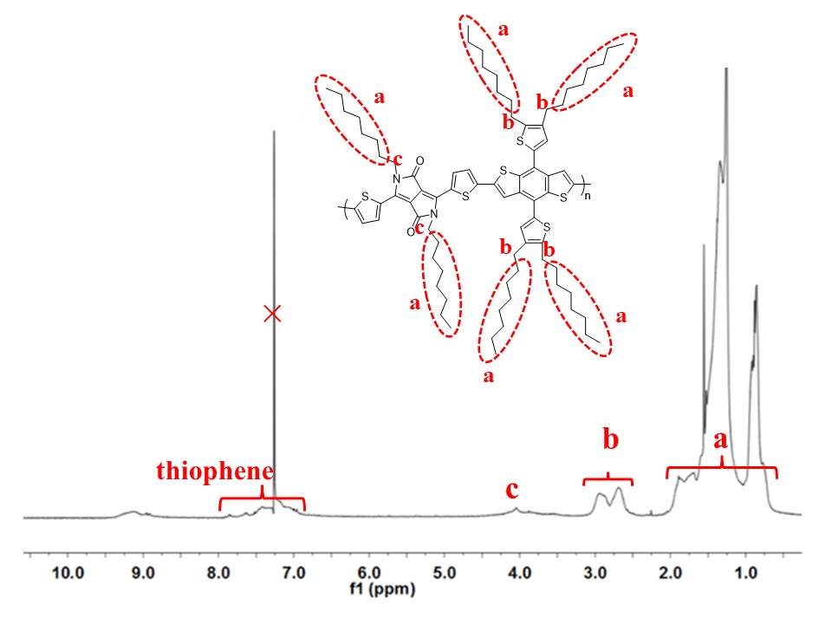
Supporting Figure S1.¹H-NMR spectra of DPP-BDT in CDCl₃.
Supporting Figure S2. Serum stability studies of ⁶⁴Cu-labeled DPP-BDT NPs.
As shown in Supporting Figure S2, serum stability studies of ⁶⁴Cu-labeled DPP-BDT NPs was subsequently conducted to validate the stability of [⁶⁴Cu] labeling in vitro and the feasibility for in vivo applications. After incubating with mouse serum at 37 ºC for 40 h, above 95% [⁶⁴Cu] still remained intact on DPP-BDT NPs at all the tested time points. Since PET imaging detected isotope rather than nanoparticles per se, high radio-stability in serum made ⁶⁴Cu-labeled DPP-BDT NPs preferable for in vivo imaging and truly reflects the distribution of nanoparticle.
Supporting Figure S3. Evaluation of the stability of DPP-BDT NPs in serum
The stability of the drug in the blood transport process is very important, so we repeated the experiment and revised some results. In order to verify the stability of DPP-BDT NPs, we simulated the blood environment and conducted an in vitro test. The following verification method was designed: The DPP-BDT NPs (1 mg) were added to 50% fatal bovine serum (FBS, 5 mL) and 50% PBS (5 mL) and incubated at 37 °C for 48 h. The samples were analysed at 0 h, 8 h, 24 h, and 48 h by DLS. As shown in Figure S3, all the hydrodynamic sizes of DPP-BDT NPs still retained at around 32 ± 2.9 nm and the polydispersity of the samples were not changed significantly. The PDI results were 0 h = 0.146 ± 0.016, 8 h =0.197 ± 0.028, 24 h = 0.213 ± 0.012, and 48 h = 0.210 ± 0.025, respectively. Therefore, we concluded that DPP-BDT NPs can be stably in bovine serum PBS buffer.
Supporting Figure S4. Photostability comparison of DPP-BDT NPs with ICG.
As displayed in Figure S4, the absorption of traditional ICG dyes is continuously reduced during the irradiation of laser light. After 60 minutes, the absorption intensity has decreased to more than 80% of the initial value. However, the absorption of DPP-BDT NPs only decreased by about 5%, and the absorption has remained basically unchanged. Therefore, the DPP-BDT NPs have excellent light stability and have obvious advantages as a photoacoustic imaging contrast agent.
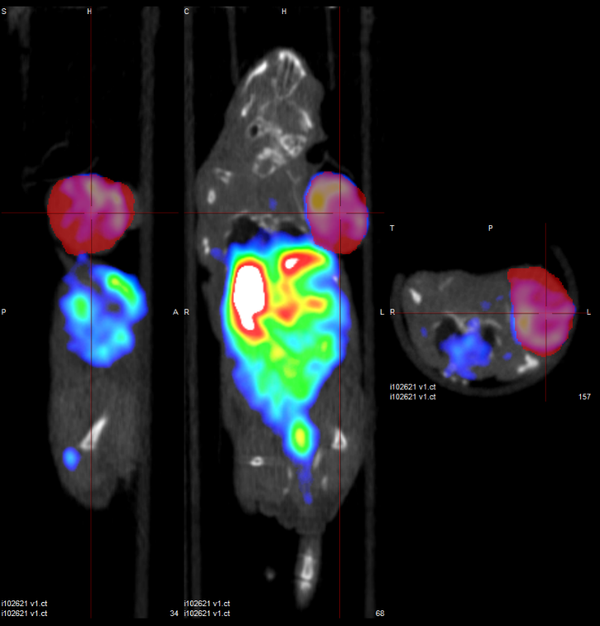
Supporting Figure S5. The representative 3D-ROI PET imaging of [⁶⁴Cu]-DPP-BDT.
We drew 2D-ROIs around the edge of the tumor and target organs showed on each slice of the merged CT images. Then the software will combine all 2D-ROIs into a 3D-ROI and read out the radioactivity in it. This is a standard analysis method in animal PET/CT imaging process. A representative PET imaging showed the ROI settings and the distribution of the nanoparticles in Figure S5.
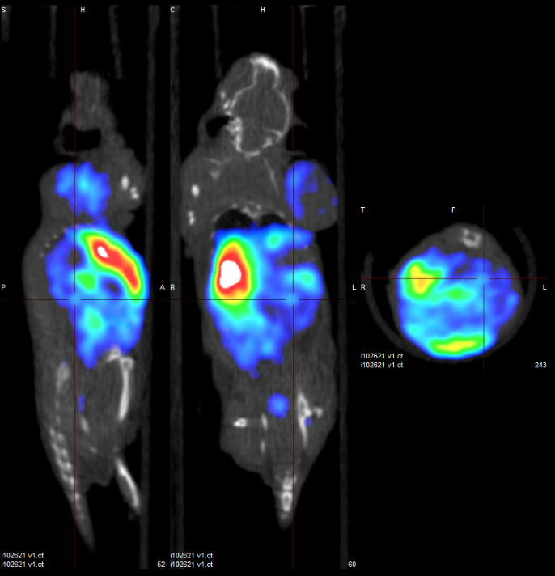
Supporting Figure S6. In vivo study of PET of [⁶⁴Cu] labeled DPP-BDT NPs
The PET imaging has been used in clinic and animal research for many years as a quantitative imaging modality. ROI analysis is a standard method for the PET imaging data process and is reliable. The radioactivity in each ROI is compatible with the ex vivo radioactivity test. In this study, we manually drew 3D-ROIs around the edge of the tumor or organ to measure the radioactivity in all tumors and interested organs over time. Since PET imaging showed different slices, the slice selected in Figure 3 did not include the kidney, so the signal of the kidney cannot be detected. In the supplementary data (Supporting Figure S6), we selected the layer that contained the kidneys, which showed the kidney signals.
Supporting Figure S7. Blood routines of mice examination were measured after the treatment with DPP-BDT NPs (2 mg/mL, 100 uL) during 30 day.
Compared to the control group, the blood chemical and biochemical indicators of all treated mice were almost no changes, suggesting the high biosafety of the DPP-BDT NPs (Supporting Figure S7).

