Alterations in the levels of circulating and endothelial progenitor cells levels in young adults with type 1 diabetes: a 2-year follow-up from the observational METRO study

Supplementary data

Supplemental Figure S1…………………………………………………………………pag. 2
Supplemental Table S1…………………………………………………………………..pag. 3
Supplemental Table S2…………………………………………………………………..pag. 4

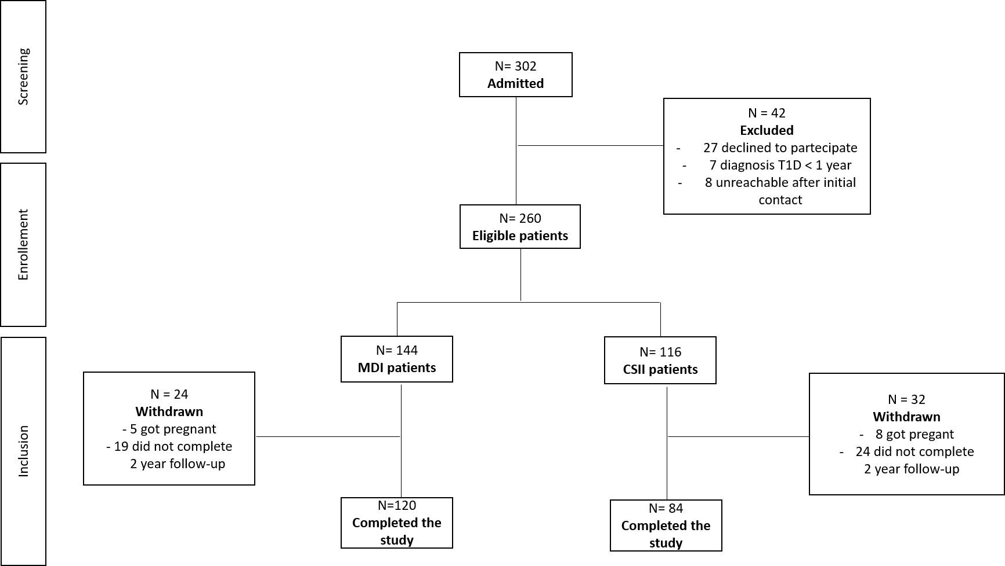

Supplementary figure 1. Process of patients selection. MDI, multiple daily injections; CSII continuous, subcutaneous insulin infusion.

Supplemental Table S1. Circulating levels of six EPCs phenotypes in type 1 diabetic patients at baseline. EPCs cell count is expressed as number/10⁶ events.
 | All patients  (n = 204) | CSII  (n = 84) | MDI  (n = 120) | P
CD34⁺ | 230 (161,280) | 225 (173,324) | 247 (173,279) | 0.91
CD133⁺ | 191 (128,238) | 178 (114,225) | 214 (138,242) | 0.13
CD34⁺CD133⁺ | 166 (100,211) | 150 (95,204) | 178 (120,214) | 0.16
CD34⁺KDR⁺ | 40 (32,45) | 42 (32,49) | 39 (29,44) | 0.09
CD133⁺KDR⁺ | 27 (23,36) | 25 (23,35) | 31 (23,38) | 0.23
CD34⁺KDR⁺CD133⁺ | 19 (14,24) | 17 (14,24) | 20 (14,24) | 0.38
Data are expressed as median (interquartile range). CSII, continuous subcutaneous insulin infusion; MDI, multiple daily insulin injections.

Supplemental Table S2. Main outcomes at 2 years according to insulin regimen (CSII/MDI).
 | CSII (n = 84) |  |  |  | MDI (n = 120)
Parameter | Baseline | 2 years | Difference | P | Baseline | 2 years | Difference | P
HbA1c (%) | 8.5 ± 1.0 | 8.1 ± 0.9 | -0.4 ± 0.9 | 0.001 | 8.5 ± 1.1 | 8.1 ± 1.3 | -0.4 ± 1.1 | <0.001
HbA1c (mmol/mol) | 69 ± 13 | 65 ± 11 | -4 ± 11 | 0.001 | 69 ± 11 | 65 ± 14 | -4 ± 11 | <0.001
FPG (mg/dL) | 217.1 ± 44.4 | 169.8 ± 63.5 | -48.6 ± 52.4 | <0.001 | 214.3 ± 65.4 | 196.8 ± 73.7 | -18.2 ± 39.4 | 0.029
MAGE (mmol/L) | 6.7 ± 2.1 | 5.6 ± 2.5 | -1.1 ± 2.1 | <0.001 | 6.5 ± 1.6 | 6.3 ± 1.7 | -0.2 ± 1.9 | 0.126
CONGA (mmol/L) | 6.8 ± 1.7 | 6.5 ± 1.9 | -0.3 ± 1.1 | 0.138 | 6.4 ± 1.8 | 6.2 ± 1.8 | -0.2 ± 1.7 | 0.245
SD (mmol/L) | 3.5 ± 0.8 | 3.2 ± 0.8 | -0.3 ± 1.1 | <0.001 | 3.5 ± 0.7 | 3.4 ± 0.7 | -0.1 ± 1.2 | 0.110
Insulin dose (UI/Kg) | 0.69 ± 0.2 | 0.51 ± 0.1 | 0.18 ± 0.1 | <0.001 | 0.69 ± 0.2 | 0.70 ± 0.2 | 0.01 ± 0.1 | 0.348
Weight (Kg) | 70.4 ± 11.5 | 70.7 ± 11.4 | 0.3 ± 2.7 | 0.436 | 68.9 ± 10.1 | 70.5 ± 11.3 | 2.4 ± 1.8 | 0.004
BMI, kg/m2 | 24.5 ± 3.1 | 24.5 ± 3.3 | 0.01 ± 1.6 | 0.992 | 23.8 ± 2.9 | 24.2 ± 2.4 | 0.4 ± 1.4 | 0.040
Total cholesterol | 167.3 ± 27.8 | 160.0 ± 25.9 | -6.5 ± 10.4 | 0.119 | 163.5 ± 28.3 | 161.8 ± 29.4 | -22.5 ± 12.3 | 0.169
HDL-choleterol | 57.3 ± 12.8 | 55.9 ± 19.6 | -2.2 ± 17.3 | 0.367 | 57.05 ± 13.1 | 58.2 ± 12.2 | 1.5 ± 17.8 | 0.147
LDL-cholesterol | 91.8 ± 24.1 | 87.1 ± 30.7 | -4.3 ± 25.7 | 0.321 | 88.9 ± 20.5 | 90.2 ± 21.1 | 2.3 ± 17.9 | 0.225
Tryglicerides | 74.5 (53 - 97) | 74.6 (42 - 99) | 0.1 ± 24.7 | 0.457 | 71 (54 - 85) | 76 (49 - 92) | 5.2 ± 28.8 | 0.366
SBP | 120 (90 - 140) | 120 (80 - 140) | 0.5 ± 0.2 | 0.876 | 120 (90 - 140) | 120 (90 - 140) | 0.2 ± 0.1 | 0.789
DBP | 77.5 (60 - 85) | 75 (60 - 80) | 1.5 ± 0.2 | 0.762 | 70 (60 - 90) | 70 (60 - 80) | 0.02 ± 1.0 | 0.982
Note: Data are expressed as mean ± standard deviation, or median (interquartile range).
Abbreviation: BMI, body mass index; CSII, continuous subcutaneous insulin infusion; CONGA, continuous overall net glycemic action; DBP, diastolic blood pressure; F, females; M, males; MAGE, mean amplitude glucose excursion; MDI, multiple insulin injections; SD, standard deviation; SBP, systolic blood pressure.

