Supplementary Information

Table S1. Oligonucleotide primers used in the study

Target gene | Sequence (5′–3′) | Annealing | Size (bp) | Reference
ipaH | F: TGGAAAAACTCAGTGCCTCT  R: GAACCAGTCCGTAAATTCATTCT | 53 °C | 425 | [40]
ipaB | F: CAAGCCCTGAATCCGATCAT  R: TGTTTACCAACAGTGGCTAC | 53 °C | 194 | Designed in this study
ipaC | F: GGGATGCTTCCTCTGCTTGT  R: CCTAGCAGCCCTATCATCAAG | 55 °C | 518 | Designed in this study
ipaD | F: AAGAAGCCGAGCTTGATGGA  R: CCTCGCCATTTCCACCTAGA | 55 °C | 450 | Designed in this study
ipgD | F: TCTTATACAAATGACGAATACCC  R: ATTGTAAGAGTGGGAAGGACA | 51 °C | 307 | [41]
Sen (ShET-2) | F: GCGATGCGTATGGGATTGAC  R: CTCCCATTCCTTCCGCAGTT | 57 °C | 244 | Designed in this study
virA | F: GCCTGCACCAGAAGTTATTG  R: AGTGTCGTTTTTAGGGACAACT | 54 °C | 550 | Designed in this study

Figure S1. Agarose gel electrophoresis showing presence of ipaB in Shigella isolates from pediatric patients.

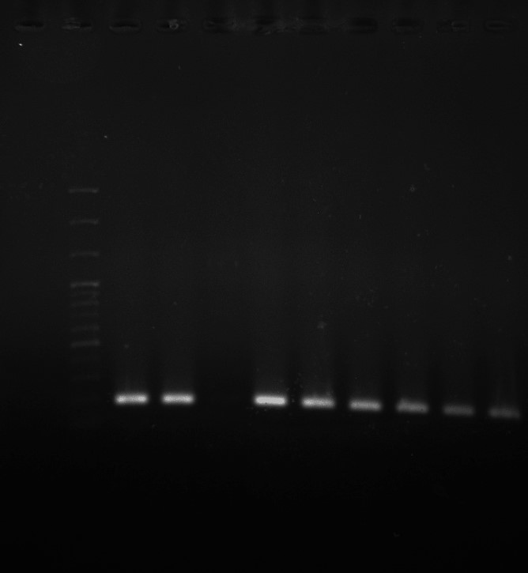
194 bp
C+
C-
L
6
4
5
7
8
3
3
2
1

C-, negative control; L, 100 bp molecular size marker; C+, positive control for ipaB gene; lane 1-8, clinical isolates of Shigella strains.

Figure S2. Agarose gel electrophoresis showing presence of ipaD in Shigella isolates from pediatric patients.

450 bp
L
C+
6
5
4
1
2
3
C-

C-, negative control; L, 100 bp molecular size marker; C+, positive control for ipaD gene; lane 1-6, clinical isolates of Shigella strains.

Figure S3. Agarose gel electrophoresis showing presence of ipaH in Shigella isolates from pediatric patients.

425 bp
L
4
C+
1
3
5
2
C-
C-, negative control; L, 100 bp molecular size marker; C+, positive control for ipaH gene; lane 1-5, clinical isolates of Shigella strains.

Figure S4. Agarose gel electrophoresis showing presence of IpgD in Shigella isolates from pediatric patients.

C+
1
2
C-
307 bp

C+
1
2
L
C-
C-, negative control; L, 100 bp molecular size marker; C+, positive control for IpgD gene; lane 1 and 2, clinical isolates of Shigella strains.

Figure S5. Agarose gel electrophoresis showing presence of ipaC in Shigella isolates from pediatric patients.

C+
C-
L
518 bp

1
2
1
2
C+
C-, negative control; L, 100 bp molecular size marker; C+, positive control for ipaC gene; lane 1 and 2, clinical isolates of Shigella strains.

Figure S6. Agarose gel electrophoresis showing presence of sen in Shigella isolates from pediatric patients.

L
5
4
3
2
1
C-
C+
244 bp
C-, negative control; L, 100 bp molecular size marker; C+, positive control for sen gene; lane 1-5, clinical isolates of Shigella strains.

Figure S7. Agarose gel electrophoresis showing presence of virA in Shigella isolates from pediatric patients.

550 bp
L
C-
6 5 4 3 2 1
C+
C-, negative control; L, 100 bp molecular size marker; C+, positive control for virA gene; lane 1-6, clinical isolates of Shigella strains.
C-
6
5
4
3
2
1
C+
L

