Supplemental Materials

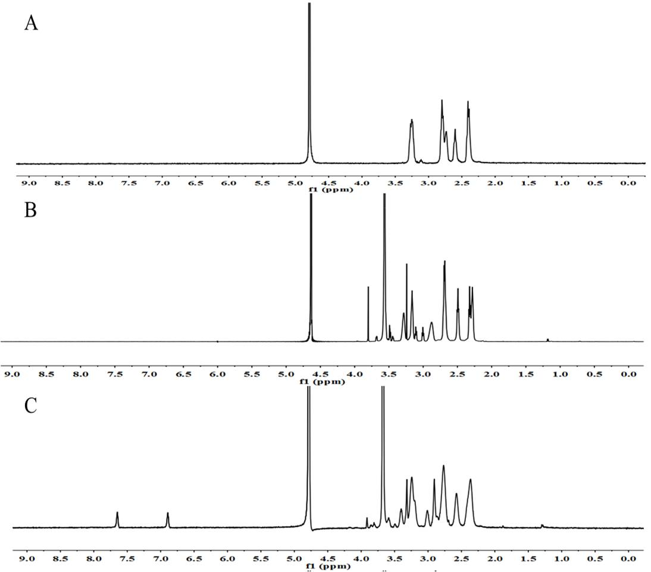
Figure S1 The ¹H NMR spectrums of different conjugates in D₂O: (A) PAMAM, (B) PAMAM-PEG (P-PEG), (C) His-PAMAM-PEG(HP-PEG).

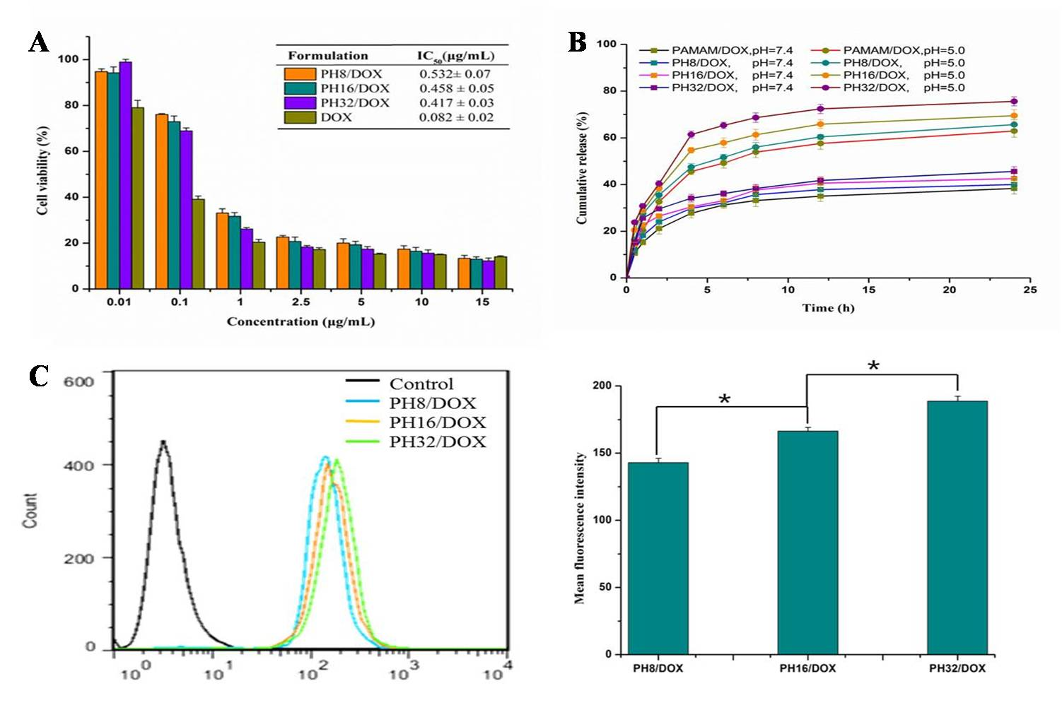
Figure S2 In vitro cytotoxicity of DOX loaded His-PAMAM conjugates with different degree of His modification against HepG2 cells after treatment for 48 h (A) and the drug release profile of DOX-loaded complexes with different degree of His modification at pH 7.4 and pH 5.0 (B). Flow cytometry of HepG2 cells after 2 h incubation with the DOX-loaded His-PAMAM complexes with different degree of His modification (C). (PH8, the molar ratio of PAMAM:His is 8:1; PH16, the molar ratio of PAMAM:His is 16:1; PH32, the molar ratio of PAMAM:His is 32:1) Data are presented as mean ± SD. (n=3, *P <0.05).

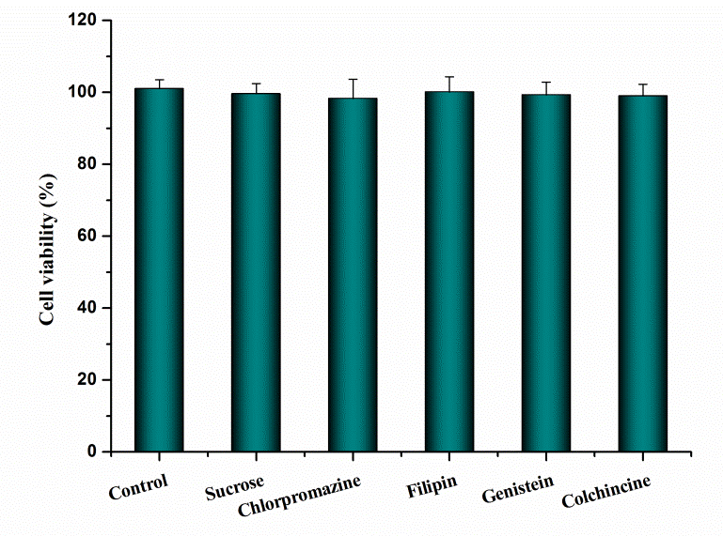
Figure S3 In vitro cytotoxicity of different endocytosis inhibitors at chosen concentration (Sucrose 150 mg/mL, Chlorpromazine 10 µg/mL, Filipin5 µg/mL, genistein 54 µg/mL, colchicines 40 µg/mL) (n=3)

