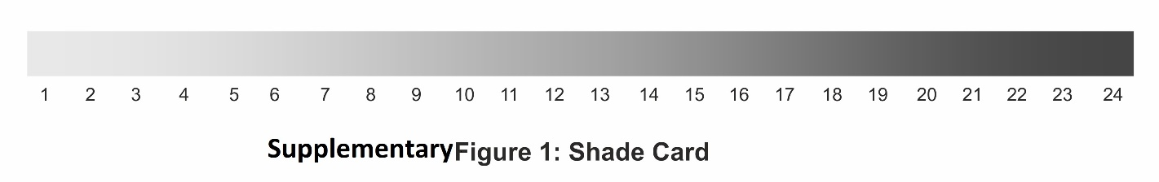

Supplementary Table 1: Image-based comparative analysis by Dermatologist
S.No. | Questions | Baseline Vs. Week4 |  | Baseline Vs. Week8
S.No. | Questions | No Improvement (%) | Improvement (%) | No Improvement (%) | Improvement (%)
1 | In which image the skin looks more moisturized. | 3 | 97 | 0 | 100
2 | In which image the skin looks more even-toned. | 3 | 97 | 8 | 92
3 | In which image the overall skin quality is visually better. | 0 | 100 | 5 | 95
4 | In which image the skin looks lighter/fairer/brighter. | 3 | 97 | 5 | 95
5 | In which image the skin has lesser fine line &wrinkles. | 5 | 95 | 5 | 95
6 | In which image the skin looks firm. | 0 | 100 | 3 | 97
7 | In which image the skin looks lesser depth (nasolabial fold) | 0 | 100 | 5 | 95

Supplementary Table 2: Self-Assessment
1. Leaves your skin moisturized
Time point | Disagree | Indecisive | Agree
Visit 2 (Week 2) | 7.89% | 0.00% | 92.11%
Visit 3 (Week 4) | 0.00% | 0.00% | 100.00%
Visit 4 (Week 8) | 0.00% | 0.00% | 100.00%
2. Makes your skin brighter
Time point | Disagree | Indecisive | Agree
Visit 2 (Week 2) | 0.00% | 7.89% | 92.11%
Visit 3 (Week 4) | 0.00% | 0.00% | 100.00%
Visit 4 (Week 8) | 0.00% | 0.00% | 100.00%
3. Makes your skin look even tone
Time point | Disagree | Indecisive | Agree
Visit 2 (Week 2) | 7.89% | 13.16% | 78.95%
Visit 3 (Week 4) | 0.00% | 0.00% | 100.00%
Visit 4 (Week 8) | 0.00% | 0.00% | 100.00%
4. Makes your skin look firmer (tight)
Time point | Disagree | Indecisive | Agree
Visit 2 (Week 2) | 5.26% | 18.42% | 76.32%
Visit 3 (Week 4) | 0.00% | 0.00% | 100.00%
Visit 4 (Week 8) | 0.00% | 0.00% | 100.00%
5. Makes your skin look younger
Time point | Disagree | Indecisive | Agree
Visit 2 (Week 2) | 2.63% | 36.84% | 60.53%
Visit 3 (Week 4) | 0.00% | 0.00% | 100.00%
Visit 4 (Week 8) | 0.00% | 0.00% | 100.00%

