Could All Types of Compassion Increase Prosocial Lying?

Supplemental Materials – Study 1
- Stimulus material

1.1 Content of application text
Chinese Version: 评委你好！我是CLX，我的专业是计量心理学。我这次写信的目的是想申请参入学校辩论队。我觉得我这一年来都表现非常好，对科研、学习都产生了很大的兴趣，但在学习之余，我想丰富一下自己的生活，锻炼一下自己的能力。因为我觉得辩论很有意思，因此想加入学校辩论队，既能让我的大学生活更加丰富多彩，又能让锻炼口才。本人态度端正，热爱祖国，拥护中国共产党。我上课认真听讲，课下认真完成老师布置的作业。不仅喜欢专业课的课本知识，还很喜欢课外知识。我觉得我还是挺好的学生，生活节俭朴素，和同学相处都十分融洽，他们都很喜欢我，我也喜欢他们。希望我们能够一直这样相处下去，这样才不会辜负了大学四年的大好时光，这四年的日子将会是我们每个人都很珍惜的一段时光。时间飞逝，生活不易，让我们彼此珍惜。
Translation: “Dear evaluator. I am CLX. My major is psychometrics. I am writing to apply for joining the school debate team. In the past year, I performed very well in my study and research. I am not only interested in scientific research but also in campus activities. I think the school debate team is a very interesting activity that not only can make my college life more colorful, but also can improve eloquence. I am a positive and optimistic person and love my motherland. I listen carefully in class and finish the homework assigned by the teacher after class. I like not only professional knowledge, but also extracurricular knowledge. In addition, I live a frugal and simple life and get along well with my classmates. They all like me and I like them too. I hope we can get along with each other all the time, so that we will not live up to the four years of good time in college. I believe that all of us cherish a period of time. Time flies. Life is not easy. Let’s cherish each other.”
Evaluations. We chose five different texts with the same theme, and then recruited 28 participants to evaluate these texts (0 = worst, 100 = best). Each participant evaluated the order of five texts in a Latin square equilibrium. According to the evaluations, we chose a poorly quality text. The evaluation scores of the selected text are displayed in Table S1.
Table S1. The raw scores of 28 participants on the poorly quality text.
Subject | Score | Subject | Score | Subject | Score | Subject | Score
1 | 73.67347 | 8 | 54.12245 | 15 | 68.44898 | 22 | 48.69388
2 | 72.44898 | 9 | 48.08163 | 16 | 61.83673 | 23 | 43.26531
3 | 58.97959 | 10 | 46.22449 | 17 | 69.4898 | 24 | 67.34694
4 | 59.12245 | 11 | 64.59184 | 18 | 69.4898 | 25 | 42.29592
5 | 51.83673 | 12 | 61.83673 | 19 | 56.12245 | 26 | 53.26531
6 | 64.69388 | 13 | 45.5102 | 20 | 48.46939 | 27 | 51.93878
7 | 61.83673 | 14 | 55.30612 | 21 | 66.40816 | 28 | 51.94326
M = 57.76 |  | SD = 9.25

Abbreviations: M, mean; SD, standard deviation.

1.2 Three applicants’ experiencing texts
Experience of other’s survival in suffering：你好，我是CLX。本想写一些有趣的事，可脑海中印象最深刻的事就是今年暑假的痛苦经历了。因为我家里经济条件不好，就想趁着暑假时间挣取下学期的生活费。于是，暑假一开始，我在一家餐厅当服务员。虽然比较累，但工作了一个月就逐渐适应了这个工作强度。但服务员的工资比较低，我就趁着上班前的时间又找了一份家教工作。我勤勤恳恳地工作了这两个多月，在开学的前两天，我才请求了辞职。两份工作使我共收获了8000元，想着下学期不用再为生活费担忧，所有的疲累就都值得啦。我坐在回学校的公交车上，小心翼翼地抱着我的包，可能是一个暑假太累了，感觉很困很困，好想立马回到学校睡上一觉…正在我精神恍惚间，下意识地感觉到有人拉了一下我的背包，我一把把包拉过来，拉链居然在开着，赶紧检查了一下，我的8000元工资已经不见了，我哽咽着请求司机和大家帮我查找，可是时间一分一秒地过去了，钱却最终也没有找见…
Translation: “Hello, I am CLX. I want to write something interesting. The most impressive thing in my mind is a painful experience of this summer vacation. In this summer vacation, I worked as a waiter/waitress in a restaurant. Although I was very tired, I had to work to earn my salary so that I won’t be poor next term. I worked hard in this place until two days before this school term started. I got a total of 8, 000 CNY from this work. I was very happy because it could cover my living expenses for the next semester. Then I sat on the bus back to school, carefully holding my bag. I felt very sleepy and a little trance. Suddenly, I felt a tug on my backpack and pulled it over. I checked it immediately and found that my salary of 8, 000 CNY had been stolen. I asked everyone to help me with a choked voice, as time went by, but I never found it.”
Experience of other’s development in suffering：你好，我是CLX。本想写一些有趣的事，可脑海中印象最深刻的事就是今年暑假的痛苦经历了。因为我计划一年后出国攻读硕士学位，故打算在暑假参加雅思考试。2000多元的报名费一交，据考试就只剩三个月。为了能一次性考过，我每天早上6点起床背单词、练口语、听听力、做阅读，练写作，一直学习到深夜。一个月后，我觉得口语和听力仍是我很大的障碍。于是我用我所有的积蓄报了一个6000多元的口语培训班。坚持了三个月，终于到了考试的当天，我早早地起了床，本来乘地铁半个小时就能到，但我想早点到，在开考前两个小时就出发了。刚到地铁站，发现人很多，挤不上去，就等下一辆，谁知道一辆一辆地过去了，人却越来越多，眼看着距离考试还剩一个小时，我赶紧出了地铁站，坐上了出租车，可刚走几分钟，就被堵在了路上，二十几分钟车子都却纹丝不动。我实在等不及了，跳下出租车，骑着单车一路狂奔。终于到达了考场，可是已经开考了半个多小时，不能再进场了…
Translation: “Hello, I am CLX. I want to write something interesting. The most impressive thing in my mind is a painful experience of this summer vacation. In this summer vacation, I spent the everyday preparing for IELTS because I wanted to study abroad. I got up at 6:00 every morning and studied till late at night to memorize words and practice oral English, listening, reading and writing. I studied hard for more than two months. But I was very anxious because if I fell the exam, I would not only waste my time and efforts, but also waste more than 2, 000 CNY of registration fee and more than 6, 000 CNY of training fee. Finally came the day of the exam. I got up early and planned to go to the exam room early. Unexpectedly, the traffic jam was so bad that my taxi couldn’t move at all. Then I had to try cycling and walking. When I arrived at the examination room with my head full of sweat, the examination had been going on for more than half an hour. I was forbidden to enter the examination room.
Neutral experience：你好，我是CLX。本想写一些有趣的事，可是好像没什么好写的 ，就描述一下我暑假去泰山旅游的事情吧。这次旅游早在半年前就计划好了，我先到达泰安，到达泰安时已是黄昏，就先在酒店住下了，第二天，天微亮我就到达了泰山。抬头看着泰山，让人望而生畏，害怕到不敢往上爬。但既然来了，还是下定了决心要登上去，征服它。于是，我努力地爬啊爬，一个小时过去了，却才爬了一点点，看着漫漫的山路，心里五味杂陈。休息了一会儿后，我又开始接着爬。最后还是爬不动了，于是找到了坐缆车的地方，乘着缆车很快就到达了山顶。山顶很冷，我不得不穿上了大衣。虽然我出发的时间比较早，但太阳已经发出了它的第一缕光从黑暗中挣脱了出来，我只看到一轮火球跃出水面，像个魔术师一样变幻出了多姿多彩的画面，不禁让人感叹，在泰山顶上看日出真的很壮丽啊。观看完日常，我又坐着缆车下了山，领略了一下泰山的美景，泰山真的是很美啊！
Translation: “Hello, I am CLX. I want to write something interesting. The most impressive thing in my mind is an ordinary experience of this summer vacation. One day during the summer vacation, I went to mount Tai in Shandong. I was very tired when I arrived, so I stayed at the hotel. The next day, just after dawn, I prepared to climb mount Tai. I tried to climb for an hour, but felt the top still was out of reach. After a short rest, I began to climb again. But it was still far from the top of the mountain. Finally, I was too tired to move, so I found a place to take the cable car, and then took the cable car quickly reached the top of the mountain. It was so cold at the top of the mountain that I had to put on my coat. Enjoying the beautiful scenery on the top of mount tai, I couldn't help admiring the spectacular scenery of mount Tai. After watching the beautiful scenery, I took the cable car down the mountain.
Evaluations. Forty participants participated in the evaluations of several applicants’ experiencing texts. According to their evaluations, we selected the above three texts. The detailed evaluation results are shown in Table S2.

Table S2. Raw score means and standard deviations in positive affect, negative affect, distress and compassion of the three applicants’ experiencing texts.
 | COSS | CODS | Neutral | F-value
 | M (SD) | M (SD) | M (SD) | F-value
Positive Affect | 2.07 (0.609) | 2.19 (0.451) | 2.07 (0.758) | 0.199
Negative Affect | 1.63 (0.652) | 1.43 (0.651) | 1.27 (0.403) | 0.393
Distress | 1.87 (0.775) | 1.71 (0.695) | 1.27 (0.405) | 0.413
Compassion | 3.02 (0.891) | 3.07 (0.856) | 1.71 (0.722) | 12.956***
Note: The values are means (standard deviations). *** p < .001.
Abbreviations: M, mean; SD, standard deviation; COSS, compassion for other’s survival in suffering; CODS, compassion for other’s development in suffering.
In addition, the ANOVA showed that there was a significant difference in compassion scores in the three texts. While the differences in positive affect, negative affect and distress were not significant. The detailed results are shown in Table S3.
Table S3. Results of significance testing in positive affect, negative affect, distress and compassion of the three applicants’ experiencing texts.
 | df | F-value | p-value
Positive Affect | 43 | 0.199 | 0.820
Negative Affect | 43 | 0.393 | 0.697
Distress | 43 | 0.413 | 0.583
Compassion | 43 | 12.956 | 0.000
- Experimental procedure

Instructions, experimental manipulation and attentions.
The first step: the participants viewed and filled an informed consent document.
The second step: the real participant was accompanied by the experimenter to enter into the laboratory. Meanwhile, the participant could see another participant in the opposite laboratory. Next, the participant was asked to sit in front of a computer screen with instructions as the following.
同学您好，欢迎参加心理学实验
对面房间的同学是一位申请加入学校辩论队的申请者，由于我们的申请者太多，为了选拔出最合适的人选，我们特意招募了一批与辩论队和申请者都无关的场外人员对申请者的入选资格进行审核。您接下来的任务就是担当这位申请者的评审人，对该申请者的即兴写作水平进行评分。您的评审结果将会作为我们是否同意他/她加入学校辩论对的重要参考，请您认真完成评审工作。阅读完后请告知主试开始实验。
Translation: “Hello, welcome to this psychology experiment. The schoolmate in the opposite room is an applicant who wants to join the school debate team. Due to the large number of applicants, in order to select the most suitable candidates, we specially recruited a group of people who have nothing to do with the debate team or the applicants to review the eligibility of the applicants. Your next task is to evaluate the content and quality of the application letter for joining the school debate team. This application text was an impromptu writing sample submitted by the applicant in the other room. Your evaluation was an important reference to help us determine whether to admit the applicant to the school debate team. Please complete the review carefully. After reading, please inform the experimenter to start the experiment.”
The third step: the experimenter opened the experimental program, and asked the participant typed capitalized initials of his/her name in order to know and greet to the fake participant with each other.
The fourth step: the participant began to practice the operation.
Questions 1 to 4 were the assessment of conscientiousness. According to instructions, participants typed his/her answers by using numeric keyboard.
Questions 5 to 8 were the assessment of ability to review. Likewise, participants typed the answers by using numeric keyboard.
The whole practice was aimed at making participants familiarize task operations.
The fifth step: the participant read evaluation criteria according to instructions.
您好，接下来您将会阅读一些评价标准，请认真阅读，但不用担心记不住，评价时将会再次呈现给您。当您读完标准后，请坐好等待对方提交短文。对方提交短文时，屏幕上会立即呈现。在对方没有提交短文前，阅读屏幕不会变动，您可以继续阅读。请您准备好后，按Q键开始阅读。
Translation: “Before rating the essay, we would like you to read about some criteria that are important in good essay writing. You will have some minutes to read through the criteria until the applicant submits the application letter (do not worry about remembering them as you will have access to this info later). When you are finished reading the criteria, please sit tight or read again until the other person submits the application letter. Once the other person submits the application letter, it will immediately appear. The reading screen doesn't change until the other person submits the application letter. Press Q key to continue when you are ready to begin reading.”
Criteria
- 总体分：以您的经验，如果把这个申请书和您同学中写的最好的申请书或您了解到的最好的申请书对比，满分100分的话，您觉得这篇申请书能得多少分？
- 属性分：五个属性每个可给1-5分。1分最差 3分中等 5分最好
1.切合题意 | 不偏题，所写内容始终是关于申请加入学校辩论队 | 得分
2.中心明确 | （1）清楚地表明自己所写得主题是申请加入学校辩论队  （2）中心始终贯穿/统帅所写得材料
3.内容充实 | （1）所写得材料丰富、全面  （2）所选得材料对表现中心来说是必要得
4.结构严谨 | （1）格式正规；有开头、中部和结尾部分  （2）从一个观点到另一个观点衔接或转折都很顺畅
5.语言流畅 | （1）语句表达通畅  （2）表述简洁明白  （3）用词准确  （4）词汇丰富
- 推荐分
您是否愿意把这篇申请书，推荐给其他需要写申请书得同学作为即兴写作得范文？评分范围是1-7。
- 非常不愿意 2.不愿意 3.轻微不愿意 4.中立 5.轻微愿意 6.愿意 7.非常愿意
Translation: Criteria
Quality. We asked the participants to assign a score according to the best writing from someone in his/her peer-group/students at his/her university (0 = worst, 100 = best).
Attributes. We asked the participants to assign a score according to the conception, focus, content, structure, and wording of the text (1 = worst, 5 = best).
Conception | The content is always about applying to join the school debate team. | Score
Focus | - Make it clear that the theme is to apply to the school debate team.  How well do they stick to their topic?
Content | The content is rich and comprehensive.  - The selected materials are necessary for the presentation the theme.
Structure | - Proper formatting, including the beginning, middle, and end  - The transition from one viewpoint to another is smooth
Wording | Unobstructed statement  Concise and clear  Proper words  Extensive vocabulary
Recommendation. We asked the participants whether they would recommend this application text to other individuals who could use it (1 = very unlikely, 7 = very likely).
The sixth step: the screen presented the application text. Then, the participant read and conducted a preliminary evaluation for the application text.
The seventh step: the participant read a cover story.
谢谢，您已经完成了对该申请信即兴写作水平的评价。接下来，我们想让您为这位申请者写一句评语，为了增加您对申请者的了解，我们要求申请者写了一段自己暑假印象最深刻的生活经历。下一页，您将会看所写的内容，请认真阅读。请准备好后，按Q键继续。
Translation: “Thank you. You have completed the evaluation task. Next, we would like you to write a comment for this applicant. To ensure that you understood the applicant well, we asked the applicant to write down one of his/her most impressive personal experiences during the summer vacation for reference. On the next page, you will see the experience. Please read it carefully. When you are ready. Press Q key to continue.”
The eighth step: the participant accepted emotional induction.
The ninth step: a blank screen presented suddenly and lasted for approximately 10 seconds. Then, the following instruction presented on the screen.
很抱歉，数据全部丢失，请您重做一遍。
Translation: “We are sorry that the computer appeared to break down suddenly and lose all previous data”
The tenth step: the experimenter entered into the laboratory and opened the E-prime experimental program again. The participant had to evaluate the same application text again according to the same evaluation criteria.
The eleventh step: the participant completed the rating of emotional scale.
感谢您的评审！非常抱歉耽误了您的时间，为了节省您的时间，我们将直接给您呈现最后一项任务，通过完成一个量表了解一些您的想法和感受，请如实填写。请您准备好后，按Q键继续。
Translation: “Thank you for your comment. We are sorry for the delay. To save your time, we will present you with the last task directly. Please fill out some scales so that we can know your thoughts and feelings. When you are ready, press Q key to continue”
The eleventh step: the experiment ended. The participant obtained 30 CNY. In addition to, the experimenter told the real purpose of this experiment to the participant, and regulated their emotions.
- Supplemental Results

3.1 Results of social perceptions
In the end of experiment 1, we asked the participants to complete some questions on social perceptions. For example, participants were first asked to answer several perceptions of the applicant, “How optimistic would you be about the applicant’s success as a future graduate student?” (1 = not at all, 7 = very). They then were required to evaluate the applicant’s personalities, including smart, dominant, warm, agreeable, competent, confident, open, likable, trusting, and trustworthy. Lastly, we asked the participants to finish several exploratory measures, such as judgment skills on morality, rule and matters of right and wrong (Lupoli et al., 2017). The analysis results showed no significant differences in these factors among the three groups. These results are displayed in Table S4.
Table S4. Results of social perceptions
 |  | Perceptions of the applicant |  |  | Morality |  |  | Rule |  |  | Matters of Right and Wrong
 | N | M(SD) | P-value |  | M(SD) | p-value |  | M(SD) | p-value |  | M(SD) | p-value
COSS | 54 | 4.89(.66) | .512 |  | 3.65(.69) | .221 |  | 5.27(.39) | .158 |  | 3.29(.54) | .177
CODS | 52 | 4.76(.60) | .512 |  | 3.71(.69) | .221 |  | 5.43(.45) | .158 |  | 3.45(.50) | .177
Neutral | 50 | 4.78(.60) | .512 |  | 3.48(.74) | .221 |  | 5.30(.53) | .158 |  | 3.25(.64) | .177
Note: The values are means (standard deviations).
Abbreviations: M, mean; SD, standard deviation; COSS, compassion for other’s survival in suffering; CODS, compassion for other’s development in suffering.

3.2 Results of gender difference
T test for gender revealed that there was no significant difference in the overall difference score, t = -0.092, p = 0.927. For quality, the difference score in the male was slightly greater than that in the female, although it did not reach the level of significance, t = 0.678, p = 0.499. For recommendation, the difference score in the male was also slightly greater than that in the female but not reach the level of significance, t = 0.927, p = 0.355. For attributes, there was no significant difference in gender, t = -0.525, p = 0.60. The results are displayed in Table S5.

Table S5. Results of gender difference. Independent-samples t test results for difference score, including mean (M), standard deviations (SD), t, and p-value.
 |  | N | M | SD | t-value p-value
Overall difference score | Male | 56 | 5.29 | 9.29 | -0.092 0.972
Overall difference score | Female | 100 | 5.41 | 7.57 | -0.092 0.972
Quality | Male | 56 | 3.61 | 7.72 | 0.678 0.499
Quality | Female | 100 | 2.85 | 6.04 | 0.678 0.499
Attributes | Male | 56 | 0.25 | 0.48 | -0.525 0.60
Attributes | Female | 100 | 0.29 | 0.43 | -0.525 0.60
Recommendation | Male | 56 | 0.67 | 1.05 | 0.927 0.355
Recommendation | Female | 100 | 0.53 | 0.89 | 0.927 0.355
3.3 Results of the individual evaluation criteria between compassion and neutral emotion
We also examined the difference score for each of the three evaluation criteria by running two-sample t-tests separately. The results showed that the participants in the compassion condition had greater difference scores for their ratings of quality (M _{compassion} = 4.25, SD _{compassion} = 6.82 vs. M _{neutral} = 0.72, SD _{neutral} = 5.73), t (154) = 3.17, p = 0.002, d = 0.544, attributes (M _{compassion} = 0.349, SD _{compassion} = 0.474 vs. M _{neutral} = 0.113, SD _{neutral} = 0.348), t (154) = 3.15, p = 0.002, d = 0.541, and recommendation (M _{compassion} = 0.706, SD _{compassion} = 0.994 vs. M _{neural} = 0.310, SD _{neural} = 0.788), t (154) = 2.47, p = 0.015, d = 0.424.
3.4 Results of the individual evaluation criteria among three emotion groups
We also examined the difference scores for each of the three evaluation criteria via one-way ANOVAs. The result showed a significant difference in the rating of quality, F (2, 153) = 8.77, p < 0.001, $η_{p}^{2}$ = 0.103. In a further analysis, the difference score for the COSS condition was significantly greater than that for the CODS condition (M _{COSS} = 5.87, SD _{COSS} = 7.08 vs. M _{CODS} = 2.58, SD _{CODS} = 6.17), t (104) = 2.55, p = 0.012, d = 0.495 and the neutral condition (M _{neutral} = 0.72, SD _{neutral} = 5.73), t (102) = 4.06, p < 0.001, d = 0.796. There was no significant difference between the difference scores of the CODS condition and the neutral condition, t (100) = 1.57, p = 0.119. In addition, the results showed a significant difference in the ratings of attributes, F (2, 153) = 12.96, p < 0.001, $η_{p}^{2}$ = 0.145. In a further analysis, the difference score for the COSS condition was significantly greater than that for the CODS condition (M _{COSS} = 0.504, SD _{COSS} = 0.475 vs. M _{CODS} = 0.188, SD _{CODS} = 0.419), t (104) = 3.62, p < 0.001, d = 0.704, as well as greater than that for the neutral condition (M _{neutral} = 0.113, SD _{neutral} = 0.348), t (102) = 4.77, p < 0.001, d = 0.936. There was no significant difference between the CODS condition and the neutral condition, t (100) = 0.993, p = 0.323. Moreover, the results showed a significant difference in the rating of recommendation F (2, 153) = 5.04, p = 0.008, $η_{p}^{2}$ = 0.062. In a further analysis, the difference score for the COSS condition was significantly greater than that for the neutral condition (M _{COSS} = 0.879, SD _{COSS} = 1.03 vs. M _{neutral} = 0.310, SD _{neutral} = 0.788), t (102) = 3.14, p = 0.002, d = 0.617. There was no significant difference between the COSS condition and the CODS condition (M _{CODS} = 0.526, SD _{CODS} = 0.930), t (104) = 1.85, p = 0.067, as well as between the CODS condition and the neutral condition, t (100) = 1.26, p = 0.21.
3.5 K-S tests
We have plotted histograms of the relevant variables and performed K-S tests to test whether these data are normally distributed in Study 1. Results showed that the texts evaluation scores were normal distribution in Study 1 as shown in Fig. S1. 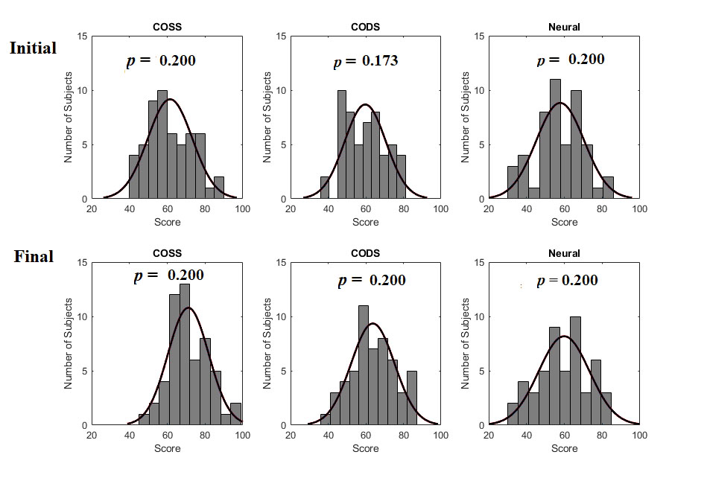
Fig. S1 The results of K-S tests in three conditions in Study 1. “Initial” indicates the participants’ first evaluation score. “Final” indicates the participants’ second evaluation score. The top three histograms in the figure are in the “Initial” condition, while the below three histograms in the figure are in the “Final” condition. The cure in each histogram is normal curve fitting. “Neutral” indicates neutral emotion. Abbreviations: COSS, compassion for other’s survival in suffering; CODS, compassion for other’s development in suffering. P-value > 0.05 indicates the result satisfies normal distribution.
3.6 Robust ANOVA
We used robust methods to check the robustness of the results in Study 1. On the whole, the results of robust ANOVA were similar to the results of one-way ANOVA tests we performed before. We found that there were significant differences on the overall difference scores between the three conditions (Ft = 13.1, p < 0.001, tr = 0.1). Post-hoc tests also showed significant differences between each two conditions. These results are presented in Table S6 and Table S7.
Table S6 The comparison of the results in three conditions of Study 1 (Robust ANOVA)
 | F_{t} | P-value
three conditions | 13.1 | <.001
Note. Method of trimmed means, trim level 0.1
Table S7 Post-hoc tests in three conditions of Study 1
 |  |  |  |  |  |  |  | 95% Confidence interval
 |  |  |  | psi-hat |  | p-value |  | Lower |  | Upper
COSS | vs | CODS |  | 4.96 |  | < .001 |  | 1.799 |  | 8.13
COSS | vs | Neutral |  | 6.84 |  | < .001 |  | 3.597 |  | 10.09
CODS | vs | Neutral |  | 1.88 |  | 0.077 |  | -0.666 |  | 4.43

Supplemental Materials – Study 2
The rating of trait compassion of 71 participants. Results are displayed in Table S8.
Table S8. These raw scores of 71 participants on the rating of trait compassion.
Subject | Score | Subject | Score | Subject | Score | Subject | Score
1 | 58.57 | 19 | 51.49 | 37 | 87.14 | 55 | 61.43
2 | 81.43 | 20 | 54.29 | 38 | 75.71 | 56 | 75.71
3 | 68.57 | 21 | 55.71 | 39 | 77.14 | 57 | 91.43
4 | 74.29 | 22 | 72.86 | 40 | 84.29 | 58 | 78.57
5 | 92.86 | 23 | 72.86 | 41 | 72.86 | 59 | 60.00
6 | 75.71 | 24 | 91.43 | 42 | 52.86 | 60 | 75.71
7 | 92.86 | 25 | 60.00 | 43 | 74.29 | 61 | 75.71
8 | 80.00 | 26 | 74.29 | 44 | 78.57 | 62 | 67.14
9 | 88.57 | 27 | 58.57 | 45 | 58.57 | 63 | 62.86
10 | 75.71 | 28 | 64.29 | 46 | 81.43 | 64 | 65.71
11 | 70.00 | 29 | 84.29 | 47 | 64.29 | 65 | 54.29
12 | 60.00 | 30 | 70.00 | 48 | 67.14 | 66 | 77.14
13 | 38.57 | 31 | 92.86 | 49 | 60.00 | 67 | 57.14
14 | 71.43 | 32 | 71.43 | 50 | 70.00 | 68 | 81.25
15 | 80.00 | 33 | 62.86 | 51 | 60.00 | 69 | 65.60
16 | 67.14 | 34 | 77.14 | 52 | 70.00 | 70 | 72.32
17 | 77.14 | 35 | 81.43 | 53 | 72.86 | 71 | 64.75
18 | 55.71 | 36 | 74.29 | 54 | 67.14
M = 70.98
  - Supplemental Results

2.1 The difference score in two compassion inducing conditions.
To test the results of study 1 again, we combined the “high trait + COSS” and “low trait + COSS” groups into one group of COSS compassion and the “high trait + CODS” and “low trait + CODS” groups into one group of CODS compassion. The results of manipulation check via a two-sample t-test showed that there was no significant difference in reporting feeling compassion between the COSS compassion and CODS compassion groups.
Furthermore, consistent with the results of study 1, the analysis of the overall twice-evaluation difference score showed that the participants in the COSS compassion group had a greater difference score than those in the CODS compassion group (M _{COSS} = 9.30, SD _{COSS} = 9.94 vs. M _{CODS} = 2.03, SD _{CODS} = 7.20), t (123) = 4.68, p < 0.001, d = 0.837. The results are displayed in Fig. S2. In addition, the results of the three evaluation criteria showed that the participants in the COSS compassion group exhibited greater difference scores in their ratings of quality (M _{COSS} = 4.89, SD _{COSS} = 11.2 vs. M _{CODS} = 0.177, SD _{CODS} = 10.8), t (123) = 2.04, p = 0.018, d = 0.429, attributes (M _{COSS} = 9.46, SD _{COSS} = 12.4 vs. M _{CODS} = 2.745, SD _{CODS} = 7.20), t (123) = 3.70, p < 0.001, d = 0.663, and recommendation (M _{COSS} = 13.5, SD _{COSS} = 15.6 vs. M _{CODS} = 3.16, SD _{CODS} = 13.7), t (123) = 3.96, p < 0.001, d = 0.708.
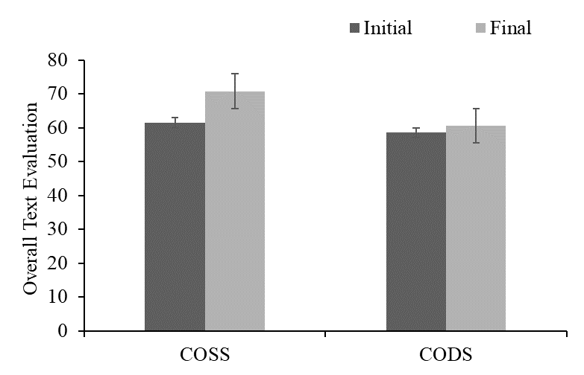
Fig. S2 The effect of two compassion groups on overall evaluations in Study 2. Overall evaluation is scored on a 0 to 100 scale. Error bars indicate standard errors.

2.2 Results of gender difference
we ran the independent-samples t test on the overall difference score in gender. The results showed that there was a marginal significance in the overall difference score, t = 1.716, p = 0.089. There was also a marginal significance in quality, t = 1.787, p = 0.076. But there was no significant difference in attributes, t = 0.693, p = 0.490 and in recommendation, t = 1.343, p = 0.182. The results are displayed in Table S9.
Table S9. Results of gender difference. Independent-samples t test results for difference score, including mean (M), standard deviations (SD), t, and p.
 |  | N | M | SD | t-value | p-value
Overall difference score | Male | 51 | 7.41 | 10.41 | 1.716 | 0.089
Overall difference score | Female | 74 | 4.50 | 8.49 | 1.716 | 0.089
Quality | Male | 51 | 4.69 | 13.33 | 1.787 0.076
Quality | Female | 74 | 1.08 | 9.24
Attributes | Male | 51 | 6.93 | 11.70 | 0.693 0.490
Attributes | Female | 74 | 5.58 | 9.92
Recommendation | Male | 51 | 10.63 | 16.89 | 1.343 0.182
Recommendation | Female | 74 | 6.85 | 14.38

2.3 trait compassion x compassion condition interaction
we ran a 2 (Trait compassion: high/low) × 2 (State compassion: COSS/CODS) ANOVA on the overall difference score. The results showed that there was a significant main effect of state compassion, F (1, 121) = 20.456, p < .001, $η_{p}^{2}$ = 0.145, but there was no main effect of trait compassion, F (1, 121) = 0.837, p = 0.362. In addition, the interaction was also not significant, F (1, 121) = 0.474, p = 0.492. Means and standard deviations of the overall difference score are displayed in Table S10.
Table S10. Means and standard deviations of the overall difference score

 |  | N | M | SD
High | COSS | 36 | 10.37 | 10.64
High | CODS | 30 | 2.21 | 7.13
Low | COSS | 27 | 7.86 | 8.90
Low | CODS | 32 | 1.85 | 7.37
Note: The values are means (standard deviations).
Abbreviations: M, mean; SD, standard deviation; COSS, compassion for other’s survival in suffering; CODS, compassion for other’s development in suffering.

2.4 Results of the individual evaluation criteria for the four groups
In addition, there were significant differences in the ratings of quality (M _{high + COSS} = 5.06, SD _{high + COSS} = 12.32 vs. M _{low + COSS} = 4.67, SD _{low + COSS} = 9.64 vs. M _{high + CODS} = 2.23, SD _{high + CODS} = 9.09 vs. M _{low + CODS} = -1.75, SD _{low + CODS} = 11.97), F(3, 121) = 2.61, p = 0.055, $η_{p}^{2}$ = 0.061, attributes (M _{high + COSS} = 10.93, SD _{high + COSS} = 13.75 vs. M _{low + COSS} = 7.51, SD _{low + COSS} = 10.22 vs. M _{high + CODS} = 3.96, SD _{high + CODS} = 5.02 vs. M _{low + CODS} = 1.59, SD _{low + CODS} = 8.69), F(3, 121) = 5.46, p = 0.001, $η_{p}^{2}$ = 0.119 and recommendation (M _{high + COSS} = 15.139, SD _{high + COSS} = 15.2 vs. M _{low + COSS} = 11.407, SD _{low + COSS} = 16.12 vs. M _{high + CODS} = 0.433, SD _{high + CODS} = 14.2 vs. M _{low + CODS} = 5.719, SD _{low + CODS} = 12.8), F(3, 121) = 6.28, p < 0.001, $η_{p}^{2}$ = 0.135.
2.5 Results of the individual evaluation criteria for the “low trait + COSS” group and “high trait + CODS” group
In addition, the results for the three evaluation criteria showed that the participants in the “low trait + COSS” group exhibited a greater difference score in their rating for recommendation (M _{low + COSS} = 11.41, SD _{low + COSS} = 16.12 vs. M _{high + CODS} = 0.433, SD _{high + CODS} = 14.206), t (55) =2.73, p = 0.008, d = 0.72. In contrast, there were no significant differences in their ratings of quality and attributes.
2.6 K-S test
We have plotted histograms of the relevant variables and performed K-S tests to test whether these data are normally distributed in Study 2. In Study 2, the final evaluation scores in CODS condition dissatisfied normal distribution, while other conditions are all normal distribution as shown in Fig. S3.

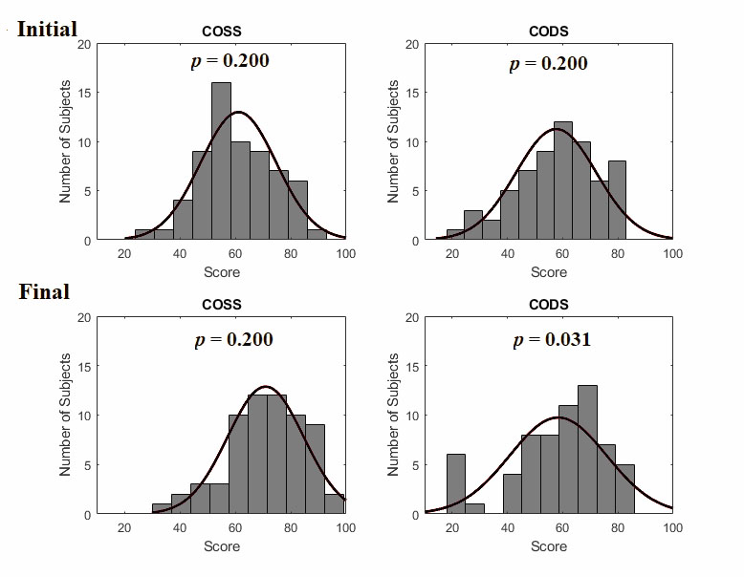
Fig. S3 The results of K-S tests in COSS and CODS conditions in Study 2. “Initial” indicates the participants’ first evaluation score. “Final” indicates the participants’ second evaluation score. The top three histograms in the figure are in the “Initial” condition, while the below three histograms in the figure are in the “Final” condition. The cure in each histogram is normal curve fitting. Abbreviations: COSS, compassion for other’s survival in suffering; CODS, compassion for other’s development in suffering. P-value > 0.05 indicates the result satisfies normal distribution.
2.7 Robust ANOVA
We also used robust methods to check the robustness of the results in Study 2. Again, the results of robust ANOVA were similar to the results of one-way ANOVA tests we performed before. A significant difference on the overall difference score was observed between the four groups in Study 2 (Ft = 5.93, p = 0.001, tr = 0.1). Further, there was a marginal significance on the overall difference score between the “low trait + COSS” group and the “high trait + CODS” group. These results are presented in Table S11 and Table S12.
Table S11 The comparison of the results in four conditions of Study 2 (Robust ANOVA)
 | F_{t} | P-value
four conditions | 5.93 | .001
Note. Method of trimmed means, trim level 0.1
Table S12 Post-hoc tests in four conditions
 |  |  |  |  |  |  |  | 95% Confidence interval
 |  |  |  | psi-hat |  | p-value |  | Lower |  | Upper
high+COSS | vs | low+COSS |  | 2.882 |  | 0.495 |  | -3.837 |  | 9.60
high+COSS | vs | high+CODS |  | 7.746 |  | 0.005 |  | 1.710 |  | 13.78
high+COSS | vs | low+CODS |  | 7.976 |  | 0.004 |  | 1.941 |  | 14.01
low+COSS | vs | high+CODS |  | 4.864 |  | 0.096 |  | -1.166 |  | 10.89
low+COSS | vs | low+CODS |  | 5.095 |  | 0.096 |  | -0.934 |  | 11.12
high+CODS | vs | low+CODS |  | 0.231 |  | 0.905 |  | -4.999 |  | 5.46

Supplemental Materials – Study 3
            - Stimulus materials
Content. Three videos were adapted from the three applicants’ experiences in study 1 to induce different types of compassion in study 3. In order to describe the video better, we made a screen shot of the video and inserted it in Supplemental Materials (Fig. S4).
Fig. S4 A screen shot of video (CODS) used in Study 3a.
Results. Forty undergraduates from South China Normal University participated in the evaluation of the three videos. Each participant watched one of the three videos and then completed the emotional rating scale. The result of ANOVA showed that there was a significant difference in reporting feeling compassion among the three videos, F (2, 37) = 3.87, p = 0.03, $η_{p}^{2}$ = 0.173. The further analysis showed that there was no significant difference in reporting experienced compassion between the COSS compassion inducement and CODS compassion inducement conditions (M _{COSS}= 2.83, SD _{COSS} = 1.027 vs. M _{CODS} = 2.643, SD _{CODS} = 0.882), t (26) = -0.526, p = 0.603. In contrast, the participants in the COSS compassion inducement condition reported feeling more compassion than those in the neutral inducement condition (M _{neutral} = 1.92, SD _{neutral} = 0.638), t (24) = 2.68, p = 0.013, d = 1.05. Moreover, the participants in the CODS compassion condition reported feeling more compassion than those in the neutral condition, t (24) = 2.37, p = 0.026, d = 0.93. In addition, there were no significant differences in the ratings of positive emotion, negative emotion and personal distress among the three groups. The detailed results are shown in Table S13.
Table S13. Raw score means and standard deviations in positive affect, negative affect, distress and compassion of three videos.
 | COSS | CODS | Neutral | F-value
 | M (SD) | M (SD) | M (SD) | F-value
Positive Affect | 1.96 (0.531) | 2.08 (0.886) | 2.05 (0.604) | 0.187
Negative Affect | 2.04 (0.58) | 2.09 (0.751) | 1.97 (0.52) | 0.241
Distress | 1.88 (0.536) | 1.97 (0.844) | 1.86 (0.376) | 0.203
Compassion | 3.13 (0.536) | 3.09 (0.844) | 1.31 (0.372) | 15.847***
Note: The values are means (standard deviations). *** p < .001.
Abbreviations: M, mean; SD, standard deviation; COSS, compassion for other’s survival in suffering; CODS, compassion for other’s development in suffering.

            - Experimental procedure
Table S14. Rules for the exchange of prizes in study 3
The Range of Dice | Prize
1 ≤ average dice < 2 | one A4 white paper
2 ≤ average dice < 3 | one black Fountain Pen
3 ≤ average dice < 4 | One Student backpack
4 ≤ average dice < 5 | One 16G USB flash drive
5 ≤ average dice ≤ 6 | One smart Bracelet

In order to make the relevance of the adjacent vs. nonadjacent die clearer in each trial, we also added the Fig. S5 to describe it.
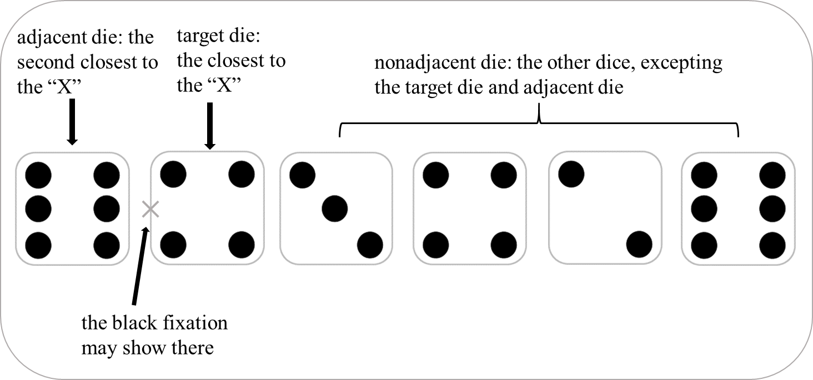
Fig. S5 Illustration of the relevance of the adjacent vs. nonadjacent die in each trial.
            - Supplemental Results
  - Error rate calculation
There were five types of error rates. Because there were 164 trials in the experiment, we calculated the overall error rate by dividing the total number of misreporting trials by 164. While the total number of misreporting trials included misreporting the larger outcome trials and the smaller outcome trials. So, we calculated the error rate of misreporting larger dice by dividing the total number of misreporting the larger trials by 164. Similarly, the error rate of misreporting smaller dice is the total number of misreporting the smaller trials divided by 164. Because, in each trial, the participants may misreport larger nonadjacent dice, we calculated the error rate for misreporting larger nonadjacent dice by dividing the total number of misreporting larger nonadjacent dice by 164. However, we calculated the error rate for misreporting larger adjacent dice in different ways. Because 84 trials were experimental trials in which the adjacent die had a larger value than the target dice, we calculated the error rates for misreporting larger adjacent dice by dividing the total number of misreporting larger adjacent dice by 84.
  - Results of gender difference
t test for gender revealed that the rate of reporting the error rate of the target dice in the male was slightly greater than that in the female, although it did not reach the level of significance, t = 0.86, p = 0.392. There was also no significant difference in misreporting a higher dice, t = 0.418, p = 0.677. The results are displayed in Table S15.
Table S15. Results of gender difference
 |  | N | M | SD | t-value | p-value
Overall error rate | Male | 44 | 0.174 | 0.206 | 0.86 | 0.392
Overall error rate | Female | 77 | 0.146 | 0.139 | 0.86 | 0.392
Misreport higher | Male | 44 | 0.128 | 0.164 | 0.418 0.677
Misreport higher | Female | 77 | 0.117 | 0.132
Misreport lower | Male | 44 | 0.022 | 0.027 | 0.993 0.323
Misreport lower | Female | 77 | 0.028 | 0.033
Abbreviations: M, mean; SD, standard deviation; COSS, compassion for other’s survival in suffering; CODS, compassion for other’s development in suffering.

References
Pittarello, A., Leib, M., Gordon-Hecker, T., & Shalvi, S. (2015). Justifications shape ethical blind spots. Psychological Science, 26(6), 794-804.
Lupoli, M. J., Jampol, L., & Oveis, C. (2017). Lying because we care: Compassion increases prosocial lying. Journal of Experimental Psychology-General, 146(7), 1026-1042.

