Table S1 List of yeasts isolates from different clinical samples with their GenBank accession no., strain no., source of isolates and details of closest similarity included in the phylogenetic analysis.

S. No. | Strain Id | Identified | Acc. No. | Source of Isolate | Closest Similarity | Percent Similarity
1 | 1_10 | Candida albicans | MK026215 | Urine | Candida albicans CBS 8781 | 99
2 | 1_11 | Candida tropicalis | MK026227 | Urine | Candida tropicalis ATCC 750 | 100
3 | 1_13 | Candida glabrata | MK026347 | Urine | Candida glabrata CBS 138 | 99
4 | 1_14 | Candida parapsilosis | MK026228 | Urine | Candida parapsilosis CBS 11059 | 100
5 | 1_17 | Clavispora lusitaniae | MK026240 | Urine | Clavispora lusitaniae CBS 5030 | 99
6 | 1_18 | Candida parapsilosis | MK026244 | Urine | Candida parapsilosis CBS 11059 | 100
7 | 1_19 | Clavispora lusitaniae | MK026212 | Sputum | Clavispora lusitaniae CBS 5030 | 100
8 | 1_22 | Candida tropicalis | MK026246 | Urine | Candida tropicalis ATCC 750 | 100
9 | 1_27 | Cyberlindnera fabianii | MK026280 | Blood | Cyberlindnera fabianii NRRL 1871 | 100
10 | 1_30 | Candida albicans | MK026362 | Urine | Candida albicans CBS 8781 | 99
11 | 1_34 | Clavispora lusitaniae | MK026218 | Sputum | Clavispora lusitaniae CBS 4413 | 100
12 | 10_1 | Candida parapsilosis | MK026210 | Sputum | Candida parapsilosis CBS 7156 | 100
13 | 10_10 | Candida glabrata | MK026342 | Sputum | Candida glabrata CBS 138 | 99
14 | 10_11 | Candida albicans | MK026363 | Urine | Candida albicans CBS 8781 | 99
15 | 10_12 | Candida albicans | MK026364 | BAL | Candida albicans CBS 8781 | 99
16 | 10_13 | Candida albicans | MK026221 | UTI | Candida albicans CBS 8781 | 99
17 | 10_14 | Trichosporon asahii | MK026306 | Blood | Trichosporon asahii CBS 2479 | 100
18 | 10_15 | Candida glabrata | MK026365 | Blood | Candida glabrata CBS 138 | 99
19 | 10_16 | Candida tropicalis | MK026283 | HVS | Candida tropicalis ATCC 750 | 100
20 | 10_17 | Candida albicans | MK026366 | HVS | Candida albicans CBS 8781 | 99
21 | 10_18 | Candida tropicalis | MK026260 | HVS | Candida tropicalis ATCC 750 | 100
22 | 10_19 | Candida tropicalis | MK026356 | HVS | Candida tropicalis NN 4 | 99
23 | 10_2 | Candida glabrata | MK026313 | Urine | Candida glabrata CBS 138 | 99
24 | 10_22 | Candida glabrata | MK026336 | HVS | Candida glabrata CBS 138 | 99
25 | 10_23 | Candida tropicalis | MK026275 | HVS | Candida tropicalis ATCC 750 | 100
26 | 10_25 | Candida tropicalis | MK026276 | HVS | Candida tropicalis ATCC 750 | 100
27 | 10_26 | Candida tropicalis | MK026350 | HVS | Candida tropicalis NN 4 | 98
28 | 10_28 | Candida albicans | MK026367 | HVS | Candida albicans CBS 8781 | 99
29 | 10_3 | Candida glabrata | MK026224 | Pericardial Fluid | Candida glabrata CBS 138 | 99
30 | 10_30 | Candida glabrata | MK026225 | HVS | Candida glabrata CBS 138 | 99
31 | 10_31 | Candida albicans | MK026368 | HVS | Candida albicans CBS 8781 | 99
32 | 10_4 | Candida albicans | MK026369 | PUS | Candida albicans CBS 8781 | 99
33 | 10_5 | Candida tropicalis | MK026314 | Urine | Candida tropicalis ATCC 750 | 100
34 | 10_6 | Candida tropicalis | MK026220 | Sputum | Candida tropicalis ATCC 750 | 99
35 | 10_7 | Candida glabrata | MK026344 | HVS | Candida glabrata CBS 138 | 99
36 | 10_8 | Candida albicans | MK026370 | PUS | Candida albicans CBS 8781 | 99
37 | 10_9 | Candida albicans | MK026371 | Cornea | Candida albicans CBS 8781 | 99
38 | 11_1 | Candida albicans | MK026372 | Urine | Candida albicans CBS 8781 | 99
39 | 11_16 | Candida tropicalis | MK026353 | Urine | Candida tropicalis NN 4 | 99
40 | 11_17 | Candida tropicalis | MK026355 | PUS | Candida tropicalis NN 4 | 99
41 | 11_18 | Candida tropicalis | MK026270 | Urine | Candida tropicalis ATCC 750 | 100
42 | 11_19 | Candida albicans | MK026310 | Sputum | Candida albicans CBS 1912 | 99
43 | 11_2 | Candida parapsilosis | MK026298 | Blood | Candida parapsilosis CBS 7156 | 99
44 | 11_3 | Candida glabrata | MK026245 | Urine | Candida glabrata CBS 138 | 99
45 | 11_6 | Candida tropicalis | MK026287 | Urine | Candida tropicalis ATCC 750 | 100
46 | 11_7 | Candida albicans | MK026293 | Urine | Candida albicans CBS 8781 | 99
47 | 11_8 | Candida parapsilosis | MK026241 | Blood | Candida parapsilosis CBS 11059 | 100
48 | 11_9 | Candida tropicalis | MK026257 | Blood | Candida tropicalis ATCC 750 | 100
49 | 12_1 | Candida glabrata | MK026315 | Urine | Candida glabrata CBS 138 | 99
50 | 12_3 | Candida parapsilosis | MK026351 | Sputum | Candida parapsilosis CBS 7156 | 100
51 | 12_4 | Candida tropicalis | MK026358 | Urine | Candida tropicalis NN 4 | 99
52 | 12_6 | Candida albicans | MK026294 | Sputum | Candida albicans CBS 1912 | 99
53 | 12_7 | Candida tropicalis | MK026271 | Sputum | Candida tropicalis ATCC 750 | 100
54 | 12_8 | Candida tropicalis | MK026256 | Urine | Candida tropicalis ATCC 750 | 100
55 | 13_11 | Candida glabrata | MK026332 | Urine | Candida glabrata CBS 138 | 99
56 | 13_14 | Candida albicans | MK026288 | Transbronchial Biopsy | Candida albicans CBS 1912 | 99
57 | 13_15 | Candida albicans | MK026239 | Transbronchial Biopsy | Candida albicans CBS 8781 | 99
58 | 13_17 | Candida albicans | MK026316 | EQUAS | Candida albicans CBS 1912 | 99
59 | 13_18 | Candida albicans | MK026373 | BAL | Candida albicans CBS 8781 | 99
60 | 13_19 | Candida tropicalis | MK026317 | Sputum | Candida tropicalis ATCC 750 | 100
61 | 13_2 | Candida parapsilosis | MK026261 | Urine | Candida parapsilosis CBS 11059 | 100
62 | 13_22 | Candida albicans | MK026324 | Urine | Candida albicans CBS 1912 | 99
63 | 13_23 | Candida tropicalis | MK026284 | Sputum | Candida tropicalis ATCC 750 | 100
64 | 13_24 | Candida tropicalis | MK026359 | Urine | Candida tropicalis ATCC 750 | 100
65 | 13_26 | Candida parapsilosis | MK026265 | Urine | Candida parapsilosis CBS 11059 | 100
66 | 13_27 | Candida tropicalis | MK026277 | Urine | Candida tropicalis ATCC 750 | 100
67 | 13_28 | Candida albicans | MK026374 | Sputum | Candida albicans CBS 8781 | 99
68 | 13_29 | Candida tropicalis | MK026299 | Blood | Candida tropicalis ATCC 750 | 100
69 | 13_30 | Candida parapsilosis | MK026285 | HVS | Candida parapsilosis CBS 7156 | 100
70 | 13_32 | Candida albicans | MK026330 | Sputum | Candida albicans CBS 1912 | 99
71 | 13_34 | Candida tropicalis | MK026318 | Urine | Candida tropicalis ATCC 750 | 100
72 | 13_36 | Lodderomyces sp. | MK026348 | Sputum | Lodderomyces elongisporus NRRL YB-4239 | 97
73 | 13_37 | Candida parapsilosis | MK026272 | Blood | Candida parapsilosis CBS 11059 | 100
74 | 13_39 | Candida albicans | MK026375 | Urine | Candida albicans CBS 8781 | 99
75 | 13_4 | Candida tropicalis | MK026266 | Urine | Candida tropicalis ATCC 750 | 100
76 | 13_8 | Candida tropicalis | MK026278 | Urine | Candida tropicalis ATCC 750 | 100
77 | 2_11 | Candida parapsilosis | MK026249 | Urine | Candida parapsilosis CBS 11059 | 100
78 | 2_13 | Candida albicans | MK026308 | Urine | Candida albicans CBS 1912 | 100
79 | 2_14 | Candida albicans | MK026376 | Urine | Candida albicans CBS 8781 | 99
80 | 2_16 | Candida tropicalis | MK026377 | Urine | Candida tropicalis ATCC 750 | 99
81 | 2_19 | Candida glabrata | MK026281 | Urine | Candida glabrata CBS 138 | 100
82 | 2_20 | Candida tropicalis | MK026235 | Urine | Candida tropicalis ATCC 750 | 100
83 | 2_21 | Candida albicans | MK026378 | Urine | Candida albicans CBS 8781 | 99
84 | 2_23 | Candida albicans | MK026379 | Urine | Candida albicans CBS 8781 | 99
85 | 2_24 | Candida tropicalis | MK026258 | Urine | Candida tropicalis ATCC 750 | 100
86 | 2_25 | Candida tropicalis | MK026273 | Sputum | Candida tropicalis ATCC 750 | 100
87 | 2_27 | Candida albicans | MK026325 | Sputum | Candida albicans CBS 1912 | 100
88 | 2_31 | Candida glabrata | MK026337 | Urine | Candida glabrata CBS 138 | 100
89 | 2_4 | Candida tropicalis | MK026223 | Urine | Candida tropicalis ATCC 750 | 100
90 | 2_5 | Candida tropicalis | MK026253 | Urine | Candida tropicalis ATCC 750 | 100
91 | 3_10 | Candida albicans | MK026380 | Urine | Candida albicans CBS 8781 | 99
92 | 3_11 | Candida albicans | MK026326 | Urine | Candida albicans CBS 1912 | 100
93 | 3_12 | Candida albicans | MK026320 | Urine | Candida albicans CBS 1912 | 100
94 | 3_13 | Candida albicans | MK026381 | Urine | Candida albicans CBS 8781 | 99
95 | 3_16 | Candida glabrata | MK026321 | Blood | Candida glabrata CBS 138 | 100
96 | 3_17 | Candida albicans | MK026327 | Sputum | Candida albicans CBS 1912 | 100
97 | 3_19 | Candida albicans | MK026382 | Sputum | Candida albicans CBS 8781 | 99
98 | 3_2 | Candida albicans | MK026383 | Urine | Candida albicans CBS 8781 | 99
99 | 3_20 | Candida albicans | MK026384 | Sputum | Candida albicans CBS 8781 | 99
100 | 3_21 | Candida albicans | MK026217 | HVS | Candida albicans CBS 8781 | 99
101 | 3_22 | Candida albicans | MK026385 | Urine | Candida albicans CBS 8781 | 99
102 | 3_24 | Candida albicans | MK026331 | Urine | Candida albicans CBS 1912 | 100
103 | 3_25 | Clavispora lusitaniae | MK026203 | Sputum | Clavispora lusitaniae CBS 4413 | 100
104 | 3_26 | Candida glabrata | MK026300 | CSF | Candida glabrata CBS138 | 100
105 | 3_3 | Candida albicans | MK026386 | Sputum | Candida albicans CBS 8781 | 99
106 | 3_4 | Candida albicans | MK026213 | Urine | Candida albicans CBS 8781 | 99
107 | 3_5 | Candida albicans | MK026387 | HVS | Candida albicans CBS 8781 | 99
108 | 3_6 | Kluyveromyces marxianus | MK026360 | Urine | Kluyveromyces marxianus CBS 712 | 99
109 | 3_7 | Kluyveromyces marxianus | MK026209 | Urine | Kluyveromyces lactis CBS 683 | 100
110 | 3_8 | Candida albicans | MK026301 | HVS | Candida albicans CBS 1912 | 100
111 | 4_12 | Candida albicans | MK026388 | Urine | Candida albicans CBS 8781 | 99
112 | 4_13 | Candida albicans | MK026263 | ETT | Candida albicans CBS 8781 | 99
113 | 4_17 | Candida albicans | MK026352 | Sputum | Candida albicans CBS 1912 | 99
114 | 4_2 | Candida africana | MK026279 | Urine | Candida africana | 99
115 | 4_21 | Candida albicans | MK026390 | Sputum | Candida albicans CBS 8781 | 99
116 | 4_22 | Candida tropicalis | MK026302 | ETT | Candida tropicalis ATCC 750 | 100
117 | 4_24 | Candida glabrata | MK026307 | Urine | Candida glabrata CBS 138 | 99
118 | 4_8 | Kluyveromyces marxianus | MK026333 | Sputum | Kluyveromyces lactis CBS 683 | 99
119 | 5_1 | Candida tropicalis | MK026231 | Urine | Candida tropicalis ATCC 750 | 99
120 | 5_10 | Candida glabrata | MK026345 | Sputum | Candida glabrata CBS 138 | 99
121 | 5_13 | Candida tropicalis | MK026274 | Urine | Candida tropicalis ATCC 750 | 100
122 | 5_16 | Candida glabrata | MK026311 | Sputum | Candida glabrata CBS 138 | 99
123 | 5_17 | Candida tropicalis | MK026230 | Urine | Candida tropicalis ATCC 750 | 100
124 | 5_18 | Kodamaea ohmeri | MK026219 | Blood | Kodamaea ohmeri | 100
125 | 5_2 | Candida tropicalis | MK026322 | RT (Blood) | Candida tropicalis ATCC 750 | 100
126 | 5_20 | Candida albicans | MK026226 | Urine | Candida albicans CBS 1912 | 100
127 | 5_6 | I. orientalis (=C. krusei= Pichia kudriavzevii) | MK026349 | Urine | I. orientalis (=C. krusei=Pichia kudriavzevii) CBS 5147 | 100
128 | 6_1 | Candida tropicalis | MK026282 | Urine | Candida tropicalis ATCC 750 | 100
129 | 6_11 | Candida tropicalis | MK026346 | Urine | Candida tropicalis ATCC 750 | 100
130 | 6_12 | Candida albicans | MK026391 | HVS | Candida albicans CBS 8781 | 99
131 | 6_13 | Candida glabrata | MK026233 | HVS | Candida glabrata CBS 138 | 99
132 | 6_14 | Candida albicans | MK026254 | HVS | Candida albicans CBS 8781 | 99
133 | 6_16 | Candida albicans | MK026392 | HVS | Candida albicans CBS 8781 | 99
134 | 6_18 | Candida albicans | MK026323 | HVS | Candida albicans CBS 1912 | 100
135 | 6_2 | Candida albicans | MK026295 | Urine | Candida albicans CBS 1912 | 100
136 | 6_3 | Candida glabrata | MK026343 | Urine | Candida glabrata CBS 138 | 99
137 | 6_5 | Candida albicans | MK026393 | ETT | Candida albicans CBS 8781 | 99
138 | 7_1 | Candida albicans | MK026394 | Sputum | Candida albicans CBS 8781 | 99
139 | 7_10 | Candida albicans | MK026395 | HVS | Candida albicans CBS 8781 | 99
140 | 7_3 | Candida glabrata | MK026304 | Blood | Candida glabrata CBS 138 | 99
141 | 7_4 | Candida albicans | MK026286 | Urine | Candida albicans CBS 1912 | 99
142 | 7_5 | Candida tropicalis | MK026396 | Sputum | Candida tropicalis ATCC 750 | 99
143 | 7_6 | Candida albicans | MK026357 | HVS | Candida albicans CBS 1912 | 99
144 | 7_9 | Candida tropicalis | MK026207 | HVS | Candida tropicalis ATCC 750 | 100
145 | 8_1 | Candida albicans | MK026206 | PUS | Candida albicans CBS 8781 | 99
146 | 8_10 | Candida tropicalis | MK026309 | ETT | Candida tropicalis ATCC 750 | 100
147 | 8_12 | Candida albicans | MK026204 | Sputum | Candida albicans CBS 8781 | 99
148 | 8_14 | Candida albicans | MK026290 | Urine | Candida albicans CBS 1912 | 100
149 | 8_15 | Candida parapsilosis | MK026341 | Blood | Candida parapsilosis CBS 7156 | 99
150 | 8_16 | Candida tropicalis | MK026255 | Urine | Candida tropicalis ATCC 750 | 100
151 | 8_17 | Candida albicans | MK026251 | Urine | Candida albicans CBS 1912 | 99
152 | 8_18 | Candida albicans | MK026205 | Sputum | Candida albicans CBS 8781 | 99
153 | 8_20 | Candida parapsilosis | MK026259 | Peritoneal Fluid | Candida parapsilosis CBS 11059 | 100
154 | 8_23 | Candida parapsilosis | MK026296 | Urine | Candida parapsilosis CBS 7156 | 100
155 | 8_3 | Candida albicans | MK026334 | HVS | Candida albicans CBS 1912 | 100
156 | 8_4 | Candida albicans | MK026305 | Urine | Candida albicans CBS 1912 | 100
157 | 8_7 | Candida albicans | MK026397 | Urine | Candida albicans CBS 8781 | 99
158 | 8_8 | Candida tropicalis | MK026268 | PUS | Candida tropicalis ATCC 750 | 99
159 | 8_9 | Candida tropicalis | MK026335 | Sputum | Candida tropicalis ATCC 750 | 100
160 | 9_10 | Candida tropicalis | MK026252 | Urine | Candida tropicalis ATCC 750 | 100
161 | 9_12 | Candida glabrata | MK026237 | Peritoneal Fluid | Candida glabrata CBS 138 | 99
162 | 9_13 | Candida glabrata | MK026236 | EQUAS | Candida glabrata CBS 138 | 99
163 | 9_2 | Candida albicans | MK026291 | ETT | Candida albicans CBS 1912 | 100
164 | 9_3 | Candida tropicalis | MK026243 | Stool | Candida tropicalis ATCC 750 | 100
165 | 9_4 | Candida albicans | MK026398 | Blood | Candida albicans CBS 8781 | 99
166 | 9_5 | I. orientalis (=C. krusei= Pichia kudriavzevii) | MK026312 | ETT | I. orientalis (=C. krusei=Pichia kudriavzevii) CBS 5147 | 99
167 | 9_6 | Candida albicans | MK026216 | Right Chick Mucosa | Candida albicans CBS 8781 | 99
168 | 9_8 | Candida tropicalis | MK026211 | Blood | Candida tropicalis ATCC 750 | 100
169 | 9_9 | Candida glabrata | MK026292 | Urine | Candida glabrata CBS 138 | 99
170 | 1_12 | Cyberlindnera fabianii | - | Blood | Cyberlindnera fabianii CBS 5640 | 99
171 | 8_13 | Candida albicans | - | Sputum | Candida albicans ATCC 18804 | 100
172 | 1_28 | Candida albicans | - | Urine | Candida albicans ATCC 18804 | 99
173 | 2_8 | Candida tropicalis | - | Urine | Candida tropicalis ATCC 750 | 100
174 | 4_5 | Candida albicans | - | Sputum | Candida albicans ATCC 18804 | 99
175 | 5_19 | Candida albicans | - | Urine | Candida albicans ATCC 18804 | 99
176 | 5_7 | Candida albicans | - | Urine | Candida albicans ATCC 18804 | 99

Table S2 List of yeasts isolates from different clinical samples and their response to antifungal agents viz., Clotrimazole (CC10), Fluconazole (FLC25), Itraconazole (IT10), Ketoconazole (KT10), Nystatin (NS100).
S. No. | Sample ID | Identity | Antifungal Agent
S. No. | Sample ID | Identity | CC10 | FLC25 | IT10 | KT10 | NS100
 | 1_10 | Candida albicans | S | I | R | S | S
 | 1_11 | Candida tropicalis | R | R | R | R | S
 | 1_13 | Candida glabrata | S | S | I | S | S
 | 1_14 | Candida parapsilosis | S | R | I | S | S
 | 1_18 | Candida parapsilosis | S | S | S | S | S
 | 1_19 | Clavispora lusitaniae | R | R | R | I | S
 | 1_22 | Candida tropicalis | R | R | R | R | S
 | 1_27 | Cyberlindnera fabianii | R | S | R | S | S
 | 1_28 | Candida albicans | S | S | S | S | S
 | 1_30 | Candida albicans | S | S | R | S | S
 | 1_34 | Clavispora lusitaniae | S | S | I | S | S
 | 2_5 | Candida tropicalis | R | R | R | R | S
 | 2_11 | Candida parapsilosis | S | R | R | S | S
 | 2_13 | Candida albicans | S | S | R | S | S
 | 2_14 | Candida albicans | S | S | I | S | S
 | 2_19 | Candida glabrata | R | R | R | - | I
 | 2_20 | Candida tropicalis | R | R | R | R | I
 | 2_21 | Candida albicans | R | R | R | R | I
 | 2_23 | Candida albicans | S | S | I | S | S
 | 2_24 | Candida tropicalis | R | R | R | R | S
 | 2_25 | Candida tropicalis | R | R | R | R | S
 | 2_27 | Candida albicans | S | S | I | S | S
 | 3_3 | Candida albicans | S | I | S | I | S
 | 3_4 | Candida albicans | I | R | R | S | S
 | 3_6 | Kluyveromyces marxianus | S | S | R | S | I
 | 3_7 | Kluyveromyces marxianus | R | R | R | R | S
 | 3_8 | Candida albicans | S | S | R | S | S
 | 3_10 | Candida albicans | S | S | S | S | S
 | 3_11 | Candida albicans | S | S | I | S | S
 | 3_13 | Candida albicans | S | S | S | S | S
 | 3_16 | Candida glabrata | R | R | R | R | I
 | 3_17 | Candida albicans | S | S | I | S | S
 | 3_19 | Candida albicans | S | R | R | R | I
 | 3_20 | Candida albicans | R | R | R | S | I
 | 3_21 | Candida albicans | S | S | I | S | S
 | 3_22 | Candida albicans | S | R | R | S | S
 | 3_24 | Candida albicans | S | S | I | S | S
 | 3_25 | Clavispora lusitaniae | R | R | R | I | S
 | 3_26 | Candida glabrata | R | R | R | R | S
 | 4_5 | Candida albicans | S | S | I | S | S
 | 4_12 | Candida albicans | S | R | R | S | S
 | 4_21 | Candida albicans | S | S | S | S | S
 | 5_1 | Candida tropicalis | R | R | R | R | S
 | 5_2 | Candida tropicalis | R | R | R | R | S
 | 5_6 | Pichia kudriavzevii | I | R | R | R | I
 | 5_7 | Candida albicans | R | R | R | R | S
 | 5_10 | Candida glabrata | I | R | R | R | S
 | 5_13 | Candida tropicalis | R | R | R | R | I
 | 5_16 | Candida glabrata | R | R | R | R | I
 | 5_17 | Candida tropicalis | R | R | R | R | S
 | 5_18 | Kodamaea ohmeri | S | R | R | S | S
 | 5_19 | Candida albicans | R | R | R | S | S
 | 5_20 | Candida albicans | I | I | R | S | S
 | 6_2 | Candida albicans | S | R | R | S | S
 | 6_3 | Candida glabrata | R | R | R | R | S
 | 6_5 | Candida albicans | S | S | I | S | S
 | 6_11 | Candida tropicalis | R | R | R | R | S
 | 6_12 | Candida albicans | R | R | R | R | I
 | 6_13 | Candida glabrata | R | R | R | R | I
 | 6_14 | Candida albicans | R | R | I | I | S
 | 6_16 | Candida albicans | R | R | I | S | S
 | 6_18 | Candida albicans | I | R | R | S | I
 | 7_1 | Candida albicans | S | S | I | S | S
 | 7_3 | Candida glabrata | R | R | R | R | S
 | 7_4 | Candida albicans | S | S | R | S | I
 | 7_5 | Candida tropicalis | R | R | R | I | S
 | 7_6 | Candida albicans | R | R | R | R | I
 | 7_9 | Candida tropicalis | R | R | R | S | S
 | 7_10 | Candida albicans | R | I | R | S | S
 | 8_1 | Candida albicans | I | I | R | S | S
 | 8_2 | Candida auris | R | R | R | I | R
 | 8_3 | Candida albicans | I | S | R | S | S
 | 8_4 | Candida albicans | R | R | R | R | S
 | 8_7 | Candida albicans | R | R | R | R | S
 | 8_8 | Candida tropicalis | R | R | R | R | S
 | 8_9 | Candida tropicalis | R | R | R | R | S
 | 8_10 | Candida tropicalis | S | S | R | S | S
 | 8_12 | Candida albicans | R | R | R | R | S
 | 8_13 | Candida albicans | R | S | I | R | S
 | 8_14 | Candida albicans | S | S | I | S | S
 | 8_15 | Candida parapsilosis | S | I | I | S | S
 | 8_17 | Candida albicans | I | S | R | S | S
 | 8_18 | Candida albicans | I | S | R | S | S
 | 8_20 | Candida parapsilosis | S | S | R | S | I
 | 8_21 | Candida albicans | S | R | I | S | S
 | 8_23 | Candida parapsilosis | S | S | I | S | I
 | 9_2 | Candida albicans | S | S | I | S | S
 | 9_5 | Pichia kudriavzevii | R | R | R | R | R
 | 9_6 | Candida albicans | S | S | S | S | S
 | 9_8 | Candida tropicalis | I | R | R | R | S
 | 9_9 | Candida glabrata | R | R | R | R | I
 | 9_10 | Candida tropicalis | R | R | R | R | S
 | 9_13 | Candida glabrata | R | R | R | R | S
 | 10_1 | Candida parapsilosis | S | R | R | S | S
 | 10_2 | Candida glabrata | R | R | R | R | I
 | 10_3 | Candida glabrata | R | R | R | R | S
 | 10_4 | Candida albicans | R | I | R | I | I
 | 10_5 | Candida tropicalis | R | R | R | R | I
 | 10_6 | Candida tropicalis | R | R | R | R | I
 | 10_7 | Candida glabrata | R | R | R | R | S
 | 10_8 | Candida albicans | I | R | R | S | S
 | 10_9 | Candida albicans | R | R | R | I | I
 | 10_10 | Candida glabrata | R | R | R | R | R
 | 10_11 | Candida albicans | R | R | R | I | I
 | 10_12 | Candida albicans | R | I | R | S | S
 | 10_13 | Candida albicans | R | R | R | R | R
 | 10_14 | Trichosporon asahii | S | R | S | S | S
 | 10_15 | Candida glabrata | R | R | R | R | I
 | 10_16 | Candida tropicalis | R | R | R | R | I
 | 10_17 | Candida albicans | S | I | I | S | S
 | 10_18 | Candida tropicalis | R | R | R | R | I
 | 10_19 | Candida tropicalis | R | R | R | R | I
 | 10_22 | Candida glabrata | R | R | R | R | S
 | 10_23 | Candida tropicalis | R | R | R | R | R
 | 10_25 | Candida tropicalis | R | R | I | R | I
 | 10_26 | Candida tropicalis | R | R | R | R | I
 | 10_28 | Candida albicans | R | R | R | R | S
 | 10_30 | Candida glabrata | R | R | R | R | S
 | 10_31 | Candida albicans | S | I | I | S | S
 | 11_1 | Candida albicans | S | R | S | R | S
 | 11_2 | Candida parapsilosis | S | S | S | S | S
 | 11_3 | Candida glabrata | R | R | R | I | S
 | 11_6 | Candida tropicalis | R | R | R | R | I
 | 11_7 | Candida albicans | I | S | I | S | S
 | 11_8 | Candida parapsilosis | S | R | R | S | S
 | 11_9 | Candida tropicalis | R | R | R | R | S
 | 11_16 | Candida tropicalis | I | R | R | S | S
 | 11_17 | Candida tropicalis | R | R | R | R | S
 | 11_18 | Candida tropicalis | R | R | R | R | S
 | 11_19 | Candida albicans | R | I | R | S | S
 | 12_1 | Candida glabrata | R | R | R | R | S
 | 12_2 | Candida albicans | S | S | I | S | S
 | 12_3 | Candida parapsilosis | S | S | I | S | S
 | 12_4 | Candida tropicalis | R | R | R | R | S
 | 12_6 | Candida albicans | S | S | I | S | I
 | 12_7 | Candida tropicalis | R | R | R | R | S
 | 12_8 | Candida tropicalis | R | R | R | R | S
 | 13_2 | Candida parapsilosis | S | S | S | S | S
 | 13_4 | Candida tropicalis | R | R | I | S | S
 | 13_11 | Candida glabrata | R | R | R | R | S
 | 13_14 | Candida albicans | S | S | I | S | S
 | 13_15 | Candida albicans | S | S | I | S | S
 | 13_17 | Candida albicans | I | S | I | I | I
 | 13_18 | Candida albicans | S | R | I | S | S
 | 13_19 | Candida tropicalis | S | R | I | S | S
 | 13_22 | Candida albicans | S | S | I | S | S
 | 13_23 | Candida tropicalis | R | R | R | S | S
 | 13_24 | Candida tropicalis | R | R | I | R | S
 | 13_26 | Candida parapsilosis | R | R | R | R | S
 | 13_27 | Candida tropicalis | R | R | R | R | S
 | 13_28 | Candida albicans | S | S | S | S | S
 | 13_29 | Candida tropicalis | S | S | I | S | S
 | 13_30 | Candida parapsilosis | R | R | R | R | S
 | 13_32 | Candida albicans | S | S | I | S | S
 | 13_36 | Lodderomyces sp. | R | R | I | S | S
 | 13_37 | Candida parapsilosis | S | S | I | R | I
 | 13_39 | Candida albicans | S | R | R | R | S
Table S3 Percentage of in vitro antifungal susceptibility testing of five antifungal agents (viz., clotrimazole, fluconazole, itraconazole, ketoconazole, nystatin) against 157 yeasts isolated during the study.
Susceptibility | Antifungal Agents
Susceptibility | Clotrimazole | Fluconazole | Itraconazole | Ketoconazole | Nystatin
Intermediate | 8.91 | 7.00 | 25.47 | 7.00 | 21.65
Resistant | 52.86 | 63.05 | 66.87 | 43.94 | 3.18
Susceptible | 38.21 | 29.93 | 7.64 | 48.40 | 75.15

Table S4 Comparison of present and previous studies on diversity of yeast in clinical samples around the world
Reference | Meletiadis et al. (2017) | Lyon et al. (2010) | Basu et al. (2003) | Kaur et al. (2016) | Present study (2019)
Identification Methods | AFLP and ITS Region Sequencing | Traditional  Microbiological Methods | Traditional  Microbiological Methods | Traditional  Microbiological Methods | 28S rRNA gene, MALDI-TOF MS and Hi-Crome
Species observed along with number of isolates | C. albicans (n= 584) | C. albicans (n= 2563) | C. albicans (n=39) | C. albicans (n=33) | C. albicans (n=75)
Species observed along with number of isolates | C. tropicalis (n= 180) | C. tropicalis (n= 180) | C. tropicalis (n=21) | C. tropicalis (n=37) | C. tropicalis (n= 50)
Species observed along with number of isolates | C. parapsilosis (n= 122) | C. parapsilosis (n= 1032) | C. parapsilosis (n=9) | C. parapsilosis (n=6) | C. parapsilosis (n= 14)
Species observed along with number of isolates | C. glabrata (n= 86) | C. glabrata (n= 1449) | C. glabrata (n=1) | C. glabrata (n=9) | C. glabrata (n= 22)
Species observed along with number of isolates | I. orientalis (n=30) | I. orientalis (n=109) | I. orientalis (n=6) | I. orientalis (n=3) | Issatchenkia orientalis (n=2)
Species observed along with number of isolates | - | - | C. guilliermondii) (n=3) | -
Species observed along with number of isolates | - | - | C. kefyr (n=6) | C. kefyr (n=2) | -
Species observed along with number of isolates | Candida spp. (n= 97) | - | - | -
Species observed along with number of isolates | - | - | - | - | C. africana (n=1)
Species observed along with number of isolates | - | Cl. lusitaniae (n=76) | - | - | Clavispora lusitaniae (n=4)
Species observed along with number of isolates | - |  | - | - | Cyberlindnera fabianii (n=2)
Species observed along with number of isolates | - | - | - | - | Trichosporon asahii (n=1)
Species observed along with number of isolates | - | - | - | - | Kluyveromyces marxianus (n=3)
Species observed along with number of isolates | - | - | - | - | Lodderomyces sp. (n=1)
Species observed along with number of isolates |  |  |  |  | Kodamaea ohmeri (n=1)
Total Strains | 1099 | 5821 | 85 | 90 | 176

Fig. S1. Representative spectra of T. asahii (10_14), Cy. fabianii (1_27), Ko. ohmeri (6_4), K. marxianus (3_8).

Fig. S2. Representative images on chromogenic medium for identification of Candida species. a) Light Green colored colonies of C. albicans. b) Cream colored colonies of C. glabrata. c) Purple fuzzy colored colonies of I. orientalis. d) Bluish green colored colonies of C. tropicalis.
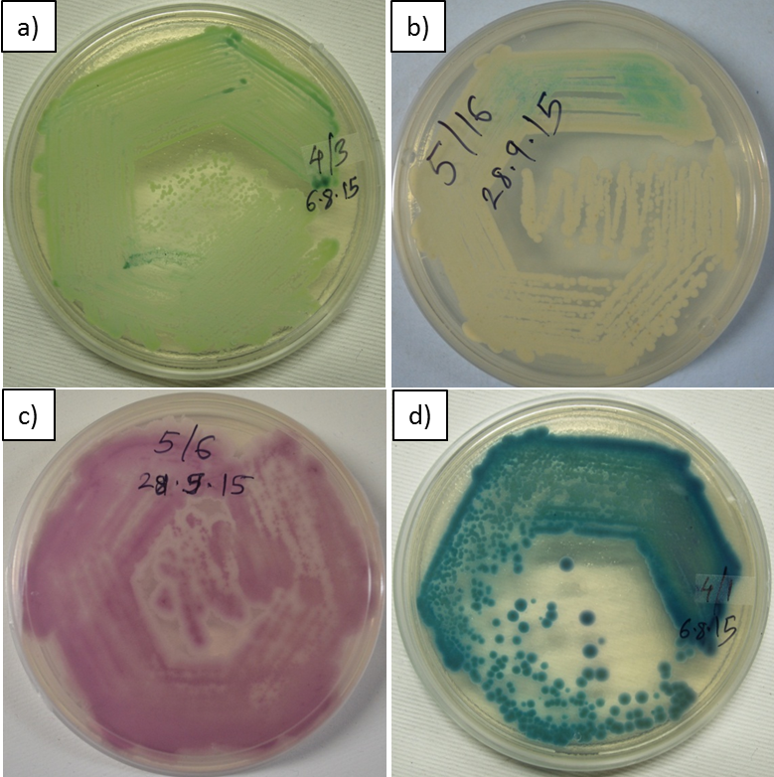

Fig. S3. Representative figure of Antifungal susceptibility pattern of C. albicans (3_13) and C. tropicalis (5_1).
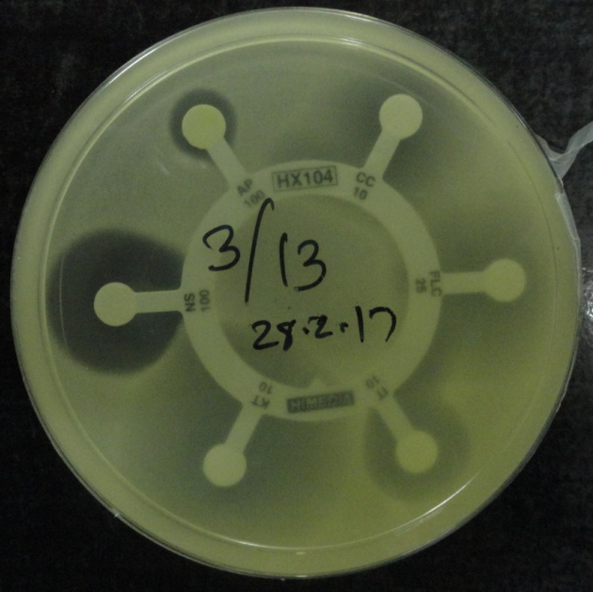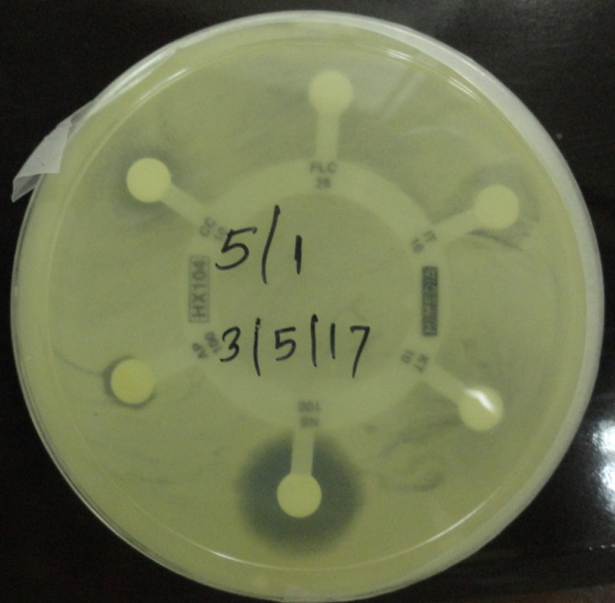

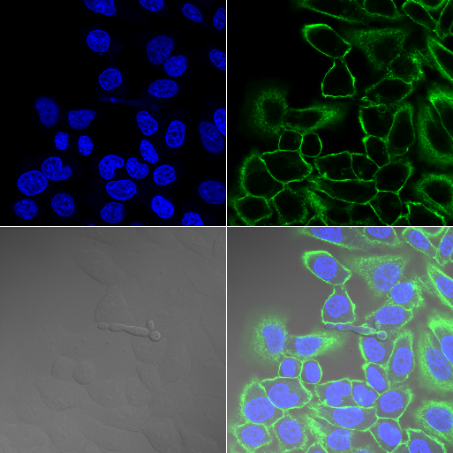
Figure S4. Confocal images of invasion of yeasts in HeLa cells. The pseudo-hyphae of Candida tropicalis (strain 10_19) invaded HeLa cells.

Figure S5. Confocal images of invasion of yeasts in HeLa cells. The yeast form of Candida parapsilosis (strain 8_20) invaded HeLa cells

