Supplementary file

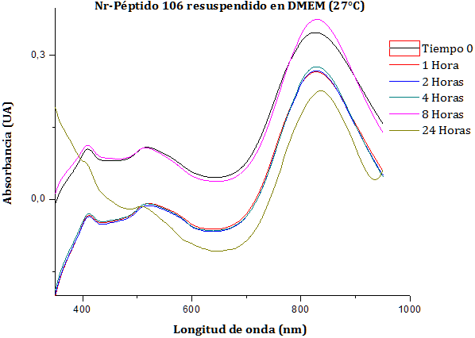
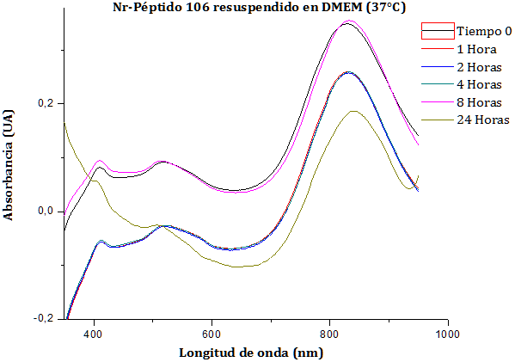
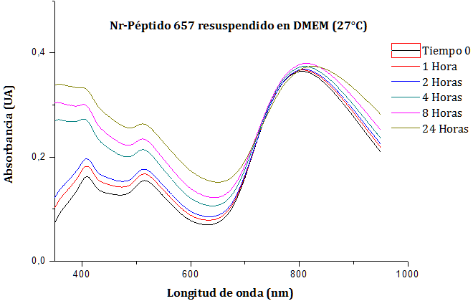
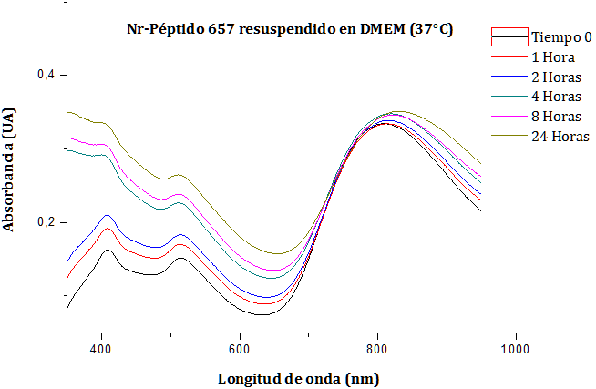
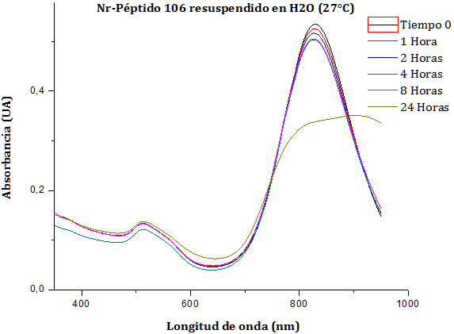
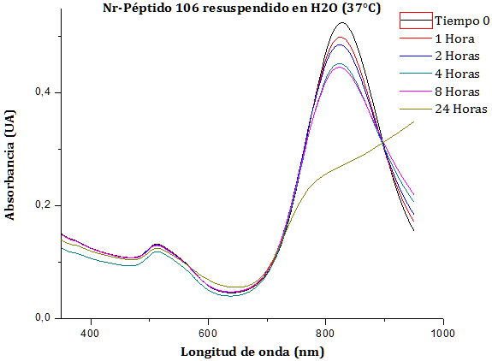
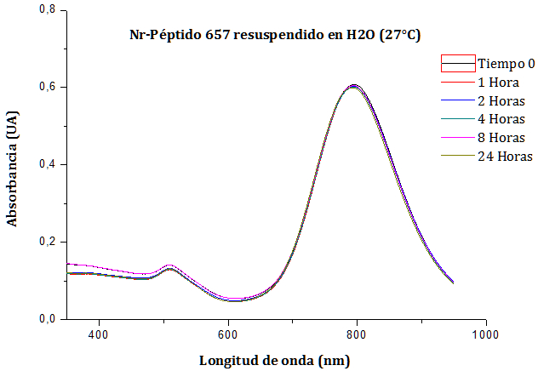
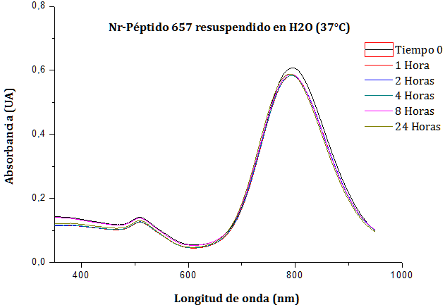
27 °C
37 °C
B
A
Absorbance (U.A)
D
C
Wavelenght (nm)

Figure S1. Stability of the GNR-peptide in aqueous solutions or culture cell medium (DMEM high glucose 10% SFB). Vis-NIR spectra were obtained at different times for 24 h. A and B: GNRCLPFFD and GNRArg₇CLPFFD respectively, incubated in cell culture medium. C and D: GNRCLPFFD and GNRArg₇CLPFFD respectively, incubated in aqueous solutions.

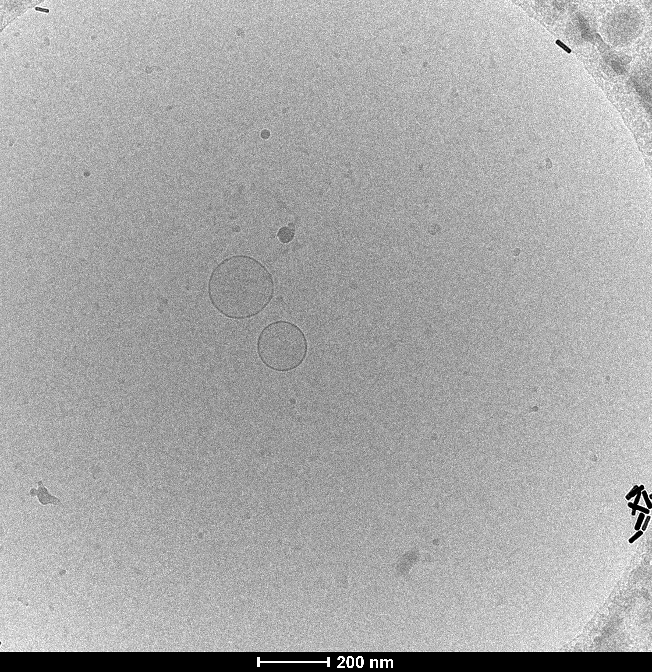
B
A
146.68 ± 0.91
C

Figure S2. Characterization of liposome S-100. Size, structural topology and morphology by means of A: dynamic light scattering, B: cryo-TEM image and C: small angle X-ray scattering (SAXS), the arrows indicate position of the 1th and 2nd order reflection (d=6.1nm).

Table S1. Percentage fitted peak area GNR, GNR-peptide (3-5 nm and 50 nm) with liposome (140 nm) over time (0-24 h). Values represent mean ± SEM of three separate experiments.
 | GNR/liposome |  |  | GNRCLPFFD/liposome |  |  | GNRCArg₇/liposome |  |  | GNRArg₇CLPFFD  /liposome
Time  (h) | GNR  (3-5 nm) | GNR  (50 nm) | liposome | GNR  (3-5 nm) | GNR  (50 nm) | liposome | GNR  (3-5 nm) | GNR  (50 nm) | liposome | GNR  (3-5 nm) | GNR  (50 nm) | liposome
0 | 38 ± 3 | 24 ± 5 | 39 ± 4 | 24 ± 1 | 26 ± 2.2 | 50 ± 3 | 18 ± 1 | 22 ± 13 | 60 ± 13 | 10 ± 2 | 8 ± 1 | 81.9 ± 2
1 | 27 ± 5 | 17 ± 0.6 | 56 ± 3 | 23 ± 0.4 | 16 ± 3.8 | 61 ± 4 | 25 ± 2 | 26 ± 3 | 49 ± 4 | 1 ± 2 | 7 ± 1 | 91.8 ± 0.4
3 | 24 ± 0.4 | 33 ± 2 | 43 ± 2 | 22 ± 0.6 | 22 ± 2.9 | 56 ± 3 | 17 ± 5 | 8 ± 2 | 76 ± 1 | 2 ± 4 | 5 ± 3 | 93 ± 6
24 | 20 ± 3 | 26 ± 7 | 54 ± 8 | 16 ± 1 | 13 ± 0.6 | 71 ± 1 | 22 ± 2 | 15.± 5 | 62 ± 6 | 0 | 5 ± 2 | 95 ± 3

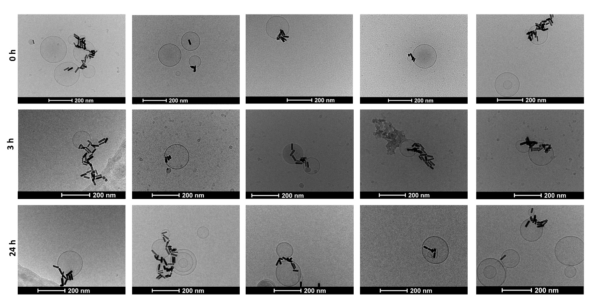
Figure S3. Representative cryo-transmission electronic microscopy image of the interaction of GNR-Arg₇CLPFFD with liposomes at different times (0, 3 and 24 h).

Figure S4. Cellular viability in SH-SY5Y cells treated with GNRs at 0.4 nM for 24 h. The control was without nanoparticles. The data are expressed as the percent of living cells. Values represent the mean ± SEM of three separate experiments in triplicate.

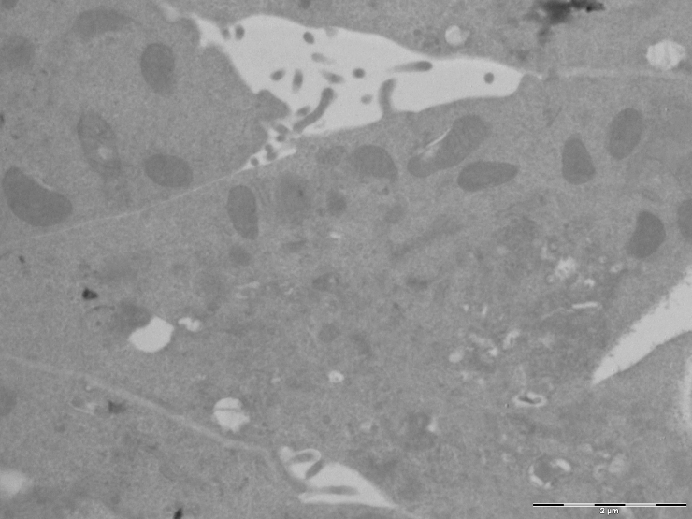

Figure S5. Representative TEM image of SH-SY5Y cells control without nanoparticles.

