Supplementary Materials
Compound 1
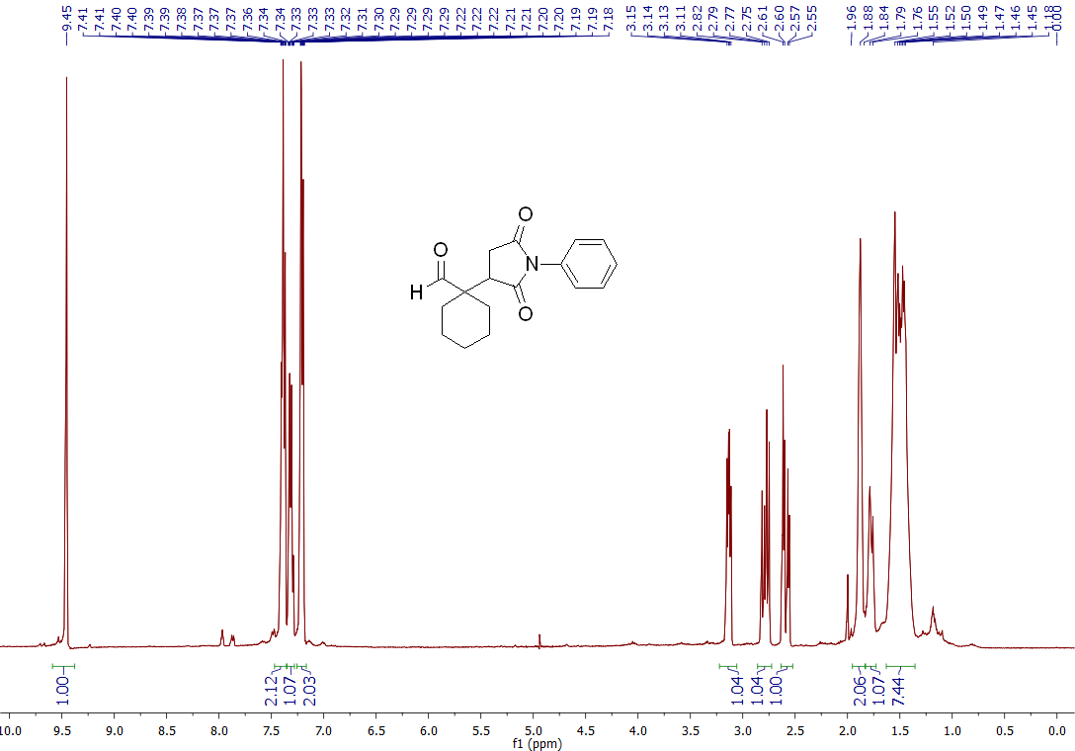
Figure S1: ¹H NMR spectrum of 1-(2,5-dioxo-1-phenylpyrrolidin-3-yl)cyclohexane-1-carbaldehyde.
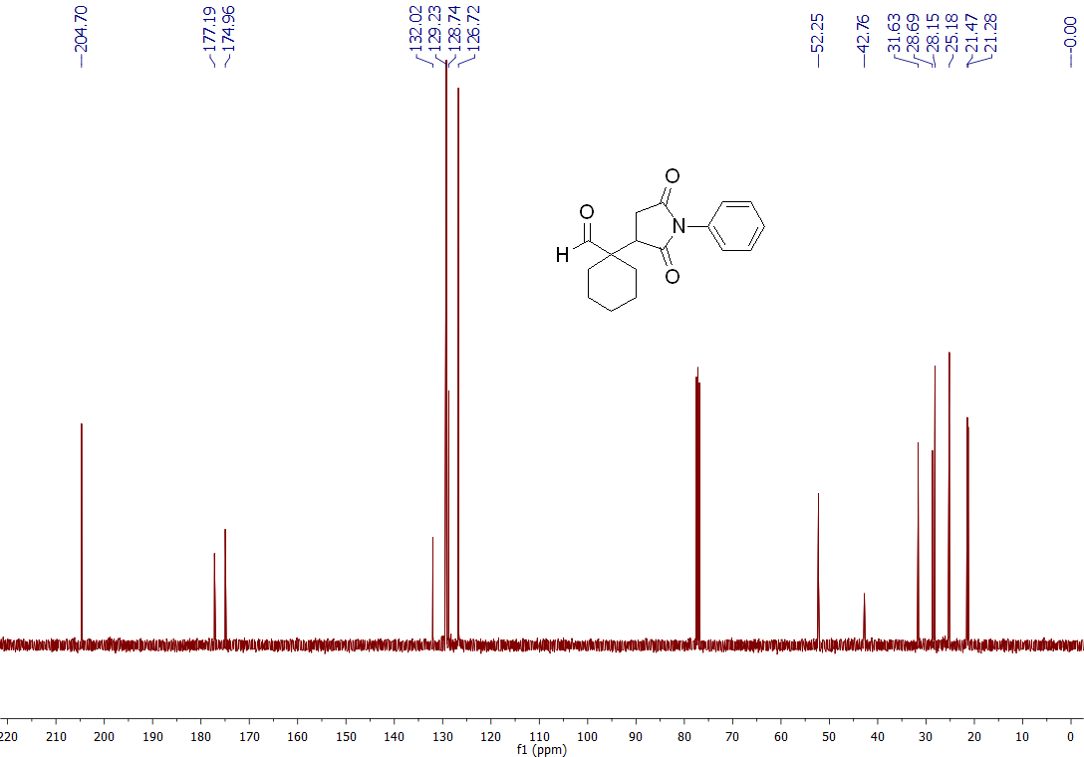
Figure S2: ¹³C NMR spectrum of 1-(2,5-dioxo-1-phenylpyrrolidin-3-yl)cyclohexane-1-carbaldehyde.

Compound 2
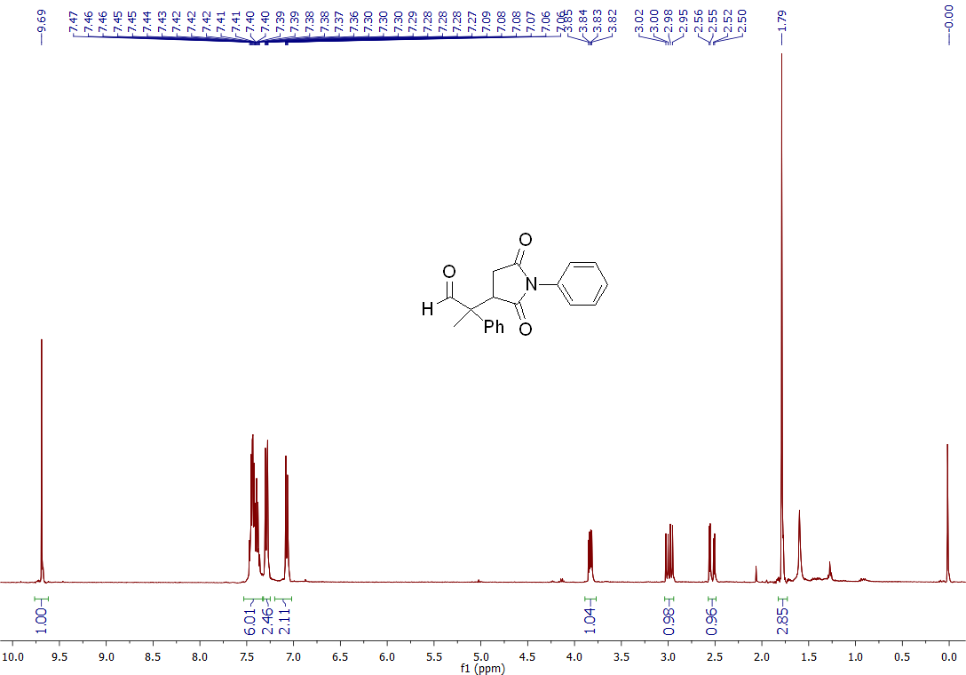
Figure S3: ¹H NMR spectrum of 2-(2,5-dioxo-1-phenylpyrrolidin-3-yl)-2-phenylpropanal.
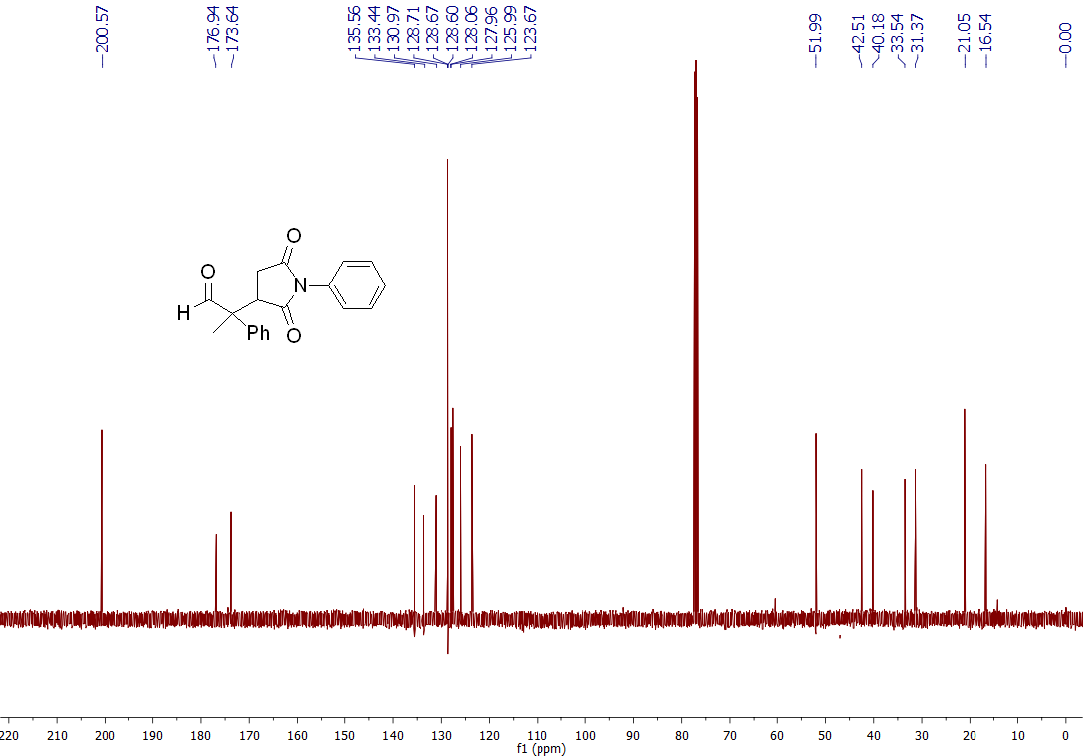
Figure S4: ¹³C NMR spectrum of 2-(2,5-dioxo-1-phenylpyrrolidin-3-yl)-2-phenylpropanal.

