Supplementary information
Asthma exacerbations and related costs 12 months before and 12 months after treatment initiation with mepolizumab
Llanos et al.
Corresponding author: Beth Hahn, 5 Moore Drive, RTP, NC 27709-3398, USA. Tel: 1-919-274-0660. Email: Beth.A.Hahn@gsk.com
Contents
Supplementary Section 1: Methods for the initial pilot study
Supplementary Figure 1: Total number of asthma exacerbations by calendar month, during the baseline and follow-up periods.
Supplementary Figure 2: Mean rate ± SD of asthma exacerbations and exacerbations requiring hospitalization during the baseline and follow-up periods in the initial pilot study.
Supplementary Figure 3: Mean costs related to asthma exacerbations during the baseline and follow-up periods in the initial pilot study.

Supplementary Section 1. Methods for the initial pilot study.
The initial pilot study (209019; HO-18-19168) retrospectively assessed asthma exacerbations and associated costs in patient data extracted from the IBM Watson Health MarketScan® Commercial Claims Database. The patient identification period was November 1, 2015 to September 30, 2016. Data from 138 patients were analyzed; the rate of asthma exacerbations (events/patient/year) and the mean asthma exacerbation-related costs were measured during the 12-month baseline and follow-up periods. Exacerbations and exacerbation-related costs were defined and assessed as per the main study (209017; HO-18-19166), except that all costs were adjusted for inflation using the Consumer Price Index (CPI) and standardized to 2016 US dollars.

Supplementary Figure 1. Total number of asthma exacerbations by calendar month, during the baseline and follow-up periodsª
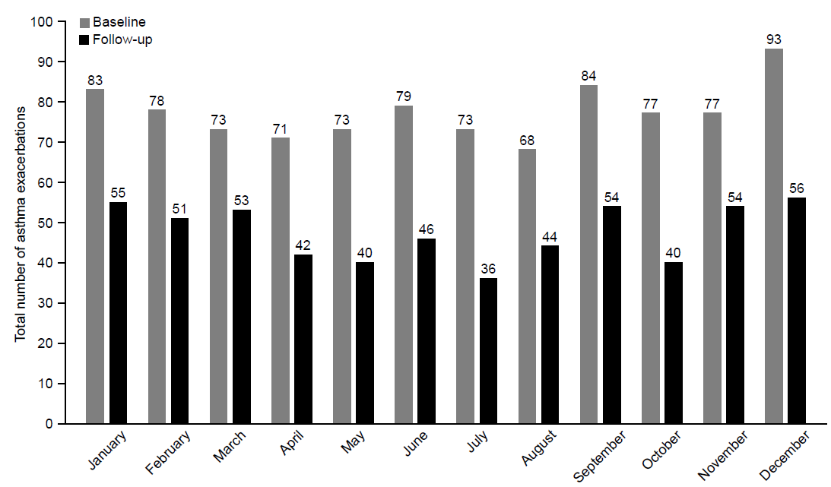
ªBaseline period defined as the 12 months before first mepolizumab treatment; follow-up period defined as the 12 months following first mepolizumab treatment.

Supplementary Figure 2. Mean rate ± SD of asthma exacerbations and exacerbations requiring hospitalization during the baseline and follow-up periods in the pilot studyª
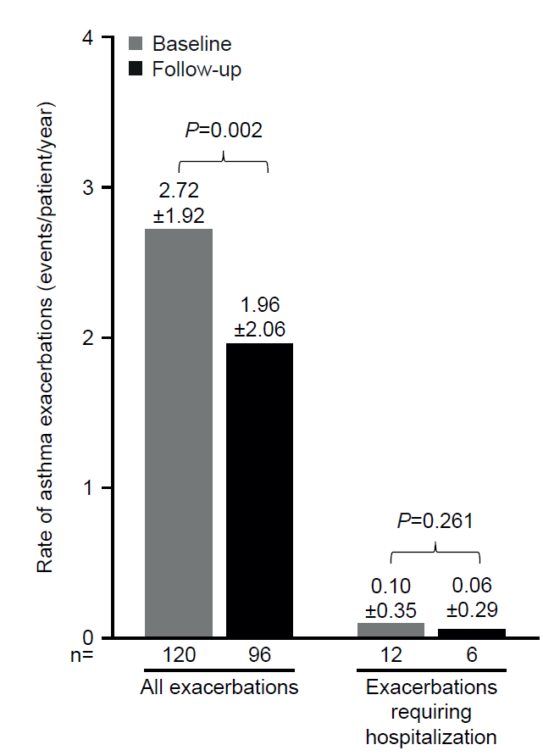
ªBaseline period defined as the 12 months before first mepolizumab treatment; follow-up period defined as the 12 months following first mepolizumab treatment.
Outpatient visits with a HCPCS code indicating mepolizumab administration were excluded from the exacerbation definition, to prevent the inclusion of planned provider visits for mepolizumab administration. Additionally, the first outpatient visit with a Current Procedural Terminology code indicating subcutaneous/intramuscular drug administration (96372, 96401) either in the 28 days following an outpatient prescription (NDC) claim for mepolizumab or prior to the next outpatient prescription claim (the earlier of the two) was excluded from the exacerbation definition.
N numbers are the numbers of patients with data available.
HCPCS, healthcare common procedure coding system; NDC, national drug code; SD, standard deviation.

Supplementary Figure 3. Mean costs related to asthma exacerbations during the baseline and follow-up periods in the pilot studyª
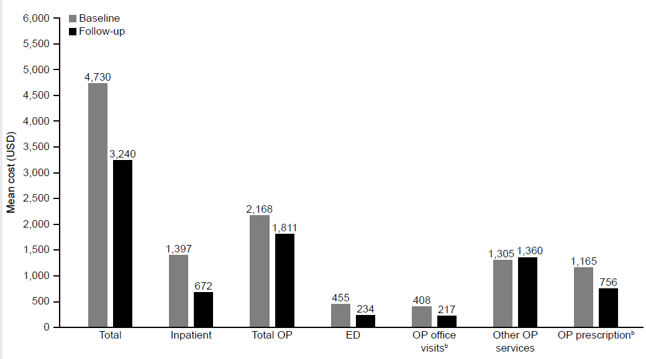ªBaseline period defined as the 12 months before first mepolizumab treatment; follow-up period defined as the 12 months following first mepolizumab treatment.
^{b}P<0.05.
Costs exclude mepolizumab acquisition and administration costs.
OP, outpatient; ED, emergency department; USD, US dollars.

