Supplementary materials
miR-520b promotes breast cancer stemness through Hippo/YAP signaling pathway
Hui Zhang^{1,2*}, Ting-yuan Lang^{3*}, Dongling Zou³, Lei Zhou^{4,5,6}, Meng Lou³, Jing-shu Liu⁷, Yun-zhe Li⁷, Dong-yan Ding⁷, Yu-cong Li^{3,7}, Na Zhang³, Xiao-dong Zheng², Xiao-hua Zeng², Qi Zhou^{1,3,8,9#}, Li Li^{1#}
¹Department of Gynecologic Oncology, Affiliated Tumor Hospital of Guangxi Medical University, Nanning 530021, Guangxi, P.R. China.
²Breast cancer center, Chongqing University Cancer Hospital & Chongqing Cancer Institute & Chongqing Cancer Hospital, Chongqing 400030, Chongqing, P.R. China.
³Department of Gynecologic Oncology, Chongqing University Cancer Hospital & Chongqing Cancer Institute & Chongqing Cancer Hospital, Chongqing 400030, Chongqing, P.R. China.
⁴Singapore Eye Research Institute, The academia, 20 College Road, Discovery Tower Level 6, Singapore, 169856, Singapore.
⁵Department of Ophthalmology, Yong Loo Lin School of Medicine, National University of Singapore, 1E Kent Ridge Road, NUHS Tower Block Level 7, Singapore, 119228, Singapore.
⁶Ophthalmology and Visual Sciences Academic Clinical Research Program, Duke-NUS Medical School, 8 college Road, Singapore, 169867, Singapore.
⁷Bioengineering College of Chongqing University, Chongqing University, Chongqing 400030, Chongqing, P.R. China
⁸Chongqing Key Laboratory of Translational Research for Cancer Metastasis and Individualized Treatment, Chongqing University Cancer Hospital & Chongqing Cancer Institute & Chongqing Cancer Hospital, Chongqing 400030, Chongqing, P.R. China.
⁹Key Laboratory for Biorheological Science and Technology of Ministry of Education (Chongqing University), Chongqing University Cancer Hospital & Chongqing Cancer Institute & Chongqing Cancer Hospital, Chongqing 400030, Chongqing, P.R. China.
*These authors contributed equally to this work
Correspondence: Li Li and Qi Zhou
Li Li
Department of Gynecologic Oncology, Affiliated Tumor Hospital of GuangXi Medical University, Nanning 530021, Guangxi, China. Email: lili5310430@163.com.
Qi Zhou
Department of Gynecologic Oncology, Chongqing University Cancer Hospital & Chongqing Cancer Institute & Chongqing Cancer Hospital, Chongqing 400030, Chongqing, China. Email: cqzl_zq@163.com.

Method details:

Primers:

For LATS2 cloning:
F: 5’-CCAAAGACTTTTCCTGCCAC-3’
R: 5’-GTGGCAGGAAAAGTCTTTGG-3’

For qRT-PCR:

CD44:
F: 5’-CTGCCGCTTTGCAGGTGTA-3’;
R: 5’-CATTGTGGGCAAGGTGCTATT-3’

CD133:
F: 5’-AGTCGGAAACTGGCAGATAGC-3’;
R: 5’-GGTAGTGTTGTACTGGGCCAAT-3’

ALDH1:
F: 5’-CCGTGGCGTACTATGGATGC-3’;
R: 5’-GCAGCAGACGATCTCTTTCGAT-3’

CTGF:
F: 5’-AAAAGTGCATCCGTACTCCCA-3’;
R: 5’-CCGTCGGTACATACTCCACAG-3’

AREG:
F: 5’-GTGGTGCTGTCGCTCTTGATA-3’;
R: 5’-CCCCAGAAAATGGTTCACGCT-3’

N-cadherin:
F: 5’-AGCCAACCTTAACTGAGGAGT-3’;
R: 5’-GGCAAGTTGATTGGAGGGATG-3’

Vimentin:
F: 5’- TGCCGTTGAAGCTGCTAACTA -3’;
R: 5’- CCAGAGGGAGTGAATCCAGATTA -3’

Snail1:
F: 5’-TCGGAAGCCTAACTACAGCGA-3’;
R: 5’-AGATGAGCATTGGCAGCGAG-3’

ZEB1:
F: 5’-TTACACCTTTGCATACAGAACCC-3’;
R: 5’-TTTACGATTACACCCAGACTGC-3’

E-cadherin:
F: 5’-ATTTTTCCCTCGACACCCGAT-3’;
R: 5’-TCCCAGGCGTAGACCAAGA-3’

ZO-1:
F: 5’-CAACATACAGTGACGCTTCACA-3’;
R: 5’-CACTATTGACGTTTCCCCACTC-3’

GAPDH:
F: 5’-ACAACTTTGGTATCGTGGAAGG-3’;
R: 5’-GCCATCACGCCACAGTTTC-3’

miR-520b:
F: 5’- AAAGTGCTTCCTTTTAGAGGG-3’
R: 5’-CAGTGCGTGTCGTGGAGT-3’

Antibodies:
Anti-LATS2 (CST, #5888, 1:1000); Anti-YAP (CST, #14074, 1:1000); Anti-phosphorylated YAP(Abcam, ab76252, 1:10000); Anti-CD44(CST, #37259, 1:1000); Anti-E-cadherin(CST, #3195, 1:1000); Anti-N-cadherin(CST, #13116, 1:1000); Anti-Snail1(CST, #3879, 1:1000); Anti-β-actin(CST, #4970, 1000); Anti-rabbit IgG, HRP-linked Antibody (CST, #7074, 1000).

Clinical information of patients used in this study
The clinical information of TCGA data and GEO data can be downloaded from data portal of Genomic Data Commons (GDC, https://gdc-portal.nci.nih.gov/legacy-archive/) and https://www.ncbi.nlm.nih.gov/geo/query/acc.cgi?acc=GSE57897.
Supplementary Table 1. The clinical information of patients related to Figure 1E.
Characteristics | Patients(n=25) | %
Age(31-63)
≤35 | 3 | 12.0
35-55 | 18 | 72.0
＞55 | 4 | 16.0
TNM Stage
Ⅰ | 3 | 12.0
Ⅱ | 13 | 52.0
Ⅲ | 7 | 28.0
Ⅳ | 2 | 8.0
Tumor Type
Luminal A | 6 | 24.0
Luminal B | 9 | 36.0
Triple Negative | 4 | 16.0
HER2 Type | 5 | 20.0

Supplementary Figures
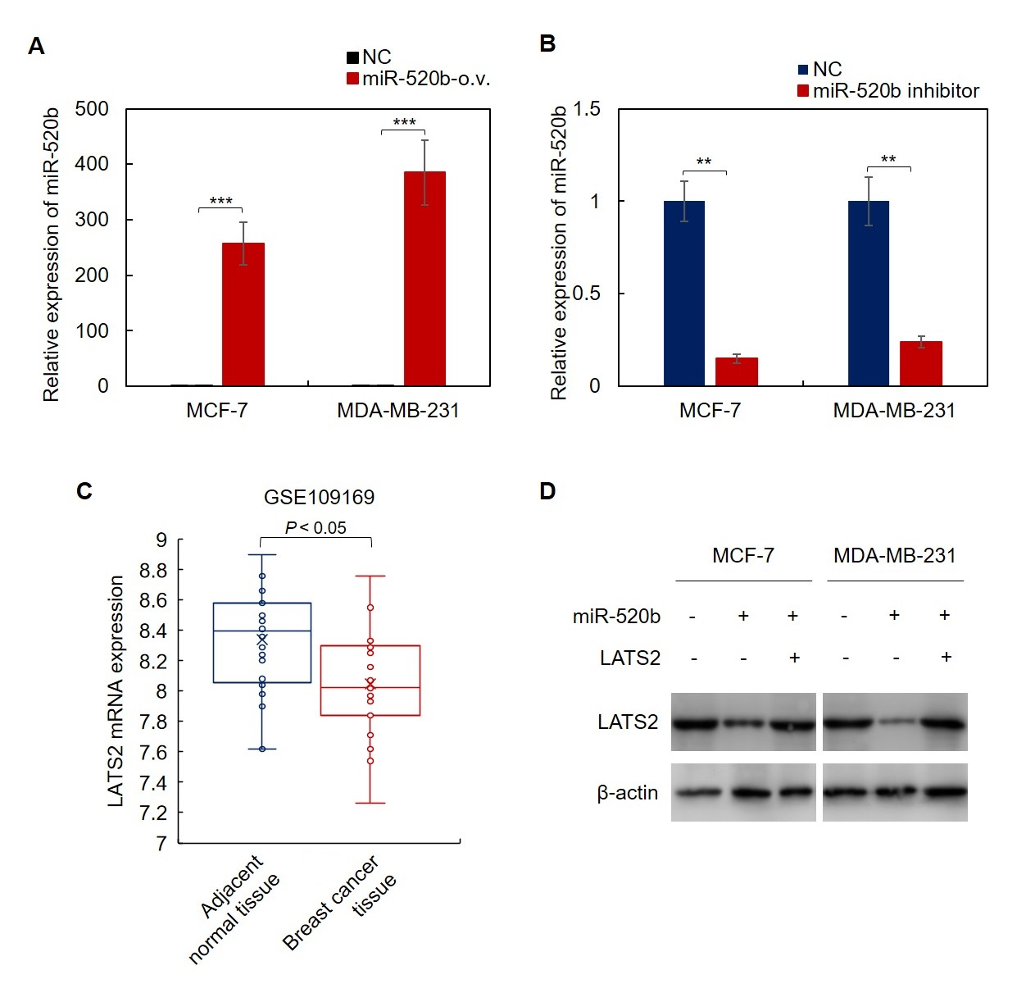
Supplementary Figure 1. (A) Characterization of miR-520b-overexpressing breast cancer cells. The expression of miR-520b in indicate cells was detected by qRT-PCR. (B) Characterization of miR-520-knockdown breast cancer cells. The expression of miR-520b in indicate cells was detected by qRT-PCR. (C) LATS2 was downregulated in breast cancer tissues. The expression of LATS2 in breast cancer tissues was analyzed by bioinformatic analysis. (D) Characterization of miR-520b-overexperssing LATS2-overexpressing breast cancer cells. The protein levels of LATS2 in indicated cells were analyzed by western blot. Student t test (**P﹤0.01, ***P﹤0.001).

