Supplementary Methods
S1 Synthesis of PNIPAM
Briefly, 1.4 g NIPAM and 0.057 g AIBN were dissolved in 6 mL dimethylformamide (DMF) in a flask. The mixture was stirred at 70ºC for 36 h under the condition of nitrogen and then precipitated into diethyl ether and purified by dialyzing against water for 7 d. PNIPAM was obtained by lyophilization.

S2 Characteristics of PNIPAM
The PNIPAM polymer was confirmed by H¹NMR spectra, FTIR spectrum and gel permeation chromatography, as shown in fig. S1B-D. Peaks between 5.5 and 6.5 ppm for hydrogens adjacent to double-bonded carbons usually appear. These peaks, labeled a, b and c on H¹NMR spectra, belonged to the chemical shift of hydrogen in carbon–carbon double bonds of NIPAM but disappeared in the H¹NMR spectra for PNIPAM, which indicated that the carbon-carbon double-bond addition occurred between monomers under the catalytic action of initiators and the PNIPAM polymer was synthesized. The FTIR spectra in Fig.S1C was also used to further confirm the chemical structure and composition of the PNIPAM and NIPAM monomer. The characteristic peaks of the NIPAM monomer at 1407 cm⁻¹ (CH₂=) and 1620 cm⁻¹ (C=C) disappeared from the FTIR spectra for PNIPAM, which indicated that the polymerization reaction had taken place. Figure 1D showed the result of gel permeation chromatography of PNIPAM. The M_{w} of PNIPAM was 29862 and polydispersity was 1.7.

Figures
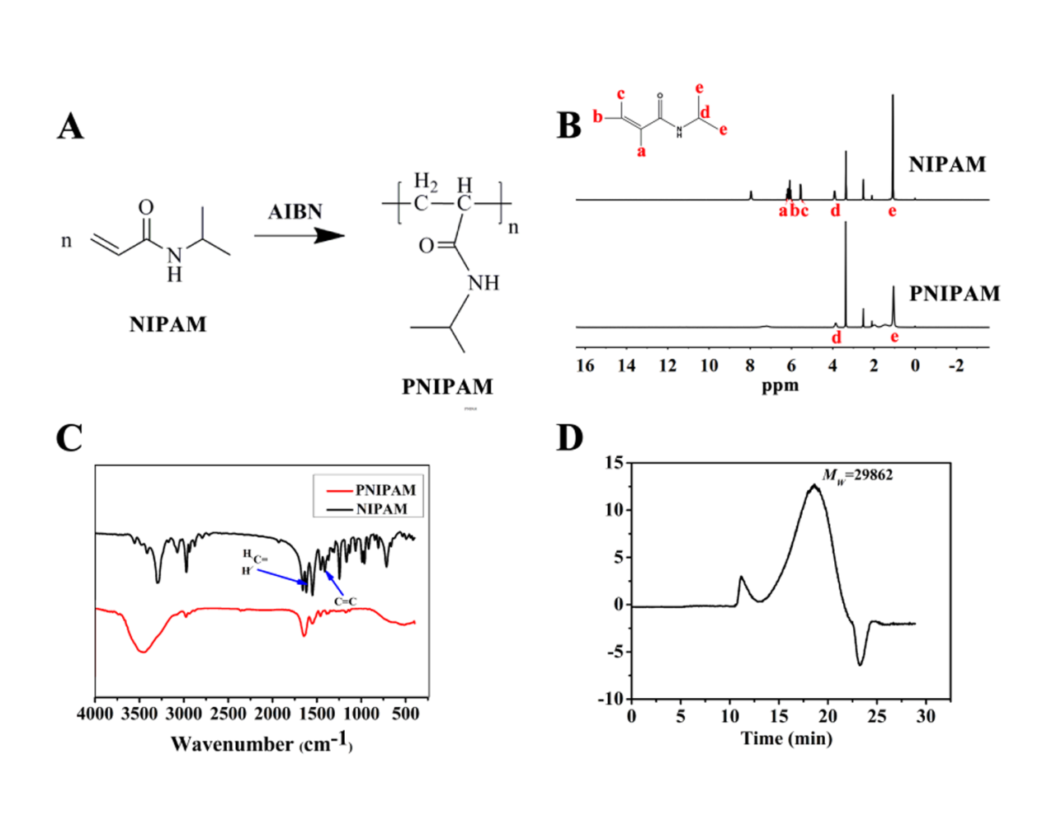
Fig.S1 Characteristics of poly(N-isopropyl-acrylamide) (PNIPAM).
(A) Synthetic route of PNIPAM, (B) H¹NMR spectrum, (C) FTIR spectrum, (D) The result of gel permeation chromatography.
Fig.S2 Storage (G′) and loss (G″) modulus changes of hydrogels with ratios
(PP 100:0) with temperature variation
FIG.S3 The skin wound model establishment and hydrogel implatation
(A: Before injecting, B: After injecting hydrogel)

Fig.S4 H&E staining and masson’s trichrome staining of natural skin tissue
(A: H&E staining, B: Masson’s trichrome staining)

