Supporting Information:
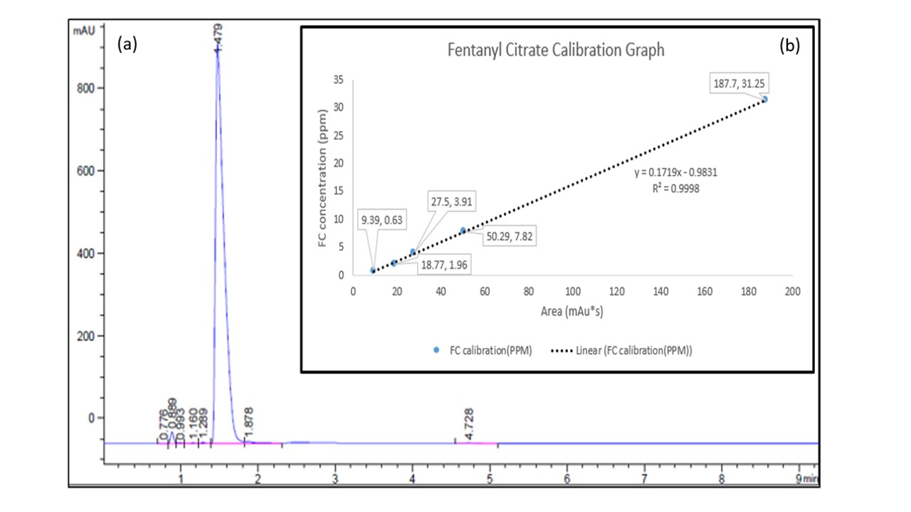

Figure S1. (a) HPLC curve of Fentanyl Citrate and (b) calibration curve of drug

Table S1. ANOVA analysis of statistical test
Secondary Phase |  | Primary Phase |  | Parameters  Factors
Within Groups | Between Groups | Within Groups | Between Groups | Parameters  Factors
4.375 | 6.535 | 4.917 | 17.083 | Sum of Squares
30 | 5 | 30 | 5 | df
0.146 | 1.307 | 0.164 | 3.417 | Mean Square
 | 8.962 |  | 20.847 | F
 | 0.00 |  | 0.00 | Sig.
Std. Deviation | Mean | Std. Deviation | Mean | groups
0.548 | 1.500±0.224 | 0.547 | 2.50±0.224 | Control Group (Group 1)
0.516 | 1.333±0.211 | 0.516 | 2.333±0.211 | NLC 0.005 (Group 2)
0.274 | 0.750±0.111 | 0.492 | 1.417±0.200 | NLC 0.01 (Group 3)
0.258 | 0.667±0.105 | 0.258 | 1.167±0.258 | NLC 0.03 (Group 4)
0.258 | 0.333±0.105 | 0.258 | 0.667±0.105 | NLC 0.06 (Group 5)
0.316 | 0.500±0.129 | 0.204 | 0.917±0.204 | Free Drug 0.06 (Group 6)

