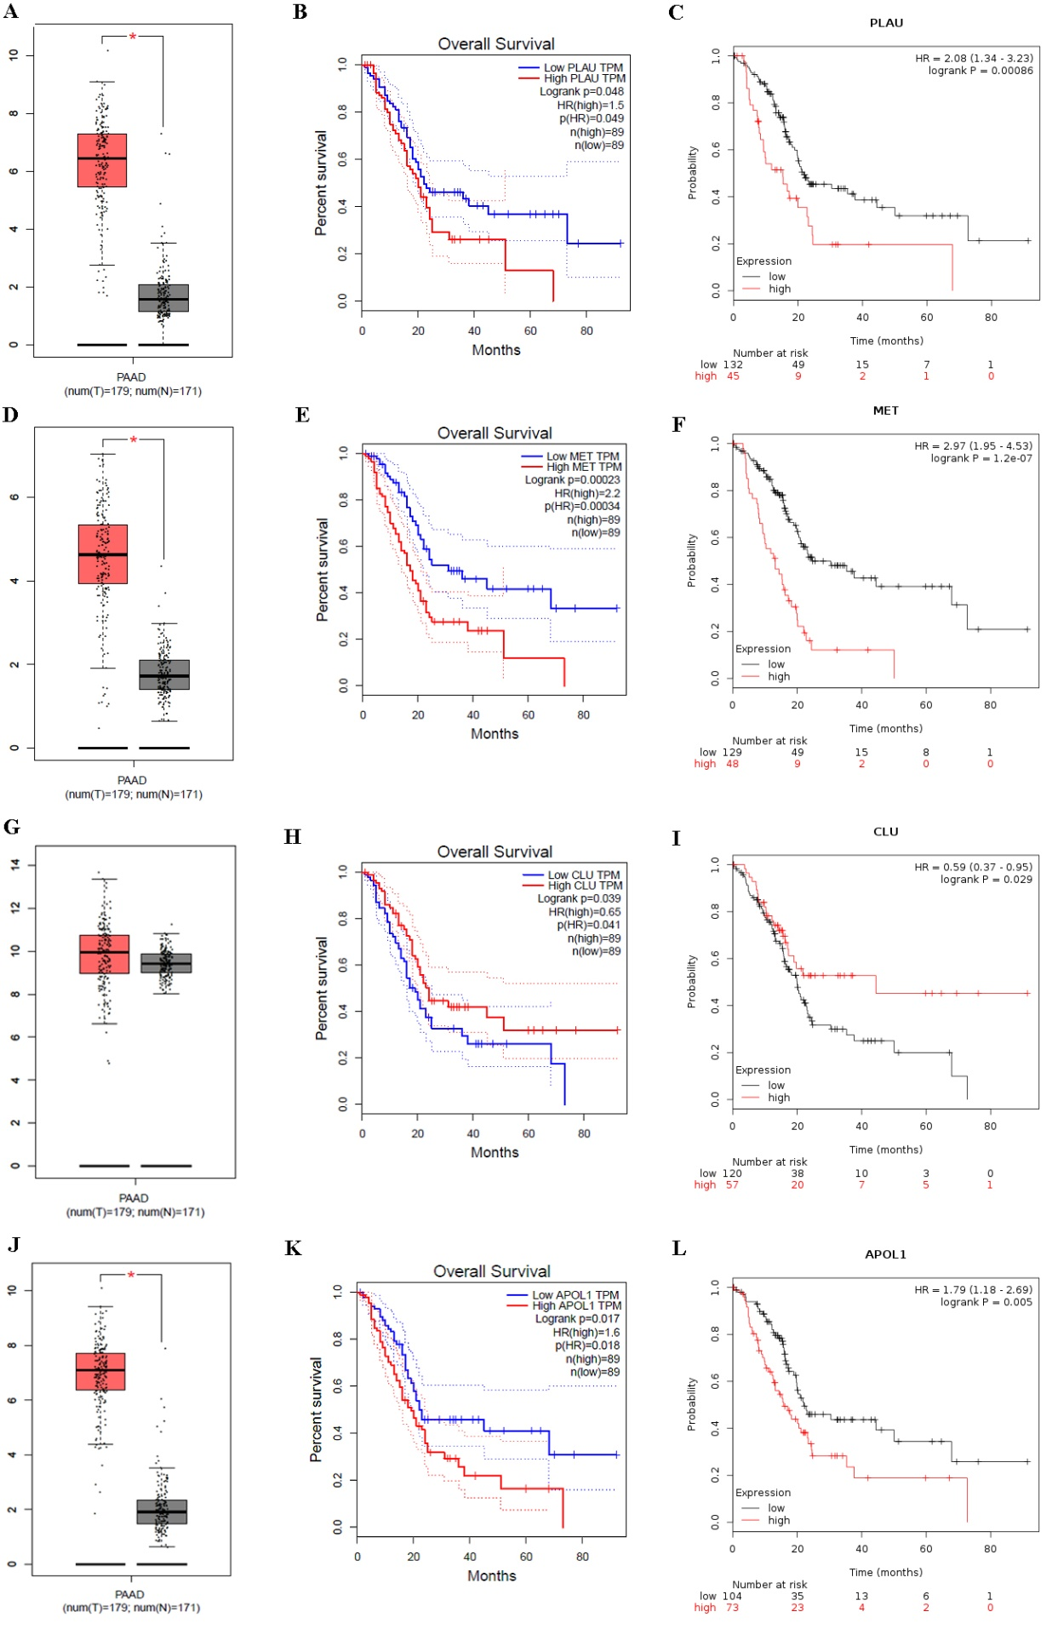
Figure S1. Expression levels analysis and prognostic values of the hub genes for PC patients. Expression levels of (A) PLAU, (D) MET, (G) CLU, (J) APOL1 by GEPIA. Overall survival analysis of (B) PLAU, (E) MET, (H) CLU, (K) APOL1 by GEPIA. Overall survival analysis of (C) PLAU, (F) MET, (I) CLU, (L) APOL1 by Kaplan–Meier plotter. Note: * means the p-value < 0.01.
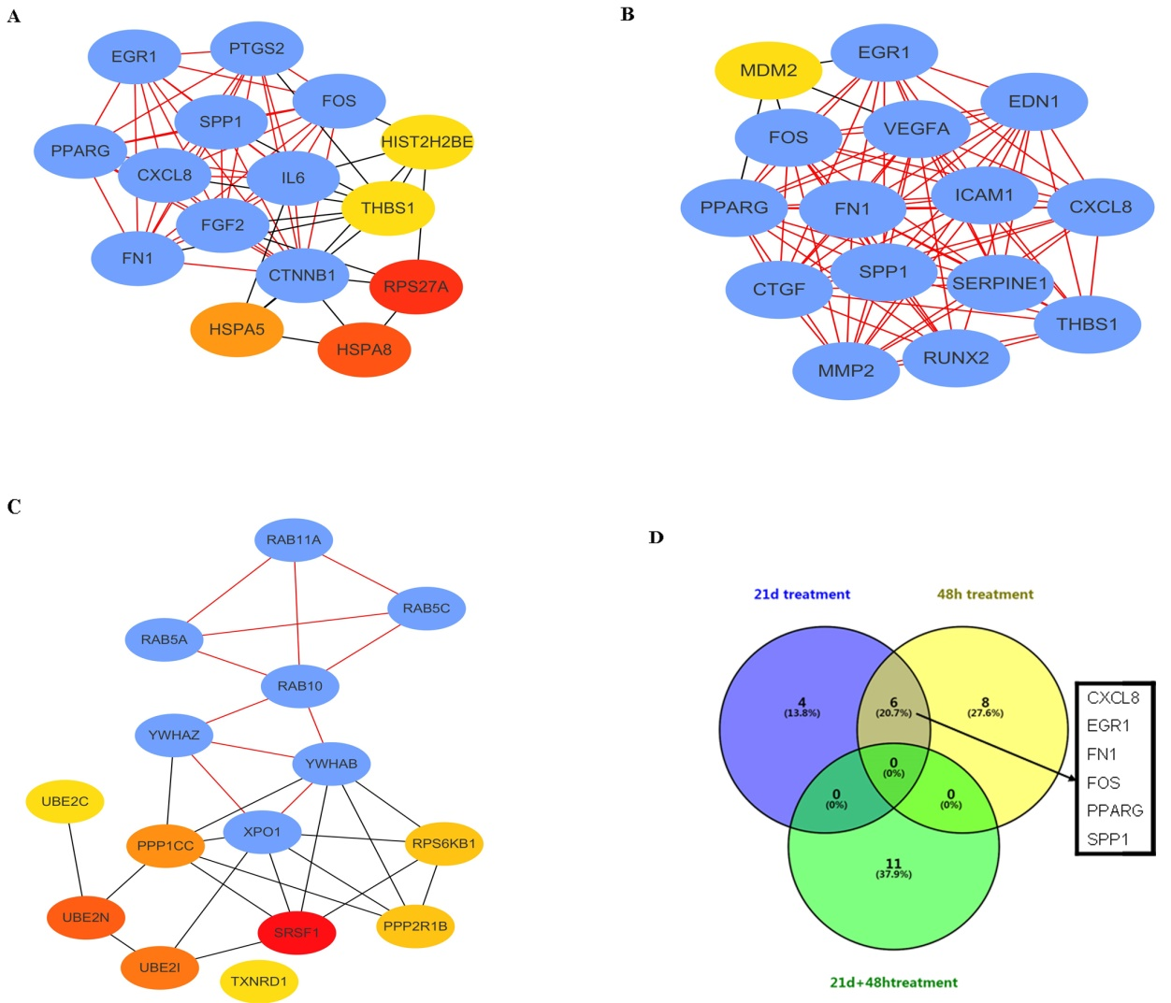
Figure S2. Establishment of modules and identified of hub genes from GSE59953. (A) PPI network of the module for control vs 21 d treatment. (B) PPI network of the module for control vs 48 h treatment. (C) PPI network of the module for control vs 21 d+48 h treatment. (D) Hub genes identified by Venn diagram from the three modules. Note: PPI: protein–protein interaction; " 21 d treatment " means cells exposure to 21 days hyperglycemia; " 48 h treatment " means cells with 48 hours TGF-β1 treatment; " 21 d + 48 h treatment " means cells exposure to 21 days hyperglycemia + subsequent TGF-β1 treatment.

Table S1. Go and KEGG pathway enrichment analysis of the DEGs between DM and PC.

Table S2. The KEGG pathway enrichment analysis for the DEGs of different groups of GSE59953.
Table S3. Identified of the hub genes of different groups of GSE59953 by Degree and MCODE-score of Cytoscape sofeware.

Table S4. The top 20 significant genes correlated with MMP9 in pancreas cancer analyzed by LinkedOmics.

