SUPPLEMENTARY DATA
Supplemental Table 1. Univariate analysis: patient characteristics and associated unadjusted outcomes
Variable | Frequency,  n (%) | Mortality, n (%) | P | Readmission, live discharges (n=1360), n (%) | P | LOS, mean (SD), days | P | Total cost, mean (SD), $ | P | Gain (loss), mean (SD), $ | P
Overall | 1439 (100.0) | 79 (5.5) |  | 340 (25.0) |  | 12 (14) |  | 21,502 (37,172) |  | –5828 (26,540)
Age group, years
18–34 | 63 (4.4) | 2 (3.2) | .5128 | 18 (29.5) | .3126 | 14 (16) | <.0001 | 38,811 (66,079) | <.0001 | –25,348 (59,784) | <.0001
35–44 | 75 (5.2) | 3 (4.0) | .5128 | 22 (30.6) | .3126 | 17 (31) | <.0001 | 29,564 (66,749) | <.0001 | –19,715 (55,176) | <.0001
45–54 | 118 (8.2) | 7 (5.9) | .5128 | 24 (21.6) | .3126 | 13 (17) | <.0001 | 29,642 (64,278) | <.0001 | –3866 (26,505) | <.0001
55–64 | 246 (17.1) | 12 (4.9) | .5128 | 62 (26.5) | .3126 | 14 (15) | <.0001 | 24,576 (37,790) | <.0001 | –2650 (27,652) | <.0001
65–74 | 315 (21.9) | 23 (7.3) | .5128 | 83 (28.4) | .3126 | 12 (12) | <.0001 | 22,423 (26,701) | <.0001 | –6394 (23,421) | <.0001
75–84 | 348 (24.2) | 14 (4.0) | .5128 | 74 (22.2) | .3126 | 10 (10) | <.0001 | 17,520 (25,548) | <.0001 | –4158 (13,605) | <.0001
≥85 | 274 (19.0) | 18 (6.6) | .5128 | 57 (22.3) | .3126 | 9 (7) | <.0001 | 13,047 (12,654) | <.0001 | –3130 (11,124) | <.0001
Sex
Female | 747 (51.9) | 43 (5.8) | .6448 | 191 (27.1) | .0601 | 12 (14) | .4845 | 19,947 (32,138) | .0992 | –5703 (27,396) | .8691
Male | 692 (48.1) | 36 (5.2) | .6448 | 149 (22.7) | .0601 | 12 (14) | .4845 | 23,180 (41,894) | .0992 | –5959 (25,636) | .8691
Payer
Medicare | 999 (69.4) | 59 (5.9) | .2409 | 236 (25.1) | .9909 | 11 (11) | .0022 | 19,358 (26,613) | .0003 | –5337 (15,662) | .0008
Medicaid | 103 (7.2) | 2 (1.9) | .2409 | 25 (24.8) | .9909 | 16 (23) | .0022 | 33,982 (65,798) | .0003 | –16,766 (50,072) | .0008
Private/other | 337 (23.4) | 18 (5.3) | .2409 | 79 (24.8) | .9909 | 12 (17) | .0022 | 24,041 (49,274) | .0003 | –4241 (39,806) | .0008
Onset
Community | 1153 (80.1) | 54 (4.7) | .007 | 263 (23.9) | .0617 | 9 (6) | <.0001 | 13,624 (13,179) | <.0001 | –2119 (12,131) | <.0001
Hospital | 286 (19.9) | 25 (8.7) | .007 | 77 (29.5) | .0617 | 25 (24) | <.0001 | 53,261 (70,758) | <.0001 | –21,494 (52,574) | <.0001
Number of hospital admissions 90 days before index admission
0 | 844 (58.7) | 37 (4.4) | .0872 | 23 (2.9) | <.0001 | 12 (15) | .78 | 22,386 (41,684) | .4741 | –5771 (28,150) | .9294
1 | 350 (24.3) | 24 (6.9) | .0872 | 163 (50.0) | <.0001 | 12 (14) | .78 | 20,989 (31,792) | .4741 | –6276 (27,548) | .9294
>1 | 245 (17.0) | 18 (7.4) | .0872 | 154 (67.8) | <.0001 | 12 (12) | .78 | 19,187 (26,198) | .4741 | –5359 (17,813) | .9294

Principal diagnosis-based CCS disease category
Diseases of the genitourinary system | 228 (15.8) | 4 (1.8) | <.0001 | 49 (21.9) | .1366 | 8 (5) | <.0001 | 10,351 (12,837) | <.0001 | –2131  (9019) | .0005
Injury and poisoning | 245 (17.0) | 6 (2.5) | <.0001 | 62 (25.9) | .1366 | 11 (12) | <.0001 | 21,509 (35,563) | <.0001 | –5368 (21,323) | .0005
Diseases of the circulatory system | 136 (9.5) | 4 (2.9) | <.0001 | 29 (22.0) | .1366 | 11 (11) | <.0001 | 21,822 (33,130) | <.0001 | –3168 (26,105) | .0005
Diseases of the digestive system | 90 (6.3) | 6 (6.7) | <.0001 | 31 (36.9) | .1366 | 15 (15) | <.0001 | 31,967 (63,085) | <.0001 | –16,390 (40,484) | .0005
Diseases of the respiratory system | 91 (6.3) | 8 (8.8) | <.0001 | 16 (19.3) | .1366 | 14 (15) | <.0001 | 21,785 (24,133) | <.0001 | –3377 (19,883) | .0005
Endocrine, nutritional, metabolic diseases, and immunity disorders | 42 (2.9) | 3 (7.1) | <.0001 | 11 (28.2) | .1366 | 11 (9) | <.0001 | 16,894 (20,862) | <.0001 | –3834 (19,026) | .0005
Neoplasms | 36 (2.5) | 7 (19.4) | <.0001 | 8 (27.6) | .1366 | 23 (29) | <.0001 | 62,402 (92,919) | <.0001 | –19,465 (69,886) | .0005
Infectious and parasitic diseases | 304 (21.1) | 33 (10.9) | <.0001 | 61 (22.5) | .1366 | 12 (13) | <.0001 | 21,591 (30,272) | <.0001 | –4236 (16,354) | .0005
Other | 267 (18.6) | 8 (3.0) | <.0001 | 73 (28.2) | .1366 | 13 (18) | <.0001 | 22,337 (38,241) | <.0001 | –8418 (35,727) | .0005
Mechanical ventilation or ICU status
Yes | 213 (14.8) | 29 (13.6) | <.0001 | 50 (27.2) | .4641 | 18 (20) | <.0001 | 43,324 (64,959) | <.0001 | –14,278 (38,120) | <.0001
No | 1226 (85.2) | 50 (4.1) | <.0001 | 290 (24.7) | .4641 | 11 (12) | <.0001 | 17,710 (28,189) | <.0001 | –4272 (23,499) | <.0001
ALaRMS value
<40 (first quartile) | 421 (29.3) | 11 (2.6) | <.0001 | 97 (23.7) | .6694 | 12 (18) | <.0001 | 21,532 (42,558) | .0001 | –9133 (38,214) | .0117
41–51 (second quartile) | 338 (23.5) | 7 (2.1) | <.0001 | 91 (27.5) | .6694 | 10 (11) | <.0001 | 17,618 (30,734) | .0001 | –2420 (18,013) | .0117
52–65 (third quartile) | 333 (23.1) | 23 (6.9) | <.0001 | 76 (24.5) | .6694 | 10 (8) | <.0001 | 17,790 (23,472) | .0001 | –4158 (19,375) | .0117
>65 (fourth quartile) | 347 (24.1) | 38 (11.0) | <.0001 | 76 (24.6) | .6694 | 14 (15) | <.0001 | 28,809 (44,878) | .0001 | –6837 (22,518) | .0117
Type of gram-negative organism
Escherichia coli | 61 (4.2) | 1 (1.6) | .4651 | 15 (25.0) | .1625 | 12 (10) | .0075 | 19,490 (19,811) | .0055 | –4553 (11,468) | .0942
Pseudomonas aeruginosa | 547 (38.0) | 32 (5.9) | .4651 | 146 (28.4) | .1625 | 13 (15) | .0075 | 24,937 (46,839) | .0055 | –5353 (27,656) | .0942
Polymicrobial | 243 (16.9) | 11 (4.5) | .4651 | 52 (22.4) | .1625 | 14 (19) | .0075 | 23,902 (40,882) | .0055 | –10,176 (32,707) | .0942
Other gram-negative | 588 (40.9) | 35 (6.0) | .4651 | 127 (23.0) | .1625 | 10 (11) | .0075 | 17,522 (24,198) | .0055 | –4554 (22,930) | .0942
Hospital teaching status
Teaching | 385 (26.8) | 21 (5.5) | .9716 | 103 (28.3) | .0896 | 16 (22) | <.0001 | 35,128 (62,877) | <.0001 | –8600 (41,388) | .0147
Non-teaching | 1054 (73.2) | 58 (5.5) | .9716 | 237 (23.8) | .0896 | 11 (9) | <.0001 | 16,524 (18,778) | <.0001 | –4536 (15,183) | .0147
Hospital size (number of beds)
≤300 | 459 (31.9) | 26 (5.7) | .8423 | 86 (19.9) | .0028 | 9 (8) | <.0001 | 16,855 (20,247) | .0012 | –5034 (15,491) | .4421
>300 | 980 (68.1) | 53 (5.4) | .8423 | 254 (27.4) | .0028 | 13 (16) | <.0001 | 23,678 (42,696) | .0012 | –6277 (31,089) | .4421
Geographic location (region)
Midwest | 368 (25.6) | 15 (4.1) | .2861 | 103 (29.2) | .0063 | 10 (9) | <.0001 | 21,969 (40,694) | .6262 | –6532 (27,139) | .6892
Northeast | 53 (3.7) | 1 (1.9) | .2861 | 16 (30.8) | .0063 | 9 (5) | <.0001 | 16,382 (11,821) | .6262 | –4372  (9838) | .6892
South | 894 (62.1) | 56 (6.3) | .2861 | 205 (24.5) | .0063 | 13 (16) | <.0001 | 21,242 (37,682) | .6262 | –5158 (27,891) | .6892
West | 124 (8.6) | 7 (5.7) | .2861 | 16 (13.7) | .0063 | 9 (7) | <.0001 | 24,180 (28,734) | .6262 | –7764 (22,333) | .6892
Abbreviations: ALaRMS, Acute Laboratory Risk of Mortality Score; CCS, Clinical Classification Software; ICU, intensive care unit; LOS, length of stay; SD, standard deviation.
Supplemental Figure 1. Case tree.
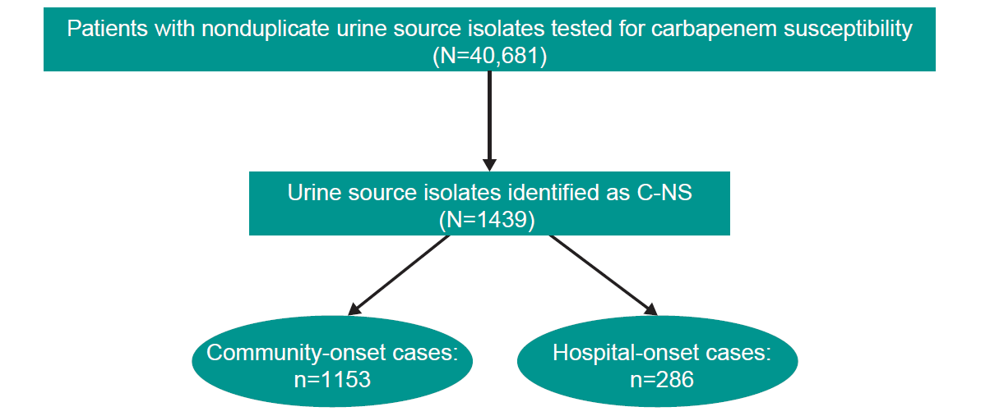
Abbreviation: C-NS, carbapenem-nonsusceptible.

