Supplementary materials

Supplementary fig. 1. There were more apoptotic cells and less ki-67 positive cells in FTY720 combined with rapamycin group. (A) FTY720 combined with rapamycin treatment contributed to tumor cells apoptosis. (B) FTY720 combined with rapamycin treatment decreased the expression of ki-67 in tumor.

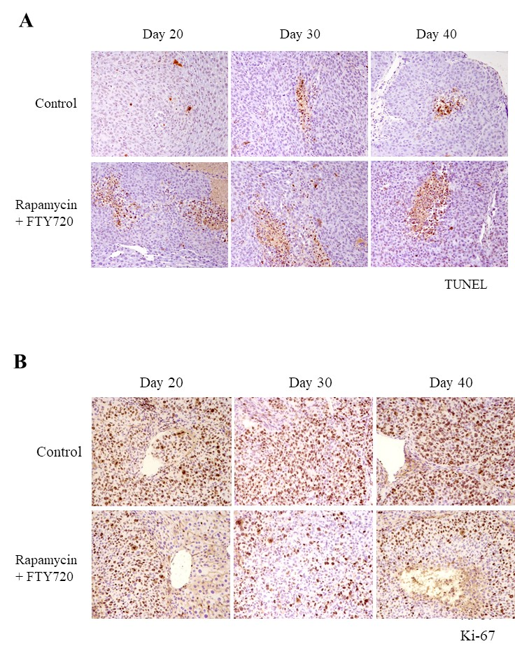
Supplementary fig 2. The overview of the story.

