Supplementary Material

Enhancing Drug Delivery for Overcoming Angiogenesis and Improving the Phototherapy Efficacy of Glioblastoma by ICG-Loaded Glycolipid-Like Micelles
Yupeng Liu¹, Suhuan Dai¹, Lijuan Wen^{1,3}, Yun Zhu², Yanan Tan², Guoxi Qiu¹, Tingting Meng¹, Fangying Yu¹, Hong Yuan¹, Fuqiang Hu¹*
¹ College of Pharmaceutical Science, Zhejiang University, 866 Yuhangtang Road, Hangzhou310058, People’s Republic of China
² Ocean College, Zhejiang University, 1 Zheda Road, Zhoushan316021, People’s Republic of China
³ National Engineering Research Center for Modernization of Traditional Chinese Medicine - Hakka Medical Resources Branch, School of Pharmacy, Gannan Medical University, Ganzhou 342700, People’s Republic of China
*Corresponding Author: Prof. Fuqiang Hu
Tel/Fax: +86-571-88208439
E-mail: hufq@zju.edu.cn

Table S1. Characterization of CSOSA, cRGD-CSOSA micelles and ICG-loaded nanoparticles.
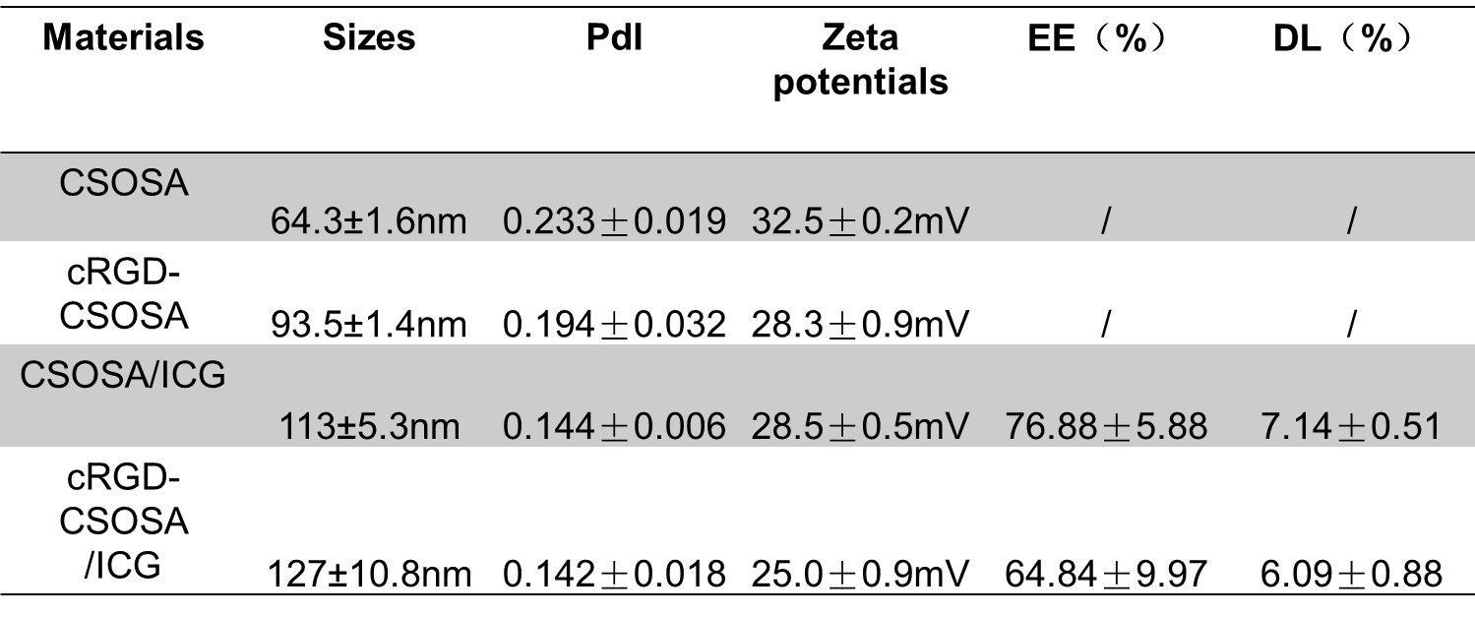

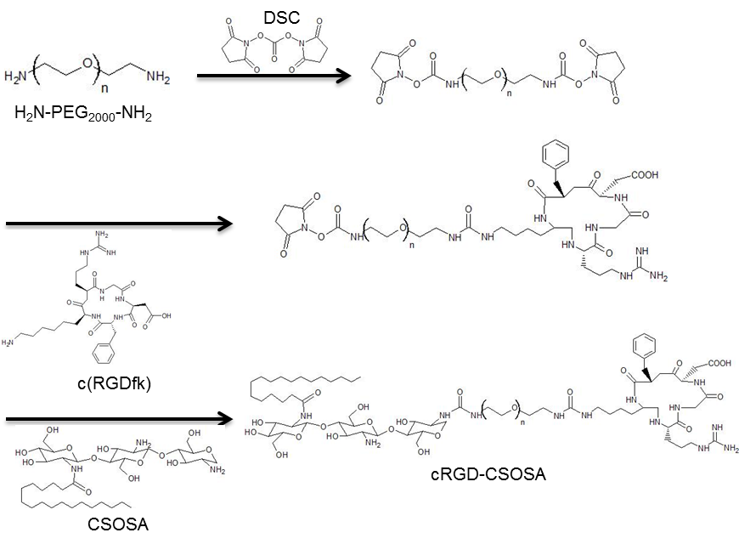
Figure S1. Synthesis route of cRGD-CSOSA.
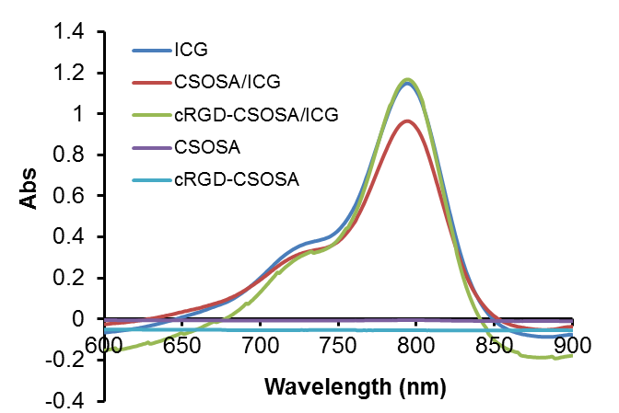
Figure S2. UV scanning of ICG, CSOSA/ICG and cRGD-CSOSA/ICG nanoparticles, the maximum absorption peak value of ICG is at 784 nm wavelength.

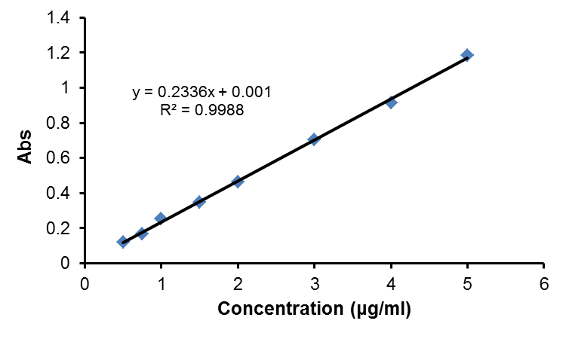
Figure S3. The standard curve of Abs at 784 nm wavelength against ICG concentration, a linear relationship between UV absorption and concentration within the concentration range of 0.5~5 μg/mL
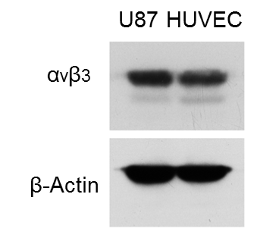
Figure S4. The expression of integrin α_{v}β₃ on HUVECs and U87 MG cells by Western blot assay.
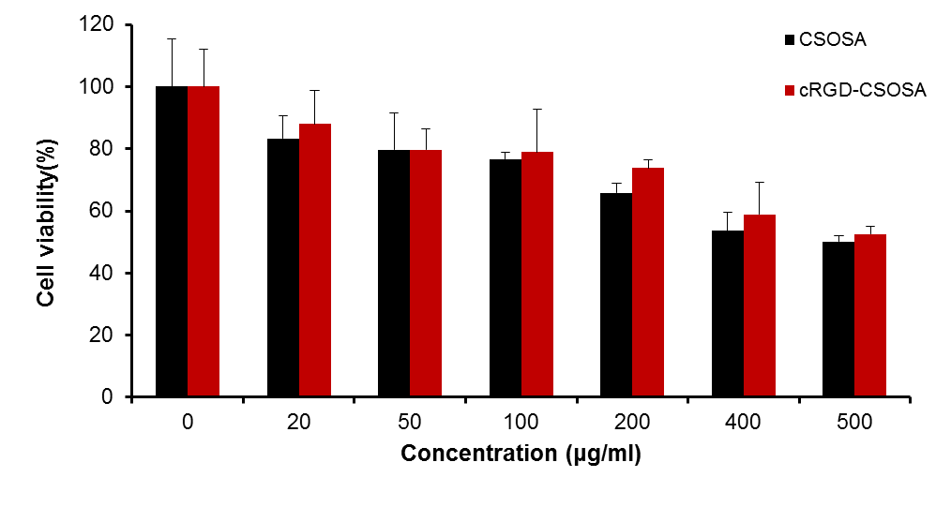
Figure S5. In vitro cytotoxicity, the safety of blank micelles.

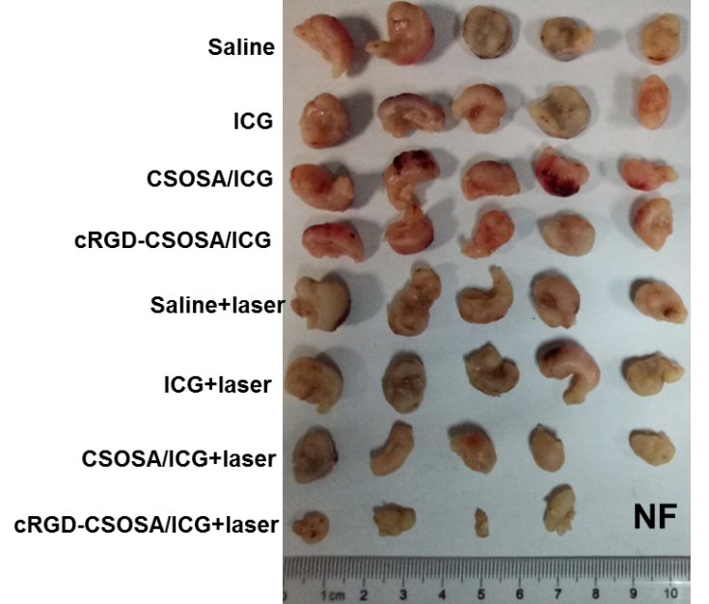
Figure S6. Ex vivo photographs of U87 MG tumors from each group after 21 days administration, “NF” indicates “not found”.

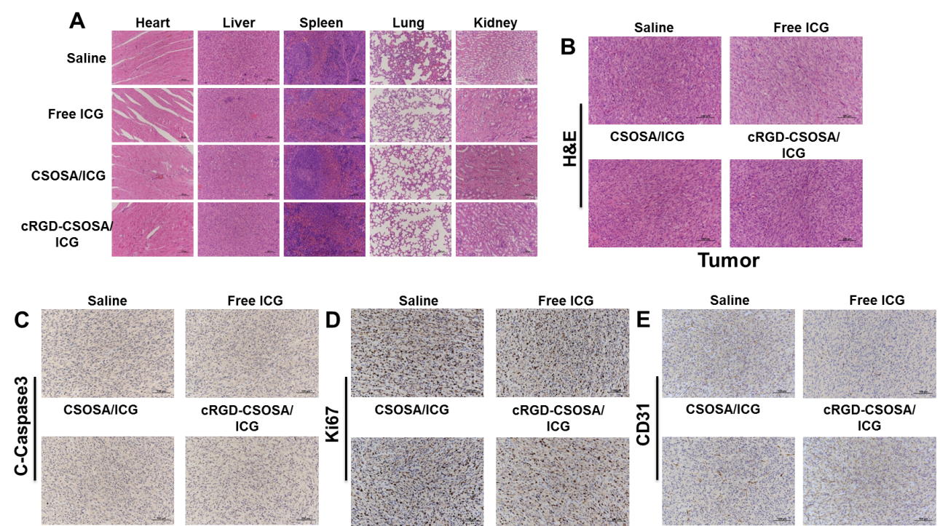
Figure S7. Histological evaluation of U87 MG tumor xenografted nude mice model in four groups without NIR irradiation. (A) HE images of major organs. (B) HE images of tumor tissue. (C) Tumor blood vessel staining with CD 31 antibody (brown). (D) The induction of apoptosis in vivo studies on tumor tissues stained with C-Caspase 3 antibodies (brown). (E) Cell proliferation evaluation by Ki67 staining (brown).

