Supplementary Figure 1

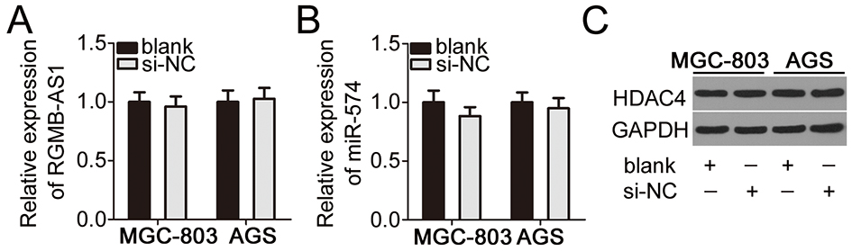

Supplementary Figure 1 Transfection with si-NC did not affect the expression of RGMB-AS1/miR-574/HDAC4 in MGC-803 and AGS cells. MGC-803 and AGS cells were transfected with or without si-NC. After transfection, expression of RGMB-AS1, miR-574, and HDAC4 were detected by means of RT-qPCR and western blotting.

