Online Data Supplement
Geographical disparity and associated factors of COPD prevalence in China: a spatial analysis of national cross-sectional study
Ning WANG; Shu CONG; Jing FAN; Heling BAO; Baohua WANG; Ting YANG; Yajing FENG; Yang LIU; Linhong WANG; Chen WANG; Wenbiao HU; Liwen FANG

e-Method 1 Detailed description of ordinary kriging method 2
e-Method 2 Detailed description of spatial scan by SaTScan software 3
e-Figure 1 Relative importance of COPD related risk factors among population aged 40 or older in different regions of China, 2015 4
e-Figure 2 Geographic disparities of COPD prevalence among different Chinese subpopulations aged 40 or older in 2015 8
e-Figure 3 Geographic disparities of the prevalence of current or former smoking among Chinese adults aged 40 or older in 2015 11
e-Figure 4. Predicted COPD prevalence among different subpopulations in 31 provincial capitals of mainland China, 2015 12
e-Table 1 The ten cities with the highest and lowest predicted COPD prevalence among Chinese adults aged 40 or older and adults aged 40 to 59 without a history of smoking (sorted by descending order) 13
e-Table 2 Spatial clusters of predicted COPD prevalence among Chinese adults aged 40or older in 2015 14

e-Method 1 Detailed description of ordinary kriging method
Ordinary kriging is one of the most widely used spatial interpolation method which is based on the regionalized variable theory. It uses the sampled data points to estimate the value over a continuous spatial area based on the spatial distribution of the empirical observations.
Two-step process is involved in Ordinary kriging interpolation. First, the spatial covariance structure among the sampled data is identified by fitting a semivariogram which can be used to quantify the spatial dependency of the data. A semivariogram is a visual depiction of the covariance in each pair of points of the sampled data. It increases with the distance between the pairs of geographic points in a specific distance range. At a certain distance, the semivariogram value reaches a plateau. To fit the semivariogram, covariances among sampled points and covariances between sampled points and the prediction points are needed.
Covariance among sampled points:
Covariance matrix of the n sampled data points
$$C_{ij}=C\left(s_{i,} s_{j}\right)=Cov(Y_{i,}Y_{j})$$
$C_{1}=\left[\begin{matrix}C_{11} & ⋯ & C_{1n} \\ ⋮ & ⋱ & ⋮ \\ C_{1n} & ⋯ & C_{nn}\end{matrix}\right]$ =
Covariance between sampled points and the prediction points:
$$C_{i0}=C\left(s_{i,}s_{0}\right)=Cov\left(Y_{i}, Y_{0} \right)$$
$$C_{0}=\left[\begin{matrix}C_{10} \\ C_{\begin{aligned}20 \\ ⋮\end{aligned}} \\ C_{n0}\end{matrix}\right]=$$
Second, weights are computed from the semivariogram which is based on the covariance structure. Weights for each prediction point are calculated according to the spatial structure between this prediction point and all the sampled points.
Covariance vector between the sampled points and the prediction point
The formula:
$$Y\left(s_{0}\right)=\sum_{i=1}^{n}{w_{i}y_{i}=\left[w_{1} ⋯ w_{n}\right] \left[\begin{matrix}y_{1} \\ ⋮ \\ y_{n}\end{matrix}\right]}$$
Where Y(S₀) refers to the predicted value which is equal to the sum of the observed value of each sampled point (y_{i}) multiplies by point-specific weight (w_{i}).

e-Method 2 Detailed description of spatial scan by SaTScan software
The SaTScan software can identify the statistically significant clusters (P<0.05) of a certain disease, where a higher than expected number of COPD patients were observed. To detect the clusters, datasets on cases, population and coordinates of the locations should be input. Based on these data, the software imposes a circular window on the map. The window is centered on each of the possible locations throughout the map and continuously varies its radius in size. The observed and expected cases inside each circle and the likelihood are calculated to examine the statistical significance.
We used the default settings for the SaTScan software for this study. The maximum spatial cluster size was set as 50% percent of the population at risk. We loaded the city-specific numbers of COPD cases which were calculated by applying the city-specific interpolated prevalence to the population aged 40 years or older retrieved from 2010 census (the most recent national census in China).

e-Figure 1 Relative importance of COPD related risk factors among population aged 40 or older in different regions of China, 2015
- East
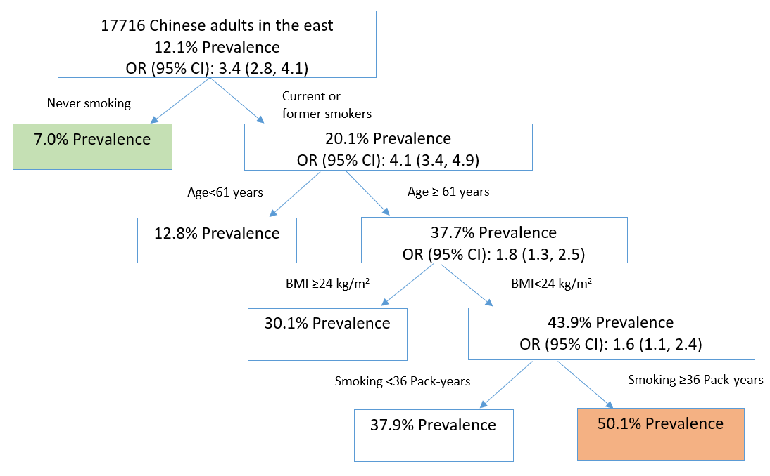

- North
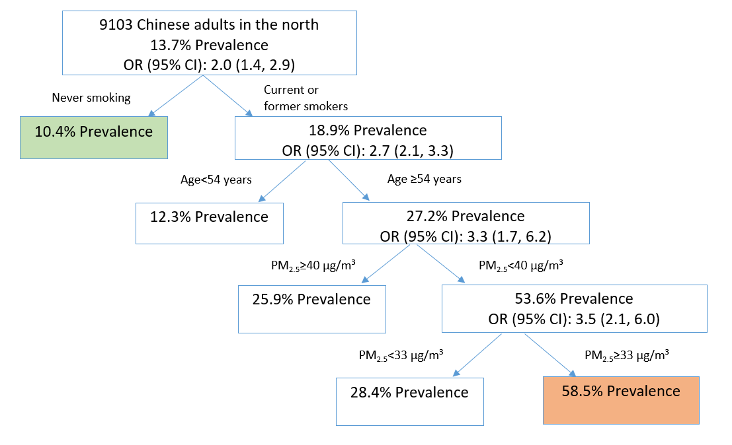
- Middle
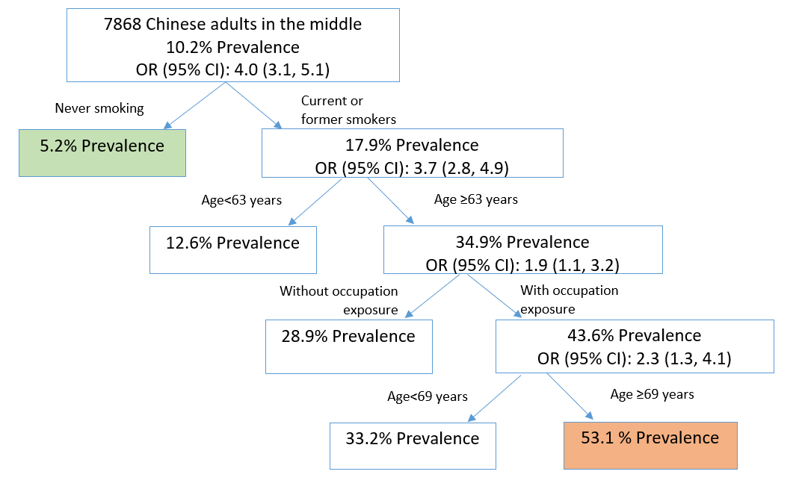

- South
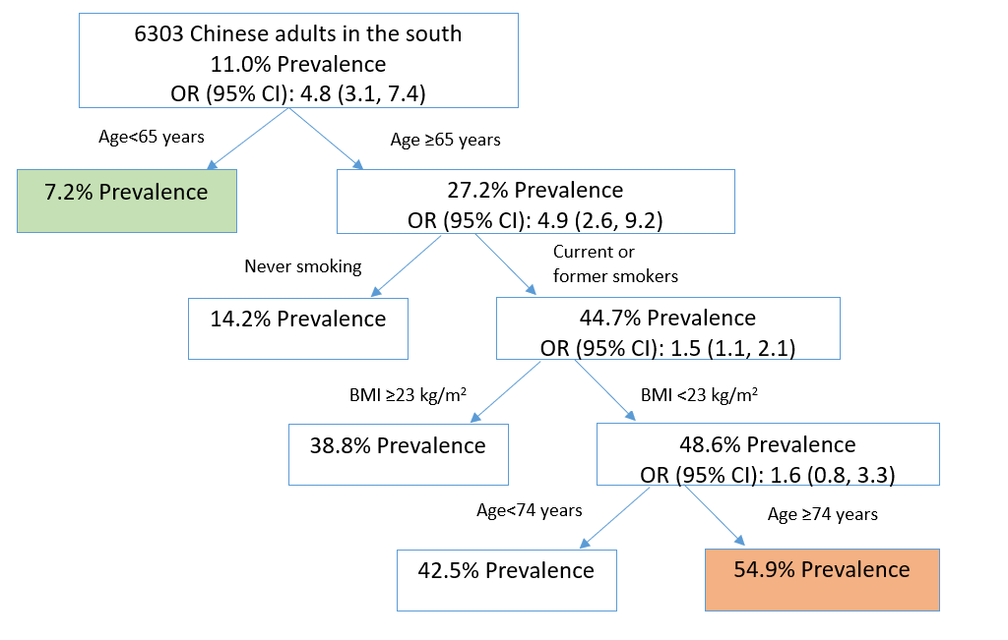

- Northeast
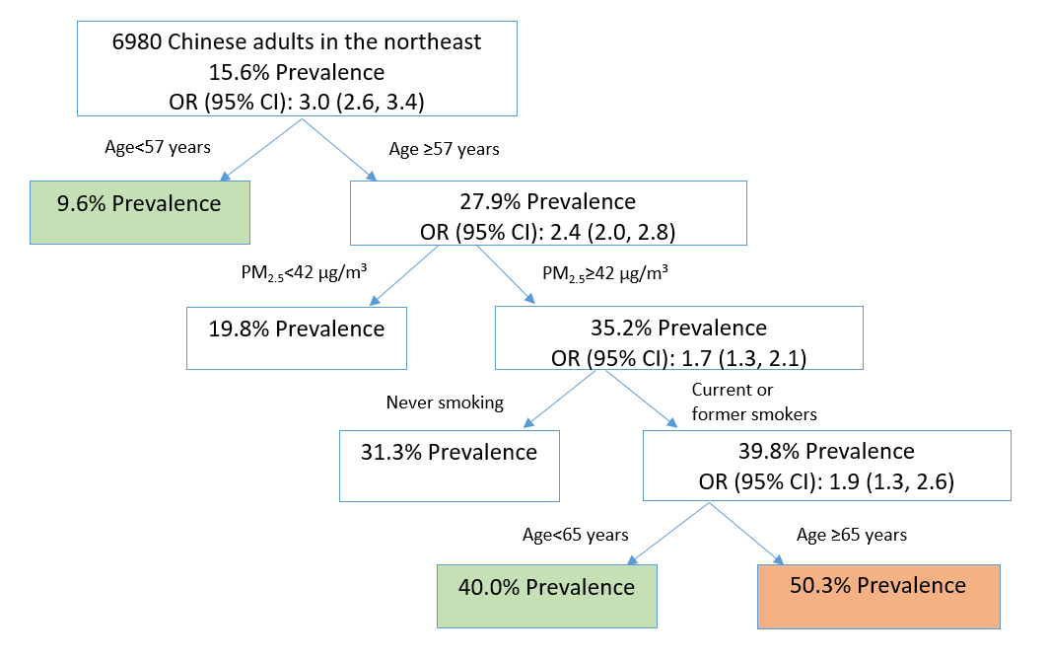

- Northwest
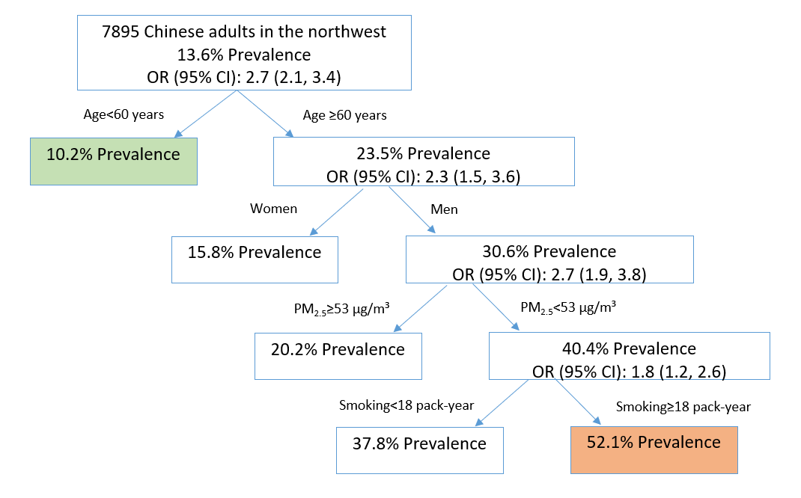

- Southwest
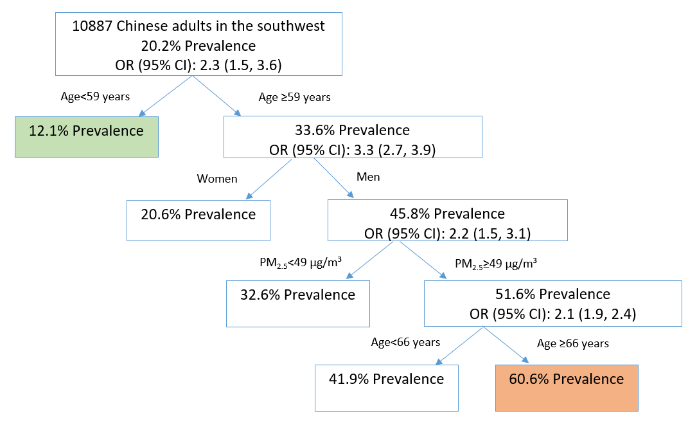

e-Figure 2 Geographic disparities of COPD prevalence among different Chinese subpopulations aged 40 or older in 2015
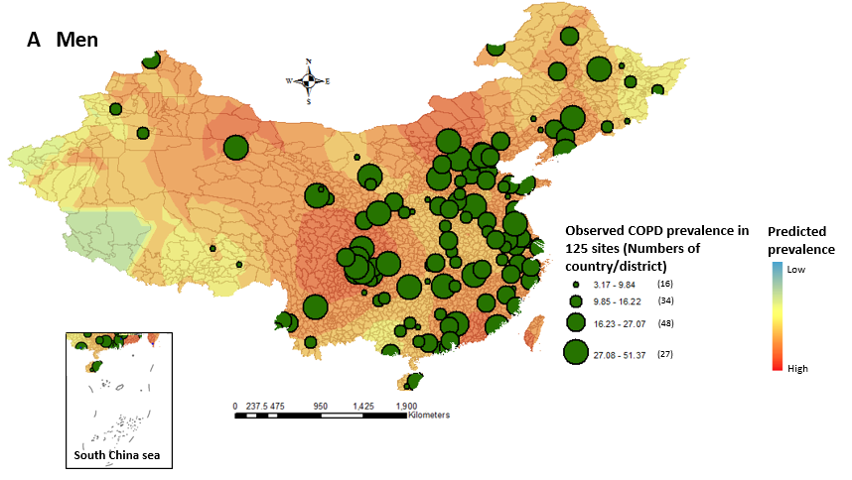

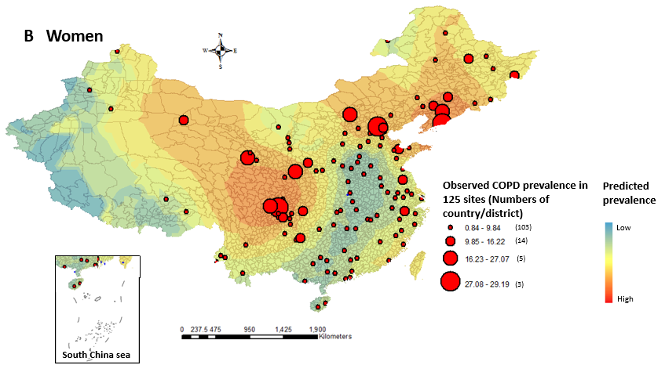
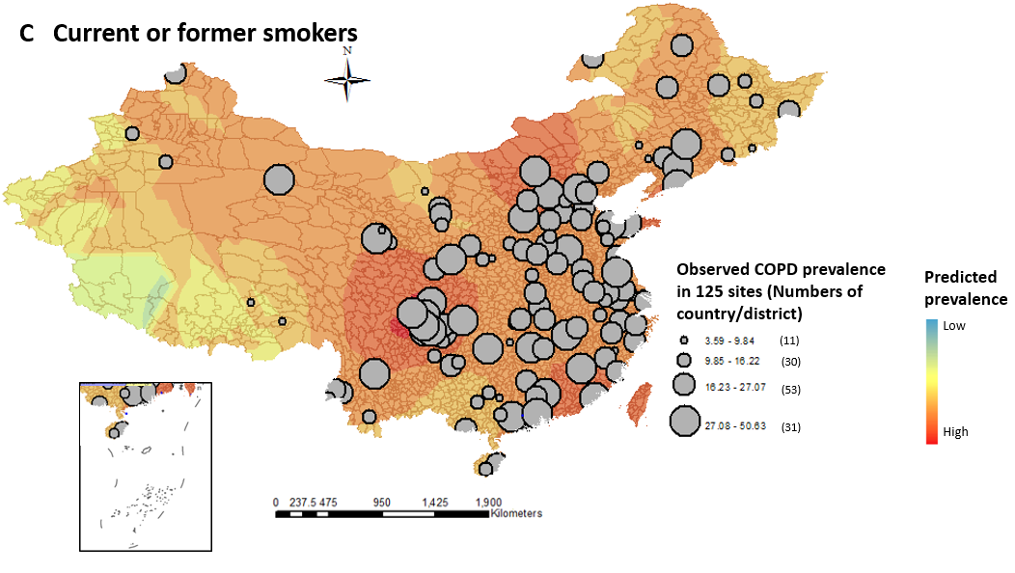

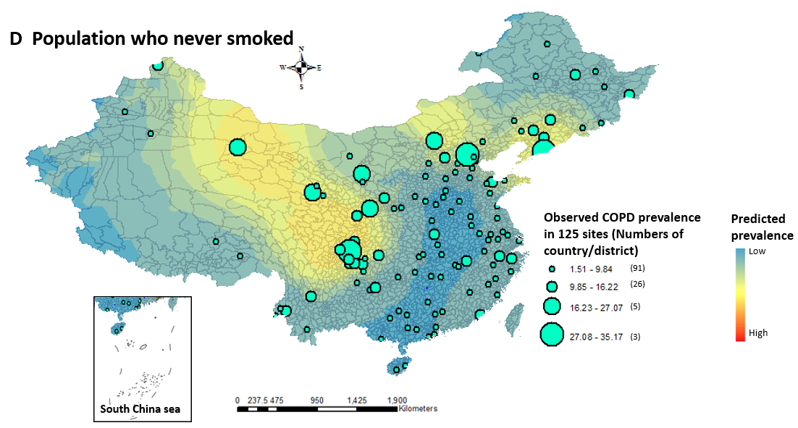

e-Figure 3 Geographic disparities of the prevalence of current or former smoking among Chinese adults aged 40 or older in 2015

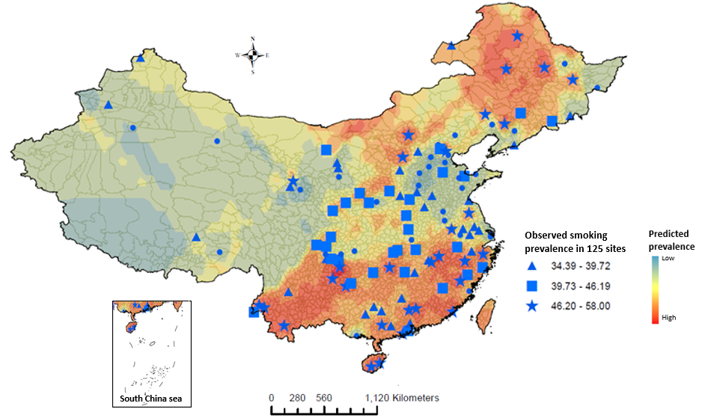

e-Figure 4. Predicted COPD prevalence among different subpopulations in 31 provincial capitals of mainland China, 2015

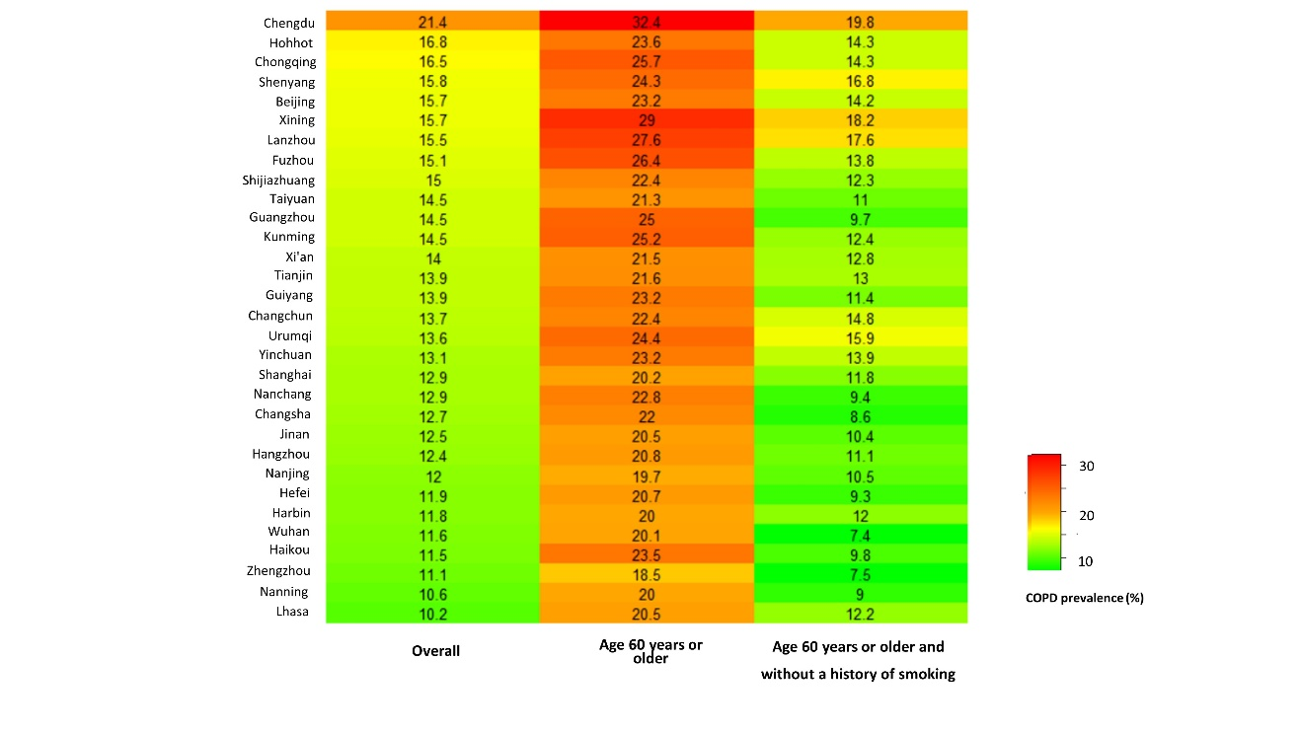

e-Table 1 The ten cities with the highest and lowest predicted COPD prevalence among Chinese adults aged 40 or older and adults aged 40 to 59 without a history of smoking (sorted by descending order)
Overall |  |  |  | Age 40-59 years without a history of smoking
Cities | Prevalence | 95% CI |  | Cities | Prevalence | 95 %CI
Top ten |  |  |  | Top ten
Deyang, Sichuan | 21.8 | 21.6-22.0 |  | Mianyang, Sichuan | 9.7 | 9.5-9.9
Chengdu, Sichuan | 21.4 | 21.2-21.5 |  | Deyang, Sichuan | 9.5 | 9.3-9.7
Suining, Sichuan | 21.3 | 21.1-21.4 |  | Guangyuan, Sichuan | 9.5 | 9.3-9.7
Meishan, Sichuan | 21.2 | 21.0-21.4 |  | Jiuquan, Gansu | 9.4 | 9.2-9.6
Ziyang, Sichuan | 21.0 | 20.8-21.2 |  | Hami(Kumul), Xinjiang | 9.2 | 9.0-9.4
Leshan, Sichuan | 21.0 | 20.8-21.2 |  | Ya'an, Sichuan | 9.2 | 9.0-9.4
Mianyang, Sichuan | 20.8 | 20.7-21.0 |  | Aba, Sichuan | 9.2 | 9.0-9.4
Ya'an, Sichuan | 20.8 | 20.7-20.9 |  | Meishan, Sichuan | 9.2 | 9.0-9.4
Neijiang, Sichuan | 20.4 | 20.2-20.5 |  | Chengdu, Sichuan | 9.2 | 9.0-9.4
Zigong, Sichuan | 20.2 | 20.0-20.5 |  | Longnan, Gansu | 9.1 | 8.9-9.3
Last ten |  |  |  | Last ten
Chongzuo, Guangxi | 10.2 | 10.1-10.3 |  | Foshan, Guangdong | 3.5 | 3.4-3.6
Shuangyashan, Heilongjiang | 10.2 | 10.1-10.2 |  | Shaoguan, Guangdong | 3.5 | 3.3-3.7
Shannan, Tibet | 10.2 | 10.1-10.2 |  | Yangjiang, Guangdong | 3.5 | 3.5-3.5
Qitaihe, Heilongjiang | 10.1 | 10.0-10.2 |  | Yunfu, Guangdong | 3.5 | 3.4-3.6
Ili Kazak, Xinjiang | 10.0 | 9.9-10.2 |  | Maoming, Guangdong | 3.4 | 3.3-3.5
Jixi, Heilongjiang | 9.9 | 9.8-10.0 |  | Chaozhou, Guangdong | 3.4 | 3.4-3.5
Rikaze, Tibet | 9.7 | 9.6-9.8 |  | Heyuan, Guangdong | 3.4 | 3.4-3.5
Kashgar, Xinjiang | 9.7 | 9.6-9.8 |  | Shantou, Guangdong | 3.3 | 3.2-3.4
Kizilsu Kirghiz, Xinjiang | 9.1 | 9.1-9.2 |  | Jieyang, Guangdong | 3.3 | 3.2-3.4
Ali, Tibet | 8.7 | 8.6-8.8 |  | Shanwei, Guangdong | 3.3 | 3.3-3.3

e-Table 2 Spatial clusters of predicted COPD prevalence among Chinese adults aged 40 or older in 2015
Cluster No., location | Radius, (km) | Population aged ≥40 years (100,000) | No. of COPD cases (100,000) |  | RR | 95% CI | P value
Cluster No., location | Radius, (km) | Population aged ≥40 years (100,000) | Expected | Observed | RR | 95% CI | P value
1, Southeast of Sichuan | 118.0 | 160.9 | 22.2 | 34.0 | 1.55 | 1.55-1.56 | <.0001
2, South of Gansu, southwest of Shaanxi,  all areas of Sichuan and Chongqing, northwest of Guizhou, and north of Yunnan; | 501.4 | 636.6 | 88.0 | 11.8 | 1.41 | 1.40-1.41 | <.0001
3, North of Gansu, southwest of Shaanxi, and northeast of Sichuan | 280.3 | 160.9 | 22.2 | 29.3 | 1.33 | 1.33-1.33 | <.0001
4, Southwest of Sichuan and north of Yunnan | 265.4 | 120.8 | 16.7 | 21.3 | 1.28 | 1.28-1.29 | <.0001
5, Middle of Chongqing | 110.3 | 151.7 | 21.0 | 25.5 | 1.22 | 1.22-1.23 | <.0001
6, Middle of Inner Mongolia, north of Shanxi, and northwest of Hebei | 362.8 | 141.3 | 19.5 | 23.6 | 1.21 | 1.21-1.22 | <.0001
7, Southwest of Guizhou | 65.5 | 44.6 | 6.2 | 7.4 | 1.21 | 1.19-1.21 | <.0001
8, South, middle, and east of Liaoning | 222.1 | 168.4 | 23.3 | 27.5 | 1.19 | 1.18-1.19 | <.0001
9, Northeast of Xinjiang and northwest of Gansu | 348.0 | 9.6 | 1.3 | 1.6 | 1.18 | 1.17-1.20 | <.0001
10, East of Guangdong and south of Fujian | 247.9 | 166.0 | 22.9 | 26.6 | 1.16 | 1.16-1.17 | <.0001
11, Northeast of Beijing and northeast of Hebei | 158.4 | 99.1 | 13.7 | 15.5 | 1.13 | 1.13-1.14 | <.0001
12, North of Jiangxi, north and middle of Fujian, and east of Guangdong | 340.1 | 350.2 | 48.4 | 54.1 | 1.13 | 1.12-1.13 | <.0001
13, East and middle of Inner Mongolia, southwest of Heilongjiang, west and middle of Jilin, Liaoning, Beijing, Tianjin, Hebei, north of Shandong, and northeast of Shanxi | 730.6 | 992.6 | 137.2 | 149.9 | 1.11 | 1.11-1.12 | <.0001
14, East of Shandong | 187.2 | 144.5 | 20.0 | 22.0 | 1.10 | 1.10-1.11 | <.0001
15, South of Zhejiang, northeast and middle of Fujian | 232.1 | 159.6 | 22.1 | 23.2 | 1.05 | 1.05-1.06 | <.0001
16, Middle of Guangdong | 85.5 | 77.8 | 10.8 | 11.1 | 1.04 | 1.03-1.04 | <.0001
17, East of Beijing, Tianjin, and east of Hebei | 173.7 | 120.8 | 16.7 | 17.3 | 1.03 | 1.03-1.04 | <.0001
18, Middle of Shandong | 95.6 | 72.3 | 10.0 | 10.3 | 1.03 | 1.03-1.04 | <.0001
19, Middle and north of Jilin, and southwest of Heilongjiang | 209.0 | 106.4 | 14.7 | 15.1 | 1.03 | 1.02-1.03 | <.0001
20, West and middle of Guizhou | 199.5 | 100.4 | 13.9 | 14.1 | 1.02 | 1.01-1.02 | <.0001
21, West of Jiangxi | 134.1 | 78.7 | 10.9 | 11.0 | 1.01 | 1.01-1.02 | <.0001
22, Middle of Shaanxi | 67.0 | 25.3 | 3.5 | 3.5 | 1.01 | 1.00-1.01 | .004

