Comparison of real-world treatment patterns among psoriasis patients treated with ixekizumab or adalimumab
eFigure 1. Kaplan Meier curve (weighted) for probability of persistence (45-day gap) (IXE versus ADA, sensitivity analyses)
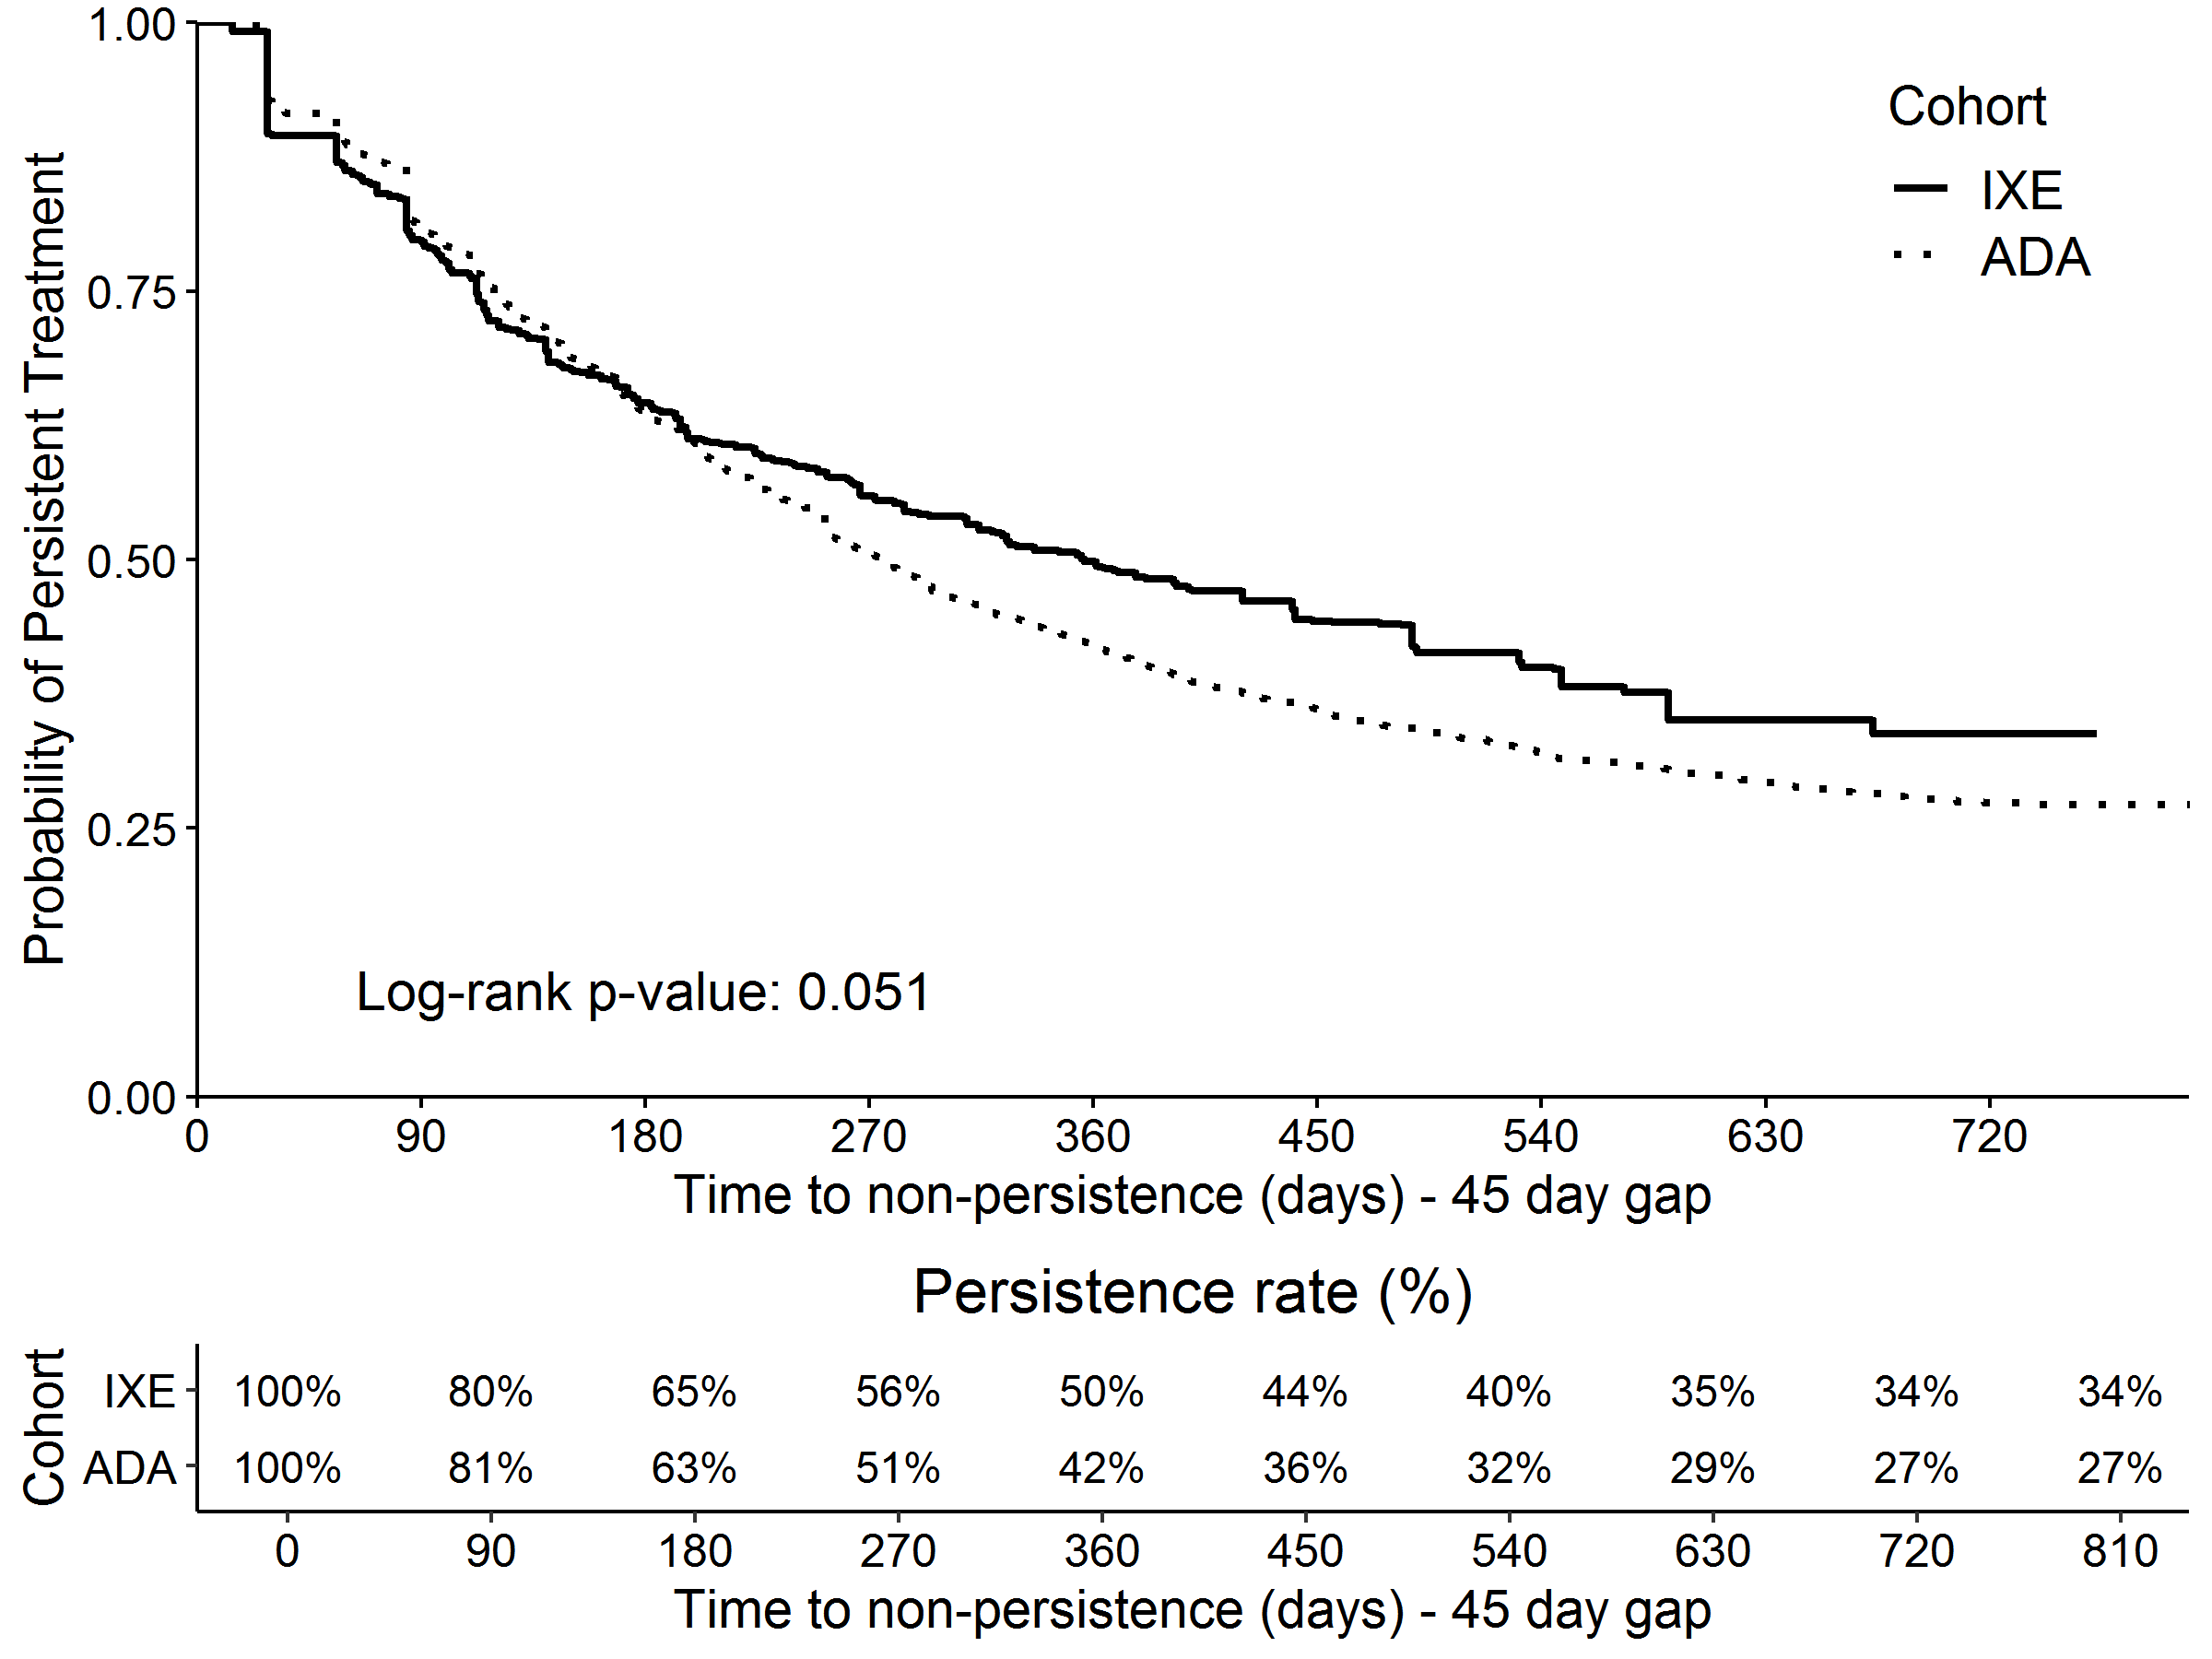
ADA, adalimumab; IXE, ixekizumab

eFigure 2. Kaplan Meier curve (weighted) for probability of persistence (90-day gap) (IXE versus ADA, sensitivity analyses)
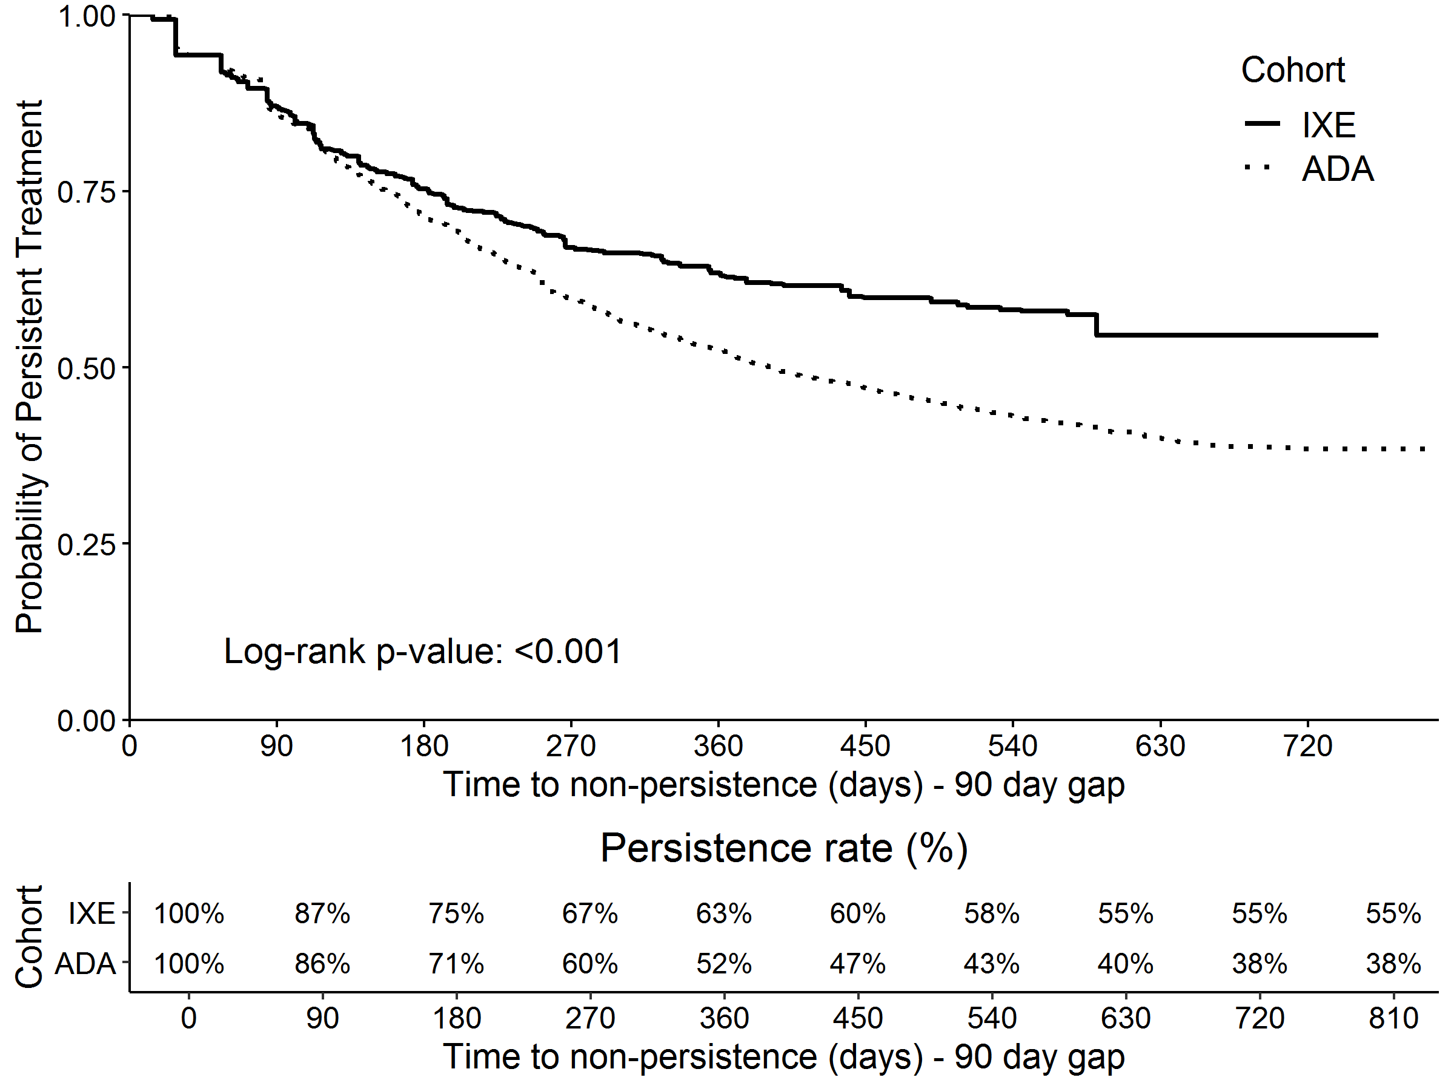
ADA, adalimumab; IXE, ixekizumab

