Supplementary materials:
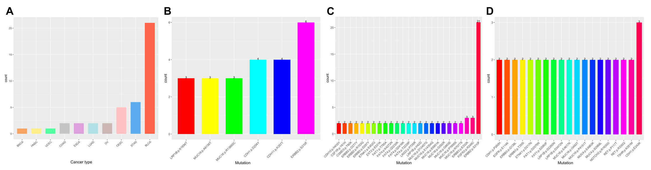
Figure S2. The distribution of HER2 S310F mutation across cancers. (A) The distribution of S310F mutation occurred in top 10 cancer types. (B) The landscape of mutations occurring more than three times in STAD. (C) The landscape of mutations occurring more than twice in BLCA. (D) The landscape of mutations occurring more than twice in BRCA.

Figure S3. The distribution of HER2 mutations in (A) BLCA, (B) STAD and (C) BRCA.

Figure S4. SDS-PAGE analysis of HER2 ECD Fc-tagged proteins under reductive condition. Lane 1, molecular weight protein markers; lane 2, HER2-ECD-WT Fc-tagged protein; lane 3, HER2-ECD-S310F Fc-tagged protein.

Figure S5. SPR analysis of the trastuzumab/pertuzumab-WT/S310F-mutant HER2 interaction by a Biacore 3000 instrument. Representative sensorgrams (coloured lines) obtained from injection of different concentrations (ranging from 0.96 to 600 nM) of trastuzumab/pertuzumab over coupled WT/S310F-mutant HER2 antigen. Curves were fitted using a bivalent analyte model (black lines).

Table S1. PCR primers used for plasmids construction
Primers | Primer sequence (5’- 3’)
Primer 1 | CGGACGTGGGATTCTGCACCCTCGT
Primer 2 | ACGAGGGTGCAGAATCCCACGTCCG
Primer 3 | CGGAATTCGCCACCATGAGGGCGAACGA
Primer 4 | ATTCTTATGCGGCCGCTTACGTTCTCTGG

