Figure S1. (A) Images of excised tumors from mice subcutaneously injected with sh-NC or sh-LINC01535-1 transfected Saos2 cells. (B) The tumor volume in sh-NC and sh-LINC01535-1 group was monitored every four days to generate the growth curve. (C) The weight of excised tumor was tested in sh-NC and sh-LINC01535-1 group. (D) LINC01535 expression in excised tumors was detected after LINC01535 knockdown. (E) The expressions of proliferation markers (Ki-67 and PCNA) in sh-NC and sh-LINC01535-1 group were observed through IHC assay. All results were showed as the mean ± SD. **P < 0.01.
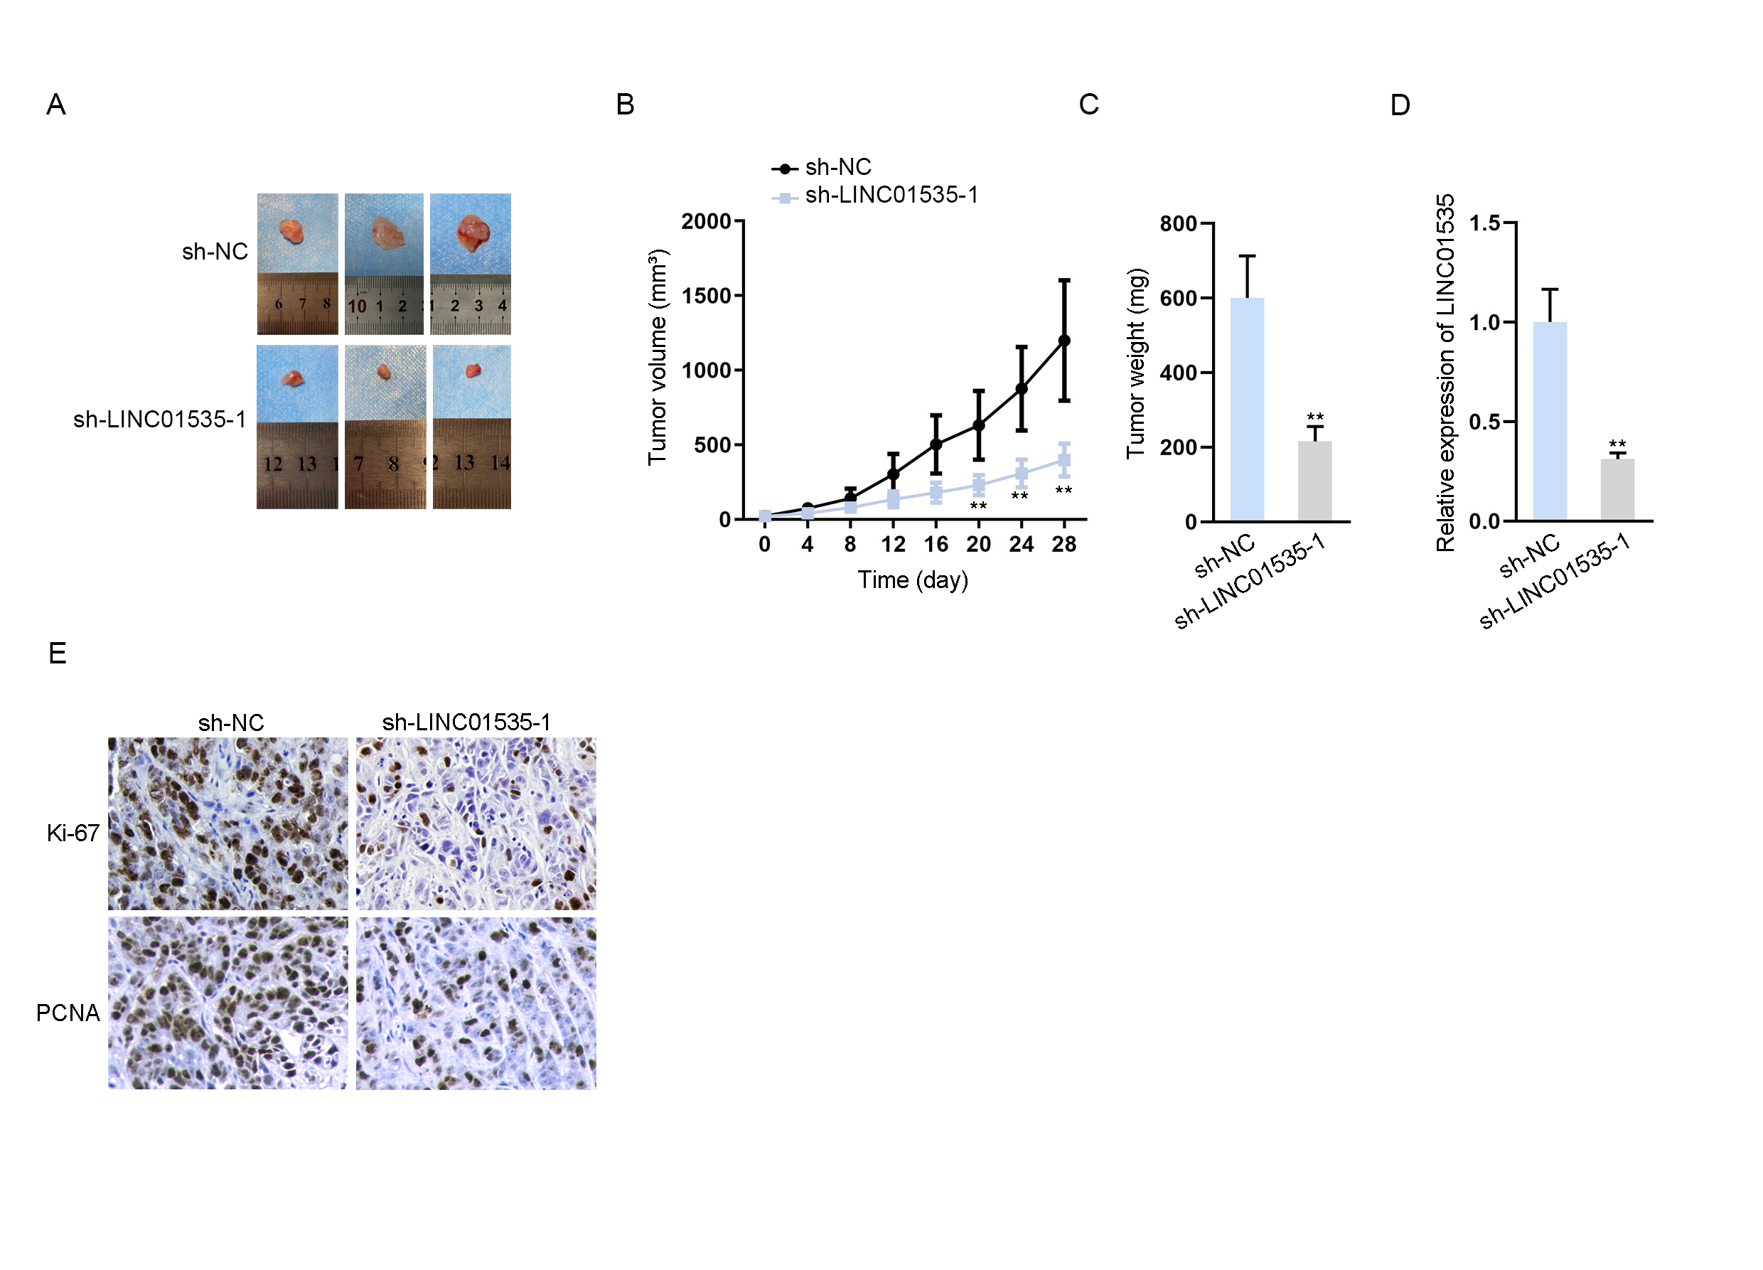

Figure S2. (A-K) Eleven predicted miRNAs’ expression levels in human osteoblasts and OS cell lines were assessed by qRT-PCR. (L) Expression of miR-214-3p was detected in cells transfected with sh-NC and sh-LINC01535-1. All results were presented as the mean ± SD. *P<0.05, **P < 0.01.