Figure S1. Study design diagram
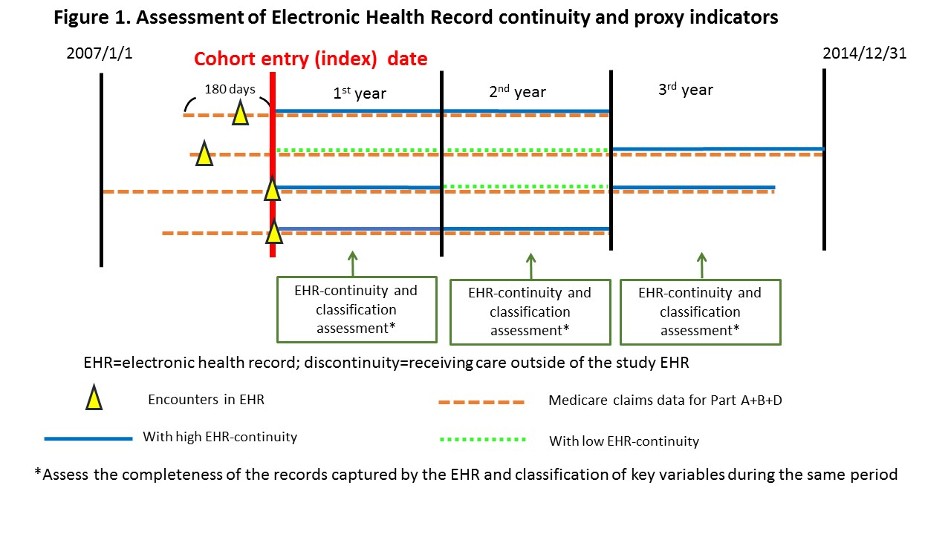

Table S1. Prediction model for EHR data-continuity cohort
Variable | Coefficient
Intercept | -0.010
Having seen the same provider twice | 0.049
Having seen the same provider >=3 times | 0.087
Having general medical exam* | 0.078
Mammography* | 0.075
Pap smear* | 0.009
PSA Test* | 0.103
Colonoscopy* | 0.064
Fecal occult blood test* | 0.034
Influenza vaccine* | 0.102
Pneumococcal vaccine* | 0.031
Having BMI recorded* | 0.017
Having 2 of the above routine care facts** | 0.049
With any one medication use record | 0.002
With at least 2 medication use records | 0.074
Having A1C ordered or value recorded* | 0.018
Having at least one inpatient or outpatient encounter | 0.091
Having at least two outpatient encounters | 0.050
With 1 diagnosis recorded in the EHR | -0.026
With at least 2 diagnoses recorded in the EHR | 0.037
Having any ED visit in the EHR | 0.078
** having 2 of the facts followed by *, EHR=electronic health records, PSA= prostate specific antigen

Table S2: The 40 patient characteristics to be assessed for accuracy of classification
25 co-morbidity variables | - 15 variables commonly used as covariates for confounding adjustment: Dementia, atrial fibrillation, chronic lung disease, chronic liver disease, chronic kidney disease, cancer, diabetes, hypertension, anemia, psychosis, depression, pneumonia, HIV, fracture, and RA  - 10 variables with validated algorithm commonly used as outcome variables: ischemic stroke, ICH, MI, AKI, hepatotoxicity, GI Bleeding, major bleeding, DVT, PE, and CHF^{11-13,14,15,16,17,18}
15 medication use variables | antiplatelet agents, antidiabetics, antihypertensives, NSAIDs, opioids, antidepressants, antipsychotics, anticonvulsants, PPIs, antiarrhythmics, statins, dementia, hormone therapy, antibiotics, and oral anticoagulants
CHF= congestive heart failure, HIV= human immunodeficiency virus, RA=rheumatoid arthritis, AKI=acute kidney injury, ICH= intracranial hemorrhage, MI= myocardial infarction, PE= pulmonary embolism, DVT= deep vein thrombosis, NSAIDs= nonsteroidal anti-inflammatory drugs, PPI= Proton pump inhibitors

Table S3. Patients population comparison between MA vs. NC sites
Variable | Training (MA) set, n=80,588  N (%) | Validation (NC) set, n=33,207  N (%) | Absolute Standardized Mean Difference
Mean (SD) age, years | 74.1 (7.7) | 73.7 (7.4) | 0.00
Female | 60,217 (57.7) | 29,544 (60.0) | 0.05
Mean (SD) CCS | 2.3 (3.3) | 2.0 (3.0) | 0.00
Dementia | 11,776 (11.3) | 5,603 (11.4) | 0.00
Atrial fibrillation | 19,144 (18.3) | 8,044 (16.3) | 0.05
Chronic lung disease | 21,334 (20.4) | 11,347 (23.0) | 0.06
Chronic liver disease | 8,119 (7.8) | 2,772 (5.6) | 0.09
Chronic kidney disease | 14,524 (13.9) | 7,233 (14.7) | 0.02
Cancer | 44,980 (43.1) | 19,628 (39.8) | 0.07
Diabetes | 23,074 (22.1) | 13,993 (28.4) | 0.15
Hypertension | 84,184 (80.6) | 41,402 (84.0) | 0.09
Anemia | 30,455 (29.2) | 14,825 (30.1) | 0.02
Psychosis | 5,201 (5.0) | 2,142 (4.4) | 0.03
Depression | 21,085 (20.2) | 8,717 (17.7) | 0.06
Pneumonia | 11,438 (11.0) | 5,336 (10.8) | 0.00
HIV | 147 (0.1) | 77 (0.2) | 0.01
Fracture | 3,569 (3.4) | 1,699 (3.5) | 0.00
RA | 2,775 (2.7) | 1,680 (3.4) | 0.04
Ischemic stroke | 1,127 (1.1) | 675 (1.4) | 0.03
ICH* | 592 (0.6) | 238 (0.5) | 0.01
MI* | 1,107 (1.1) | 517 (1.1) | 0.00
AKI* | 5,941 (5.7) | 2,964 (6.0) | 0.01
Hepatotoxicity* | 346 (0.3) | 153 (0.3) | 0.00
GI Bleeding* | 2,001 (1.9) | 1,100 (2.2) | 0.02
Major bleeding* | 4,644 (4.5) | 3,015 (6.1) | 0.07
DVT* | 958 (0.9) | 428 (0.9) | 0.01
PE* | 660 (0.6) | 368 (0.8) | 0.01
CHF* | 11,701 (11.2) | 5,342 (10.8) | 0.01
EHR= electronic health record, stand. Diff. = standardized difference, CHF= congestive heart failure, HIV= human immunodeficiency virus, RA=rheumatoid arthritis, AKI=acute kidney injury, ICH= intracranial hemorrhage, MI= myocardial infarction, PE= pulmonary embolism, DVT= deep vein thrombosis, NSAIDs= nonsteroidal anti-inflammatory drugs, PPI= Proton pump inhibitors. * Variables based on validated algorithms commonly used to define study outcomes^{11-13,14,15,16,17,18}.

Table S4. Correlation between predicted vs. observed EHR data-continuity measured by Spearman coefficients
Dataset | Training (MA) set | Validation set (NC)
Overall population | 0.78 | 0.73
Age groups
65-<75 | 0.78 | 0.72
75-<85 | 0.79 | 0.73
>=85 | 0.76 | 0.73
Gender
female | 0.78 | 0.74
male | 0.77 | 0.72
Ethnicity
white | 0.76 | 0.73
black | 0.76 | 0.70
others | 0.82 | 0.75
CCS
<=0 | 0.76 | 0.74
1-2 | 0.78 | 0.76
>=2 | 0.78 | 0.73
CCS= combined comorbidity score (J Clin Epidemiol. 2011;64 [7]:749-759). The higher the score, the higher the mortality.

Table S5-1. Representativeness of the EHR data-continuity cohort in the training (MA) set
 | Low EHR data-continuity N (%)* | High EHR data-continuity N (%)** | Stand. Diff.***
Mean age (SD) | 74.1 (7.6) | 72.7 (7.2) | 0.18
Female, % | 55,119 (58.6) | 12,804 (56.1) | 0.05
Dementia | 10,916 (11.6) | 1,772 (7.8) | 0.13
Atrial fibrillation | 17,305 (18.4) | 3,689 (16.2) | 0.06
Chronic lung disease | 18,937 (20.1) | 4,512 (19.8) | 0.01
Liver disease | 6,925 (7.4) | 1,992 (8.7) | 0.05
Chronic kidney disease | 12,286 (13.1) | 3,385 (14.8) | 0.05
Cancer | 40,593 (43.1) | 10,001 (43.8) | 0.01
Diabetes | 19,696 (20.9) | 5,427 (23.8) | 0.07
Hypertension | 73,727 (78.3) | 18,695 (81.9) | 0.09
Anemia | 27,218 (28.9) | 6,274 (27.5) | 0.03
Psychosis | 4,676 (5.0) | 914 (4.0) | 0.05
Depression | 18,684 (19.9) | 4,741 (20.8) | 0.02
Pneumonia | 10,012 (10.6) | 2,379 (10.4) | 0.01
HIV | 103 (0.1) | 55 (0.2) | 0.03
Fracture | 3,204 (3.4) | 670 (2.9) | 0.03
RA | 2,572 (2.7) | 686 (3.0) | 0.02
Ischemic stroke | 5,043 (5.4) | 1,061 (4.7) | 0.03
ICH | 1,995 (2.1) | 394 (1.7) | 0.03
MI | 842 (0.9) | 238 (1.0) | 0.02
AKI | 5,164 (5.5) | 1,375 (6.0) | 0.02
Hepatotoxicity | 1,010 (1.1) | 377 (1.7) | 0.05
GI bleeding | 6,506 (6.9) | 1,674 (7.3) | 0.02
Major bleeding | 12,345 (13.1) | 3,272 (14.3) | 0.04
DVT | 4,256 (4.5) | 1,066 (4.7) | 0.01
PE | 1,802 (1.9) | 491 (2.2) | 0.02
CHF | 10,288 (10.9) | 2,343 (10.3) | 0.02
*Patients in the lower 8 deciles of predicted EHR data-continuity;
**Patients in the top 2 deciles of predicted EHR data-continuity
***Stand diff= Standardized difference.
CHF= congestive heart failure, HIV= human immunodeficiency virus, RA=rheumatoid arthritis, AKI=acute kidney injury, ICH= intracranial hemorrhage, MI= myocardial infarction, PE= pulmonary embolism, DVT= deep vein thrombosis, NSAIDs= nonsteroidal anti-inflammatory drugs, PPI= Proton pump inhibitors

Table S5-2. Representativeness of the EHR data-continuity cohort in NC dataset
 | Low EHR data-continuity N (%)* | High EHR data-continuity N (%)** | Stand. Diff.***
Mean age (SD) | 73.9 (7.4) | 72.8 (7.1) | 0.16
Female, % | 25,333 (60.3) | 4,211 (57.7) | 0.05
Dementia | 4,743 (11.3) | 725 (9.9) | 0.04
Atrial fibrillation | 6,649 (15.8) | 1,280 (17.5) | 0.05
Chronic lung disease | 9,440 (22.5) | 1,682 (23.1) | 0.01
Liver disease | 2,144 (5.1) | 500 (6.9) | 0.07
Chronic kidney disease | 5,704 (13.6) | 1,327 (18.2) | 0.13
Cancer | 16,201 (38.6) | 2,951 (40.4) | 0.04
Diabetes | 11,287 (26.9) | 2,537 (34.8) | 0.17
Hypertension | 34,527 (82.2) | 6,264 (85.8) | 0.10
Anemia | 11,894 (28.3) | 2,553 (35.0) | 0.14
Psychosis | 1,741 (4.1) | 303 (4.2) | 0.00
Depression | 7,008 (16.7) | 1,383 (19.0) | 0.06
Pneumonia | 4,334 (10.3) | 858 (11.8) | 0.05
HIV | 33 (0.1) | 38 (0.5) | 0.08
Fracture | 1,378 (3.3) | 282 (3.9) | 0.03
RA | 1,392 (3.3) | 266 (3.6) | 0.02
Ischemic stroke | 524 (1.2) | 138 (1.9) | 0.05
ICH | 182 (0.4) | 48 (0.7) | 0.03
MI | 364 (0.9) | 119 (1.6) | 0.07
AKI | 2,208 (5.3) | 684 (9.4) | 0.16
Hepatotoxicity | 118 (0.3) | 28 (0.4) | 0.02
GI bleeding | 810 (1.9) | 254 (3.5) | 0.10
Major bleeding | 2,097 (5.0) | 833 (11.4) | 0.24
DVT | 319 (0.8) | 99 (1.4) | 0.06
PE | 280 (0.7) | 82 (1.1) | 0.05
CHF | 4,342 (10.3) | 932 (12.8) | 0.08
*Patients in the lower 8 deciles of predicted EHR data-continuity;
**Patients in the top 2 deciles of predicted EHR data-continuity
***Stand diff= Standardized difference.
CHF= congestive heart failure, HIV= human immunodeficiency virus, RA=rheumatoid arthritis, AKI=acute kidney injury, ICH= intracranial hemorrhage, MI= myocardial infarction, PE= pulmonary embolism, DVT= deep vein thrombosis, NSAIDs= nonsteroidal anti-inflammatory drugs, PPI= Proton pump inhibitors

Table S6. Representative assessment: discrepancy* of a comorbidity score** category in patients with high vs. low care-continuity
Year after cohort entry: | 1 | 2 | 3 | 4 | 5 | 6 | 7
MA
Top decile vs. the rest, training set | 0.01 | 0.02 | 0.02 | 0.02 | 0.02 | 0.03 | 0.04
Top two deciles vs. the rest, training set | 0.02 | 0.02 | 0.02 | 0.02 | 0.02 | 0.02 | 0.02
NC
Top decile vs. the rest, validation set | 0.06 | 0.05 | 0.05 | 0.04 | 0.03 | 0.03 | 0.03
Top two deciles vs. the rest, validation set | 0.05 | 0.04 | 0.04 | 0.04 | 0.03 | 0.03 | 0.03
* Quantified by mean standardized difference (MSD); a MSD of <0.1 indicates acceptable discrepancy
**combined comorbidity score [J Clin Epidemiol. 2011;64(7):749-759.]

