Supplementary information

Silver-containing titanium oxide nanocapsules for combating multidrug-resistant bacteria

Figure S1: Energy-dispersive X-ray spectrum of 8ANA.

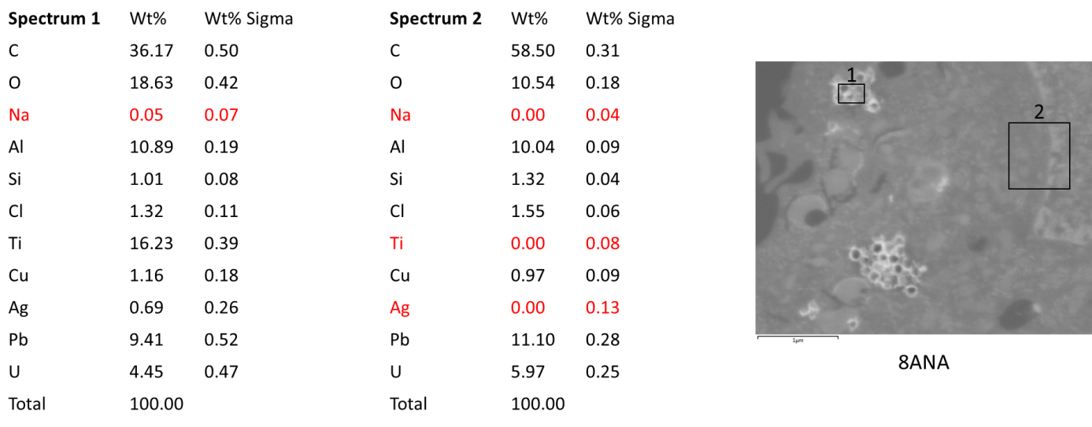
Figure S2: Elemental analysis from EDS of macrophages after incubation with 8ANA. Red values in the tables are below the detection limit. J774A.1 macrophages were incubated at 37°C overnight with particles at a concentration of 10 µg/mL (8ANA).

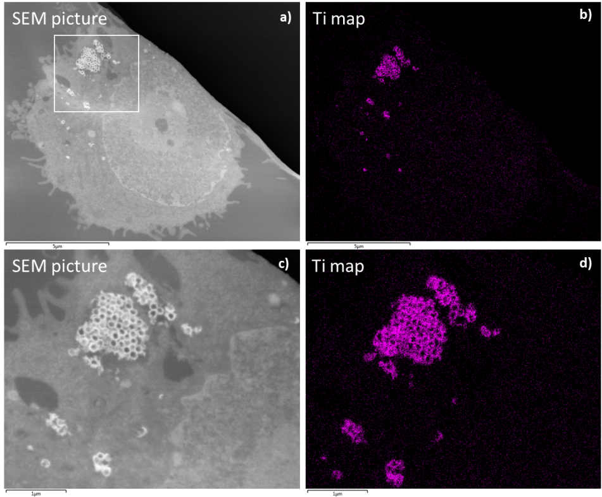
Figure S3: SEM images (a, c) and the corresponding titanium map (b, d) of the macrophages after incubation with 2AM. J774A.1 macrophages were incubated at 37°C overnight with particles at a concentration of 10 µg/mL (2AM).

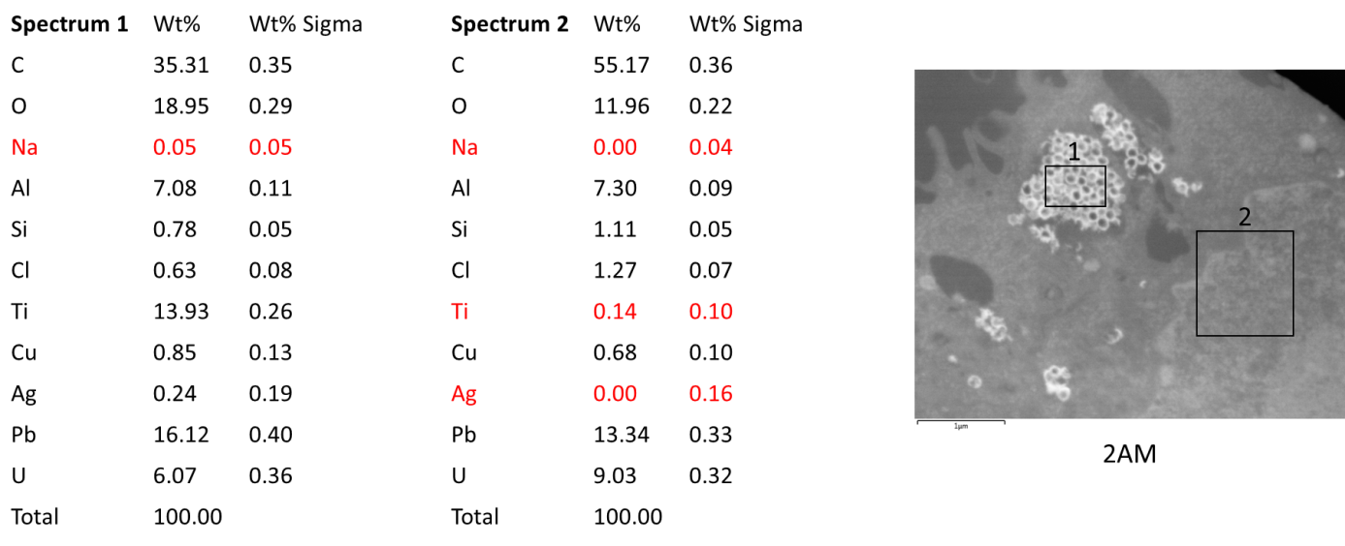
Figure S4: Elemental analysis from EDS of macrophages after incubation with 2AM. Red values in the tables are below the detection limit. J774A.1 macrophages were incubated at 37°C overnight with particles at a concentration of 10 µg/mL (2AM).

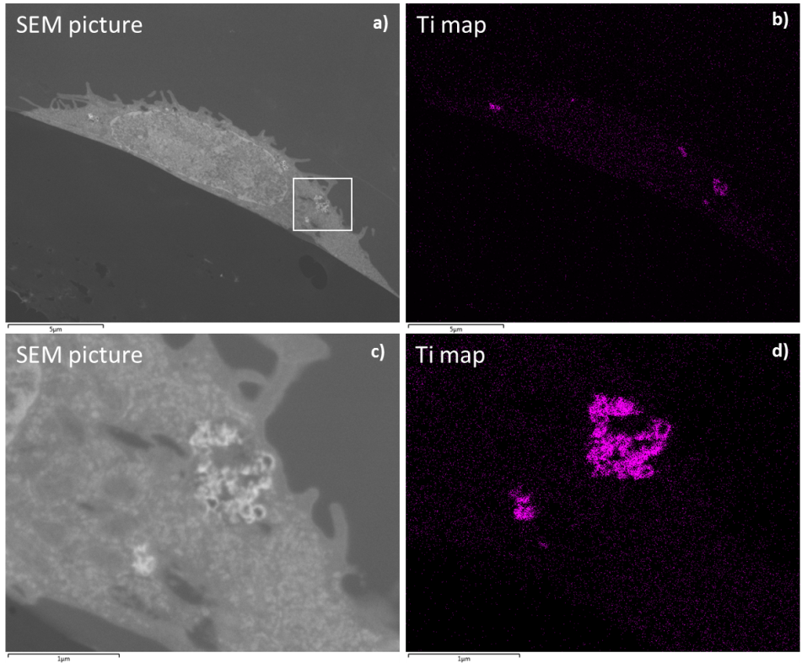
Figure S5: SEM images (a, c) and the corresponding titanium map (b, d) of the macrophages after incubation with 2ANA. J774A.1 macrophages were incubated at 37°C overnight with particles at a concentration of 10 µg/mL (2ANA).

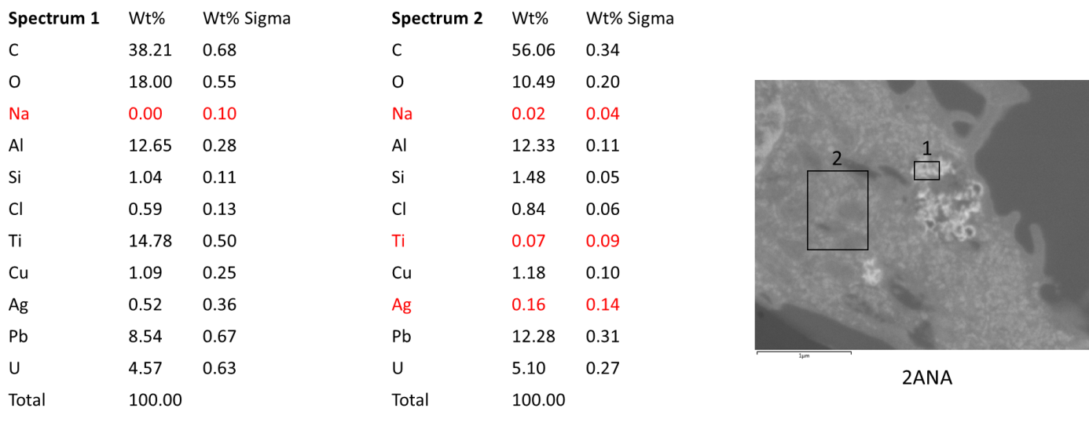
Figure S6: Elemental analysis from EDS of macrophages after incubation with 2ANA. Red values in the tables are below the detection limit. J774A.1 macrophages were incubated at 37°C overnight with particles concentration of 10 µg/mL (2ANA).

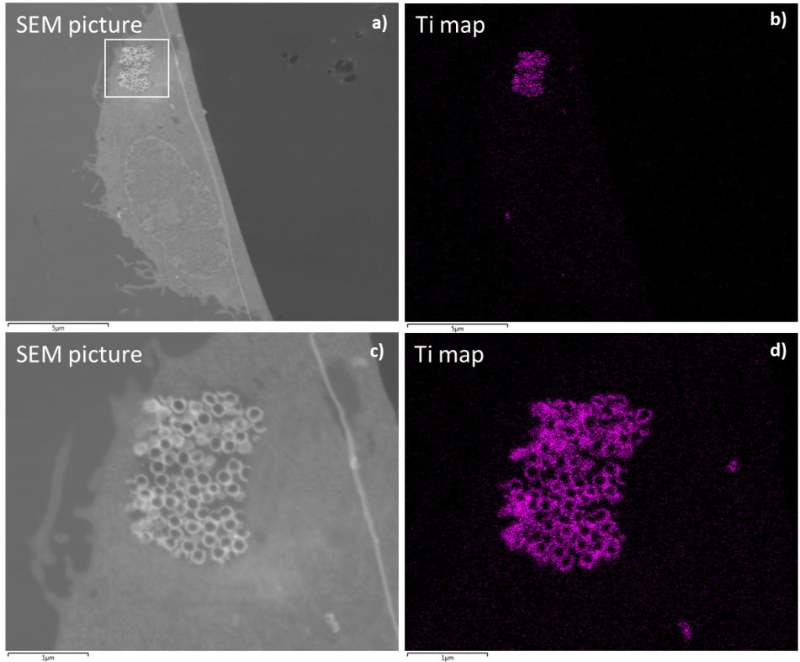
Figure S7: SEM images (a, c) and the corresponding titanium map (b, d) of the macrophages after incubation with 8AM. J774A.1 macrophages were incubated at 37°C overnight with particles at a concentration of 10 µg/mL (8AM).

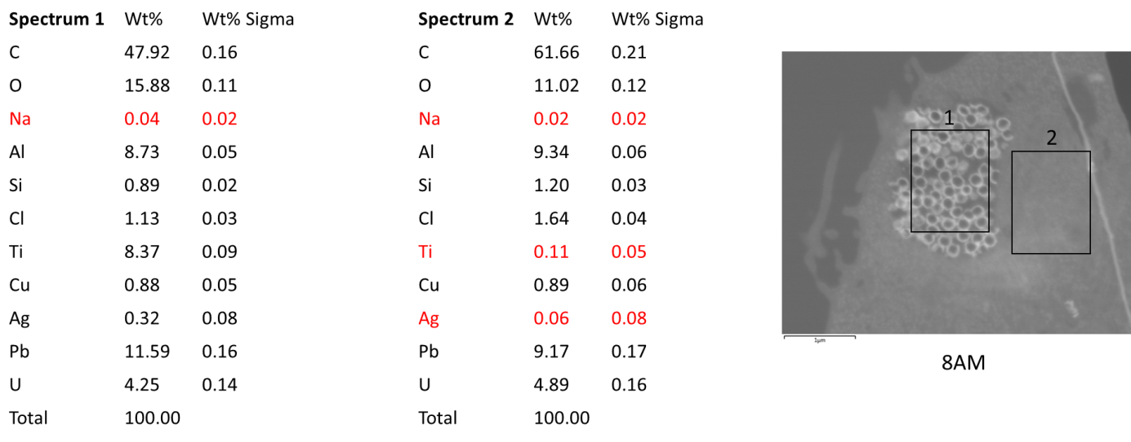
Figure S8: Elemental analysis from EDS of macrophages after incubation with 8AM. Red values in the tables are below the detection limit. J774A.1 macrophages were incubated at 37°C overnight with particles concentration of 10 µg/mL (8AM).

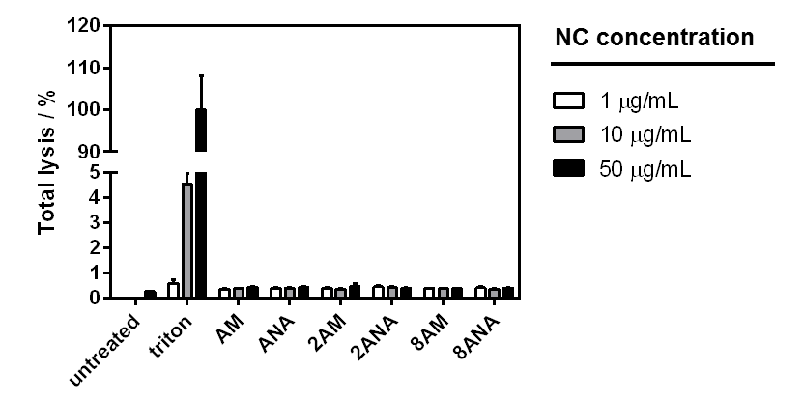
Figure S9: Red blood cells are not lysed by TiO₂ amorphous (AM) and anatase (ANA) containing 2% (2AM, 2ANA) or 8% silver (8AM, 8ANA). Sheep red blood cells were incubated at 37°C for 1 h with different concentrations of nanocapsules containing 2% or 8% silver. Hemolysis was quantified by spectrometry at 541 nm. Triton X-100 (0.01%, 0.1% and 1%) was used to assess maximum red blood cell lysis. The graph shows the mean of two independent experiments.

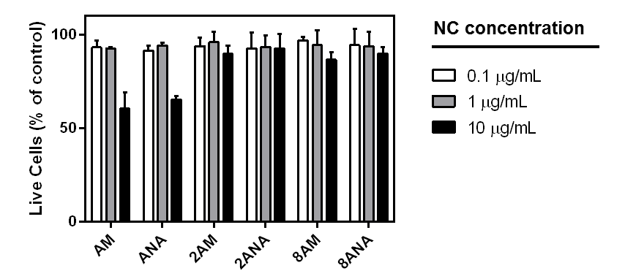
Figure S10: Cell viability of L929 fibroblasts in presence of different concentrations of amorphous and anatase TiO₂ nanocapsules with (8AM, 8ANA, 2AM, 2ANA) and without (AM, ANA) silver after 24 h. The effect of nanocapsules was determined by MTT assay. Results are expressed relative to the untreated control, which was defined as 100%. The mean and standard deviation from at least three independent experiments are shown.

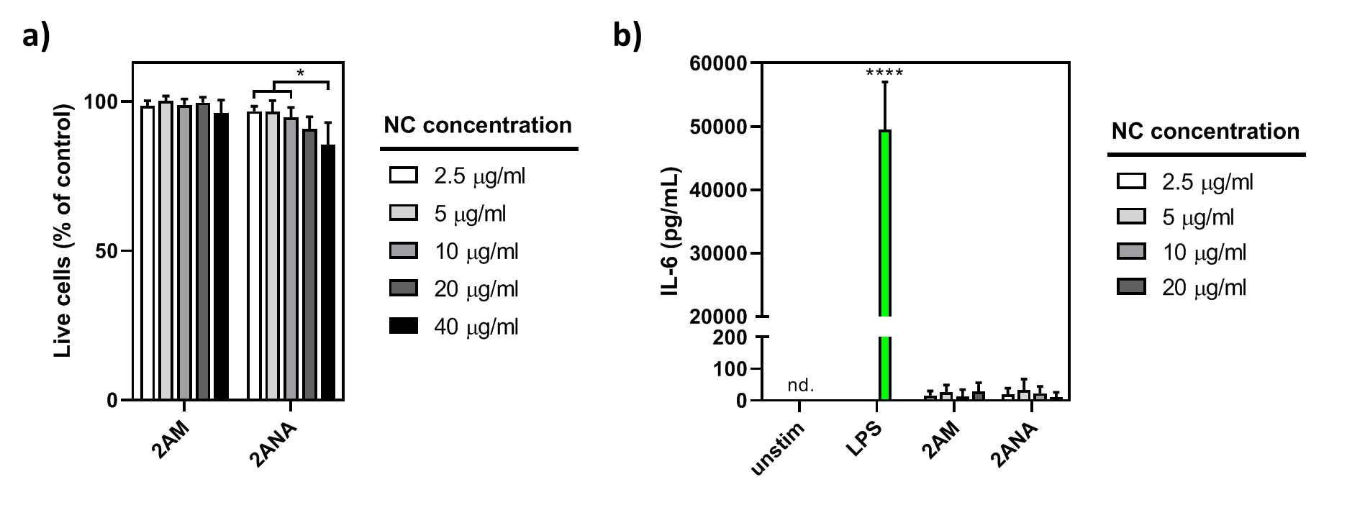
Figure S11: Impact of Ag-TiO₂ NC on viability and activation of bone marrow-derived dendritic cells (BMDCs). BMDCs were incubated at 37 °C for 24 h with different concentrations of Ag-TiO₂ NC containing 2% silver. a) Viability was assessed with Zombie violet staining by flow cytometry. Live cell percentages refer to control cells incubated without nanocapsules. The only statistical significant difference is found between the lower concentrations (2.5, 5 and 10 µg/mL) and the highest concentration (40 µg/mL) of 2ANA as determined by two-way ANOVA (p*<0.05). b) The production of the pro-inflammatory cytokine IL-6 was determined in the cell culture supernatants by ELISA. Lipopolysaccharide (LPS) was included as positive control. The IL-6 production by LPS is significantly higher compared to 2AM or 2ANA as determined by one-way ANOVA (p****<0.0001). Both graphs show the mean and standard deviation of three independent experiments. nd. = not detectable.

Cell culture and in vitro cytotoxicity measurements for L-929 fibroblasts
L-929 murine ﬁbroblast cells (ATCC, CCL-1) were cultured in RPMI-1640 (Gibco), supplemented with 10% heat-inactivated fetal bovine serum (GE Healthcare Life Sciences) and antibiotics (10,000 U/mL penicillin, 10 mg/mL streptomycin; Gibco). For the cytotoxicity measurements cells were seeded in 96-well culture plates at 3.1x10³ cells/cm² density. After an overnight incubation, cells were exposed to 0.1, 1 and 10 µg/mL nanocapsules for 1 day.
The effects of nanocapsules were evaluated by the MTT (3-(4,5-dimethylthiazol-2-yl)-2,5-diphenyltetrazolium bromide) assay (Sigma-Aldrich, M5655) that reports the combined effects of proliferation (number of viable cells) and cellular metabolic activity.¹ The assay is based on the accumulation of dark blue formazan crystals inside living cells after their exposure to MTT (10 μL of 5 mg/mL), which is measured spectrophotometrically by the addition of dimethylsulfoxide (DMSO, 100 μL/well, 30 min incubation at room temperature on orbital shaker) that permeabilizes the cell membrane and results in the liberation and solubilization of the formazan crystals. The formazan concentration was quantified using a multilabel plate reader (PerkinElmer VICTOR X3) by measuring the absorbance at 570 nm.

Reference:
1. Mosmann T. Rapid Colorimetric Assay for Cellular Growth and Survival: Application to Proliferation and Cytotoxicity Assays. Journal of Immunological Methods. 1983;65:55-63.

