Supporting Information

Enhancing antitumor efficacy of nucleoside analog 5-fluorodeoxyuridine on HER2-overexpressing breast cancer by affibody-engineered DNA nanoparticle

Chao Zhang,¹ Mengnan Han,¹ Fanghua Zhang,¹ Xueli Yang,¹ Jie Du,¹ Honglei Zhang,^{1*} Wei Li^{1*} and Shengxi Chen²
¹College of Chemistry and Environmental Science, Key Laboratory of Chemical Biology of Hebei Province, Laboratory of Medicinal Chemistry and Molecular Diagnosis of the Ministry of Education, Hebei University, Baoding 071002, China; ²Biodesign Center for BioEnergetics, Arizona State University, Tempe 85287, USA

Correspondence: Honglei Zhang; Wei Li
College of Chemistry and Environmental Science, Key Laboratory of Chemical Biology of Hebei Province, Laboratory of Medicinal Chemistry and Molecular Diagnosis of the Ministry of Education, Hebei University, Baoding 071002, China
Tel +86 312 592 9009
Fax +86 312 592 9009
E-mail: zhanghonglei@hbu.edu.cn; liweihebeilab@163.com

Table S1. Detailed information of the ssDNA sequence
ssDNA | Sequence
A13 | 5’-ACACTACGTCAGAACAGCTTGCATCACTGGTCACCAGAGTA-3’
B13 | 5’-ACGAGCGAGTTGATGTGATGCAAGCTGAATGCGAGGGTCCT-3’
C13 | 5’-TCAACTCGCTCGTAACTACACTGTGCAATACTCTGGTGACC-3’
D13 | 5’-TCTGACGTAGTGTATGCACAGTGTAGTAAGGACCCTCGCAT-3’
A13F | 5’ -NH₂-FFFFFFFFFFACACTACGTCAGAACAGCTTGCATCACTGGTCACCAGAGTA-3’
B13F | 5’-FFFFFFFFFFACGAGCGAGTTGATGTGATGCAAGCTGAATGCGAGGGTCCT-3’
C13F | 5’-FFFFFFFFFFTCAACTCGCTCGTAACTACACTGTGCAATACTCTGGTGACC-3’
D13F | 5’-FFFFFFFFFFTCTGACGTAGTGTATGCACAGTGTAGTAAGGACCCTCGCAT-3’
FAM-B13F | 5’-FAM/FFFFFFFFFFACGAGCGAGTTGATGTGATGCAAGCTGAATGCGAGGGTCCT 3’
Cy5.0-B13F | 5’-Cy5.0/FFFFFFFFFFACGAGCGAGTTGATGTGATGCAAGCTGAATGCGAGGGTCCT 3’
5-Fluorodeoxyuridine is denoted as F.

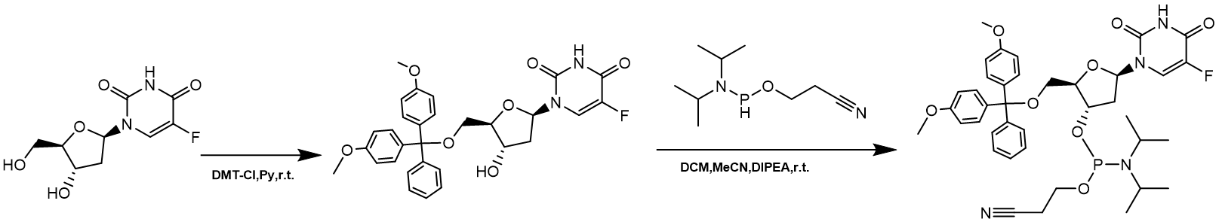

Scheme S1. Synthesis route of 5-fluorodeoxyuridine phosphoramidite

Scheme S2. Strategy for preparing the FUdR-DNA-affibody chimera

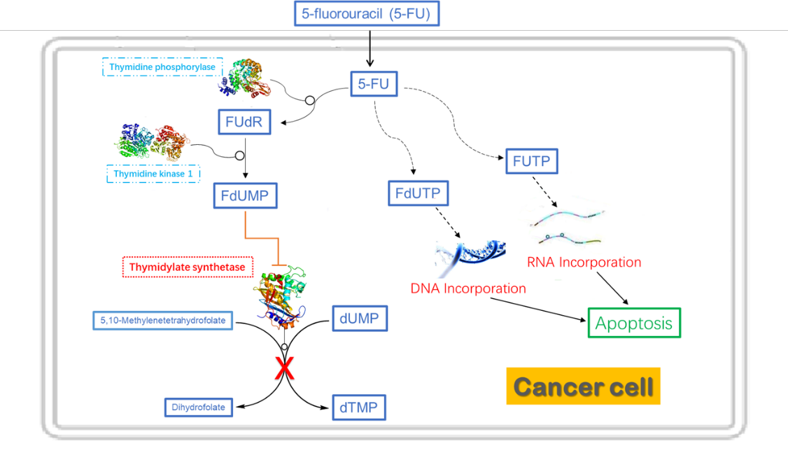
Figure S1 Metabolism of Fluorouracil. Cytotoxic metabolites of 5-FU comprise FUTP, FdUTP and FdUMP. The latter played the most significant effect, the inhibition of the Thymidylate synthase. The administered 5-FU or its prodrugs need Thymidine phosphorylase to be converted to 5-fluorodeoxyuridine, followed by undergoing one-step enzymatic conversion (Thymidine kinase 1) to form FdUMP. The cellular effects of FUTP and FdUTP are less pronounced, which both serve as substrates for the incorporation into RNA or DNA, respectively.
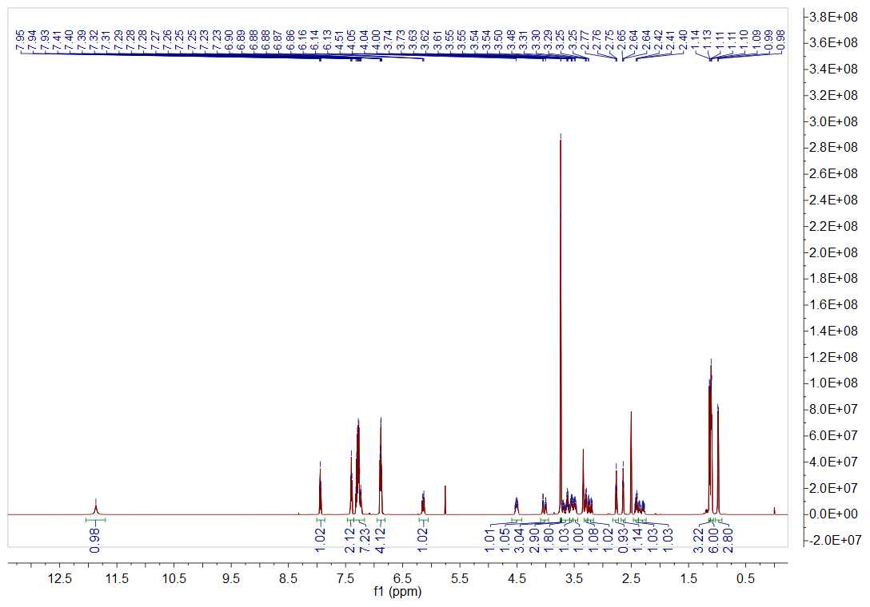
Figure S2 1H NMR spectrum of 5-fluorodeoxyuridine phosphoramidite
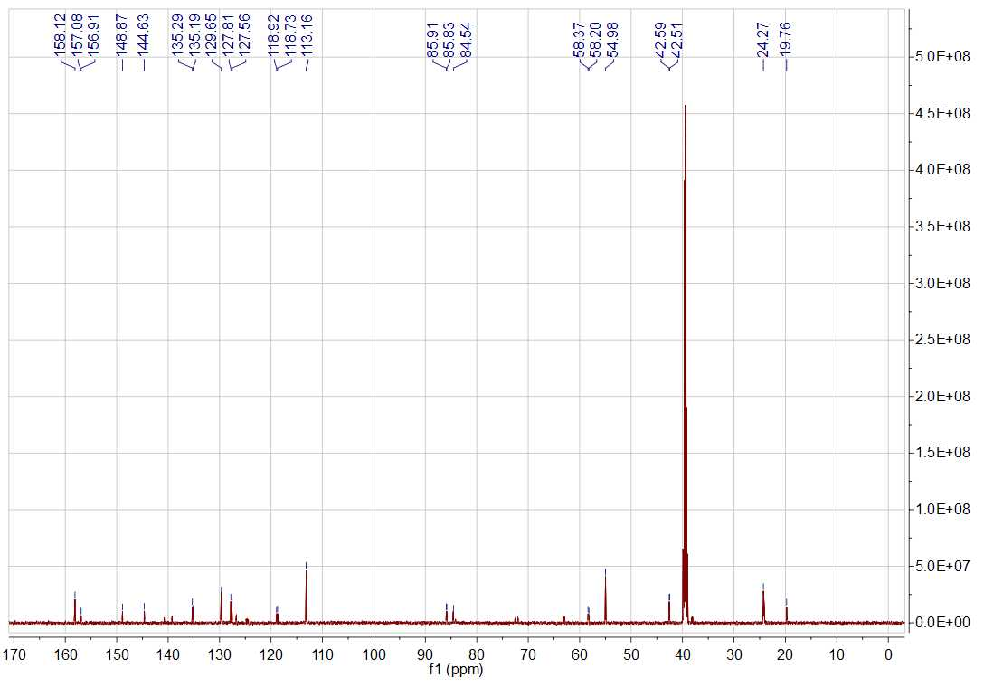
Figure S3 ¹³C NMR spectrum of 5-fluorodeoxyuridine phosphoramidite
Figure S4 Mass spectra of 5-fluorodeoxyuridine-containing DNA strands. (A) A13F-NH₂; (B) B13F; (C) C13F; (D) D13F. Calculated (calc) and experimental (exp) molecular weights are compiled for comparison, and listed in table S2.
Table S2. Summary of mass spectrometry results of 5-fluorodeoxyuridine-containing DNA strands
DNA strands | MW (calc) | MW (exp)
A13F-NH₂ | 15808.0 | 15806.0
B13F | 15851.9 | 15850.4
C13F | 15561.7 | 15560.3
D13F | 15721.8 | 15720.4
Figure S5 Characterization of 5-fluorodeoxyuridine-containing DNA strands. The results were analyzed on a 10% denatured PAGE. Lane 1, B13; lane 2, B13F; lane 3, DNA Marker-B.

Figure S6 Characterization of purified affibody. The crude lysate of E. coli expression and purified affibody were loaded onto a 12% SDS-PAGE gel with protein weight standards. Lane 1, crude lysate of E. coli expression, lane 2, purified affibody.
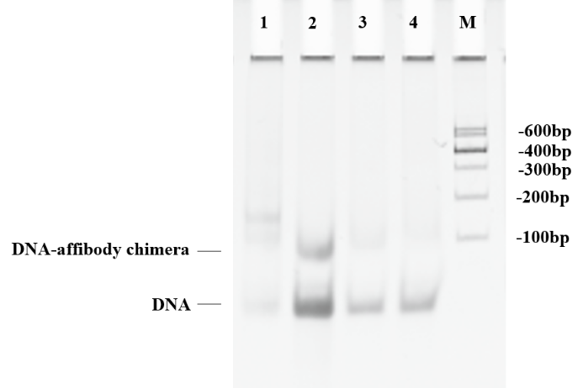

Figure S7 Purification of DNA-affibody chimera using a Capto DEAE column. The results were analyzed on a 10% native polyacrylamide gel followed by GelStain staining. Lane 1, flow through from Capto DEAE column; lane 2, first elution with 500 mM NaCl; lane 3, second elution with 500 mM NaCl; lane 4, elution with 1000 mM NaCl; lane M, DNA Marker-B.

Figure S8 Purification of DNA-affibody chimera using a HisTrap HP column. The results were analyzed on a 10% native polyacrylamide gel followed by GelStain staining. Lane 1, flow through from HisTrap HP column; lane 2, first elution with 150 mM imidazole; lane 3, second elution with 150 mM imidazole; lane M, DNA Marker-B.
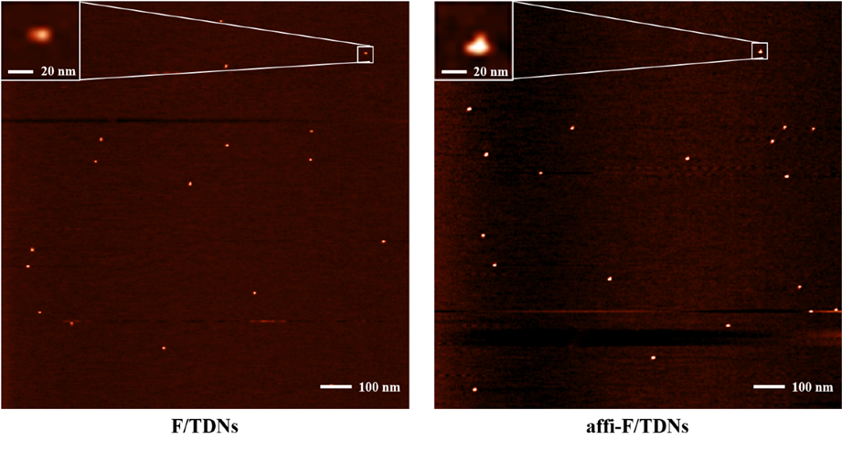

Figure S9 AFM image of F/TDNs and affi/F-TDNs.

Figure S10 Stability analysis of affi-F/TDNs in FBS. Single-stranded FUdR-DNA and affi-F/TDNs were incubated in 50% non-inactivated FBS at 37 °C for 1-8 h and then analyzed with 10% native polyacrylamide gel.

Figure S11 Digestion of affi-F/TDNs by DNase II after 8h.

Figure S12 Representative H&E images (200×) of the major organs of the mice treated with PBS and affi-F/TDNs.

