Supplementary material

Tables
Table S1. The volumes of polyelectrolytes used for the formation of consecutive layers of the multilayer shell.
 | AOT/PLL  (core) | PGA | PLL | PGA | PLL | PGA | PLL-g-PEG
NC-PGA | 10 ml | 1 ml | 2 ml | 2 ml | 4.5 ml | 6 ml | ----
NC-PEG | 10 ml | 1 ml | 2 ml | 2 ml | 4.5 ml | 6 ml | 25 ml
 | AOT/PLL  (core) | PGA | PLL-RhB | PGA | PLL-RhB | PGA | PLL-g-PEG
NC-PGA-RhB | 10 ml | 1 ml | 2 ml | 2 ml | 4.5 ml | 6 ml | ----
NC-PEG-RhB | 10 ml | 1 ml | 2 ml | 2 ml | 4.5 ml | 6 ml | 25 ml
Notes: Concentration of PLL, PLL-RhB, PGA and PLL-g-PEG was 2000 ppm.
Abbreviations: SD, standard deviation.

Figures
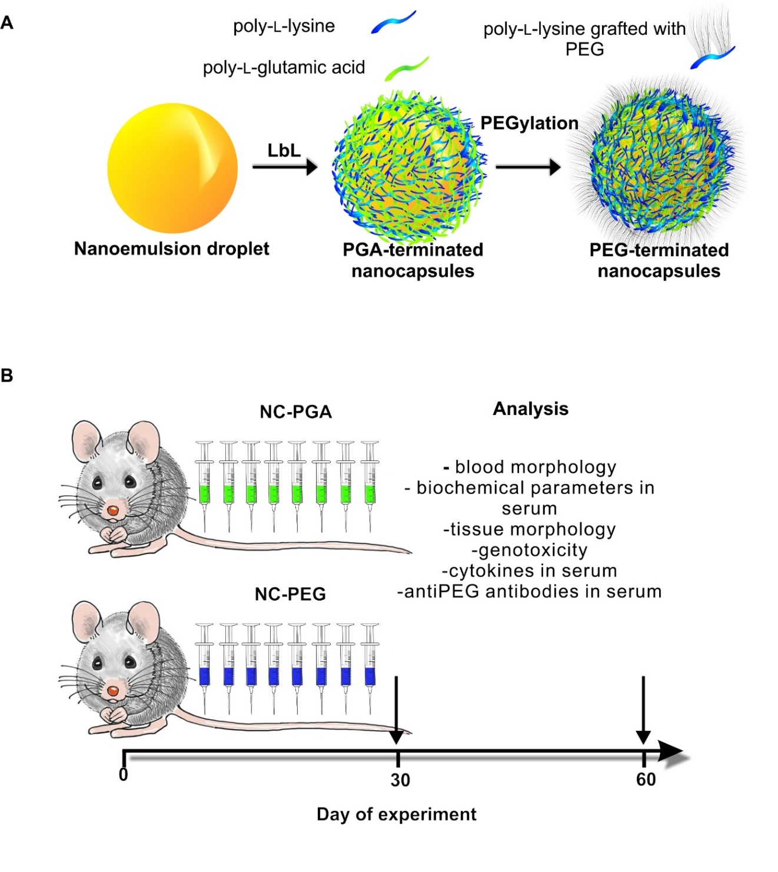
Figure S1. Structure of polyelectrolyte nanocapsules functionalized with two different stealth polymers and scheme of the experiment performed to assess the toxicity of the nanocapsules.
Notes: (A) Polyelectrolyte nanocapsules were obtained by encapsulation of nanoemulsion droplets in shells formed of poly-amino acids, poly-L-lysine (PLL) and poly-L-glutamic acid (PGA), poly-L-lysine grafted with PEG (PEGylation) using layer-by-layer (LbL) method. (B) 8 doses of NC-PEG (PGA-terminated polyelectrolyte nanocapsules) and NC-PGA (PEG-terminated polyelectrolyte nanocapsules) were administered intravenously to mice. Animals were euthanized on 30th or 60th day of experiment and sera and tissues were isolated for further analysis.
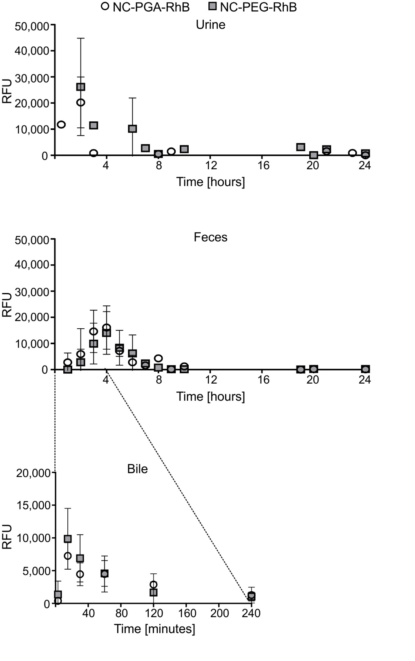
Figure S2. Identification of major routes of NC-PGA-RhB and NC-PEG-RhB elimination after intravenous administration.
Notes: Mice were kept individually in metabolic cages. Urine and faces were collected for 24 h. Bile samples were isolated post mortem. Fluorescence was measured for samples obtained at different time points. Each point represents the mean ± SD (n=2-5). The differences in sample size (n) results from the lack of urine or low bile volume in gall bladder at some time points in the case of some mice.
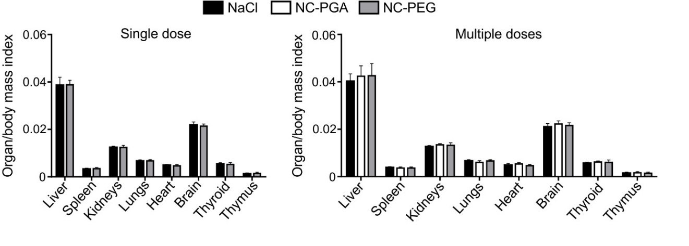
Figure S3. Determination of organ to body mass index for animals injected with a single dose or with multiple doses of polyelectrolyte nanocapsules.
Notes: Animals were injected with 15 mM NaCl, NC-PGA, or NC-PEG. Calculations were performed according to the following formula: organ/body mass index = organ mass/body mass. Bars represent means ± SD (n=5).
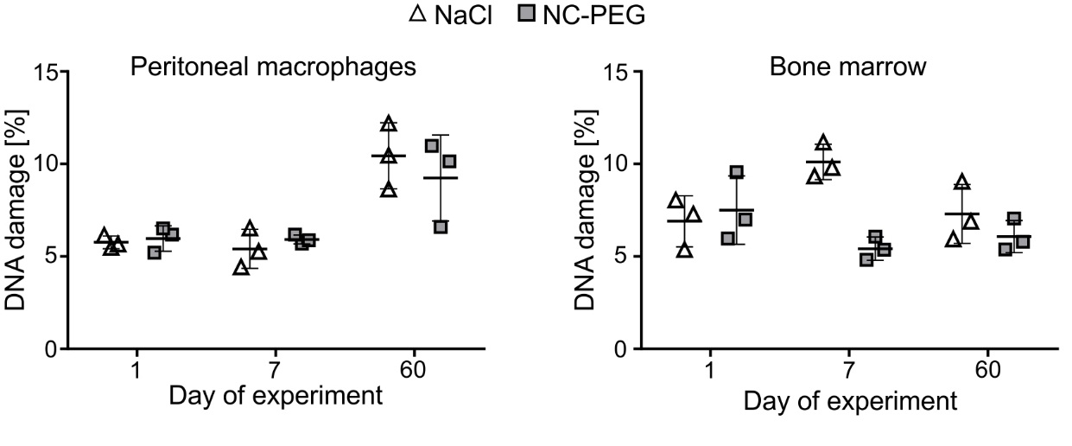
Figure S4. Analysis of DNA damage in peritoneal macrophages or in cells isolated from bone marrow of animals exposed to a single dose of NC-PEG.
Notes: Analysis was performed using comet assay. Animals were sacrificed on 1st, 7th or 60th day of experiment. The percentage of DNA in the comet tail (% DNA damage) was determined from two slides per sample with 50 randomly selected cells per slide. Each point represents an individual mouse (n=3).
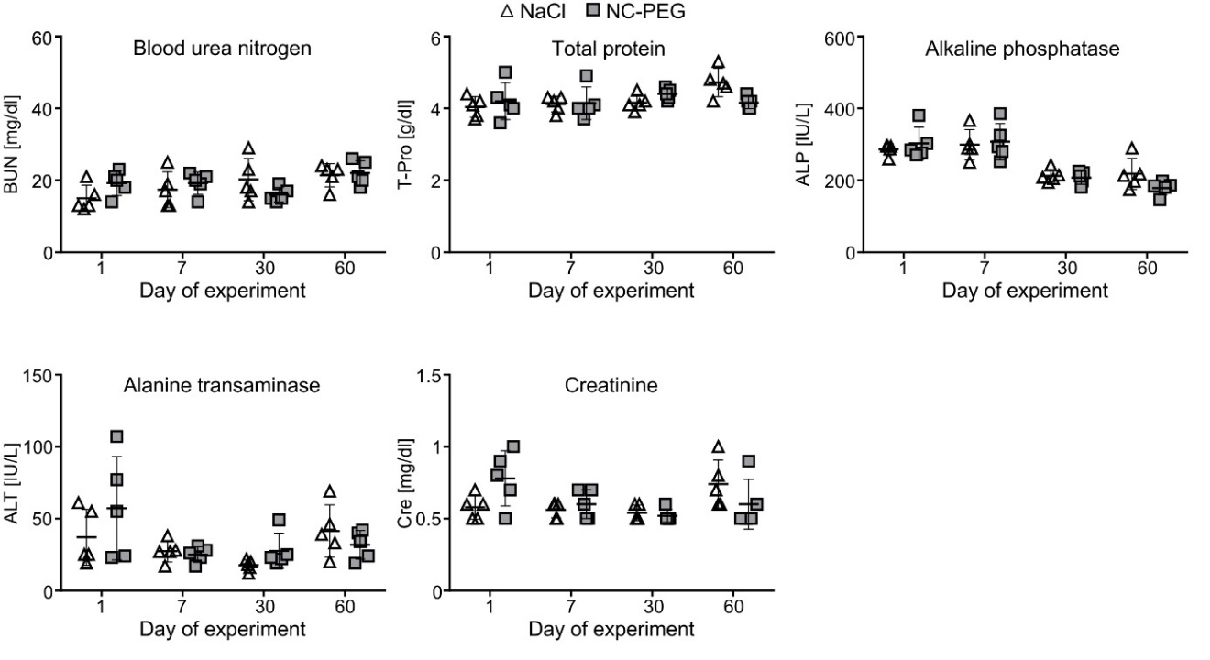
Figure S5. Biochemical analysis of sera from animals after single administration of NC-PEG.
Notes: Animals were euthanized on 1st, 7th, 30th or 60th day of experiment. Blood was isolated by cardiac puncture and biochemical markers of hepatotoxicity and nephrotoxicity were analyzed labeled in sera. Each point in graphs represents an individual mouse. The line for each group represents the mean ± SD (n=5).
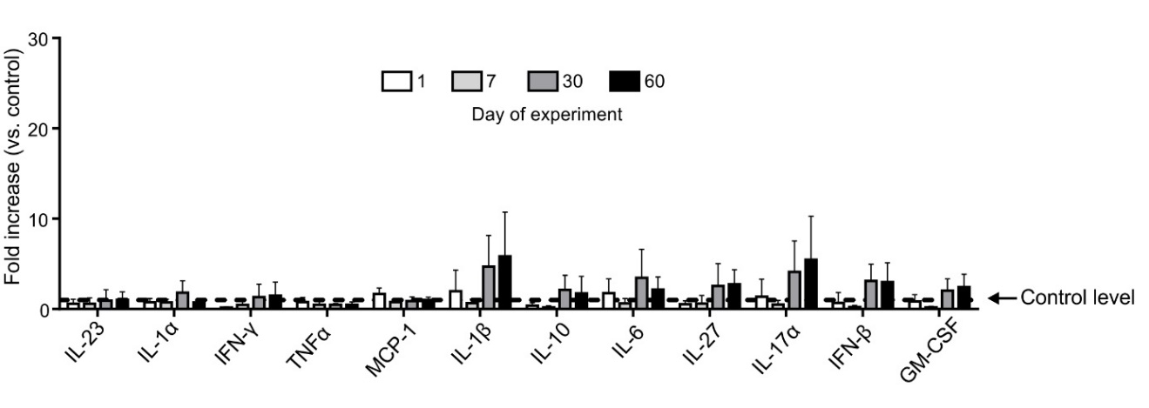
Figure S6. Analysis of cytokine concentrations in mice sera after single administration of NC-PEG.
Notes: Mice were injected intravenously with a single dose of 15 mM NaCl (control) or NC-PEG. Cytokine concentrations in sera isolated on 1st, 7th, 30th or 60th day of experiment were determined using LEGENDplex Mouse inflammation Panel kit and the BD LSRFortessa flow cytometer. Control level corresponds to cytokine concentrations in sera of animals injected with 15 mM NaCl. Bars represent means ± SD (n=5).

