Table S1 The sequences for primers and siRNAs
Primer name | Sequence
circGFRA1-F | CCTCCGGGTTAAGAACAAGC
circGFRA1-R | CTGGCTGGCAGTTGGTAAAA
miR-188-3p-F | CUCCCACATGCAGGG
miR-188-3p-R | GTGCAGGGTCCGAGGT
miR-188-3p -RT | GTCGTATCCAGTGCAGGGTCCGAGGTATTCGCACTGGATACGACATGCAAA
GAPDH-F | ATGGGGAAGGTGAAGGTCG
GAPDH-R | GGGGTCATTGATGGCAACAATA
U6-F | CTCGCTTCGGCACA
U6-R | AACGCTTCACGAATTTGCGT
si-GFRA1 | GCAAATTTACAGATCTCGCCT
miR-188-3p mimic | CUCCCACAUGCAGGGUUUGCA
anti- miR-188-3p | UGCAAACCGACUUGUGGGAG
NC | UUCUCCGAACGUGUCACGUUU

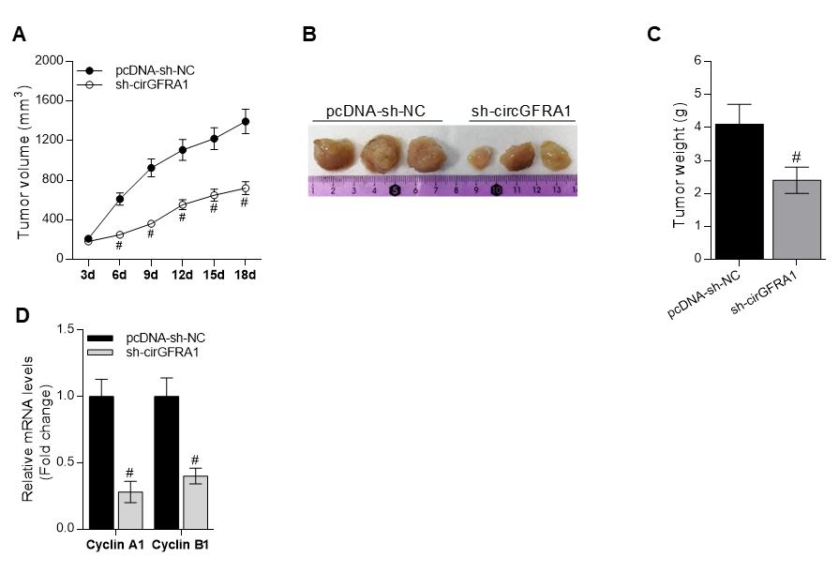
Supplementary Figure 1
Supplementary figure 1. CircGFRA1 regulate the proliferation of NSCLC tumors in vivo. The NCI-H838 cells were transfected with pcDNA-sh-NC, sh-circGFRA1 for 72 h, then the cells were inoculated subcutaneously into nude mice. (A) Tumor volume was markedly decreased in sh-circGFRA1 group when compared to pcDNA-sh-NC. #P < 0.05 compared with pcDNA-sh-NC. (B) Representative images of resected tumor masses in pcDNA-sh-NC, sh-circGFRA1 group. (C) Tumor weight was markedly decreased in sh-circGFRA1 group when compared to pcDNA-sh-NC. #P < 0.05 compared with pcDNA-sh-NC. (D) The expression of proliferation-related genes including Cyclin A1, Cyclin B1 was detected by RT-qPCR, #P < 0.05 compared with pcDNA-sh-NC.

Supplementary Figure 2
Supplementary figure 2. The phosphorylation level of AKT was detected by Western Blot. The phosphorylation level of AKT was detected in NCI-H838 cells after circGFRA1 and LY26402 was given individually or jointly.

