Supplementary Table 1 Baseline characteristics
Characteristic | Number (%) or average (range)
Age (years) | 60.4±10.5 (26~81)
Sex
Male | 74 (64.3)
Female | 41 (35.7)
Symptom
Epigastric pain | 46 (40.0)
Jaundice | 56 (48.7)
Serum bilirubin (mg/dL) | 8.2±7.9 (0.28~33.5)
Serum bilirubin (>3mg/dL) | 56 (48.7)
CEA (>4.7ng/mL) | 24 (20.9)
CA19-9 (>39U/mL) | 56 (48.7)
Preoperative biliary drainage | 25 (21.7)

Supplementary Table 2 Clinicopathologic Characteristics
Characteristic | Number (%) or average (range)
Tumor margin
Negative | 82 (71.3)
Positive | 33 (28.7)
Tumor size (cm) | 3.4±2.1
Differentiation
Well | 77 (67.0)
Moderate | 28 (24.3)
Poor | 10 (8.7)
Vascular invasion | 7 (6.1)
Perineural invasion | 49 (42.6)
Lymph node metastasis
N0 | 61 (53.0)
N1 | 49 (42.6)
N2 | 5 (4.4)
TNM stage
I | 6 (5.22)
II | 37 (32.2)
IIIA | 18 (15.6)
IIIB | 40 (34.8)
IVA | 8 (7.0)
IVB | 6 (5.2)
Bismuth Type
I | 3 (2.6)
II | 21 (18.4)
IIIa | 17 (14.8)
IIIb | 27 (23.7)
IV | 47 (40.9)

Supplementary Table 3 The rates of R0 resection for the different surgical
procedures in various types of hilar CC
Surgery procedures (n) | R0 rate (%)
Total R0 resection | 82/115 (71.3)
Operation type (in type III and IV)
With liver resection | 59/82 (72.0)
Without liver resection | 5/9 (55.6)
Type I | 3/3 (100)
Type II | 15/21 (71.4)
Type IIIa | 14/17 (82.4)
Type IIIb | 20/27 (74.1)
Type IV | 30/47 (63.8)

Supplementary Figure 1. Distribution of patients by treatment depending on pretherapeutic workup and surgical findings.

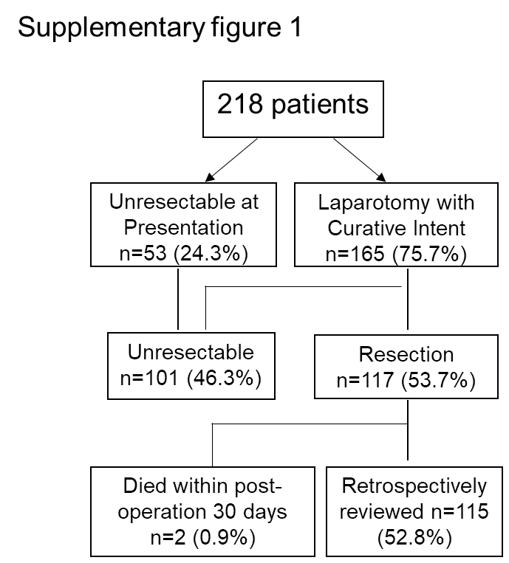

Supplementary Figure 2. The preoperative level of bilirubin was associated with postoperative liver function recovery. *P<0.05

