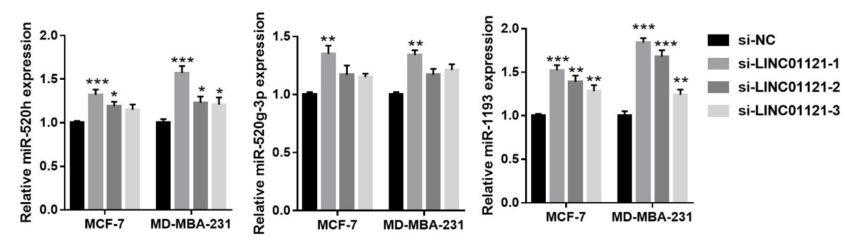
Supplement figure 1: The effect of LINC01121 knockdown on miR-520h, miR-520g-3p, and miR-1193 expression. The expression of miR-1193, miR-520h, and miR-520g-3p in MCF-7 and MDA-MB-231 cells was measured by qRT-PCR after transfected si-LINC01121-1/2/3 at 48 h. (*p < 0.05, **p < 0.01, ***p < 0.001 vs si-NC)

