Supporting information

A pH-responsive charge-reversal drug delivery system with tumor-specific drug release and ROS generation for cancer therapy

Scheme S1. Synthesis route of PEG-b-P((LL-g-TK-PTX)-(LL-g-DMA)).

Fig. S1 ¹H NMR spectrum of TK in CDOD₃.

Fig. S2 ¹H NMR spectrum of TK in DMSO_{d6}.

Fig. S3 Liner ion trap mass spectrum of TK-PTX record in a

Fig. S4 Hemolysis rate of PVD-NPs, PD-NPs, and PVS-NPs.

Fig. S5 Mean fluorescence intensity (MFI) analyzed by flow cytometry of DCF signal in NIH-3T3 cells after treated with PD-NPs, VK3, PVD-NPs, and PVD-NPs + DIC.

Fig. S6 Cytotoxicity of PTX, VK3, PTX+VK3, PVD-NPs, and PD-NPs against NIH-3T3 cells. Data showed as mean ± SD, n = 6.

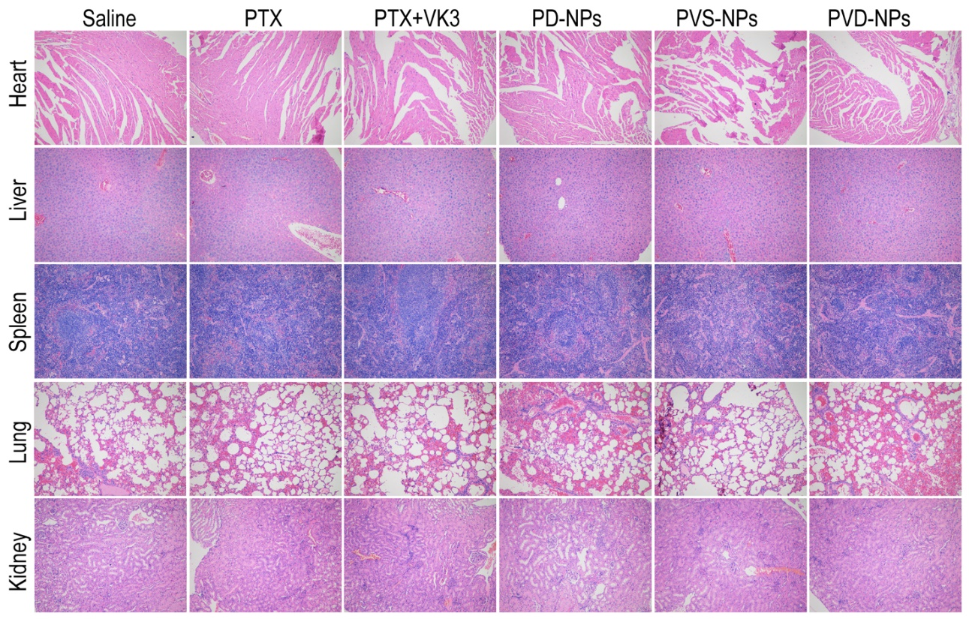
Fig. S7 Images of H&E staining of major organs sections, the images were acquired at 20× objective.

