Supplementary Table 1 Associations between obesity indices and lung function parameters stratified by gender and smoking status (N=3442).
Stratification  Characteristic |  |  | FEV₁ |  |  | FVC |  |  | FEV₁/FVC
 |  |  | Estimated changes(ml) (95% CI) | P value of effect  Modification‖ |  | Estimated changes (ml)  (95% CI) | P value of effect  modification |  | Estimated changes (ml)  (95% CI) | P value of effect  modification
BMI*
 | Gender |  |  | 0.5987 |  |  | 0.9866 |  |  | 0.1335
 |  | Male | 1.41 (-7.43,10.24) |  |  | -2.72 (-13.58,8.13) |  |  | 0.14 (-0.01,0.30)
 |  | Female | -1.23 (-6.07,3.60) |  |  | -3.08 (-8.67,2.50) |  |  | 0.02 (-0.07,0.12)
 | Smoking status |  |  | 0.9926 |  |  | 0.4634 |  |  | 0.0505
 |  | Smokers | 1.49 (-8.77,11.74) |  |  | -3.67 (-16.21,8.87) |  |  | 0.19 (0.01,0.38)
 |  | Nonsmokers | 0.52 (-4.17,5.22) |  |  | -1.20 (-6.70,4.30) |  |  | 0.03 (-0.06,0.12)
WC†
 | Gender |  |  | 0.0467 |  |  | 0.0042 |  |  | 0.7924
 |  | Male | -6.34 (-10.21,-2.47) |  |  | -7.17 (-11.86,-2.48) |  |  | -0.01(-0.08,0.07)
 |  | Female | -2.30 (-4.23,-0.38) |  |  | -2.53 (-4.77,-0.29) |  |  | 0.004(-0.036, 0.044)
 | Smoking status |  |  | 0.2129 |  |  | 0.1708 |  |  | 0.5439
 |  | Smokers | -4.37 (-9.74,1.00) |  |  | -4.96 (-11.41,1.49) |  |  | -0.02 (-0.12,0.09)
 |  | Nonsmokers | -3.15 (-4.99,-1.31) |  |  | -3.64 (-5.80,-1.47) |  |  | 0.01 (-0.03,0.04)
WHR†
 | Gender |  |  | 0.0073 |  |  | 0.0089 |  |  | 0.9197
 |  | Male | -8.37 (-14.21,-2.52) |  |  | -8.35 (-15.45,-1.26) |  |  | -0.04 (-0.15,0.07)
 |  | Female | -5.05 (-7.89,-2.22) |  |  | -5.32 (-8.63,-2.02) |  |  | 0.001 (-0.06,0.06)
 | Smoking status |  |  | 0.0668 |  |  | 0.1347 |  |  | 0.5707
 |  | Smokers | -5.66 (-12.40,-1.08) |  |  | -3.80 (-11.92,4.32) |  |  | -0.08 (-0.21,0.05)
 |  | Nonsmokers | -5.65 (-8.45,-2.84) |  |  | -6.40 (-9.71,-3.10) |  |  | 0.01 (-0.05,0.07)
WHtR‡
 | Gender |  |  | <.0001 |  |  | <.0001 |  |  | 0.2156
 |  | Male | -24.97 (-30.48,-19.45) |  |  | -32.40 (-39.16,-25.65) |  |  | 0.09 (-0.01,0.19)
 |  | Female | -11.09 (-13.78,-8.40) |  |  | -12.21 (-15.34,-9.09) |  |  | -0.003 (-0.06,0.05)
 | Smoking status |  |  | 0.0003 |  |  | <.0001 |  |  | 0.1051
 |  | Smokers | -24.94 (-32.20,-17.67) |  |  | -33.66 (-42.50,-24.82) |  |  | 0.11 (-0.03,0.25)
 |  | Nonsmokers | -12.52 (-15.11,-9.93) |  |  | -14.28 (-17.32,-11.23) |  |  | 0.01 (-0.04,0.06)
Abbreviations: BMI, Body mass index; WC, Waist circumference; WHR, Waist-to-hip ratio; WHtR, Waist-to-height ratio; FEV₁, forced expiratory volume in 1 s; FVC, forced vital capacity.
Estimated changes in lung function parameters (95% CI) in associations with one-unit increase of BMI or WC and 1% increase of WHR or WHtR.
*Models were adjusted for gender(male/female), age(continuous), city (Wuhan/Zhuhai), occupational hazard exposure (yes/no), drug status (yes/no), smoking status (smokers/nonsmokers), drinking status (drinkers/nondrinkers), regular physical activity (yes/no), cooking meals at home (yes/no), and family income (≥40,000/<40,000 RMB/year).
†Models were adjusted for *models plus height, and weight.
‡ Models were adjusted for *models plus weight.
‖P values for effect modification were calculated by adding an interaction term of the obesity indices (as a continuous variable) and the stratification variable in generalized linear models.

Supplementary Table 2 Associations between obesity indices and lung function parameters in smokers stratified by abdominal obesity (N=724).
Obesity indices§ |  | N (%) | Estimated changes in ml (95% CI) of FEV₁ | Estimated changes in ml (95% CI) of FVC | Estimated changes in ml (95% CI) of FEV₁/FVC
BMI*
 | Non-abdominal obesity | 374 (51.7) | 10.24 (-11.91,32.38) | 6.34 (-21.18,33.86) | 0.21 (-0.18,0.60)
 | Abdominal Obesity | 350 (48.3) | 1.20 (-13.51,15.92) | -8.51 (-26.19,9.16) | 0.31 (0.03,0.59)
WC†
 | Non-abdominal obesity | 374 (51.7) | 1.95 (-5.13,9.02) | 0.46 (-8.27,9.18) | 0.03 (-0.11,0.17)
 | Abdominal Obesity | 350 (48.3) | -13.23 (-25.75,-0.72) | -10.48 (-25.23,4.27) | -0.11 (-0.36,0.14)
WHR†
 | Non-abdominal obesity | 374 (51.7) | 4.74 (-8.88,18.35) | 5.50 (-11.29,22.30) | -0.05(-0.32,0.21)
 | Abdominal Obesity | 350 (48.3) | -2.26 (-13.73,9.22) | -2.22(-11.26,15.70) | -0.07(-0.30,0.16)
WHtR‡
 | Non-abdominal obesity | 374 (51.7) | -13.91 (-24.90,-2.92) | -21.30(-34.92,-7.68) | 0.10 (-0.11,0.30)
 | Abdominal Obesity | 350 (48.3) | -38.22 (-51.02,25.42) | -52.00 (-67.27,-36.74) | 0.23 (-0.03,0.49)
Abbreviations: BMI, Body mass index; WC, Waist Circumference; WHR, Waist-to-Hip Ratio/100; WHtR, Waist-to-Height Ratio/100; FEV₁, forced expiratory volume in 1 s; FVC, forced vital capacity.
*Models were adjusted for gender(male/female), age(continuous), city (Wuhan/Zhuhai), occupational hazard exposure (yes/no), drug status (yes/no), smoking status (smokers/nonsmokers), drinking status (drinkers/nondrinkers), regular physical activity (yes/no), cooking meals at home (yes/no), and family income (≥40,000/<40,000 RMB/year).
†Models were adjusted for *models plus height, and weight.
‡Models were adjusted for *models plus weight.
§Estimated changes in lung function parameters (95% CI) in associations with one-unit increase of BMI or WC and 1% increase of WHR or WHtR.
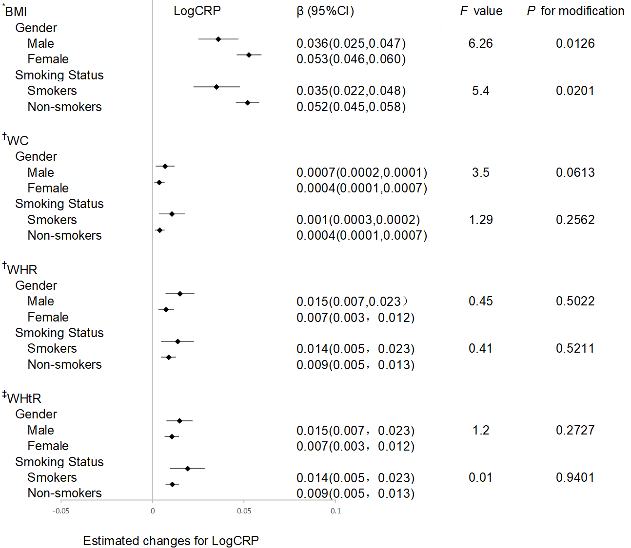
Supplementary Figure 1 Associations between obesity indices and CRP stratified by gender and smoking status. Estimated changes in plasma LogCRP(95% CI) in associations with one-unit increase of BMI or WC and 1% increase of WHR or WHtR.
Abbreviations: CRP, C-reactive protein; BMI, Body mass index; WC, Waist circumference; WHR, Waist-to-hip ratio; WHtR, Waist-to-height ratio.
*Models were adjusted for gender(male/female), age(continuous), city (Wuhan/Zhuhai), occupational hazard exposure (yes/no), drug status (yes/no), smoking status (smokers/nonsmokers), drinking status (drinkers/nondrinkers), regular physical activity (yes/no), cooking meals at home (yes/no), and family income (≥40,000/<40,000 RMB/year).
†Models were adjusted for *models plus height, and weight.
‡ Models were adjusted for *models plus weight.

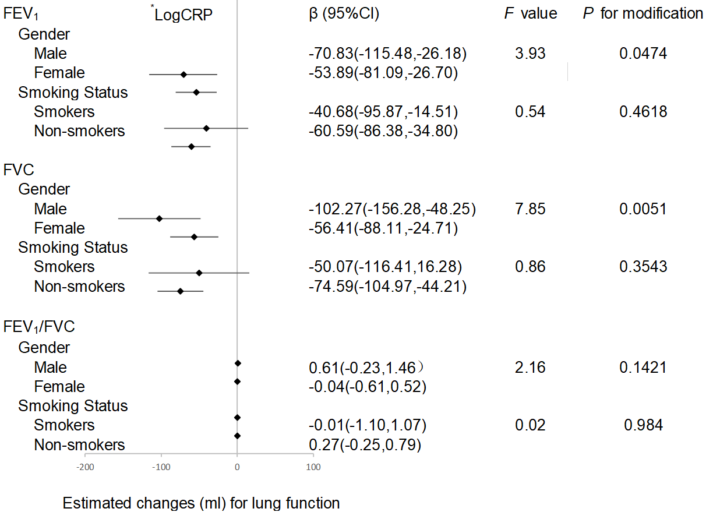
Supplementary Figure 2 Associations between CRP and lung function parameters stratified by gender and smoking status.
Abbreviations: CRP, C-reactive protein; FEV1, forced expiratory volume in 1 s; FVC, forced vital capacity.
* Log-transformed CRP.
Models were adjusted for gender(male/female), age(continuous), city (Wuhan/Zhuhai), occupational hazard exposure (yes/no), drug status (yes/no), smoking status (smokers/nonsmokers), drinking status (drinkers/nondrinkers), regular physical activity (yes/no), cooking meals at home (yes/no), and family income (≥40,000/<40,000 RMB/year).

