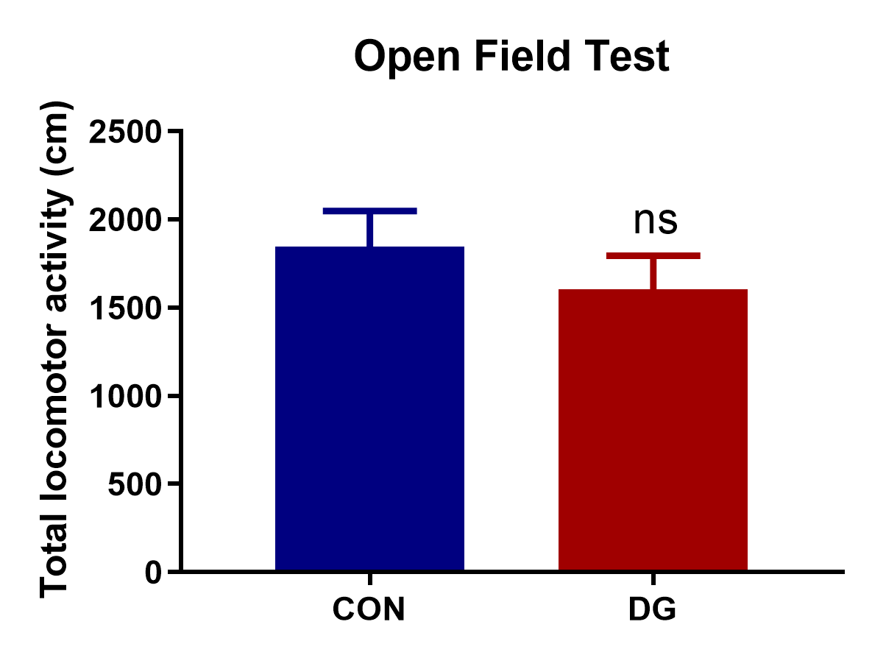
Figure S1 Effects of DG treatment on the total locomotor activity in the open field test (OFT).

Table S1. Primer Pairs for RT-qPCR*
Gene | Forward Primer (From 5` to 3`) | Reverse Primer (From 5`to 3`)
C3G | CAAAGCCAGTTTCTGCCACC | AAGGCACTGGGAGTACATGC
Ras | TGGCTGGAAGTAGGAGGTGT | CAGAAGAGAAGGGCTGCACA
Crk | TGGAGGTAACCAGGAGGGTT | AAGGCTGTCTTGTCGTAGGC
Rap1 | GTGCCTTGTCCCCGAAAATC | GTCCACACACCTGGCAAATC
NT3 | ACCGAACTCGAGTCCACCT | TGGAATTCTGACCTGGTGGC
Raf | GCCCTTCCTCTGAAGGTTCC | CGAATTGCATCCTCAATCATCCT
TrkA | CAAAGCCGTGGAACAGCATC | TCTCATTGAGCACAGAGCCG
TrkB | ATCGTGGCATTTCCGAGGTT | TATACCTGCCTGAGCCCTGA
B-Raf | GAGGGGTCTCATCCCAGAGT | GCAGCTTTCGGCAAAAGTCA
MEK1 | TGCCCAGTGGAGTATTCAGTC | AGTCTACCTCCTCGGCATCA
MEK2 | GCAGATGGAGAGCCCCATAG | GCTGTCCATCCCATGACCACT
Erk1 | TACCGAGCCCCAGAGATCAT | GGAAGATAGGCCGGTTGGAG
Erk2 | AGAGTGCCTTCTGACTTTCCT | GAAGACCTGATGGAGACGACG
BDNF | ACGTGACAAAACGTAAGGAAGTGGA | TCTCACCTGGTGGAACTGGAT
NGF | ATCGCTCTCCTTCACAGAGTTT | TGTACGGTTCTGCCTGTACG
β-actin | GCCACCAGTTCGCCATGGAT | TCTGGGCCTCGTCACCCACATA
*RT-qPCR was used to detect the genes expression in the NT3-TrkA and Ras-MAPK pathways. C3G, Rap guanine nucleotide exchange factor 1; Ras, HRas proto-oncogene; Crk, CRK proto-oncogene adaptor protein; Rap1, RAP1A member of RAS oncogene family; NT3, NTF3 neurotrophin 3; Raf, Raf-1 proto-oncogene serine/threonine kinase; TrkA, neurotrophic receptor tyrosine kinase 1;TrkB, neurotrophic receptor tyrosine kinase 2;B-raf, B-Raf proto-oncogene serine/threonine kinase; MEK1, mitogen-activated protein kinase kinase 1; MEK2, mitogen-activated protein kinase kinase 2;Erk1, mitogen-activated protein kinase 1;Erk2, mitogen-activated protein kinase 2; BDNF, brain derived neurotrophic factor;NGF, nerve growth factor.

Table S2. Key diﬀerential metabolites in the comparison of diterpene ginkgolides (DG) and control (CON) groups in rat hippocampus
Metabolites | Mass | R.t (min) | VIP score | T-test (p) | Fold change
Oxalic acid | 173 | 14.093 | 1.21 | 0.022 | 2.91
Ribitol | 217 | 19.789 | 1.80 | <0.001 | 14.77
3-Cyanoalanine | 141 | 12.436 | 1.26 | 0.012 | 0.49
Adenine | 165 | 19.665 | 1.11 | 0.046 | 1.48
5-Thymidylic acid | 113 | 16.000 | 1.35 | 0.013 | 1.57
Eicosenoic acid | 136 | 23.365 | 1.82 | <0.001 | 0.37
D-Glucose | 160 | 19.781 | 1.09 | 0.040 | 1.48
Hesperetin | 225 | 6.773 | 1.60 | 0.003 | 1.50
Aspirin | 210 | 9.010 | 1.41 | 0.005 | 1.32
Fructose 6-phosphate | 217 | 22.755 | 1.22 | 0.034 | 1.58
N-Methylhydantoin | 139 | 8.093 | 1.59 | 0.007 | 1.27
2-Hydroxypyridine | 152 | 6.809 | 1.48 | 0.023 | 1.13
Gamma-Aminobutyric acid | 142 | 8.610 | 1.66 | 0.002 | 0.87
6-Phosphogluconic acid | 204 | 22.996 | 1.07 | 0.037 | 1.15
Allantoic acid | 203 | 17.351 | 1.31 | 0.018 | 0.90
Aniline | 136 | 6.656 | 1.54 | 0.008 | 1.23
Beta-Alanine | 174 | 13.378 | 1.45 | 0.006 | 1.14
Creatine | 115 | 15.377 | 1.95 | <0.001 | 0.75
D-Alanyl-D-alanine | 188 | 14.706 | 1.47 | 0.004 | 1.19
Ethanolamine | 178 | 6.569 | 1.93 | <0.001 | 1.41
Gallic acid | 282 | 8.913 | 1.47 | 0.003 | 2.10
Glycine | 102 | 8.169 | 2.32 | <0.001 | 0.24
Methyl Palmitoleate | 139 | 8.265 | 1.48 | 0.038 | 1.23
Mono(2-ethylhexyl)phthalate | 223 | 7.220 | 1.65 | 0.002 | 1.31
Nicotinuric acid | 207 | 6.695 | 1.42 | 0.048 | 1.17
O-Phosphoethanolamine | 225 | 18.576 | 2.22 | <0.001 | 1.35
Phosphate | 181 | 15.659 | 2.37 | <0.001 | 0.46
Phytanic acid | 216 | 14.678 | 1.50 | 0.016 | 1.27
Spermine | 139 | 8.356 | 1.52 | 0.018 | 1.28

Table S3. Key diﬀerential metabolites in the comparison of diterpene ginkgolides (DG) and control (CON) groups in rat prefrontal cortex
Metabolites | Mass | R.t (min) | VIP score | T-test (p) | Fold change
Mono(2-ethylhexyl)phthalate | 222 | 7.218 | 1.28 | 0.013 | 1.22
Cytidine monophosphate | 218 | 23.489 | 1.55 | 0.004 | 0.76
1-Aminocyclopentanecarboxylate | 156 | 9.871 | 1.27 | 0.020 | 1.31
2,3-Dimethylsuccinic acid | 75 | 6.881 | 1.88 | 0.007 | 5.21
Phosphate | 158 | 10.765 | 1.89 | 0.046 | 1.10
Malonic acid | 222 | 11.544 | 1.69 | 0.030 | 1.25
Urea | 189 | 10.407 | 1.30 | 0.048 | 1.11
Sucrose | 217 | 24.283 | 1.28 | 0.033 | 0.52
Myoinositol | 217 | 21.050 | 2.11 | 0.017 | 1.08
L-Lactic acid | 117 | 7.132 | 1.63 | 0.029 | 0.93
L-Serine | 218 | 12.231 | 1.98 | 0.005 | 1.09
L-Isoleucine | 158 | 11.123 | 2.17 | 0.015 | 1.12
L-Phenylalanine | 218 | 16.441 | 1.70 | 0.034 | 1.11
Fumaric acid | 222 | 15.164 | 1.30 | 0.050 | 1.30
Glycolic acid | 177 | 7.322 | 1.54 | 0.014 | 0.48
Adenosine | 165 | 24.329 | 2.12 | 0.002 | 0.16

Table S4. Molecular and cellular functions in rat hippocampus (HP) and prefrontal cortex (PFC)

HP-molecular and cellular functions | p-Value | Molecules | PFC-molecular and cellular functions | p-Value | Molecules
Cellular function and maintenance | 2.03×10⁻²-8.35×10⁻⁶ | 10 | Cellular growth and proliferation | 4.65×10⁻²-2.99×10⁻⁴ | 7
Molecular transport | 2.03×10⁻²-8.35×10⁻⁶ | 12 | Cell death and survival | 4.65×10⁻²-1.69×10⁻³ | 9
Small molecule biochemistry | 2.35×10⁻²-2.41×10⁻⁵ | 14 | Amino acid metabolism | 4.65×10⁻²-2.25×10⁻³ | 5
Amino acid metabolism | 2.03×10⁻²-9.02×10⁻⁵ | 6 | Lipid metabolism | 2.82×10⁻²-2.25×10⁻³ | 6
Cell death and survival | 2.64×10⁻²-9.66×10⁻⁵ | 13 | Molecular transport | 4.65×10⁻²-2.25×10⁻³ | 9

