Supplementary Information

GOLD classifications, COPD hospitalization, and all-cause mortality in chronic obstructive pulmonary disease: The HUNT Study

Laxmi Bhatta ¹*, Linda Leivseth ², Xiao-Mei Mai ¹, Anne Hildur Henriksen ^{3,4}, David Carslake ^{5,6}, Yue Chen ⁷, Arnulf Langhammer ^{8 #}, Ben Michael Brumpton ^{4,5,9 #}

¹Department of Public Health and Nursing, NTNU Norwegian University of Science and Technology, Trondheim, Norway
²Centre for Clinical Documentation and Evaluation (SKDE), Northern Norway Regional Health Authority, Tromsø, Norway
³Department of Circulation and Medical Imaging, NTNU Norwegian University of Science and Technology, Trondheim, Norway
⁴Clinic of Thoracic and Occupational Medicine, St. Olavs Hospital, Trondheim University Hospital, Trondheim, Norway
⁵MRC Integrative Epidemiology Unit at the University of Bristol, Bristol, UK
⁶Population Health Sciences, University of Bristol, Bristol, UK
⁷School of Epidemiology and Public Health, University of Ottawa, Ottawa, Canada
⁸HUNT Research Centre, NTNU Norwegian University of Science and Technology, Levanger, Norway
⁹K.G. Jebsen Center for Genetic Epidemiology, NTNU Norwegian University of Science and Technology, Trondheim, Norway

#- Equal contributions
*- Corresponding author: Laxmi Bhatta laxmi.bhatta@ntnu.no , Department of Public Health and Nursing, Faculty of Medicine and Health Sciences, NTNU Norwegian University of Science and Technology, P.O. Box 8905, MTFS, NO-7491, Trondheim, Norway

Figure S1. Flow chart – Selection of participants aged ≥40 years in the HUNT2 study

N= 1300
All participants with COPD*

*Participants having persistent airflow limitation (post-bronchodilator FEV₁/FVC<0.70) concurrent with respiratory symptoms (daily cough in periods, cough with phlegm, wheezing, and dyspnea) or self-reported doctor-diagnosed COPD

N= 5678
Invited to post-bronchodilator spirometry
(Performed β₂-agonist reversibility test)
(Invitation based on random & symptom sample from rural and airflow limitation sample from urban municipalities)

(Airflow limitation criteria based on pre-bronchodilator measurements and defined as FEV₁/FVC <0.75 or FEV₁<80% of predicted by European Coal and Steel Community (ECSC) equations)

N= 59006
Invited to HUNT2 (1995-1997)
N= 44384
Participated in HUNT2

N= 3261
Participated and acceptable spirometry

N=3529
Participated in spirometry
N= 4821
Invited symptom sample
N= 857
Invited random sample

N= 649
Participated in spirometry
N= 579
Participated and acceptable spirometry

N= 9423
Invited to the HUNT2 Lung Study (performed pre-bronchodilator spirometry)
5% random sample (N=2300 from 37261)
symptom sample (N=7123)
N= 1234
Participants with COPD*

N= 66
Participants with COPD*

Airflow limitation | ppFEV₁ <50% | C | D | ≥2 | Exacerbation history
Airflow limitation | ppFEV₁ ≥50% | A | B | <2 | Exacerbation history
 |  | mMRC <2 | mMRC ≥2
 |  | Symptom
High risk | C | D | ≥2 exacerbation history  OR  ppFEV₁ <50%
Low risk | A | B | <2 exacerbation history  AND  ppFEV₁ ≥50%
 | mMRC <2 | mMRC ≥2
 | Low symptom | High symptom

Figure S2. GOLD 2011 classification of COPD.

Figure S3. Cumulative incidence curves of GOLD classifications for COPD hospitalization and all-cause mortality among participants with COPD aged ≥40 years in the HUNT2 study (N=1300).

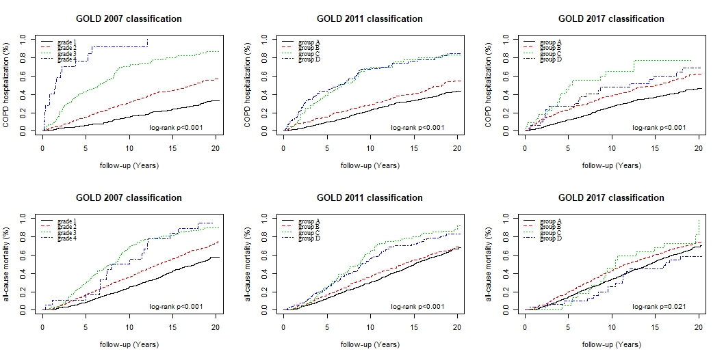

Table S1. Lists of ICD codes for COPD hospitalizations.
 | ICD-10 | ICD-9
*- Primary diagnosis | Bronchitis, not specified as acute or chronic * J40 | Chronic airway obstruction, not elsewhere classified * 496
*- Primary diagnosis | Simple and mucopurulent chronic bronchitis * J41 | Bronchitis, not specified as acute or chronic * 490
*- Primary diagnosis | Unspecified chronic bronchitis * J42 | Bronchitis, not specified as acute or chronic * 490
*- Primary diagnosis | Emphysema * J43 | Emphysema * 492
*- Primary diagnosis | Other chronic obstructive pulmonary disease (COPD) * J44 | Chronic bronchitis * 491
#- Primary diagnosis but in combination with a secondary diagnosis of J40-J44 from ICD-10 or 490-492 and 496 from ICD-9 | Influenzas # J09, J10, J11 | Influenzas # 487, 488
 | Pneumonias # J12 – J18 | Pneumonias # 480 – 486
 | Dyspnoea # R06.0 | Shortness of breath # 786.05
 | Acute bronchitis # J20 | Acute bronchitis # 466.0
 | Unspecified acute lower respiratory infection # J22
 | Respiratory failure, not elsewhere classified # J96 | Respiratory failure # 518.81, 518.83, 518.84

Table S2. Akaike Information Criteria (AIC) for models predicting COPD hospitalization and all-cause mortality from GOLD 2007, GOLD 2011 and GOLD 2017 classifications among COPD participants aged ≥40 years in the HUNT2 study (N=1300).
Outcomes | GOLD 2007 ¶ | GOLD 2011 ¥ | GOLD 2017 †
Outcomes | AIC * | AIC * | AIC *
COPD hospitalization | 6744 | 6808 | 6911
All-cause mortality | 11860 | 11912 | 11961
Abbreviations: HUNT2 (Nord-Trøndelag Health Study 1995-1997), GLI (Global Lung Function Initiative), AIC (Akaike Information Criteria), BD (bronchodilator)
*- Model 1- the Cox model included GOLD 2007, GOLD 2011, or GOLD 2017.
¶ - grade 1 – percent-predicted forced expiratory volume in first second (ppFEV₁) ≥80; grade 2 –80>ppFEV₁≥50; grade 3 –50>ppFEV₁≥30; grade 4 –ppFEV₁<30
¥ - group A – ppFEV₁≥50 and exacerbation history <2 and modified Medical Research Council dyspnoea scale (mMRC) <2; group B – ppFEV₁≥50 and exacerbation history <2 and mMRC ≥2; group C – ppFEV₁<50 or exacerbation history ≥2 and mMRC <2; group D – ppFEV₁<50 or exacerbation history ≥2 and mMRC ≥2
†- group A – mMRC <2 & exacerbation history <2; group B – mMRC ≥2 & exacerbation history <2; group C – mMRC <2 & exacerbation history ≥2; group D – mMRC ≥2 & exacerbation history ≥2

Table S3. Hazard ratios for GOLD 2007, GOLD 2011, and GOLD 2017 among participants with COPD aged ≥40 years in the HUNT2 study (N=1300).
Outcomes | GOLD categories ¶, ¥, † | GOLD 2007 ¶ | GOLD 2011 ¥ | GOLD 2017 †
Outcomes | GOLD categories ¶, ¥, † | HR (95% CI) € | HR (95% CI) € | HR (95% CI) €
COPD hospitalization | grade 1/ group A | Reference | Reference | Reference
COPD hospitalization | grade 2/ group B | 1.93 (1.53-2.43) | 1.31 (1.05-1.64) | 1.50 (1.24-1.82)
COPD hospitalization | grade 3/ group C | 4.57 (3.40-6.14) | 2.75 (2.05-3.70) | 2.30 (1.35-3.90)
COPD hospitalization | grade 4/ group D | 14.57 (8.10-26.21) | 3.17 (2.42-4.16) | 1.63 (1.01-2.65)
All-cause mortality | grade 1/ group A | Reference | Reference | Reference
All-cause mortality | grade 2/ group B | 1.53 (1.31-1.80) | 0.97 (0.82-1.15) | 1.09 (0.94-1.27)
All-cause mortality | grade 3/ group C | 2.77 (2.22-3.46) | 1.60 (1.26-2.04) | 1.01 (0.62-1.63)
All-cause mortality | grade 4/ group D | 4.40 (2.59-7.47) | 1.95 (1.55-2.46) | 0.99 (0.61-1.61)
Abbreviations: HUNT2 (Nord-Trøndelag Health Study 1995-1997), GOLD (global initiative for chronic obstructive lung disease), HR (Hazard ratio), CI (confidence interval), BD (bronchodilator)
€- Model 3- adjusted for age, sex, smoking, body mass index, education, physical activity, cardiovascular diseases, asthma ever, diabetes ever, systolic blood pressure, and cholesterol
¶ - grade 1 – percent-predicted forced expiratory volume in first second (ppFEV₁) ≥80; grade 2 –80>ppFEV₁≥50; grade 3 –50>ppFEV₁≥30; grade 4 –ppFEV₁<30
¥ - group A – ppFEV₁≥50 and exacerbation history <2 and modified Medical Research Council dyspnoea scale (mMRC) <2; group B – ppFEV₁≥50 and exacerbation history <2 and mMRC ≥2; group C – ppFEV₁<50 or exacerbation history ≥2 and mMRC <2; group D – ppFEV₁<50 or exacerbation history ≥2 and mMRC ≥2
†- group A – mMRC <2 & exacerbation history <2; group B – mMRC ≥2 & exacerbation history <2; group C – mMRC <2 & exacerbation history ≥2; group D – mMRC ≥2 & exacerbation history ≥2

