Supplementary material 3

JBI critical appraisal checklist for randomized controlled trials
Reviewer Date
Author Year Record Number
 | Yes | No | Unclear | NA
- Was true randomization used for assignment of participants to treatment groups? | □ | □ | □ | □
- Was allocation to treatment groups concealed? | □ | □ | □ | □
- Were treatment groups similar at the baseline? | □ | □ | □ | □
- Were participants blind to treatment assignment? | □ | □ | □ | □
- Were those delivering treatment blind to treatment assignment? | □ | □ | □ | □
- Were outcomes assessors blind to treatment assignment? | □ | □ | □ | □
- Were treatments groups treated identically other than the intervention of interest? | □ | □ | □ | □
- Was follow-up complete, and if not, were strategies to address incomplete follow-up utilized? | □ | □ | □ | □
- Were participants analyzed in the groups to which they were randomized? | □ | □ | □ | □
- Were outcomes measured in the same way for treatment groups? | □ | □ | □ | □
- Were outcomes measured in a reliable way? | □ | □ | □ | □
- Was appropriate statistical analysis used? | □ | □ | □ | □
- Was the trial design appropriate, and any deviations from the standard RCT design (individual randomization, parallel groups) accounted for in the conduct and analysis of the trial? | □ | □ | □ | □
Overall appraisal: Include □ Exclude □ Seek further info □
Comments (Including reason for exclusion)

JBI critical appraisal checklist for quasi-experimental studies
(non-randomized experimental studies)
Reviewer Date
Author Year Record Number
 | Yes | No | Unclear | Not applicable
- Is it clear in the study what is the ‘cause’ and what is the ‘effect’ (i.e. there is no confusion about which variable comes first)? | □ | □ | □ | □
- Were the participants included in any comparisons similar? | □ | □ | □ | □
- Were the participants included in any comparisons receiving similar treatment/care, other than the exposure or intervention of interest? | □ | □ | □ | □
- Was there a control group? | □ | □ | □ | □
- Were there multiple measurements of the outcome both pre-and post the intervention/exposure? | □ | □ | □ | □
- Was follow up complete and if not, were differences between groups in terms of their follow up adequately described and analysed? | □ | □ | □ | □
- Were the outcomes of participants included in any comparisons measured in the same way? | □ | □ | □ | □
- Were outcomes measured in a reliable way? | □ | □ | □ | □
- Was appropriate statistical analysis used? | □ | □ | □ | □
Overall appraisal: Include □ Exclude □ Seek further info □
Comments (Including reason for exclusion)

JBI Critical Appraisal Checklist for Cohort Studies
Reviewer Date
Author Year Record Number
 | Yes | No | Unclear | Not applicable
- Were the groups similar and recruited from the same population? | □ | □ | □ | □
- Were the exposures measured similarly to assign people  to both exposed and unexposed groups? | □ | □ | □ | □
- Was the exposure measured in a valid and reliable way? | □ | □ | □ | □
- Were confounding factors identified? | □ | □ | □ | □
- Were strategies to deal with confounding factors stated? | □ | □ | □ | □
- Were the groups/participants free of the outcome at the start of the study (or at the moment of exposure)? | □ | □ | □ | □
- Were the outcomes measured in a valid and reliable way? | □ | □ | □ | □
- Was the follow up time reported and sufficient to belong enough for outcomes to occur? | □ | □ | □ | □
- Was follow-up complete, and if not, were the reasons to loss to follow-up described and explored? | □ | □ | □ | □
- Were strategies to address incomplete follow-up utilized? | □ | □ | □ | □
- Was appropriate statistical analysis used? | □ | □ | □ | □
Overall appraisal: Include □ Exclude □ Seek further info □
Comments (Including reason for exclusion)

JBI critical appraisal checklist for analytical cross-sectional Studies
Reviewer Date
Author Year Record Number___
 | Yes | No | Unclear | Not applicable
- Were the criteria for inclusion in the sample clearly defined? | □ | □ | □ | □
- Were the study subjects and the setting described in detail? | □ | □ | □ | □
- Was the exposure measured in a valid and reliable way? | □ | □ | □ | □
- Were objective, standard criteria used for measurement of the condition? | □ | □ | □ | □
- Were confounding factors identified? | □ | □ | □ | □
- Were strategies to deal with confounding factors stated? | □ | □ | □ | □
- Were the outcomes measured in a valid and reliable way? | □ | □ | □ | □
- Was appropriate statistical analysis used? | □ | □ | □ | □
Overall appraisal: Include □ Exclude □ Seek further info □
Comments (Including reason for exclusion)

Supplementary material 4
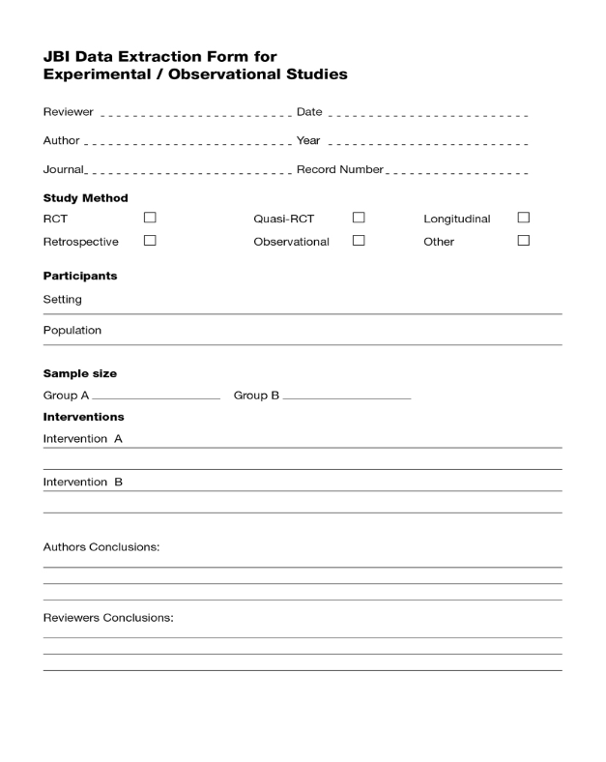
Insert page break
