Supplementary information

Supplementary information 1. List of trial sites
S No. | Institution name
1. | Instituto de la Vision, Buenos Aires, Argentina
2. | Consultario Oftalmológico Dr. Fabián Lerner, Buenos Aires, Argentina
3. | Hospital Militar Central, Buenos Aires, Argentina
4. | Oftalmología 20/20, Santiago, Chile
5. | Fundación Oftalmológica de Santander –FOSCAL, Floridablanca, Colombia
6. | Fundacion Oftalmologica Nacional, Bogota, Colombia
7. | Hobart Eye Surgeons, Hobart Australia
8. | Dr. S. Pourjavan oogarts BVBA, Zaventem, Belgium
9. | Oogartsenpraktijk Alken, Alken, Belgium
10. | Breyer & Kaymak & Klabe Augenchirurgie, Düsseldorf, Germany
11. | Augenzentrum Kamppeter, Bayreuth, Germany
12. | Universitätsklinik um Giessen und Marburg GmbH, Marburg, Germany
13. | Universitätsklinik um Magdeburg A.ö.R. Universitätsaugen klinik, Magdeburg, Germany
14. | Aristotle University of Thessaloniki, Thessaloniki, Greece
15. | Ippokrateio General University, Thessaloniki, Greece
16. | Fondazione IRCCS Policlinico San Matteo, Pavia, Italy
17. | Azienda Ospedaliera Universitaria Senese, Siena, Italy
18. | Azienda Ospedaliero – Universitaria Ospedali Riuniti di Trieste, Trieste, Italy
19. | IRCCS Fondaz. G.B. Bietti Oftalmologia, Roma, Italy
20. | Ospedale Santa Maria della Misericordia, Perugia, Italy
21. | OPTEGRA, Wroclaw, Poland
22. | Centrum Leczenia Jaskry, Lodz, Poland
23. | Profesorskie Centrum Okulistyki "Optimum" Sp. z o.o, Gdansk, Poland
24. | Hospital Univ. Miguel Servet, Zaragoza, Spain
25. | Hospital Universitario Torrevieja, Torrevieja, Spain
26. | Valles Oftalmologia Recerca, Sant Cugat Del Valles (BCN), Spain
27. | Hospital Universitario Principe de Asturias, Alcala de Henares, Spain
28. | Hinchingbrooke Hospital, Huntingdon, UK
29. | St Thomas' Hospital, London, UK
30. | ISEC Sdn. Bhd, Mid Valley, Malaysia
31. | Gleneagles Penang Medical Center – Eye Clinic, Penang, Malaysi
32. | Hospital Selayang, Selangor, Malaysia
33. | Seoul National University Hospital, Seoul National University Hospital
34. | Kangbuk Samsung Hospital, Seoul, South Korea
35. | Tri-Service General Hospital, Taipei, Taiwan

Supplementary information 2. Selection of the study eye
If one eye was dosed, it was chosen as the study eye. If both eyes were dosed, the study eye was chosen based on the worse eye analysis. The worse eye was defined as the eye with higher IOP at 09:00 averaged across the 2 eligibility visits. If both eyes had equal IOP, then the worse eye was defined as the eye with the higher intraocular pressure (IOP) at 11:00 averaged across the 2 eligibility visits. If both eyes had equal IOP at the 09:00 and 11:00 time points, then the right eye was selected for analysis.

Supplementary information 3. Key exclusion criteria
Key exclusion criteria included the following:
- Central corneal thickness (CCT) >620 μm as measured by pachymetry in either eye
- Schaffer angle grade <2 as measured by gonioscopy in either eye
- Cup/disc ratio >0.80 in either eye
- Best-corrected visual acuity (BCVA) score worse than 55 Early Treatment Diabetic Retinopathy Study (ETDRS) letters (equivalent to ~20/80 Snellen, 0.60 logMAR, or 0.25 decimal) in either eye
- Mean IOP ≥28 mmHg at any time point during the screening/eligibility phase
- Severe central visual field loss in either eye or field loss threatening fixation in either eye
- Hypersensitivity to α-adrenergic agonists, carbonic anhydrase inhibitors, sulfonamide derivatives, or to any component of the study medications.

Supplementary information 4. Efficacy and safety assessments
IOP was measured at each visit using a Goldmann applanation tonometer. Two consecutive IOP measurements were taken for each eye. If the 2 measurements for the same eye differed by ≤4 mmHg, the average value was considered as the mean IOP for that eye. If the 2 measurements for the same eye differed by >4 mmHg, a third measurement was taken and the 2 closest values were averaged. If the
3 measurements differed by equal amounts, the 3 measurements were averaged.
BCVA was measured at each visit using an ETDRS visual acuity (VA) chart at
3 meters (10 feet) or 4 meters (13 feet). Achromatic automated perimetry was performed using either a Humphrey Field Analyzer or Octopus Perimeter. Visual field examinations were performed on the right eye first using appropriate corrected vision.
Slit-lamp biomicroscopy exams were conducted at each visit and included assessment of the aqueous cells and flare and the lens. Each parameter was graded according to pre-specified grading scale and was conducted prior to IOP measurements or instillation of fluorescein. Dilated fundus examinations were performed at the screening visit and exit visit. Examination included assessments of vitreous, retina/macula/choroid, optic nerve, and cup/disc ratio (horizontal and vertical axis) for both eyes. Pachymetry and gonioscopy were performed at the screening visit alone. For the pachymetry assessment, the CCT of each eye was measured using a direct probe or optical coherence tomography (OCT). For the gonioscopy assessment, measurements were performed prior to instillation of dilating or miotic drops, with high magnification, and with as little light as possible to potentiate visualization of the angle in its natural configuration. The angular width of the angle recess was graded according to a prespecified grading scale.

Supplementary information 5. Safety results
Mean changes in pulse rate were small (mean change <1.6 beats per minute at any post-dose time point in both treatment groups. Similarly, mean changes in systolic blood pressure (SBP) and diastolic blood pressure (DBP) were small: ≤3.3 mmHg for SBP and ≤2.5 mmHg for DBP in the BBFC+TTFC group and ≤1.9 mmHg for SBP and ≤1.2 mmHg for DBP in the vehicle+TTFC group. There was no difference between the groups in mean BP or pulse rates.
The mean change in BCVA from baseline (BL) was similar between treatment groups at Weeks 2 and 6. The change in VA of the worse eye at all post-BL assessments was similar between the treatment groups. The majority of patients had changes in BCVA of ≤9 letters (increase or decrease). Two (3.0%) patients in each treatment group experienced a 10–14 letter decrease in BCVA and 1 (1.5%) patient in the BBFC+TTFC group had a decrease in BCVA of ≥15 letters with a loss in VA from 85 letters at BL to 64 letters at Week 2. An adverse event (AE) was reported for the loss, which was related to investigational product and it resolved without treatment. By the last on-therapy visit (Week 6) this patient had a BCVA of 90 letters.
No patients in either treatment group had a worsening in slit-lamp parameters at Week 2 or 6 (aqueous flare and cells, presence, or lens or lens status). Analysis of the visual field showed that the change from BL at Week 6 for mean defect and mean deviation was similar between the 2 treatment groups. One patient receiving BBFC+TTFC had a worsening in vitreous score in both eyes from the absence of any opacity to the presence of opacity in the vitreous at Week 6. Another patient receiving BBFC+TTFC had a worsening in optic nerve score from mild abnormality to moderate abnormality at Week 6. No AEs were reported for these patients, as the findings were not considered clinically relevant by the investigator. There was no change in the cup/disc ratio at Week 6.

Supplementary tables
Supplementary table ST1. Mean change from baseline in ocular perfusion pressure (mmHg) at Week 6 by individual time points and overall (Full analysis set)

Visit | Time point | BBFC+TTFC  N=67 |  |  |  | Vehicle+TTFC  N=67
Visit | Time point | OPP  Mean (SD)  n=61 | Change in OPP*  Mean (SD) |  |  | OPP  Mean (SD)  n=67 |  | Change in OPP*  Mean (SD)
ªBL | 09:00 | 50.3 (6.63) | – |  |  | 50.2 (7.22) |  | –
 | 11:00 | 49.7 (6.21) | – |  |  | 50.2 (7.88) |  | –
Week 6 | 09:00 | 52.9 (7.29) | 2.6 (5.17) |  |  | 52.2 (9.01) |  | 1.9 (6.17)
 | 11:00 | 51.5 (6.64) | 1.9 (5.68) |  |  | 51.4 (8.13) |  | 1.3 (5.87)
 |  | OPP  Mean (SD) |  | Increase in OPP  Mean (SD) |  |  | OPP  Mean (SD) | Increase in OPP  Mean (SD)
^{b}BL | – | 49.9 (6.04) |  |  | – |  | 50.0 (7.30) | –
Week 6 | – | 52.5 (6.39) |  |  | 2.6 (4.68) |  | 52.1 (8.38) | 2.1 (5.29)
ªBL is defined as the average of the 09:00 values at both eligibility visits for the 09:00 calculation. BL is defined as the average of the 11:00 values at both eligibility visits for the 11:00 calculation
^{b}BL is defined as the average of the 09:00 and 11:00 values, where the values used are the average time-matched hour values at both eligibility visits, respectively. At each time point, only patients with a value at both BL and that time point are included in the calculation of change
*Change=Post-BL−BL
Ocular Perfusion Pressure is defined as 2/3* [diastolic blood pressure + 1/3 (systolic blood pressure – diastolic blood pressure) − IOP]
BBFC, brinzolamide 1%/brimonidine 0.2% fixed-dose combination; BL, baseline; FAS, full analysis set; N, total number of patients; OPP, ocular perfusion pressure; SD, standard deviation;
TTFC, travoprost 0.004%/timolol 0.5% fixed-dose combination

Supplementary table ST2. Mean change in intraocular pressure (mmHg) from baseline at each visit by time point and mean diurnal intraocular pressure at Week 6 in patients with 15:00 data (Full analysis set)

Visit | Time point |  | BBFC+TTFC  N=67 |  |  |  | Vehicle+TTFC  N=67
Visit | Time point | n | IOP  Mean (SD) | Change in IOP  Mean (SD) |  | n | IOP  Mean (SD) | Change in IOP  Mean (SD)
ªBL | 09:00 | 25 | 23.3 (1.49) | – |  | 24 | 23.1 (1.48) | –
 | 11:00 | 25 | 22.4 (2.25) | – |  | 24 | 21.8 (2.28) | –
 | 15:00 | 25 | 21.6 (2.16) | – |  | 24 | 20.3 (2.48)
Week 6 | 09:00 | 23 | 18.2 (3.89) | −5.0 (3.59) |  | 24 | 19.4 (4.57) | −3.7 (4.13)
 | 11:00 | 23 | 16.0 (3.42) | −6.4 (3.13) |  | 24 | 18.7 (4.21) | −3.1 (4.01)
 | 15:00 | 20 | 16.4 (2.98) | −5.2 (3.41) |  | 22 | 18.3 (3.01) | −1.9 (2.88)
 |  |  | Diurnal IOP  Mean (SD) |  | Change in IOP  Mean (SD) | n | Diurnal IOP  Mean (SD) | Change in IOP  Mean (SD)
^{b}BL | – | 25 | 22.6 (1.85) |  | – | 24 | 22.3 (1.76) | –
Week 6 | – | 23 | 17.4 (3.50) |  | −5.2 (3.08) | 24 | 19.3 (4.34) | −3.0 (3.85)
ªBL is defined as the average of the 09:00 values at both eligibility visits for the 09:00 calculation. BL is defined as the average of the 11:00 values at both eligibility visits for the 11:00 calculation.
^{b}BL is defined as the average of the 09:00 and 11:00 values, where the values used are the average time-matched hour values at both eligibility visits, respectively. At each time point, only patients with a value at both BL and that time point are included in the calculation of change
*Change=Post-BL−BL
BBFC, brinzolamide 1%/brimonidine 0.2% fixed-dose combination; BL, baseline; FAS, full analysis set; N, total number of patients; IOP, intraocular pressure; SD, standard deviation; TTFC, travoprost 0.004%/timolol 0.5% fixed-dose combination

Supplementary table ST3. Treatment-related adverse events (Safety set)

Preferred term | BBFC+TTFC  N=67 | Vehicle+TTFC  N=67
Treatment-related AE, n (%) | 10 (14.9) | 1 (1.5)
Asthenia | 2 (3.0) | 0 (0.0)
Ocular hyperemia | 1 (1.5) | 1 (1.5)
Punctate keratitis | 2 (3.0) | 0 (0.0)
Bradycardia | 1 (1.5) | 0 (0.0)
Ciliary hyperemia | 1 (1.5) | 0 (0.0)
Conjunctivitis allergic | 1 (1.5) | 0 (0.0)
Dizziness | 1 (1.5) | 0 (0.0)
Drug hypersensitivity | 1 (1.5) | 0 (0.0)
Dry mouth | 1 (1.5) | 0 (0.0)
Dysgeusia | 1 (1.5) | 0 (0.0)
Dyspnea | 1 (1.5) | 0 (0.0)
Eye discharge | 1 (1.5) | 0 (0.0)
Eye pain | 1 (1.5) | 0 (0.0)
Eye pruritus | 1 (1.5) | 0 (0.0)
Fatigue | 1 (1.5) | 0 (0.0)
Headache | 1 (1.5) | 0 (0.0)
Vision blurred | 1 (1.5) | 0 (0.0)
AE, adverse event; BBFC, brinzolamide 1%/brimonidine 0.2% fixed-dose combination; N, total number of patients; n, number of patients; TTFC, travoprost 0.004%/timolol 0.5% fixed-dose combination
Figure S1. Mean diurnal intraocular percentage change from baseline at Week 6 (full analysis set)
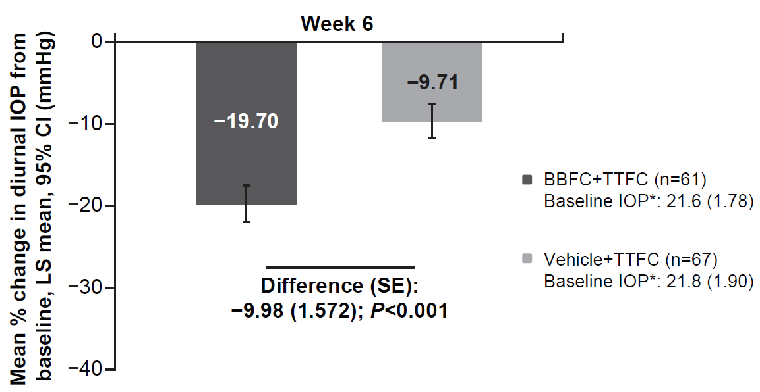

*BL IOP expressed as mean (SD) and defined as the average of 09:00 and 11:00 values
BBFC, brinzolamide 1%/brimonidine 0.2% fixed-dose combination; BL, baseline; CI, confidence interval; FAS, full analysis set; IOP, intraocular pressure; LS, least square; n, number of patients; SE, standard error; TTFC, travoprost 0.004%/timolol 0.5% fixed-dose combination

Figure S2. (a) Mean change in intraocular pressure from baseline at individual time points (11:00 and 09:00) at Week 6 (full analysis set)

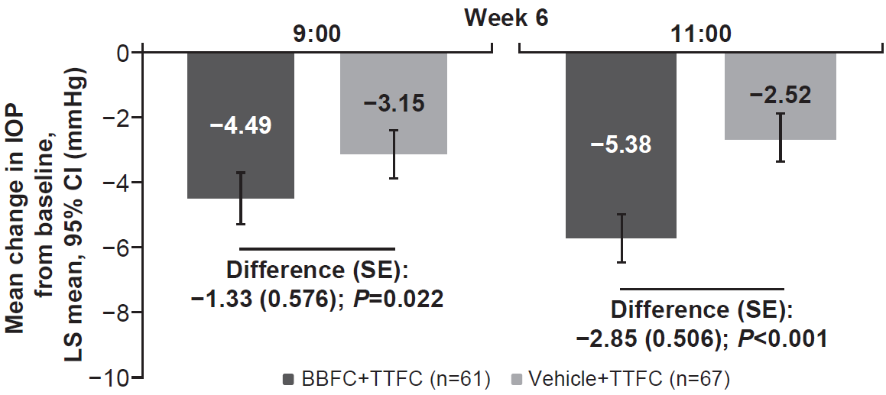

Figure S2. (b) Mean percentage change in intraocular pressure from baseline at individual time points (11:00 and 09:00) at Week 6 (full analysis set)

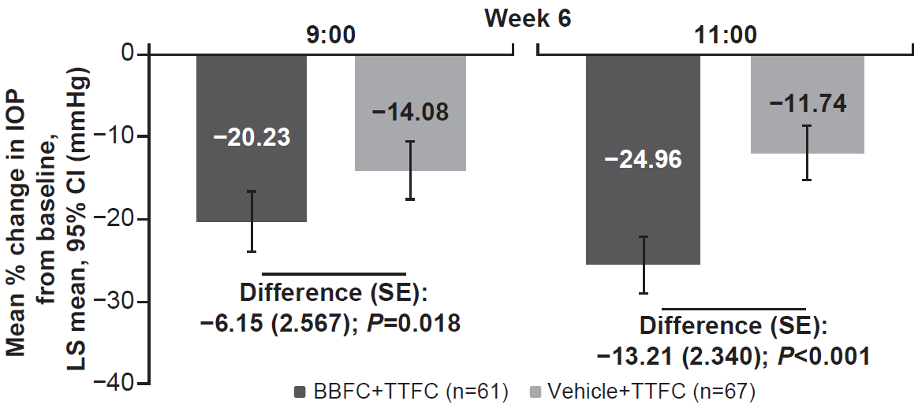

BBFC, brinzolamide 1%/brimonidine 0.2% fixed-dose combination; CI, confidence interval; FAS, full analysis set; IOP, intraocular pressure; LS, least square; n, number of patients; SE, standard error; TTFC, travoprost 0.004%/timolol 0.5% fixed-dose combination

Figure S3. Percentage of patients reaching intraocular pressure (mmHg) target at Week 6 (full analysis set)

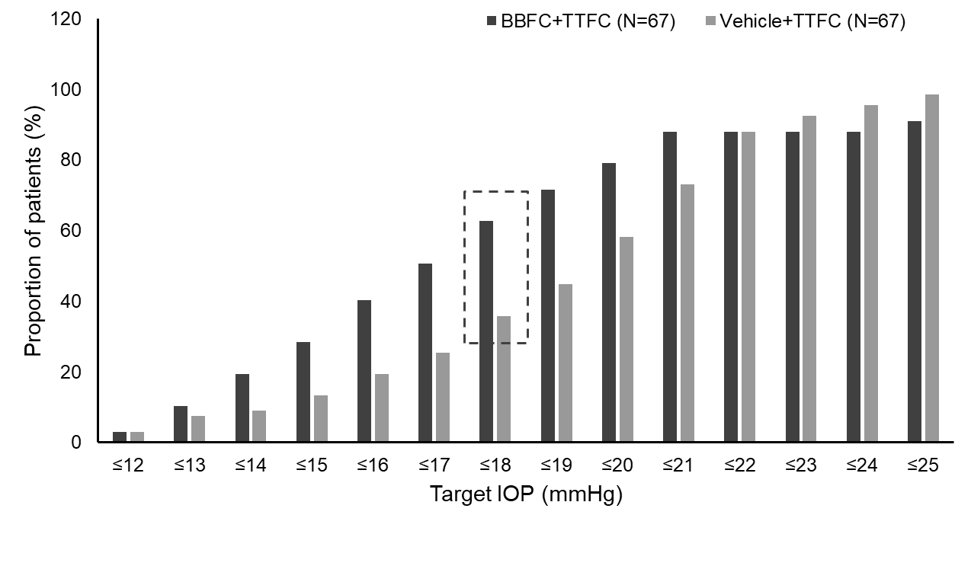

IOP target categories are cumulative
BBFC, brinzolamide 1%/brimonidine 0.2% fixed-dose combination; FAS, full analysis set; IOP, intraocular pressure; N, total number of patients; TTFC, travoprost 0.004%/timolol 0.5% fixed-dose combination

