Supplementary data

Figure S1 Time-series concentrations of air pollutants in Taipei City and Hualien, Taitung, and Pingtung Counties in the period 2006 – 2016. (A – D) NO₂, (E – H) NO_{X}, (I – L) CO, (M – P) PM_{2.5}, and (Q – T) PM₁₀
Figure S2 Exposure-response data on the relationships between ambient air pollutant concentrations and hazard ratios (HRs) of active TB adopted from Lai et al. (2016). (A) NO₂, (B) NO_{X}, (C) CO, (D) PM_{2.5}, and (E) PM₁₀
Table S1 Incidence rates in the regions of Taiwan during the period from 2006 to 2016
Table S2 Probability distributions of air pollutant concentrations (LN(gm, gsd) denotes the lognormal distribution with a geometric mean (gm) and a geometric standard deviation (gsd))

Figure S1
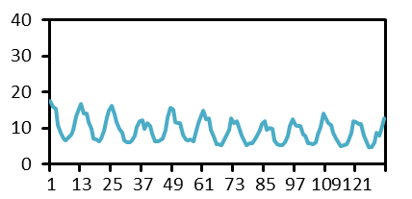
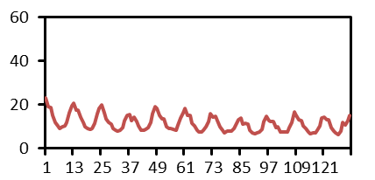
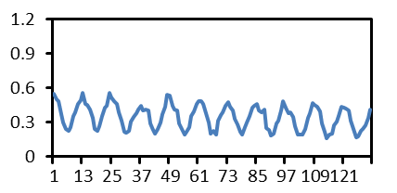
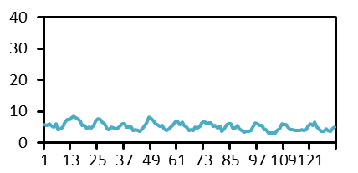
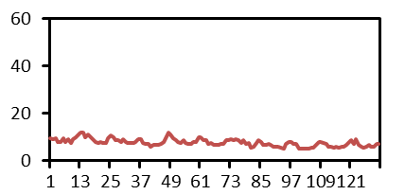
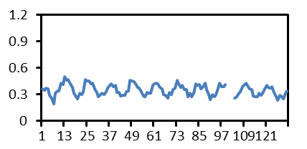
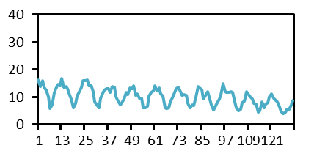
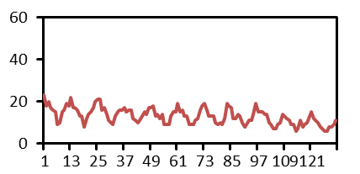
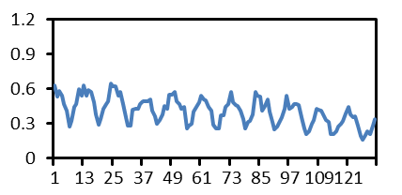
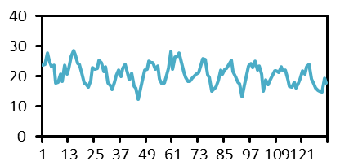
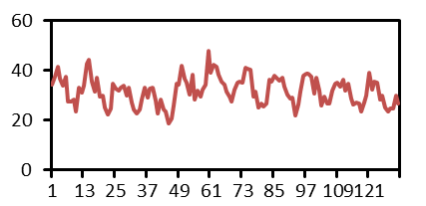
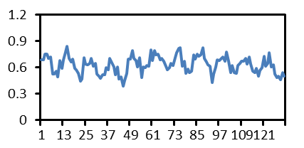
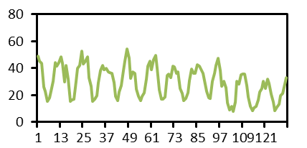
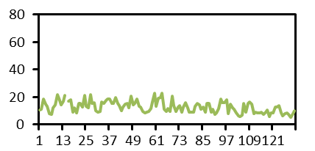
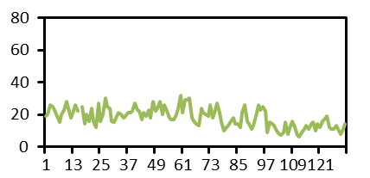
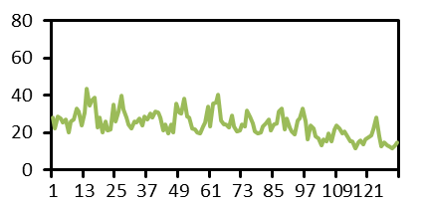
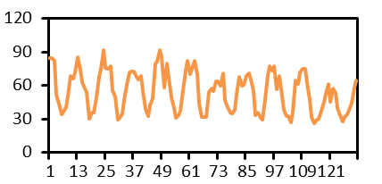
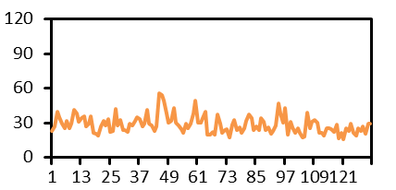
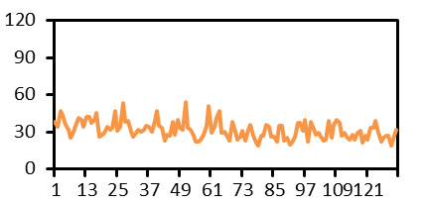
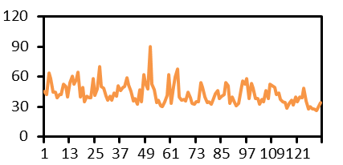
Taipei City
Hualien County
Taitung County
Pingtung County
NO₂ (ppb)
NO_{X} (ppb)
CO (ppm)
Concentration
Time (year)
A
E
I
B
F
J
C
G
K
D
H
L
O
P
N
PM_{2.5} (μg/m³)
M
PM₁₀ (μg/m³)
Q
R
S
T
2006
2008
2010
2012
2014
2016
2006
2008
2010
2012
2014
2016
2006
2008
2010
2012
2014
2016
2006
2008
2010
2012
2014
2016

Figure S2

95% upper confidence limit
Regression model predicted
95% lower confidence limit
A
B
PM_{2.5} concentration (μg/m³)
PM₁₀ concentration (μg/m³)
NO₂ concentration (ppb)
NO_{X} concentration (ppb)
CO concentration (ppm)
Hazard ratio (HR) of active TB
C
D
E

Table S1 Incidence rates in the regions of Taiwan during the period from 2006 to 2016
Region | Incidence rate (per 100,000 populations) |  |  |  |  |  |  |  |  |  |  | Average incidence (per 100,000 populations)
Region | 2006 | 2007 | 2008 | 2009 | 2010 | 2011 | 2012 | 2013 | 2014 | 2015 | 2016 | Average incidence (per 100,000 populations)
Taipei City | 47 | 49 | 45 | 42 | 41 | 38 | 35 | 33 | 34 | 30 | 30 | 38.6 ± 6.8
New Taipei City | 58 | 60 | 56 | 55 | 53 | 51 | 49 | 48 | 45 | 42 | 39 | 50.7 ± 6.7
Keelung City | 80 | 74 | 69 | 54 | 66 | 58 | 60 | 59 | 47 | 47 | 46 | 60.0 ± 11.2
Yilan County | 75 | 76 | 78 | 61 | 60 | 59 | 55 | 56 | 56 | 54 | 43 | 61.2 ± 10.8
Taoyuan City | 57 | 55 | 52 | 47 | 47 | 44 | 44 | 40 | 41 | 39 | 33 | 45.3 ± 7.3
Hsinchu City | 50 | 46 | 33 | 36 | 37 | 31 | 29 | 35 | 32 | 28 | 27 | 34.9 ± 7.2
Hsinchu County | 59 | 48 | 39 | 47 | 44 | 40 | 34 | 35 | 36 | 36 | 33 | 41.0 ± 8.0
Miaoli County | 53 | 40 | 45 | 42 | 39 | 33 | 38 | 32 | 33 | 34 | 32 | 38.2 ± 6.6
Taichung City | 57 | 52 | 55 | 49 | 50 | 46 | 44 | 41 | 41 | 39 | 41 | 46.8 ± 6.3
Changhwa County | 71 | 71 | 73 | 68 | 61 | 60 | 59 | 54 | 55 | 52 | 49 | 61.2 ± 8.3
Nantou County | 81 | 79 | 72 | 75 | 74 | 79 | 77 | 64 | 64 | 59 | 64 | 71.6 ± 7.4
Yunlin County | 86 | 75 | 80 | 79 | 75 | 70 | 70 | 66 | 70 | 63 | 61 | 72.4 ± 7.5
Tainan City | 67 | 61 | 66 | 57 | 55 | 52 | 49 | 48 | 47 | 47 | 46 | 54.2 ± 7.7
Chiayi City | 50 | 62 | 53 | 49 | 53 | 46 | 47 | 49 | 47 | 36 | 43 | 48.7 ± 6.5
Chiayi County | 71 | 66 | 66 | 61 | 60 | 69 | 63 | 56 | 52 | 47 | 48 | 60.0 ± 8.1
Kaohsiung City | 89 | 78 | 75 | 69 | 73 | 70 | 72 | 64 | 63 | 61 | 56 | 70.1 ± 9.1
Pingtung County | 110 | 95 | 100 | 90 | 94 | 97 | 95 | 86 | 78 | 71 | 77 | 90.3 ± 11.5
Taitung County | 105 | 92 | 100 | 113 | 100 | 97 | 81 | 77 | 79 | 70 | 66 | 89.1 ± 15.3
Hualien County | 120 | 114 | 105 | 109 | 100 | 82 | 91 | 83 | 79 | 73 | 72 | 93.5 ± 17.1

Table S2 Probability distributions of air pollutant concentrations (LN(gm, gsd) denotes the lognormal distribution with a geometric mean (gm) and a geometric standard deviation (gsd))
Air pollutant | Unit | Taipei City | Hualien County | Taitung County | Pingtung County
NO₂ (Figure 2A) | ppb | LN(20.53, 1.18) | LN(9.60, 1.40) | LN(5.07, 1.26) | LN(8.78, 1.39)
NO_{X} (Figure 2B) | ppb | LN(31.17, 1.20) | LN(12.55,1.35) | LN(7.49, 1.22) | LN(11.08, 1.35)
CO (Figure 2C) | ppm | LN(0.62, 1.17) | LN(0.39, 1.35) | LN(0.34, 1.20) | LN(0.33, 1.39)
PM_{2.5} (Figure 2D) | μg/m³ | LN(23.37, 1.33) | LN(17.23,1.43) | LN(12.04, 1.40) | LN(27.22, 1.57)
PM₁₀ (Figure 2E) | μg/m³ | LN(41.96, 1.25) | LN(30.83, 1.25) | LN(27.56, 1.29) | LN(51.44, 1.41)

