Allylated curcumin analog CA6 inhibits TrxR1 and leads to ROS-dependent apoptotic cell death in gastric cancer through Akt-FoxO3a

Vinothkumar Rajamanickam^{1,#,} Tao Yan^{1,#}, Liangrong Wu¹, Yanni Zhao¹, Xiaohong Xu¹, Heping Zhu¹, Xi Chen¹, Meihong Wang¹, Zhoudi Liu¹, Zhiguo Liu¹, Guang Liang¹, Yi Wang^{1,*}

¹ Chemical Biology Research Center, School of Pharmaceutical Sciences, Wenzhou Medical University, Wenzhou 325035, Zhejiang, P. R. China.

Short title: CA6 inhibits gastric cancer by inhibiting TrxR1

This supplementary file includes the supplementary methods, 1 table and 3 figures.

Supplementary methods
Apoptotic cell death determination in gastric cancer cells
BGC-823 and SCG-7901 cells were seeded at a density of 3×10⁵ cells per well in 6-well plates and allowed to attach overnight. BGC-823 and SGC-7901 cells were pretreated with NAC (5 mM) for 2 h before exposure to CA6 (15 μM) for 24 h. To evaluate morphological features of apoptosis, phase contrast images were captured. Cells were also stained with Hoechst 33258 and fluorescence images were acquired.

FoxO3a cell staining
BGC-823 cells were seeded at the density of 1×10⁵ cells in 15-mm glass bottom cell culture dishes and allowed to attach overnight. The next day, cells were exposed to CA6 (15 μM) for 12 h. Where indicated, NAC (5 mM) was administered for 2 h as a pretreatment. Cells were fixed with 4% paraformaldehyde for 5 min and permeabilized with 0.25% Triton X100 for 10 min. Then, cells were blocked with 1% bovine serum albumin in PBS for 30 min. Fixed cells were incubated with antibodies against FoxO3a and p-FoxO3a (1:200) overnight at 4 °C. Phycoerythrin (PE)-labeled secondary antibody (1:500) was used for detection. Cells were counterstained with DAPI. Images were captured using an epifluorescence microscope (Nikon, Japan).

Histology of tissues from mice treated with CA6
BGC-823 cells were injected subcutaneously into the right flank of seven-week-old athymic BALB/c nu/nu female mice. Mice were then treated with vehicle only, 10 mg/kg CA6, 20 mg/kg CA6, or 50 mg/kg curcumin. All treatments were administered every day for 12 days. Following euthanasia, heart, liver and kidney tissues were harvested and fixed in a 4% paraformaldehyde. Tissues were sliced into 5-μm thick sections. Standard hematoxylin and eosin staining was performed.

Supplementary Table:

Supplementary Table S1. siRNA sequences.
Target | Species | Sequence
ATF4 | Human | sense 5'-GCCUAGGUCUCUUAGAUGATT-3'  antisense 5'-UCAUCUAAGAGACCUAGGCTT-3'
TrxR1 | Human | sense 5'-GCAAGACUCUCGAAAUUAUTT-3'  antisense 5'-AUAAUUUCGAGAGUCUUGCAG-3

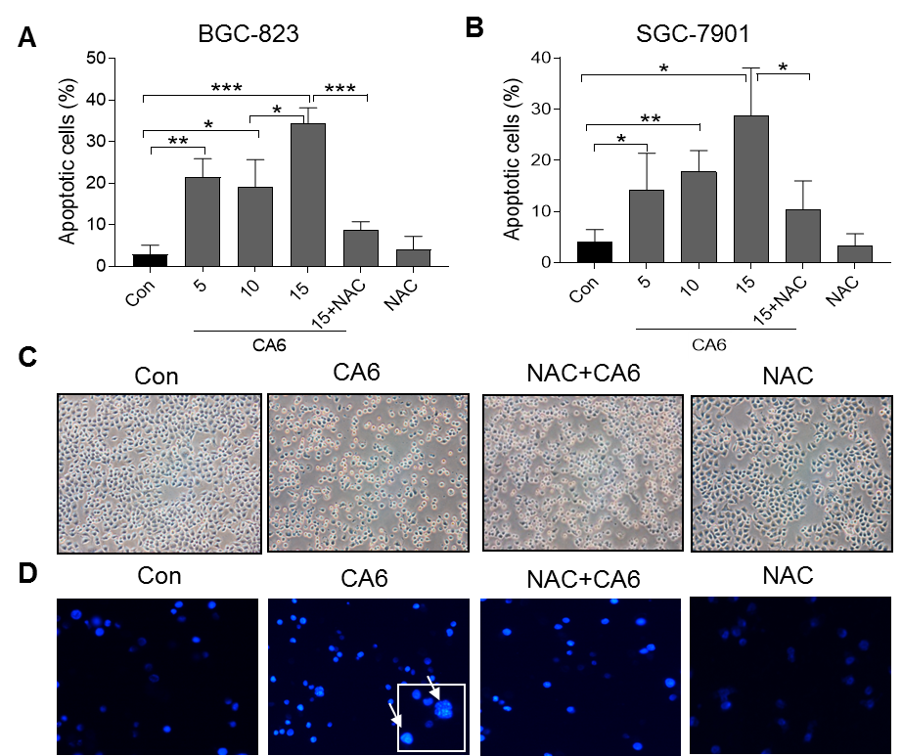
Supplementary Figure S1. CA6 induces apoptosis in gastric cancer cells.
BGC-823 and SGC-7901 cells were pretreated with NAC (5 mM) for 2 h before exposure to CA6 (5, 10 or 15 µM) for 24 h. (A, B) Percentage of cell apoptosis was determined by Annexin-V/PI staining. Representative dot plots are shown in Fig.3A [n = 3; *P<0.05, **P<0.01, ***P<0.001]. (C, D) CA6 (15 µM) induced morphological features of apoptotic cell death in BGC-823 cells. Phase contrast (C) and Hoechst 33258 (D) staining images showing cell shrinkage and condensed chromatin.

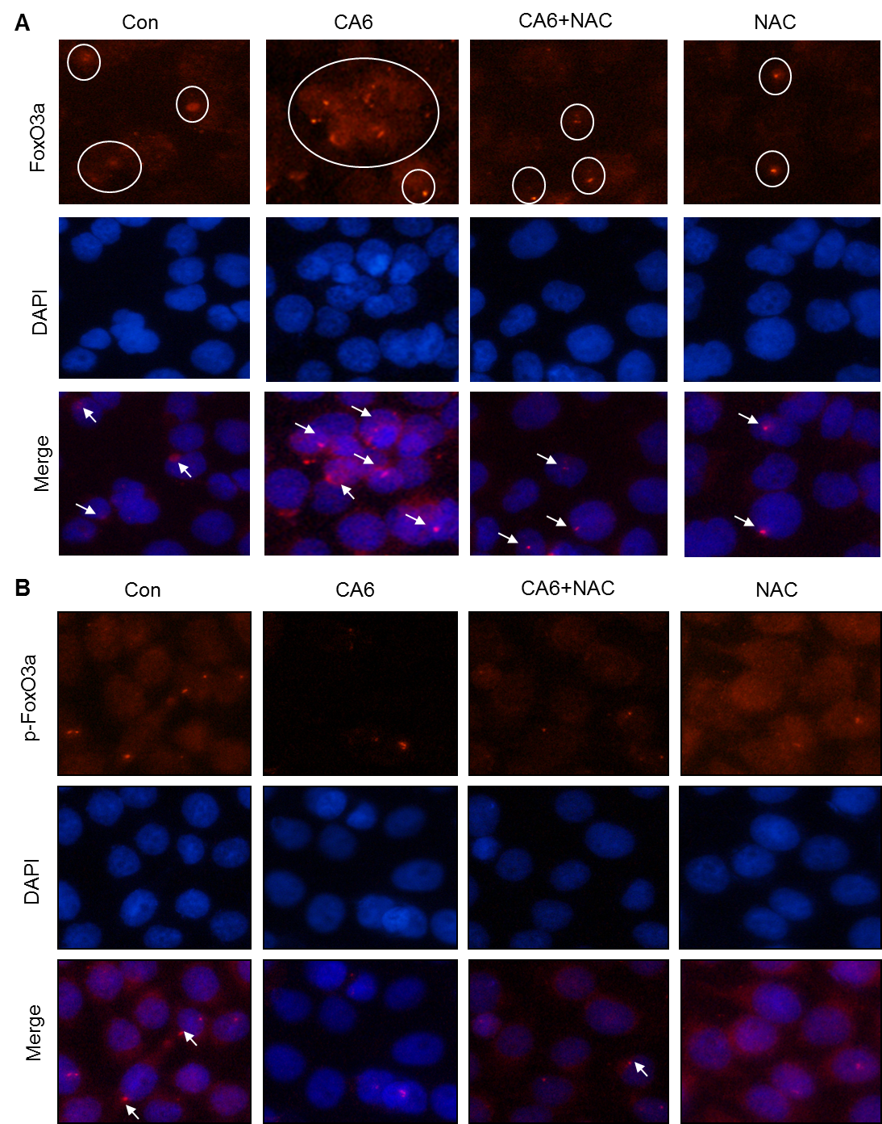
Supplementary Figure S2. CA6 causes dephosphorylation and nuclear accumulation of FoxO3a in gastric cancer cells.
BGC-823 cells were exposed to CA6 (15 µM) for 12 h, with or without pretreatment of NAC (5 mM) for 2 h. (A) Fluorescence cell staining showing immunoreactivity to FoxO3a (red) in cells following CA6 treatment. (B) Staining of cells for p-FoxO3a (red) following CA6 treatment. Cells were counterstained with DAPI (blue).
Supplementary Figure S3. Cytotoxicity effect of CA6 on heart, kidney, and liver tissues of mice.
BGC-823 cells were implanted in nude mice. Mice were then treated with CA6 (10 or 20 mg/kg) or curcumin (50 mg/kg) for 12 days. Heart, kidney, and liver tissues were harvested and stained with hematoxylin and eosin (H&E). Histological analysis shows no significant pathological alterations among the groups.

-

