Supplement A: Research Design
Clinicians were recruited by convenience sampling and advertisement. The HEXACO personality questionnaire² and Integrative Medicine Attitude Questionnaire (IMAQ)³ were administered by online consenting (n=21). At the end of the survey, the participants were given a choice to leave contact information to participate in an interview. Interviews were performed in-person or by telephone, and the conversation was transcribed. The summative analysis (frequency of codes) was made for 15 interviews. By referencing the concept map,¹ directed content analysis⁷ was performed on six interviews. The initial study protocol and modification were approved by the University's Institutional Review Board.

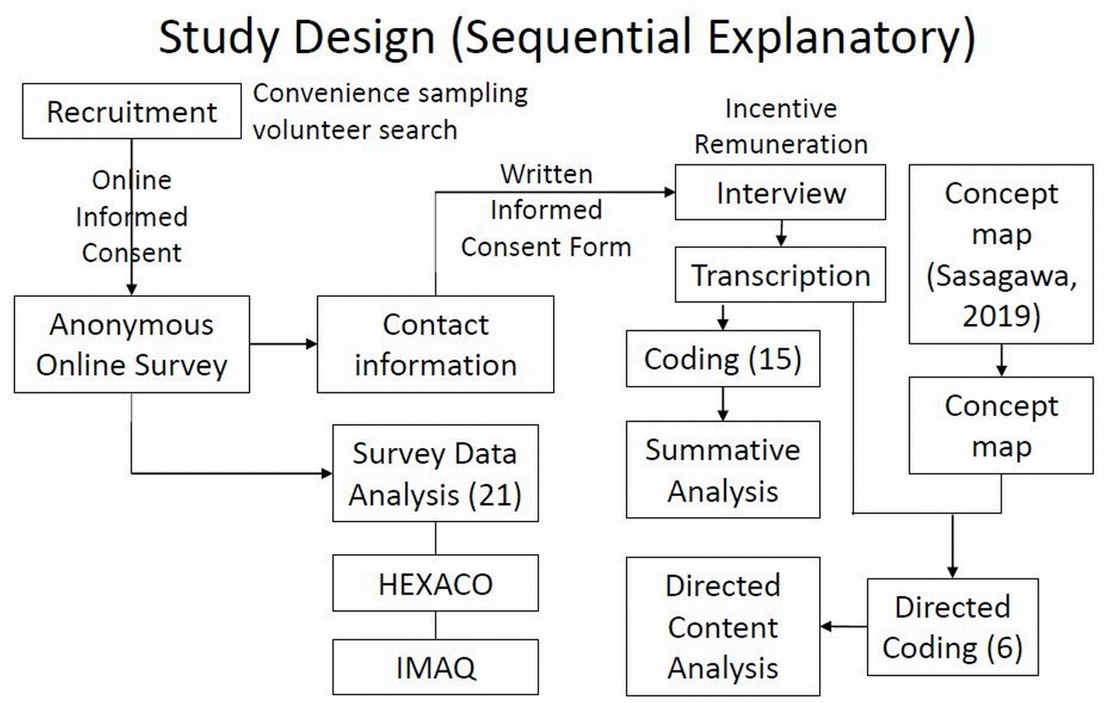

Supplement B: Summative Codes
Summative Codes: Positively or negatively stated factors are indicated by “+” or “-“ in an appropriate column. The disposition and/or environmental factors that are a non-directional opinion or comment are indicated by “0”.

