Supplementary Data
Advanced Mg, Zn, Sr, Si multi-substituted hydroxyapatites for bone regeneration
Corina Garbo, Janis Locs, Matteo D’Este, Gerard Demazeau†, Aurora Mocanu, Cecilia Roman, Ossi Horovitz and Maria Tomoaia-Cotisel

Figure S1 Comparison of experimental XRD pattern for calcined HAPc-10%Sr with PDF 34-0484 for Ca₉Sr(PO₄)₆(OH)₂, red lines.

Table S1 Characteristic wave numbers (in cm⁻¹) of the main absorption maxima in the FTIR spectra of the eight hydroxyapatites
1  HAP  non calc. | 2  HAP  calc. | 3  HAPc  non  calc. | 4  HAPc calc. | 5  HAPc-  5%Sr  non  calc. | 6  HAPc-5%Sr  calc. | 7  HAPc-  10%Sr  non calc. | 8  HAPc-  10%Sr  calc. | Assignment of vibrations
3570  3438  1635  -  1421  1094  1043  962  875  634  603  567  472 | 3571  3435  1631  1446  1415  1093  1043  962  -  633  604  567  473 | 3567  3430  1635  1457  1422  1097  1038  963  875  sh  604  565  (472) | 3569  3431  1632  1451  1416  1096  1037  963  876  630  604  566  473 | 3565  3420  1634  1452  1419  1096  1037  962  875  sh  604  565  472 | 3568  3430  1634  1448  1416  1095  1041  962  877  sh  604  565  472 | sh  3429  1633  1446  1419  1095  1040  961  875  sh  603  565  472 | 3568  3431  1637  1447  1417  1094  1038  961  876  sh  603  565  472 | stretching: structural O-H from HAP  O-H…O stretching –abs. water with H-bonding  absorbed water bending mode ν₂  CO₃²⁻  CO₃²⁻  PO₄ asymmetric stretching ν₃  -“-  PO₄ symmetric stretching ν₁ (forbidden in IR)  CO₃²⁻  structural OH – libration  PO₄ asymmetric bending ν₄  -“-  PO₄ symmetric bending ν₂
Abbreviations: sh = shoulder; abs. water = absorbed water; non calc. = non calcined lyophilized; calc. = calcined lyophilized; values for the highest absorption peak are listed in bold.
Figure S2 Calcined lyophilized HAPc-5%Sr (sample 6, in Table 1): distribution maps of individual elements, as given by EDX spectrum.

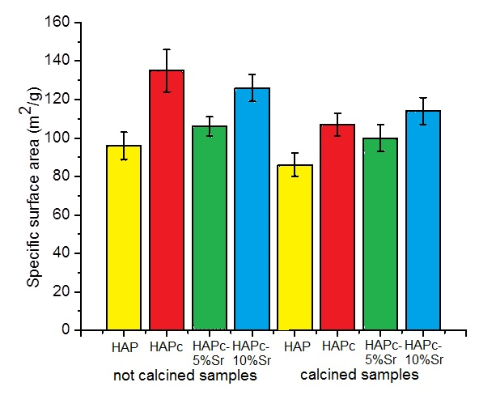
Figure S3 Specific surface areas of all investigated nano powders; error bars indicate the standard deviations.

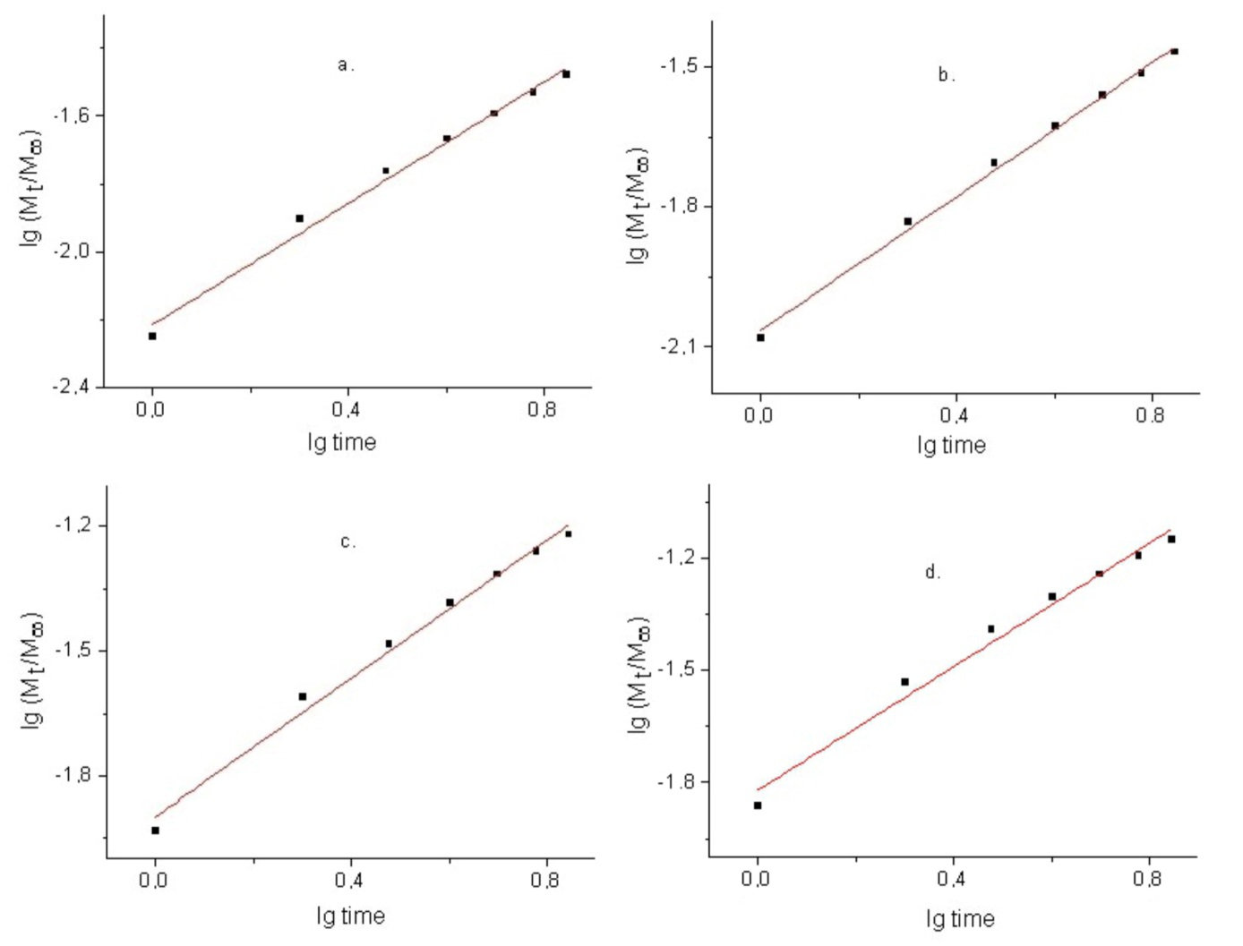
Figure S4 Korsmeyer-Peppas regression lines for strontium release profiles from HAPc-5%Sr non calcined in water (a) and in SBF (c) as well as from HAPc-5%Sr calcined in water (b) and in SBF (d).

