Supporting Information

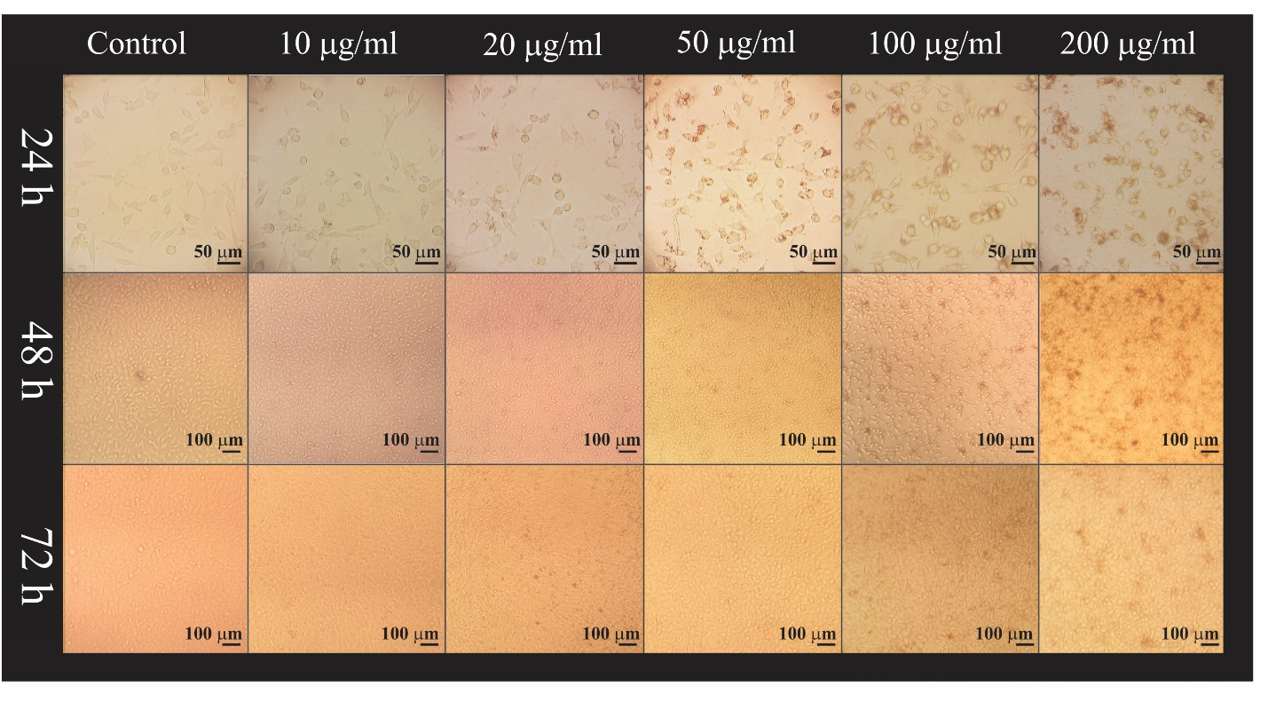
Figure S1 : Light microscopy images of the cells exposed to different concentrations of PS-IONs for 24,48 and 72 hours.

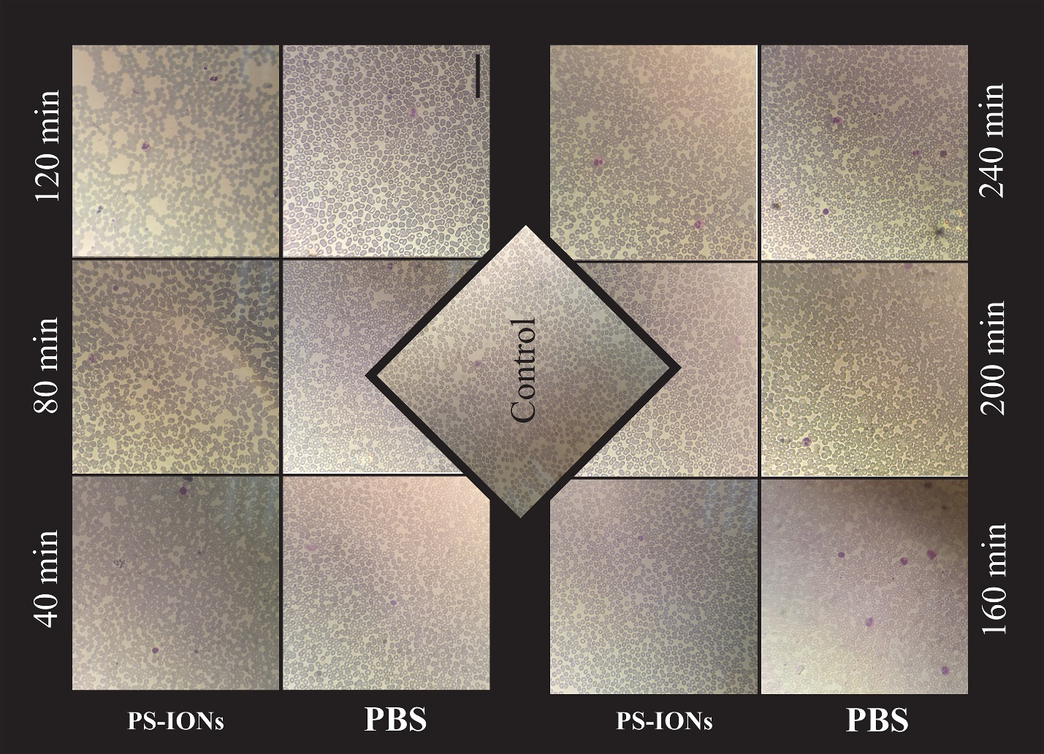
Figure S2 : Light microscopic images of blood smears prepared samples from EDTA-anticoagulated blood without dilution (control) and after addition of PS-IONs (final concentration 200 μg /mL) and PBS in 40 min time intervals up to 4 h. Scale bar, 50 µm .
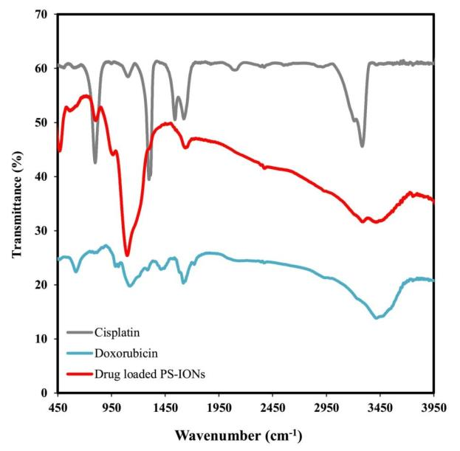
Figure S3 : FT-IR spectra of CDDP (grey line), DOX (blue ine) and drug loaded PS-IONs (red line).

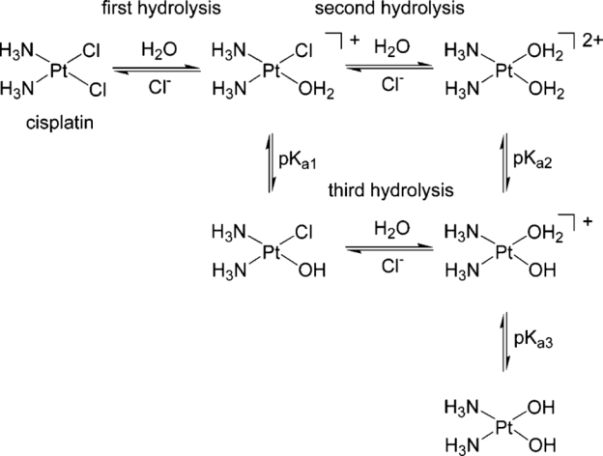
Figure S4: CDDP hydrolysis[44]

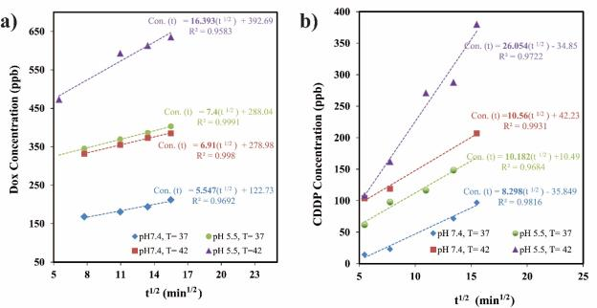
Figure S5: Release profiles of DOX (a) and CDDP (b) from PS-IONs as a function of square root of time.
According to the Higuchi equation, the release rate constant in each condition can be calculated from the slop of fitted lines [43].

