ORIGINAL RESEARCH
Supplementary materials

Multifunctional immunoliposomes combining catalase and PD-L1 antibodies overcome tumor hypoxia and enhance immunotherapeutic effects against melanoma
Yu Hei¹,BingHong Teng ^{2,3}, ZiQian Zeng^{2,3},SiQi Zhang³,Qian Li³,JiJia Pan³,ZuYuan Luo³, ChunYang Xiong^{1,*},ShiCheng Wei^{2,3,*}

¹ Department of Mechanics and Engineering Science, College of Engineering, Peking University, Beijing, China;
² Department of Oral and Maxillofacial Surgery, School and Hospital of Stomatology, Peking University, Beijing, China;
³ Laboratory of Biomaterials and Regenerative Medicine, Academy for Advanced Interdisciplinary Studies, Peking University, Beijing, China.

*Correspondence: Prof. ChunYang Xiong
Department of Mechanics and Engineering Science, College of Engineering,Peking University, Beijing, China.
Tel: +86 10 62757940
Email : cyxiong@pku.edu.cn

*Correspondence: Prof. ShiCheng Wei
Department of Oral and Maxillofacial Surgery, School and Hospital of Stomatology, Peking University, Beijing, China
Tel: +86 10 82195780
Email : sc-wei@pku.edu.cn

Figure S1. X-ray photoelectron spectra and N1s peaks of different groups.
Notes : (A) DSPE-PEG2000 and aPDL1. (B) DSPE-PEG2000-NHS and aPDL1.
Abbreviations: aPDL1, programmed death ligand 1 monoclonal antibody; DSPE-PEG2000, Distearoylphosphatidylethanoloamine-methoxy-polyethylene glycol MW:2000; DSPE-PEG2000-NHS, 1,2-distearoyl-sn-glycero-3-phosphoethanolamine-N- [succinimidyl(polyethylene glycol)]
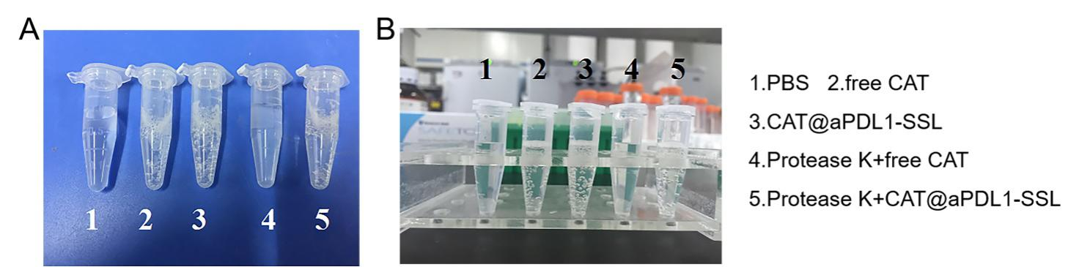

Figure S2 A,B O₂ production by free CAT and CAT@aPDL1-SSLs in H₂O₂ solution under different conditions.
Abbreviations : CAT, catalase; CAT@aPDL1-SSLs ,CAT-loaded immunoliposomes.
Figure S3 A,B Effects of control (PBS), aPDL1-SSLs, CAT@SSLs, and CAT@aPDL1-SSLs on tumor hypoxia status.
Notes:(A) Immunofluorescence images of tumor slices harvested from B16-F10 tumor-bearing mice following intravenous injection with four different formulations. The blue signals represent nuclei stained by DAPI and the red signals represent HIF-1α protein stained by anti-HIF-1α antibody, respectively. (B) The quantitative results of HIF-1α positive areas analyzed using Image J software based on the images shown in (A). (n = 3, results are means ± S.D. ,Scale bar: 100 μm,* P < 0.05)
Abbreviations : aPDL1, programmed death ligand 1 monoclonal antibody; CAT, catalase; SSL, sterically stabilized liposome; aPDL1-SSLs, aPDL1 modified immunoliposomes; CAT@aPDL1-SSLs, CAT-loaded immunoliposomes.
Figure S4 A-E. Flow cytometry analysis of CD8⁺ and CD4⁺ tumor infiltrating T cells.
Abbreviations : aPDL1, programmed death ligand 1 monoclonal antibody; CAT, catalase; SSL, sterically stabilized liposome; aPDL1-SSLs, aPDL1 modified immunoliposomes; CAT@aPDL1-SSLs, CAT-loaded immunoliposomes.

