Fig.S1. Ultraviolet-visible spectrum of MONPs.
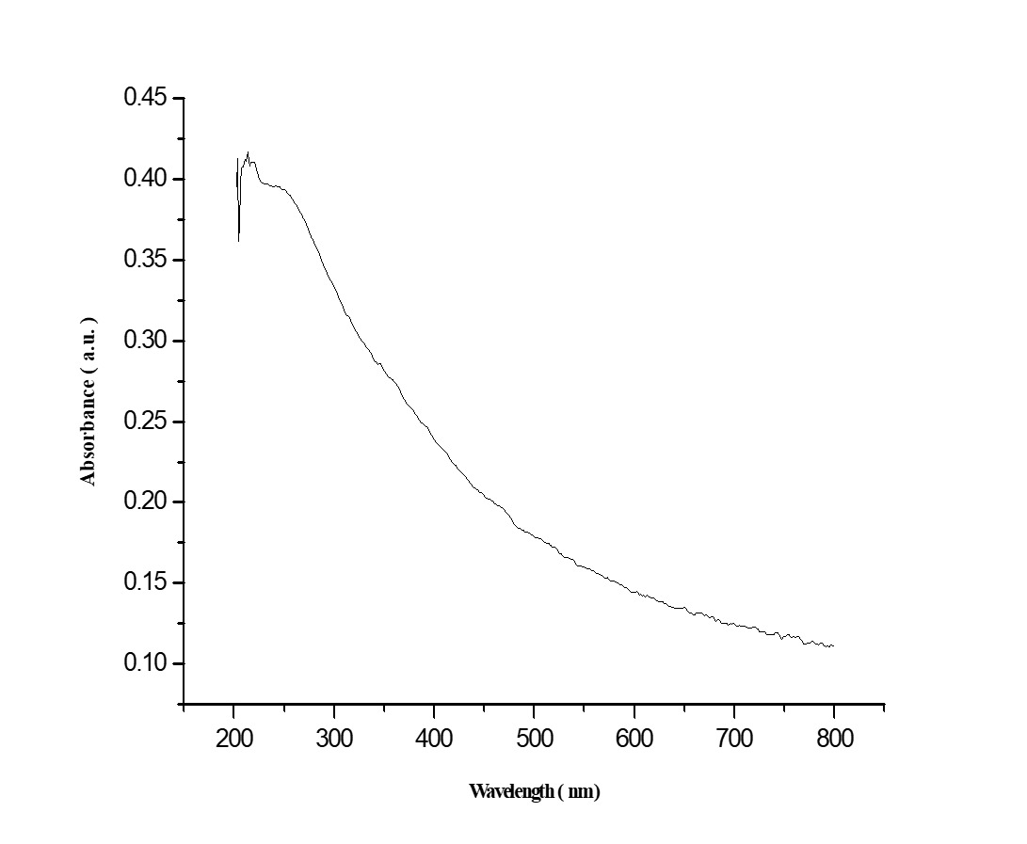
Abbreviations: MONPs, Manganese oxide nanoparticles

Fig S2. Size distribution and concentration obtained by nanoparticle tracking analysis (NTA) for MONPs.
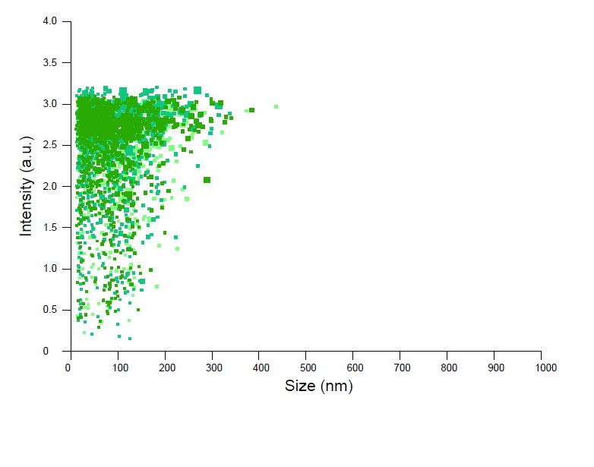

Fig S3. Time-course of the change in paw withdrawal threshold to heat stimulation in partial sciatic nerve transection (PSNT) rats and the effect of MONPs on thermal paw withdrawal latency in Sham and PSNT rats.
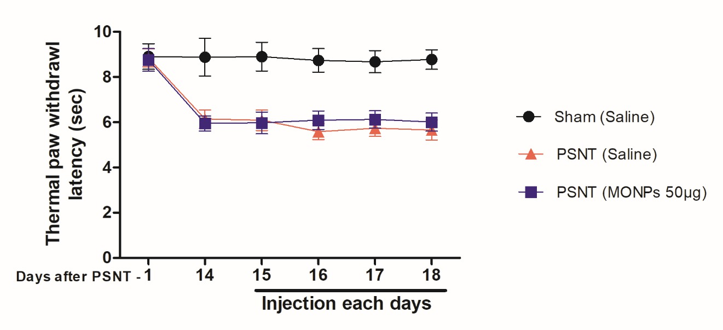
Differences between paw withdrawal threshold to radiant heat stimuli in rats with sham surgery (N = 6) and PSNT were assessed preoperatively on the day of surgery (indicated as day -1 on the x-axis) and on day 14 after surgery. After PSNT, significant thermal hyperalgesia developed on day 14. The effect of intrathecal MONPs (50 μg) on the antihyperalgesic effect was measured for 60 minutes after saline or nanoparticle injection from days 14 to 18 after PSNT. p<0.01.
Abbreviations: PSNT, partial sciatic nerve transection; MONPs, Manganese oxide nanoparticles

Fig S4. Effects of intrathecal single injection of saline 10μL or 50μg MONPs in 10 μL saline, on the tail flick latency of PSNT rats on day 14 of PSNT, (N=6).
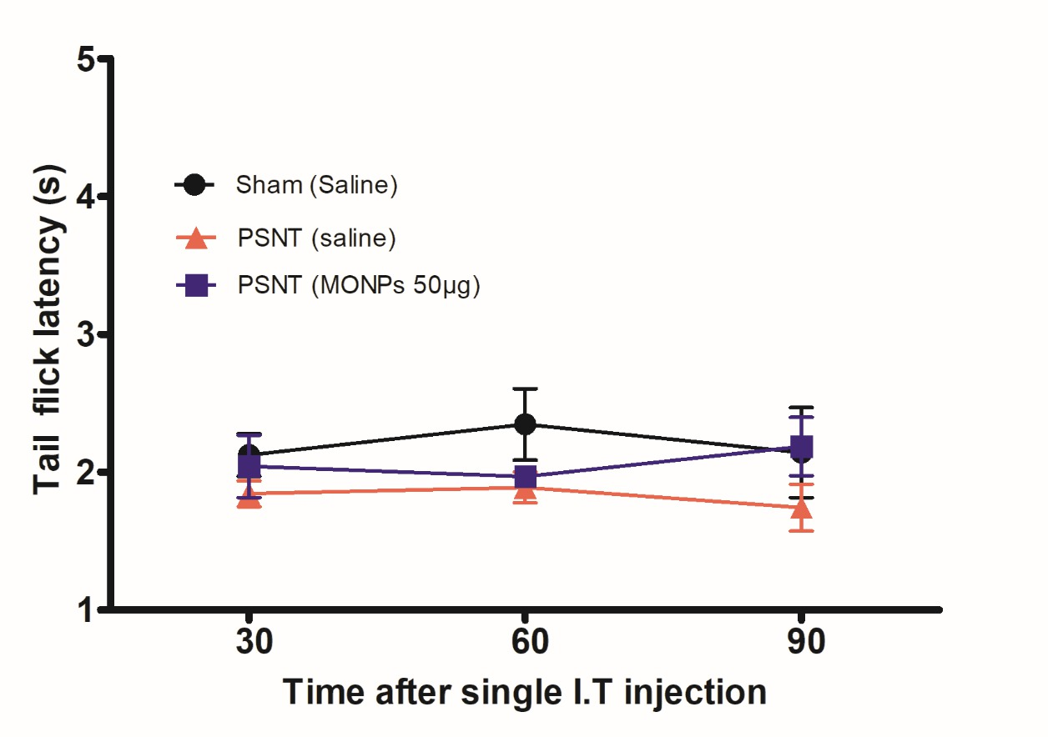
Abbreviations: MONPs, Manganese oxide nanoparticles PSNT, partial sciatic nerve transection

Fig S5. Hematoxylin and eosin staining in the spinal cord sections. Sections from group (a) display only a small number of lymphocytes (circle marks) normal oligodendrocytes (arrow marks) with protruding perinuclear halos with poorly stained substances (star marks). Sections from group (b)display lymphocyte infiltration along with oligodendrocyte localization. Sections from group (c) display low number of lymphocytes and oligodendrocytes in comparison with group b. Group a, Sham-operated; Group b, saline-treated after PSNT; Group c, MONPs-treated after PSNT.
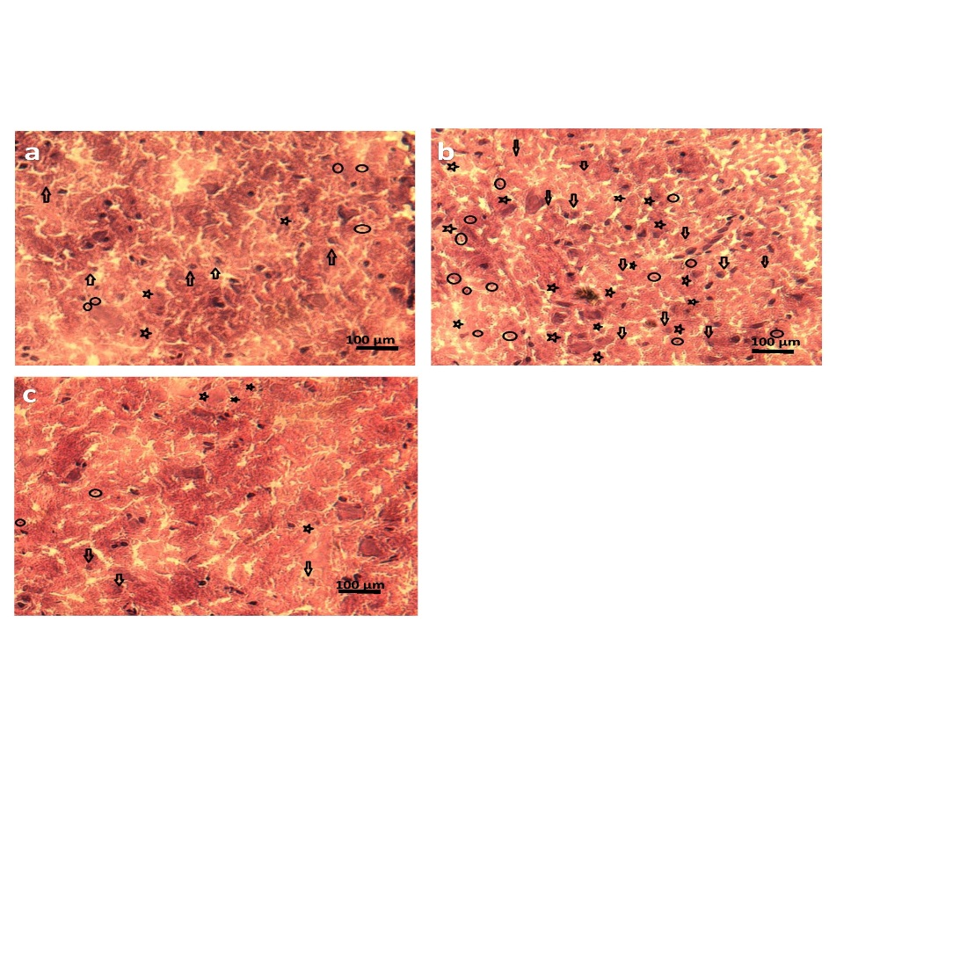
Abbreviations: MONPs, Manganese oxide nanoparticles PSNT, partial sciatic nerve transection

