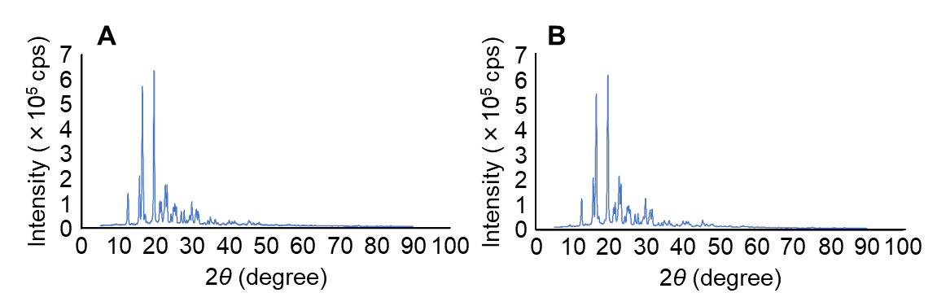
Supplemental data 1 Morphology of MXD with or without bead mill treatment in XRD.
Notes: (A) XRD pattern of MXD not treated with bead mill. (B) XRD pattern of MXD treated with bead mill. The morphology of MXD did not differ with or without bead mill treatment.
Abbreviations: MXD, minoxidil; XRD, powder X‑ray diffraction.

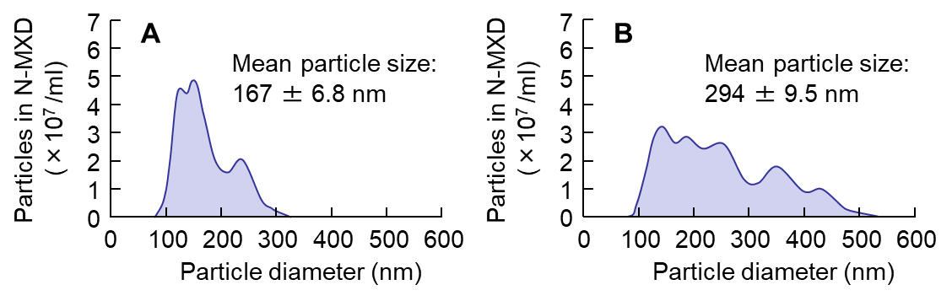
Supplemental data 2 Particle size frequencies of N-MXD 2 (A) and 4 (B) weeks after preparation.
Abbreviations: N-MXD, formulation based on minoxidil nanoparticles.

