Supplementary table 1 Relationship between serum AAT levels and the causes of mortality of the subjects with COPD during entire 10 years

 | AAT <116 | AAT 116 to ≤141 | AAT >141
Number of all mortalities, N | 22 | 54 | 36
Respiratory diseases, N (%) | 10 (45) | 16 (30) | 19 (53)
Lung cancer, N (%) | 5 (23) | 13 (24) | 6 (17)
Other cancer, N (%) | 3 (14) | 8 (15) | 7 (19)
Cardiovascular diseases, N (%) | 1 (5) | 9 (17) | 2 (6)
Other reasons, N (%) | 3 (14) | 8 (15) | 2 (6)
p = 0.34 by Fisher’s exact test
Abbreviations: AAT, alpha-1 antitrypsin

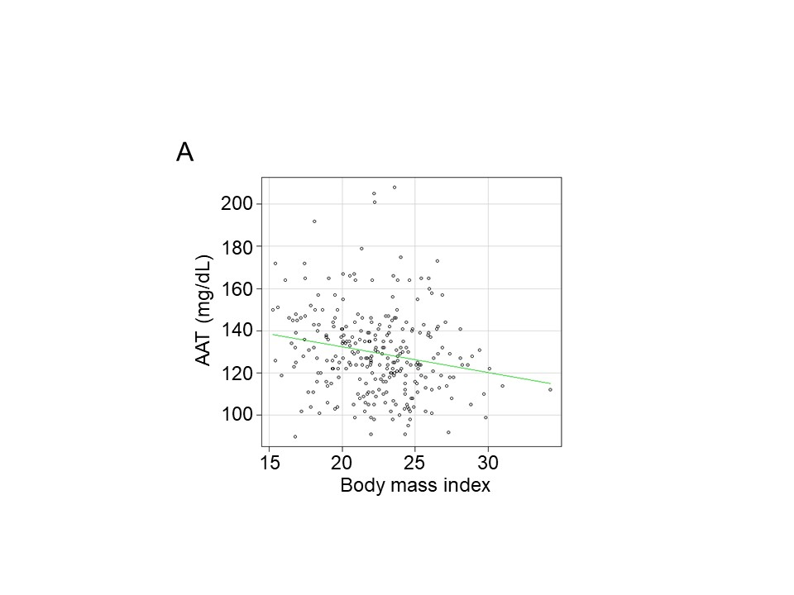
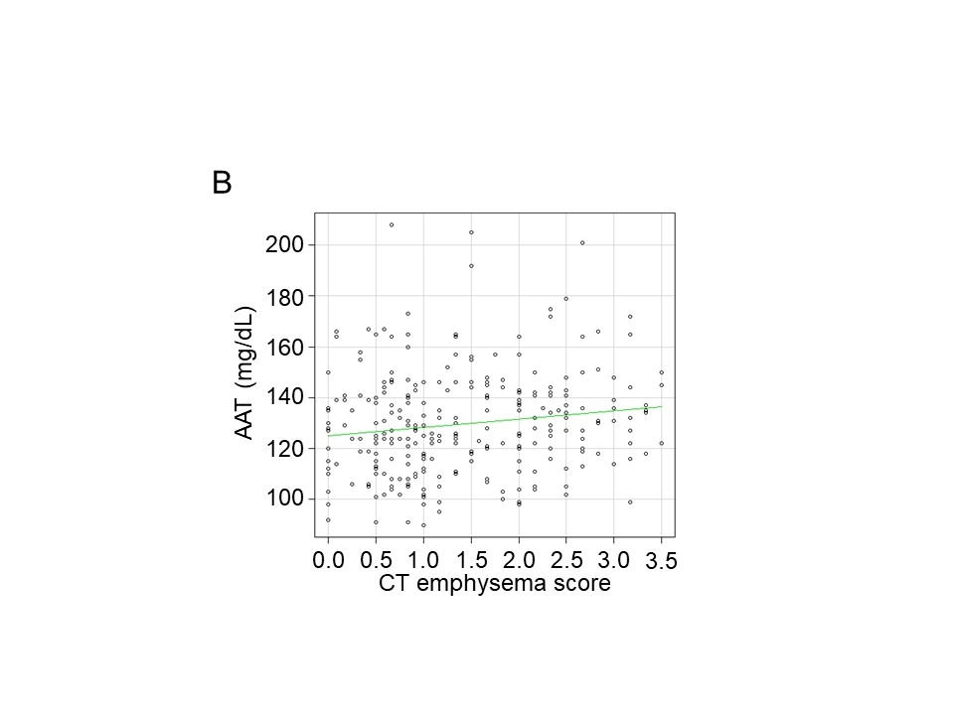
Supplementary figure 1 Spearman’s correlations between serum AAT levels and clinical parameters.
(A) Body mass index (ρ = -0.21, p < 0.01) and (B) CT emphysema score (ρ = 0.15, p = 0.01)
Abbreviations: AAT, alpha-1 antitrypsin; CT, computed tomography

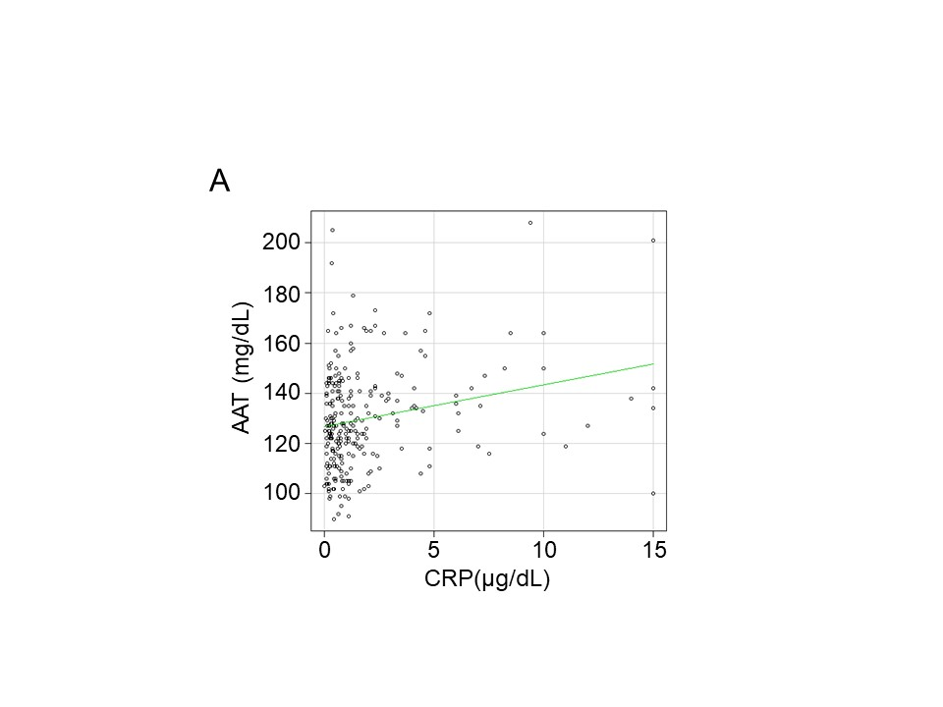
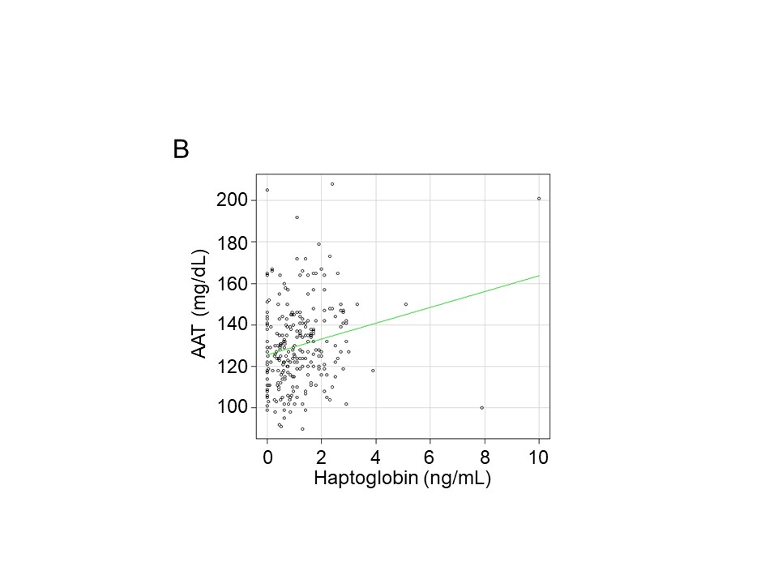
Supplementary figure 2 Spearman’s correlations between serum AAT levels and other
inflammatory markers.
(A) C-reactive protein (ρ = 0.20, p = 0.001), (B) haptoglobin (ρ = 0.18, p = 0.003), (C) blood neutrophil counts (ρ = 0.16, p = 0.006)
Abbreviations: AAT, alpha-1 antitrypsin; CRP. C-reactive protein

