Supplementary Information

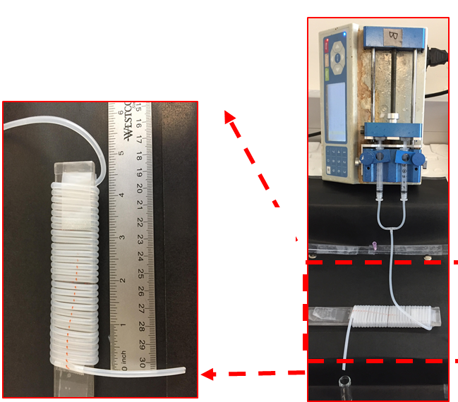

Supplementary Figure 1. Experimental setup for formulating LCP.

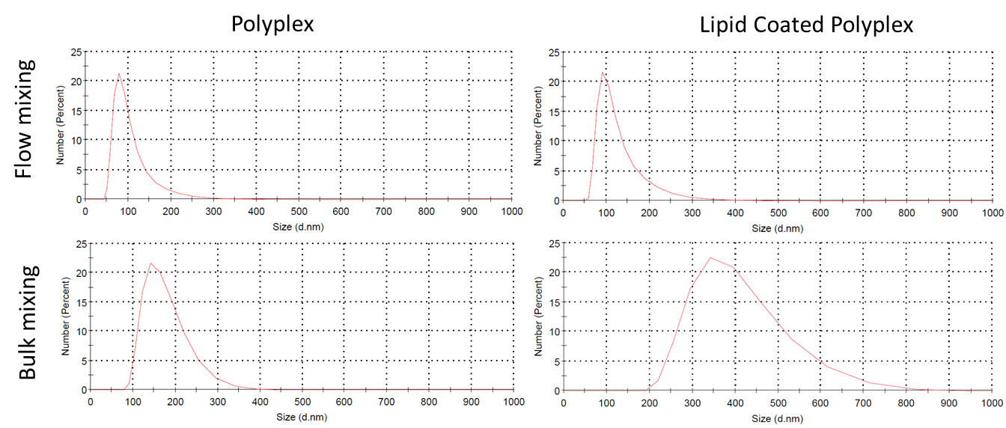
Supplementary Figure 2. Comparing effect of flow mixing and bulk mixing on particle size distribution. For flow mixing, polyplex and LCP were prepared using the fluidics channel at a N/P ratio of 10 and using 4 mM lipid mixture, respectively. For bulk mixing, polyplex were prepared by mixing 1mL of 60 µg plasmid to 1 mL of CD_{2.5kD}-PEI in 20mM HEPES buffer at a N/P ratio of 10 in a glass vial, followed by brief vortexing of 30 seconds. Lipid coating was performed using lipid film hydration method where the polyplex solution was added to a dried lipid film developed by evaporating 1mL of 4mM lipid mixture in a round bottom flask followed by hydration of 30 mins and vortexing for 2 min.
Supplementary Figure 3. Negative stain TEM images of (A) Polyplex and (B) LCP. Polyplex were made using N/P ratio of 10; LCP were coated with 4 mM lipid solution (CHEMS:DOPE:DSPC:DSPE-mPEG_{2k} = 34:54:10:2)

Supplementary Figure 4. Effect of heparin concentration on polyplex dissociation. Polyplex (N/P 10) were incubated with different concentrations of heparin sulfate solution in 20 mM HEPES for 30 min at 25 ºC followed by evaluation of pDNA release using the PicoGreenTM assay.

Supplementary Figure 5. Encapsulation (A) and loading efficiency (B) of curcumin. Curcumin content was quantified by monitoring absorbance of curcumin containing samples at 425 nm using a plate reader.

Supplementary Figure 6. Cytotoxicity analysis of LCP formulations. MB49 cells were treated with different LCP formulations for 4 h followed by washing to remove uninternalized particles. The cells were incubated for another 24 h before adding the MTS reagent. After incubating for 1 h, the absorbance of soluble formazan formed due to bio-reduction of MTS by the live MB49 cell population was measured at 490 nm. All treatments for each formulation was performed in triplicate and error bars represent standard deviations of the mean (n=3).

