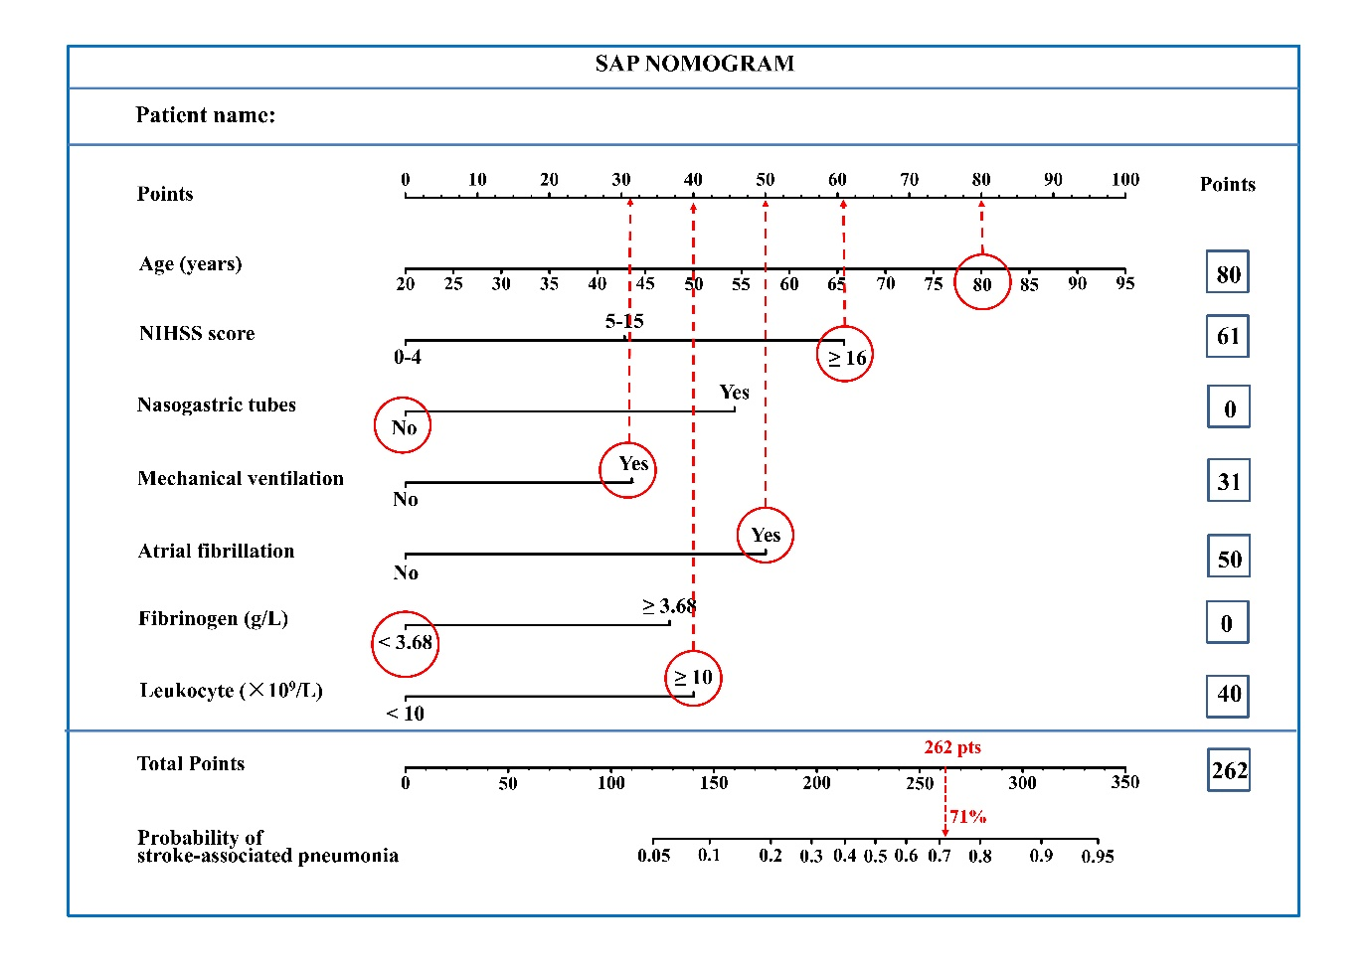
Supplementary Figure 1. Example of using the SAP nomogram. There is an 80-year-old stroke patient, we can mark his age (80 years old) on the “Age (years)” axis, and draw a vertical line to the “Points” axis to obtain the corresponding points of this predictor. Repeating this process, this patient also has the baseline NHISS score of 16 (61 points). He underwent mechanical ventilation (31 points) and atrial fibrillation (50 points), but no nasogastric tubes (0 points). The baseline leukocyte was 11.0*10⁹/L (40 points), and the baseline fibrinogen was 2.96 g/L (0 points). His total score is therefore 80+61+31+50+0+40+0=262 points. Mark this sum on the “Total Points” axis, and draw a vertical line down to cross the “Probability of Stroke-associated pneumonia” axis, and the corresponding probability of experiencing early SAP after stroke is around 71%.

