Supplementary Figure 1

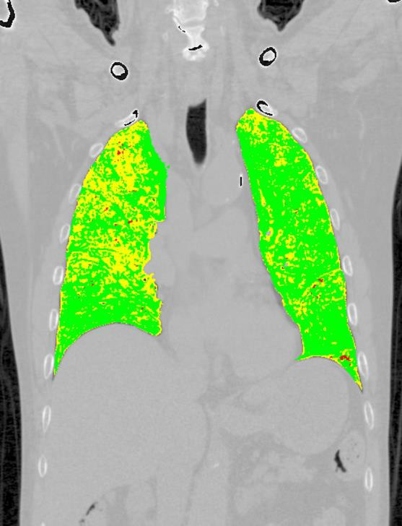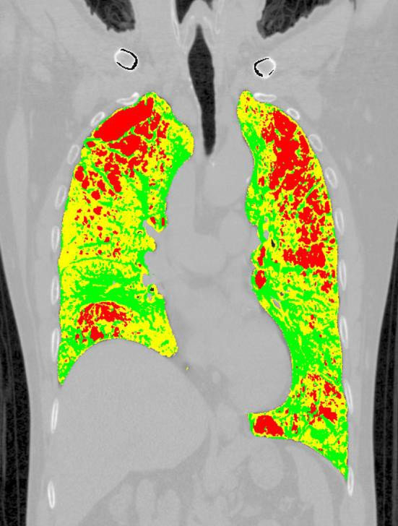
A
B

Supplementary Figure 1 Colored DPM map images of (A) a non-COPD smoker and (B) a COPD patient.
(A) 72-year-old male. (B) 63-year-old male with a GOLD 2 classification. From the three classifications, DPM_{Normal} is shown in green, DPM_{GasTrap} is shown in yellow, and DPM_{Emph} is shown in red.
DPM: disease probability measure; GOLD: Global Initiative for Chronic Obstructive Lung Disease; DPM_{Normal}: normal lesion recognized by DPM; DPM_{GasTrap}: gas trapping lesion recognized by DPM; DPM_{Emph}: emphysematous lesion recognized by DPM.

