Supporting Information

ADDITIONAL FIGURES

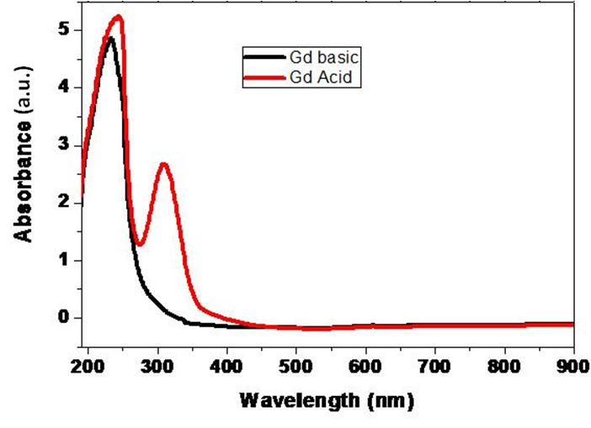

Figure S1: UV Vis spectra of Gd -Au complex under basic (black line i.e. Gd basic) and acidic (red line i.e. Gd acid) conditions in aqueous solution.

Figure S2. Changes in the UV-Vis absorption spectra of Gd@ AuNPs (NP1 NP2 NP3) when incubated in cell culture media (DMEM + 10% FBS) respectively up to 72h. The absorption peak of nanoparticles was unchanged and the size and shape were not compromised

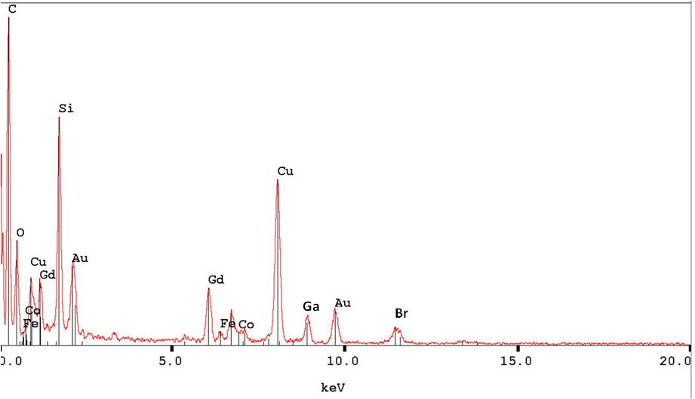
Figure S3: EDX microanalysis of Gd@AuNPs

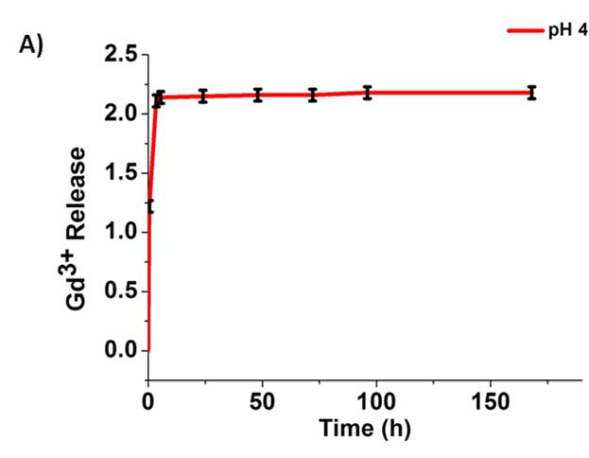
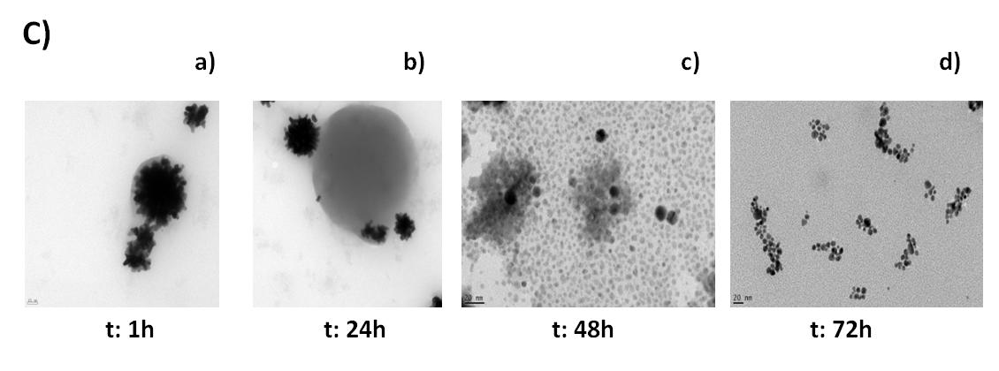
Figure S4: (A) Percentage (%) of Gd (III) as Au-@Gd complex , released from NP3 overtime in PBS (37 °C) at pH = 4.0 (red dots). (B) Variations of the Raman band intensity at 260 cm⁻¹versus time. NP3 was incubated in PBS (37 °C) at pH 4.0 ; (C) TEM images and conformational shape modifications under PBS (37 °C) .

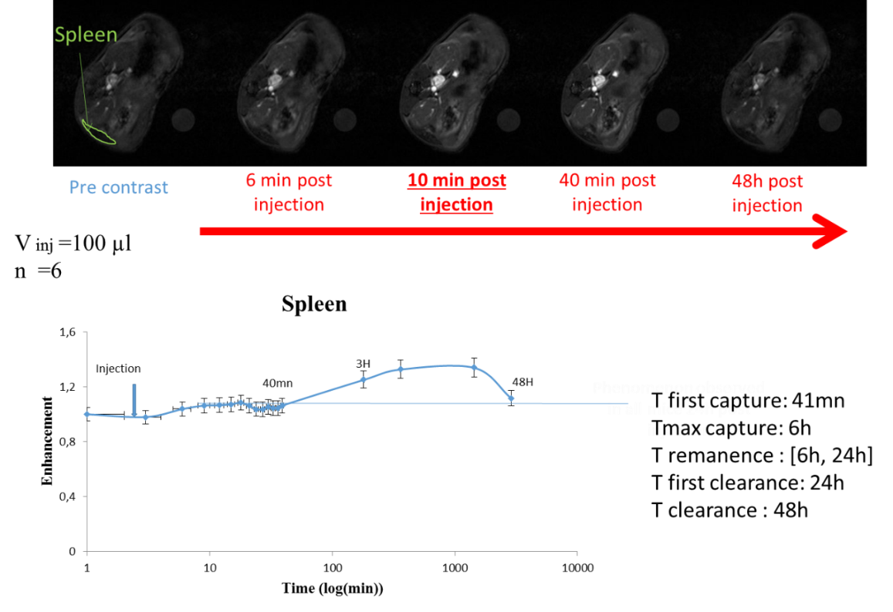

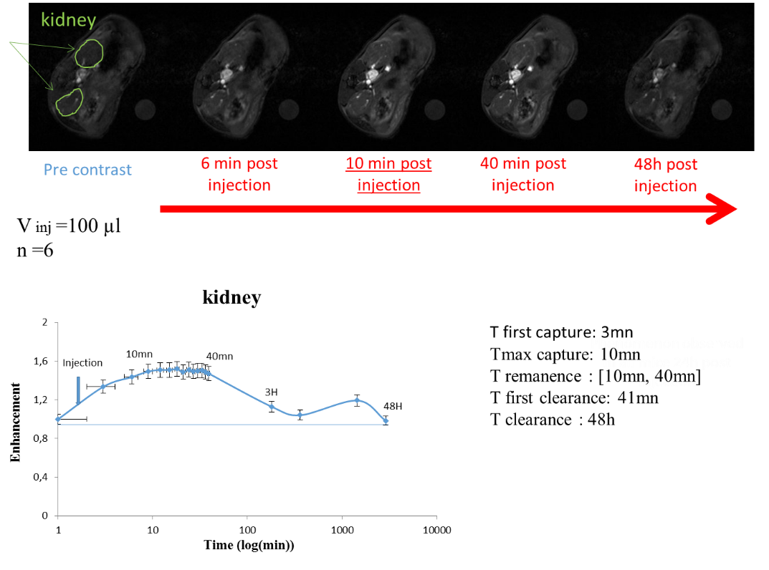
Figure S5: Spleen and kidney organs biodistribution recorded by In vivo DCE MRI at 7T.

ADDITIONAL TABLES

Table S1: z-potential and hydrodynamic diameter of NP1, NP2, NP3.

Synthetic product | Zeta potential  (mV) | Hydrodynamic diameter  (nm) | PdI
NP1 | -25 ± 2 | 20 ± 2 | 0.3±2
NP2 | -20 ± 1 | 40± 2 | 0.3±2
NP3 | 23 ± 1 | 60± 2 | 0.3±2

